Some of the errors faced in Jenkins:

1. One error which wasted the complete day is as below:

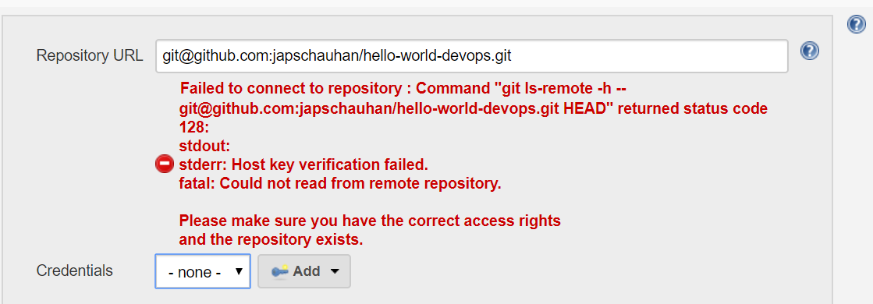

I was getting the above error again and again, even after adding all of the required key-values in the GitHub. As I was practicing, I have build multiple EC2 environments as well, but still the error was there. At the end issue was found at the GitHub end as below:

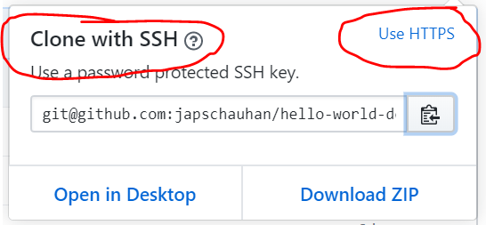

While using github URL in Jenkins to configure a job, we need to specify the HTTPS link, but I was specifying SSH link and hence the host-key error was coming. Stupidity is, if you (by mistake) click on “USE SSH” link of the default view(screenshot below), Github will make it default for all of the existing repository.

