Below are the step to follow installing Jenkins on AWS EC2 RHEL machine:

1. First requirement for Jenkins in JAVA, hence on a fresh server we first need to install JAVA using below command:  
    sudo yum install java
2. After installing java we need to install Jenkins using below commands:  
   sudo wget -O /etc/yum.repos.d/jenkins.repo http://pkg.jenkins-ci.org/redhat/jenkins.repo

sudo rpm --import https://jenkins-ci.org/redhat/jenkins-ci.org.key

sudo yum install jenkins

1. After that we need to start the Jenkins service using below command:  
   sudo service jenkins start
2. We can check the status of service using command:  
   systemctl status jenkins.service
3. Now, in the next step we need to configure the Jenkins port 8080 on the AWS EC2 instance, for that we go to the EC2 instance page and go to the security groups:  
     
   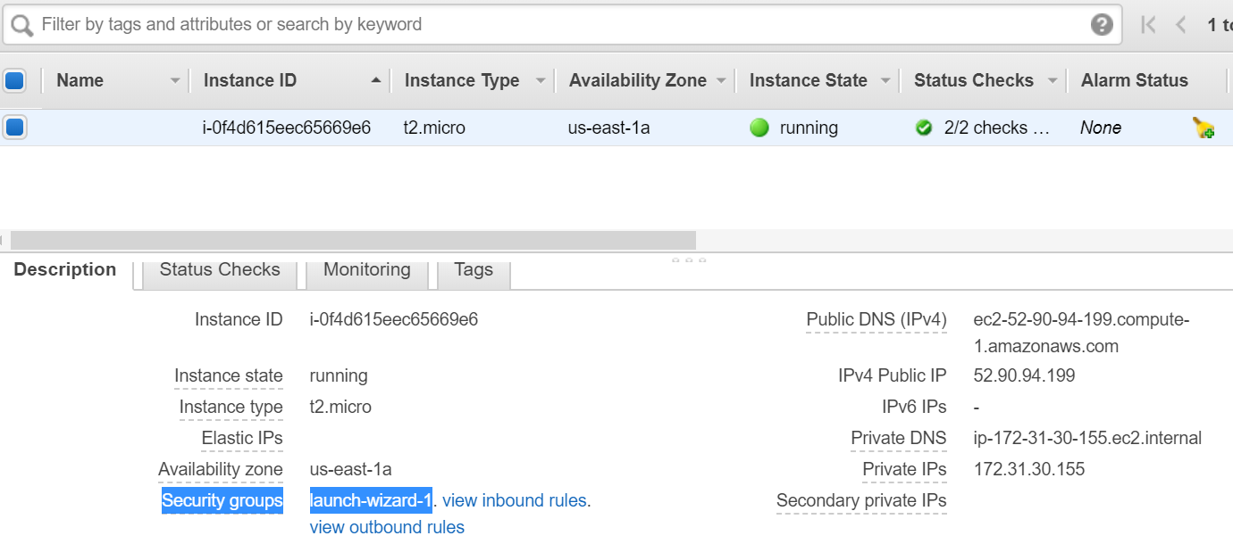
4. In the security group we need to add the custom TCP rule for all user via port 8080:

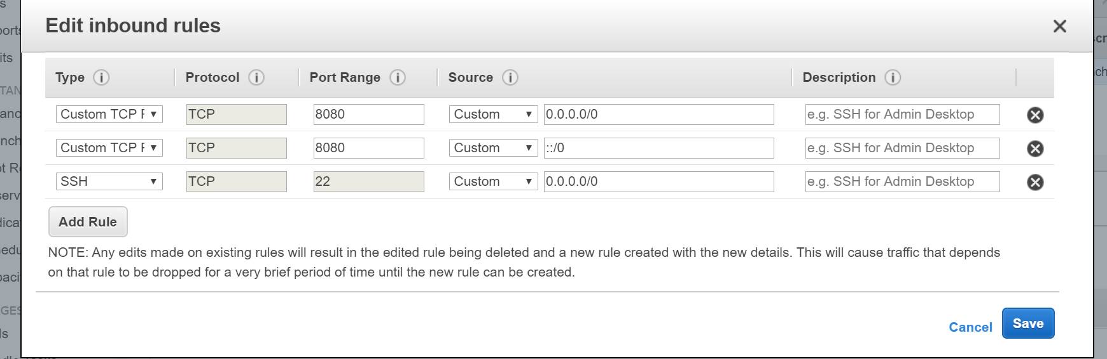

1. After that we can access the Jenkins using the URL:  
   <Public IP of EC2 instance>:8080  
   