Few basic details for Jenkins:

Default Jenkins installation directory:

Default Jenkins HOME directory: /var/lib/Jenkins

* This value can be changed using below three methods:  
  Edit the JENKINS_HOME variable in your Jenkins configuration file (e.g. /etc/sysconfig/jenkins on Red Hat Linux).
* Use your web container's admin tool to set the JENKINS_HOME environment variable.
* Set the environment variable JENKINS_HOME before launching your web container, or before launching Jenkins directly from the WAR file.
* Set the JENKINS_HOME Java system property when launching your web container, or when launching Jenkins directly from the WAR file.
* Modify web.xml in jenkins.war (or its expanded image in your web container). This is not recommended.

This value cannot be changed while Jenkins is running.

**User management:**

Users can be created using the create user option in manage Jenkins:

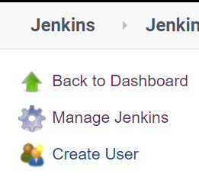

To restrict user access on the Jenkins, we need to use role-based authentication plugin, which can be installed from manage plugin:

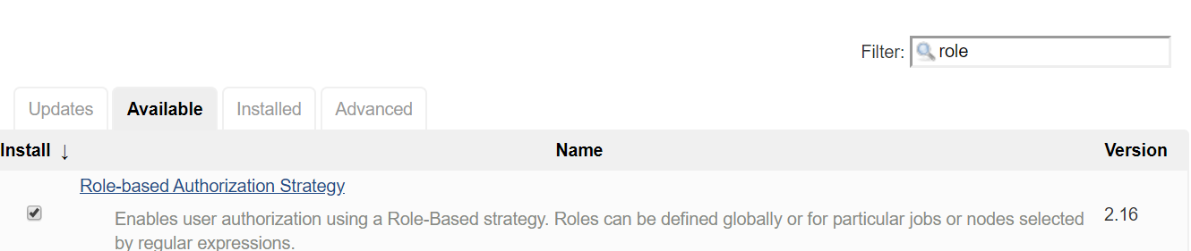

Plugins can also be installed using the hpi file, which can be downloaded from the plugin official website.

After installing the plugin, we need to select “role-based strategy” in “configure global securirty”, both shown below:

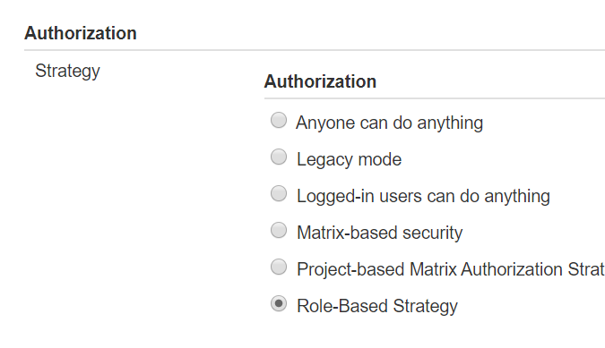

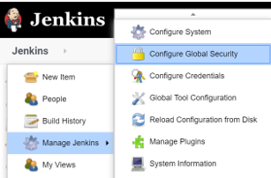

The above two steps will enable a new option in manage Jenkins, known as “manage and assign roles”

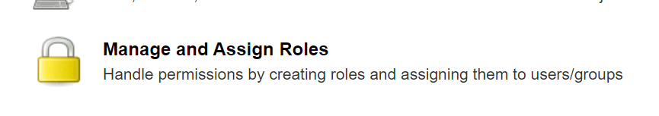

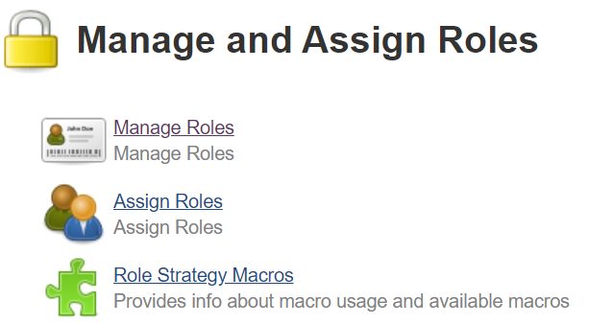

The manage role used for creating and managing roles. For creating a role there are three level of access available:

1. Global role: to provide access globally
2. Item roles:
3. Node role:

Later on these roles can be assigned to any user as per the requirements.