

Republic of the Philippines

Laguna State Polytechnic University

Province of Laguna

**HEALTH APPOINTMENT BOOKING SYSTEM**

Prepared by: Lyka Alliah Cailles

Course & Section: BSCS 2-A

**TABLE OF CONTENTS**

* Introduction
* System User-interface
* SQL server script
* System code

**Introduction**

Appointment scheduling systems are used by primary and specialty care clinics to manage access to service providers, as well as by hospitals to schedule elective surgeries. Many factors affect the performance of appointment systems including arrival and service time variability, patient and provider preferences, available information technology and the experience level of the scheduling staff. appointment scheduling eliminates urgent time-wasting phone calls, freeing you up to tackle the important tasks that makes your business money.

**System User Interface**

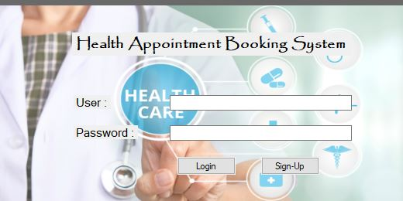

Start Page (Log-in/Sign up)

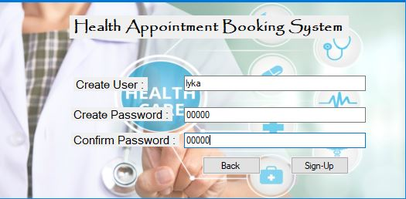

Sign up Page



Main Page

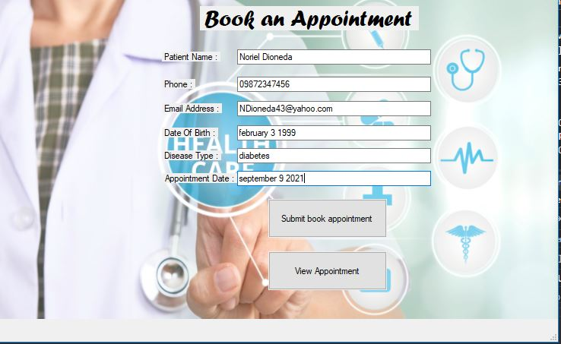

Book Appointment Page(Scheduling)

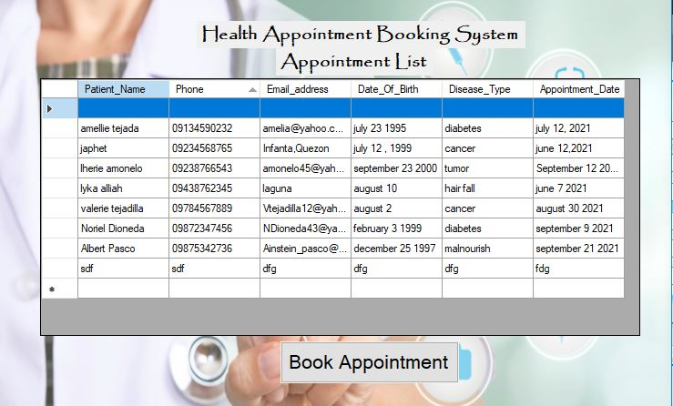

List of Appointed(Scheduled)

**SQL Server Script (XAMPP/MYSQL)**

Library of MySQL

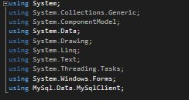

Server Connection

Getting the user and password during log in

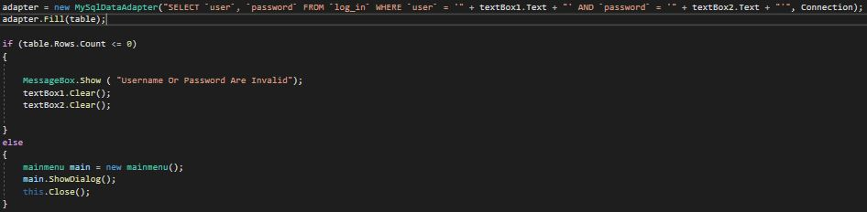

Inserting the appointing record on the database MySQL XAMPP

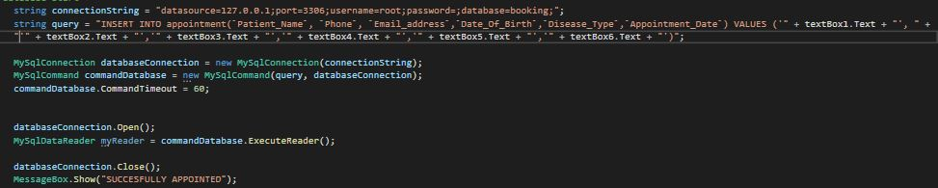

Showing record to the System using the data Grid View

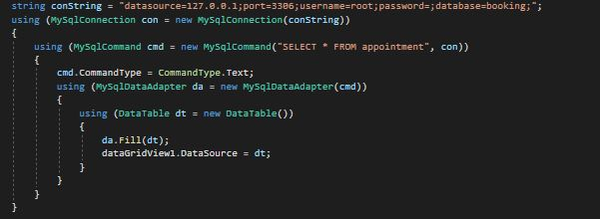

**C++ DLL**

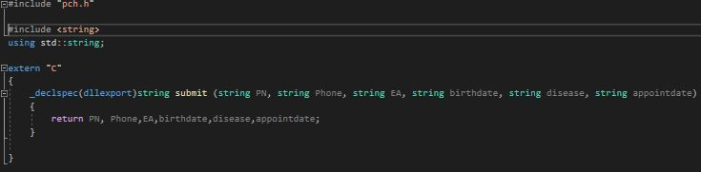

 A **DLL** is a library that contains code and data that can be used by more than one program at the same time. In this dll it composed a variable that is going to use in the body program.

**System Code**

Start page login/sign up coding

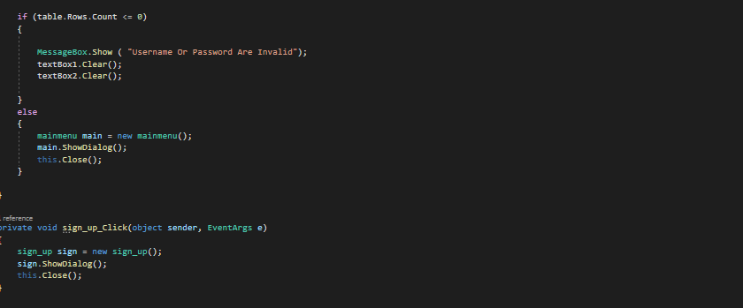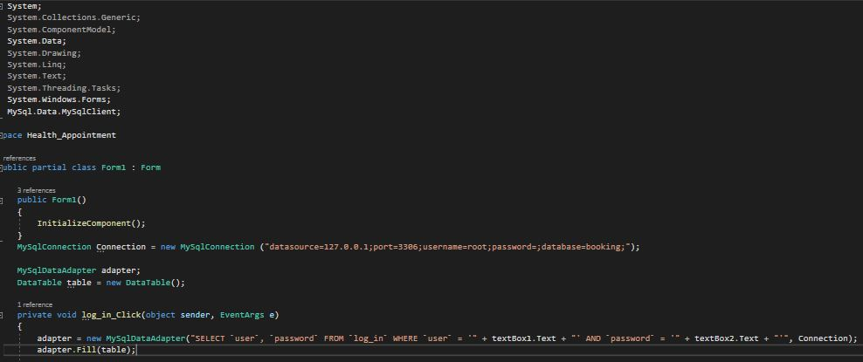

In this part of program it show how to login and the form where the sign up will go when clicked. XAMPP MySQL has been used in order to store the username and password of the person in clinic.

Sign-up Page 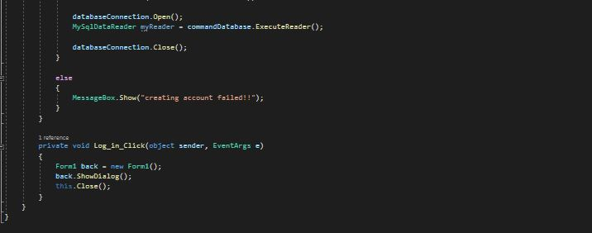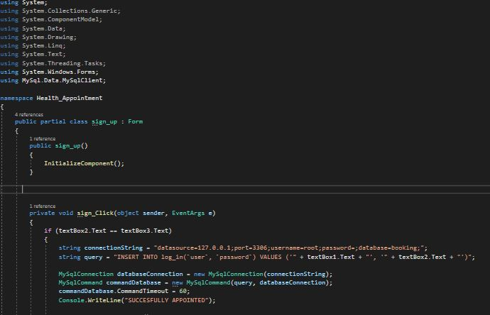

In this form it shows how to sign up and how the system saves the username and password during signing up and what will happen if doesn’t meet the condition on signing up.

Main Page

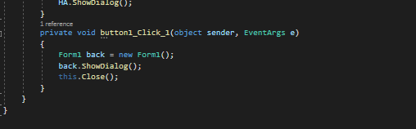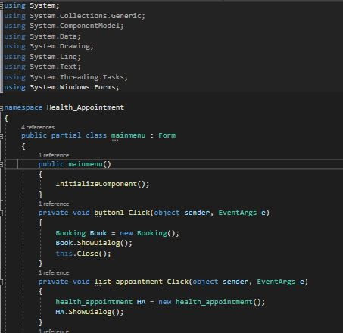

In this form syntax it only shows what form or page is going to appear in the event of clicking the buttons.

Scheduling an appointment

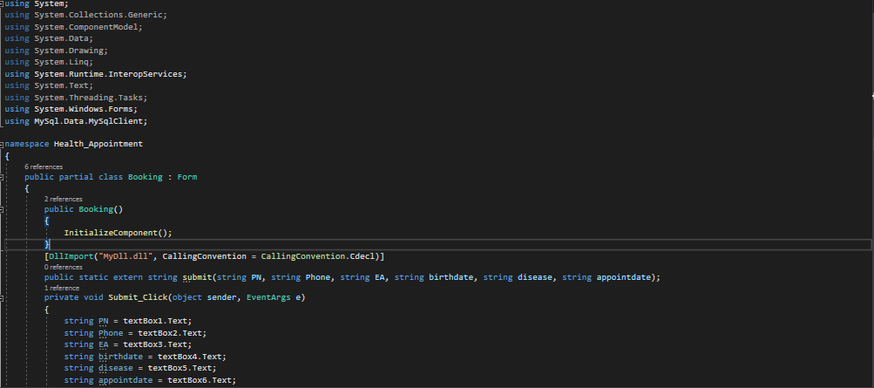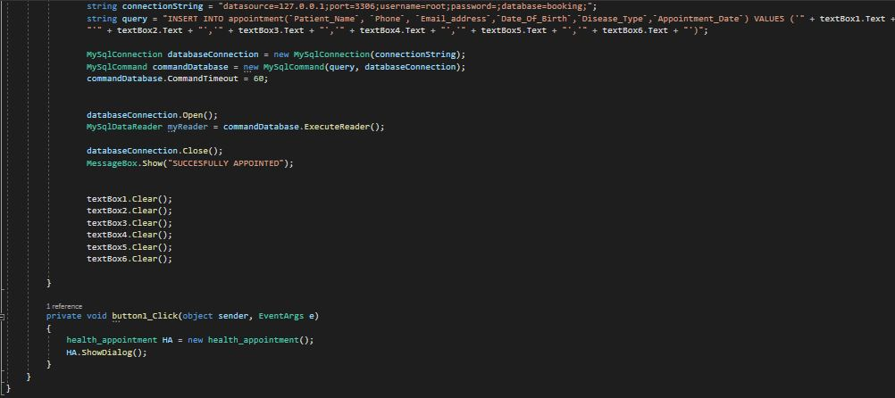

In this part the DLL has been use together with MySQL XAMPP Syntax. To store the scheduling information in the data base. Other scheduling system can use this kind of DLL to link the program.

List of appointed(Scheduled)

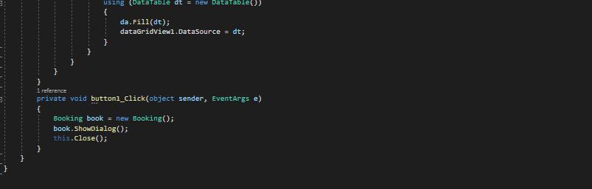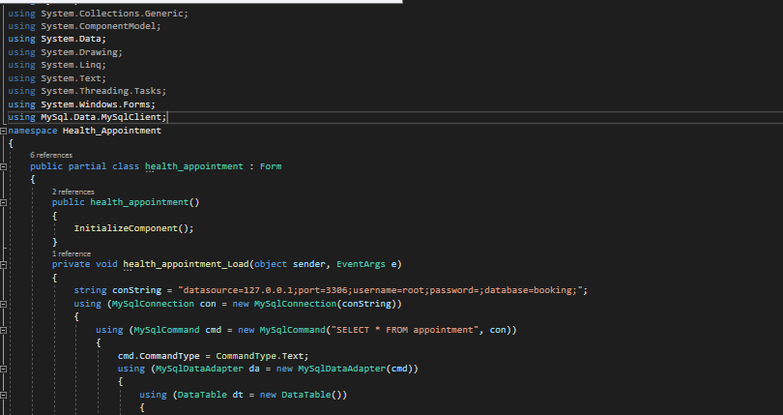

In this part of program, it displays the information of every person appointed. It is display on the data grid view.