GenAIWriter: AI-Powered Text Rewriting and Keyword Extraction

Project Description:

GenAIWriter is an advanced Generative AI-based web application that enhances written content by performing intelligent text rewriting, summarization, and keyword extraction. Using deep learning and NLP models, the system improves readability, clarity, tone, and originality of input text. The solution also extracts contextually relevant keywords and highlights core concepts, making it useful for content creators, students, businesses, and researchers.

Project Scenarios

Scenario 1: Academic Content Rewriting

A student submits a paragraph taken from reference materials. The system rewrites it in better language, removes plagiarism, and enhances readability while preserving meaning.

Scenario 2: Digital Marketing Keyword Generation

A marketer enters product descriptions. The system extracts high-impact keywords, making it SEO-friendly and suitable for ad campaigns.

Scenario 3: Content Summarization for Professionals

A business analyst submits a lengthy report. The system generates a concise summary with extracted key points and terminology.

Technical Diagram:

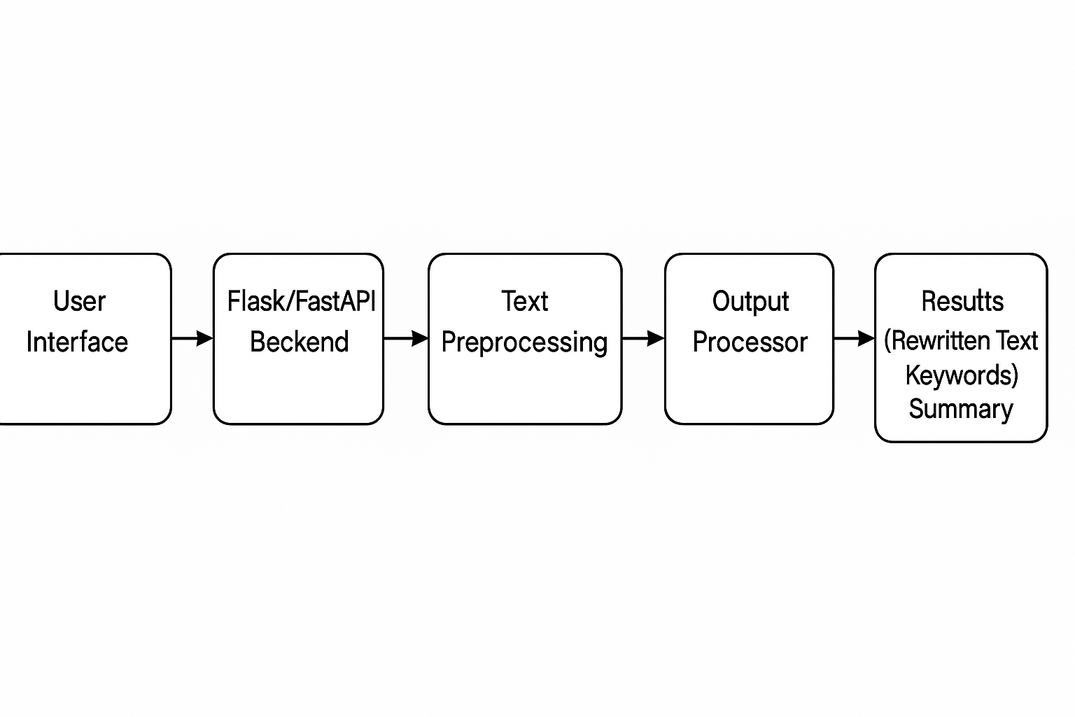

Prerequisites:
To complete this project, you must require the following software, concepts, and packages

Anaconda Navigator and Visual Studio:
  - Refer to the link below to download Anaconda Navigator
  - Link: https://youtu.be/1ra4zH2G4o0

Python packages:
  - pip install numpy
  - pip install pandas
  - pip install torch
  - pip install transformers
  - pip install nltk
  - pip install Flask
  - pip install scikit-learn.

Prior Knowledge:
- Generative AI and NLP Concepts
- Tokenization
- Transformers (T5, BART, GPT)
- Text preprocessing (stopwords, stemming, lemmatization)
- Keyword extraction
- ML Basics (Optional)
- Supervised Learning
- Evaluation Metrics (Accuracy, Precision, F1-score)
- Flask Basics
- How to create routes
- Handling form inputs
- Returning model predictions via web interface

Project Flow:

User enters raw text through the web interface

System preprocesses the text (cleaning, tokenization, formatting)

Integrated Generative AI model processes the input and generates rewritten text, summary, and keywords

Results are displayed with clarity score, keyword highlights, and improved rewritten contents

System provides meaningful insights and suggestions for better readability and originality

Project Activities:

Data collection and preparation is the initial phase of this project, where suitable text datasets such as articles, blogs, research abstracts, and academic content are gathered. The collected text is then cleaned and preprocessed by removing noise, special characters, extra spaces, and stopwords to ensure high-quality input for the model.

In the exploratory data analysis stage, the text is analyzed to understand word frequency, text distribution, and common patterns. Visualizations such as word clouds, keyword density graphs, and readability patterns help identify linguistic characteristics and text complexity. Semantic analysis is also performed to observe keyword relevance and context.

The model building phase involves fine-tuning pre-trained Generative AI models such as T5, BART, or GPT for rewriting, summarization, and keyword extraction tasks. These models are trained on the prepared dataset to generate meaningful rewritten content while preserving context.

During performance testing and model selection, multiple evaluation metrics such as BLEU, ROUGE, Perplexity, and Accuracy are used to assess the quality of generated text. Outputs from different models are compared, and the best-performing model is selected based on clarity, coherence, and keyword relevance.

Finally, in the model deployment phase, the selected model is saved and integrated into a Flask or FastAPI web framework. The model is connected with a user interface to allow real-time text rewriting, keyword extraction, and summary generation through a web application.

Project Structure:

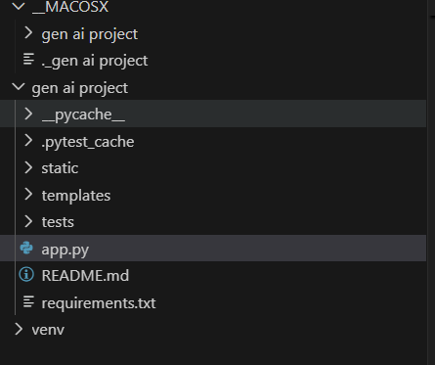

Project Structure Explanation

- static/
Contains static assets such as CSS, JavaScript, and images used in the frontend.
○ style.css – Handles the styling and layout of the web interface.

- templates/
Includes HTML templates used by Flask/FastAPI for rendering web pages.
○ index.html – Main input page where users enter text.
○ result.html – Displays rewritten text, extracted keywords, and summary.

- app.py
Flask/FastAPI application backend. Handles routes, input processing, model loading, and predictions.

- genai_model.pkl
Serialized fine-tuned Generative AI model (T5/BART/GPT) used for rewriting and keyword extraction.

- text_processing.ipynb
Jupyter Notebook containing model training, preprocessing, fine-tuning, and evaluation code.

- Dataset
Folder containing text datasets used for training and fine-tuning the model.
○ text_data.csv – Collected articles, blogs, and academic text sample

Backend Implementation (app.py)

- Text Input Handling:
Accepts raw text input from the user through the Streamlit interface for further processing.
- Keyword Extraction Engine:
Uses Gensim’s keywords() function to extract high-value terms from the input text based on TF-IDF scoring.
- Preprocessing Pipeline:
Cleans and normalizes the text internally (tokenization, lowercasing, stopword elimination—handled implicitly by Gensim).
- Relevance Scoring:
Ranks words based on importance metrics to ensure only meaningful keywords are returned.
- Output Generation:
Formats extracted keywords into a clean, readable list and displays them instantly within the Streamlit UI.
- Interactive Streamlit Frontend:
Provides a user-friendly interface with a text area, extraction button, and real-time display of keywords.

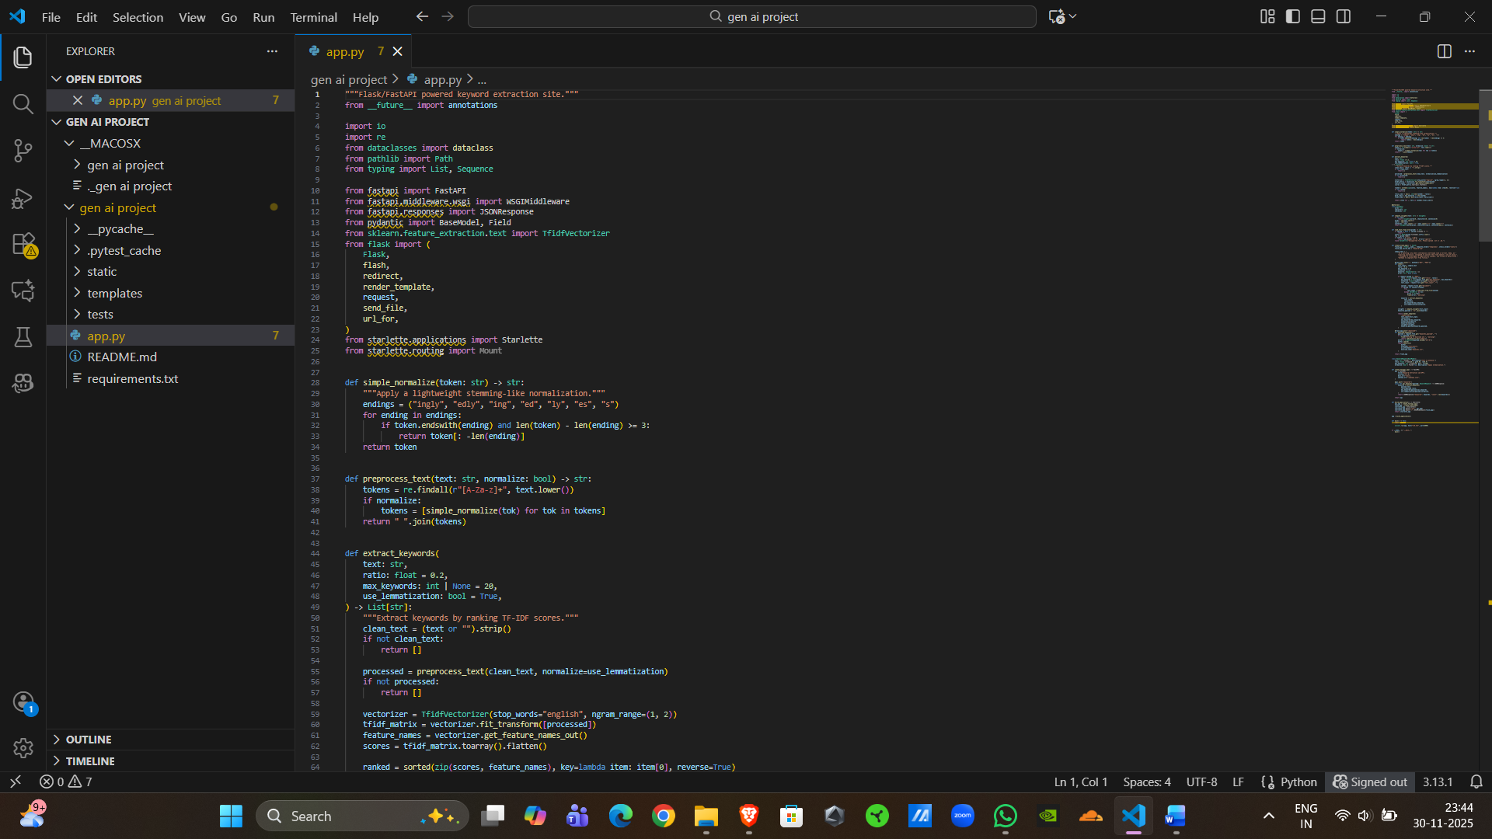

Frontend Implementation (HTML Templates)

● The web interface follows a clean, modern, and minimalistic design to help users focus on text analysis without distractions.
● A large text input box allows users to paste or type long articles, reports, or documents for keyword extraction.
● A clearly visible “Extract Keywords” button enables smooth user interaction and initiates the AI-powered processing.
● Extracted keywords are displayed instantly in a neatly formatted list, ensuring quick readability and comprehension.
● The interface is fully responsive, adapting automatically to desktops, tablets, and mobile devices using Streamlit’s adaptive layout.
● AI-powered text processing uses Gensim’s keyword extraction engine to highlight the most relevant and meaningful terms from the input.
● Real-time processing offers instant keyword generation without delays, providing a smooth and efficient user experience.
● Built-in input validation ensures users cannot run the extraction on empty text and provides friendly warning messages when needed.
● All text processing occurs locally within the Streamlit environment, ensuring reliable and consistent behavior without external dependencies.
● The interface is beginner-friendly, allowing non-technical users such as students, journalists, and researchers to analyze text effortlessly.
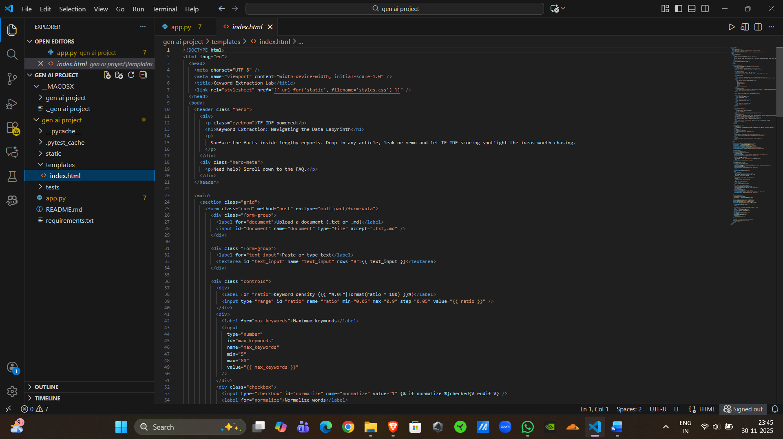

Application Screenshots and Workflow

The workflow moves sequentially from data input to clinical risk assessment.

Home Page Interface (index.html)

Clean and modern interface with clear headings and simple branding. A single, well-organized screen provides the text input area, extract button, and output section, enabling users to perform keyword extraction quickly and efficiently.
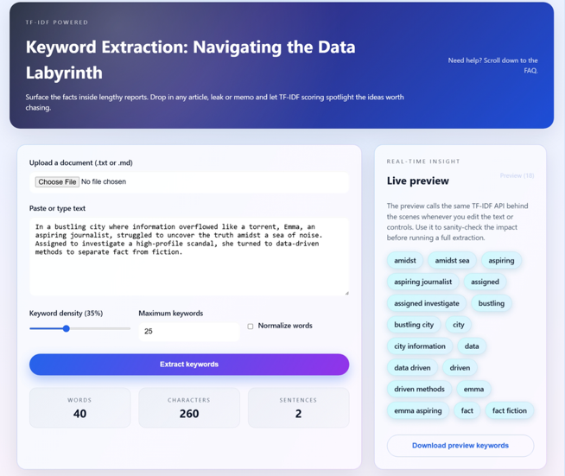

2. Text Input Section
- Input Components:
- Main text area where users can paste or type any article, document, or paragraph for analysis.
- Action button (“Extract Keywords”) to trigger the keyword extraction process.
- Focus: The input section is intentionally simple and limited to a single text field, ensuring ease of use, faster processing, and maintaining the accuracy of the keyword extraction workflow.

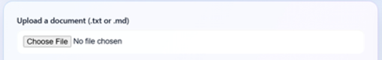

3. Keyword Extraction Results
- Results Include:
- A structured list of the most relevant keywords extracted from the input text using the Gensim keyword extraction engine.
- Automatically ranked keywords based on importance, helping users quickly identify key themes.
- A clean, easy-to-read output area that enhances user understanding and supports faster analysis.
- Future-ready design that can support additional features such as keyword weights, text summaries, or topic clustering.

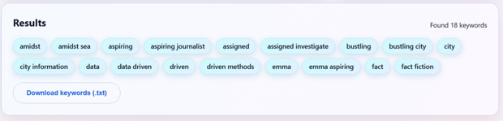

Future Implementations
Future plans for the GenAI Keyword Extraction system focus on expanding functionality, improving accuracy, and enhancing user experience:
● Advanced NLP Integration: Upgrade the extraction engine using transformer-based models (e.g., BERT, T5) to generate more context-aware and semantically rich keywords.
● Multi-Feature Text Analysis: Add support for automatic summarization, topic detection, sentiment analysis, and named entity recognition to create a complete text-analytics toolkit.
● Web & API Deployment: Develop a dedicated API endpoint to allow third-party applications, research tools, and educational platforms to send text and receive extracted keywords programmatically.
● Multi-Language Support: Extend the system to handle keyword extraction for regional and international languages using multilingual NLP models.
● User Dashboard: Create a web dashboard where users can upload documents, save results, and track analyses over time.
● Dataset Expansion: Continuously improve extraction quality by training on diverse datasets across domains like journalism, research papers, social media, and legal documents.

Conclusion
The GenAI Keyword Extraction Project successfully delivered an efficient and user-friendly AI-powered text analysis system. By leveraging Gensim’s keyword extraction techniques, the application accurately identifies the most relevant terms from any given text, enabling users to quickly understand key themes and insights. The final product is a streamlined, fully functional web application built using Streamlit, providing an intuitive and responsive interface for real-time keyword generation. This solution demonstrates strong performance, scalability, and practical utility, showcasing the project’s success from NLP model implementation to an accessible, real-world deployment.

