Installation of Anaconda and setting up an environment

1. Download Anaconda 3 (you can skip the registration):
https://www.anaconda.com/download
Now we need to set up an own environment and install additional python packages. You can use Anaconda to install manually all packages or the PowerShell terminal to do it automatically.

a) Manual installation
2. Start Anaconda and create a new environment. Choose Python 3.11 or 3.12. to use the functions for C2C analysis that has been developed in the AAC group.
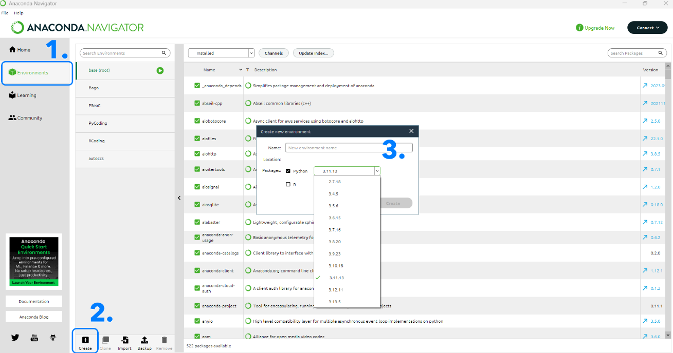
3. Installing packages
Select your new environment, to install packages. Select not installed in the drop down menu. Search for the package to install, e.g. pandas, and select the package.
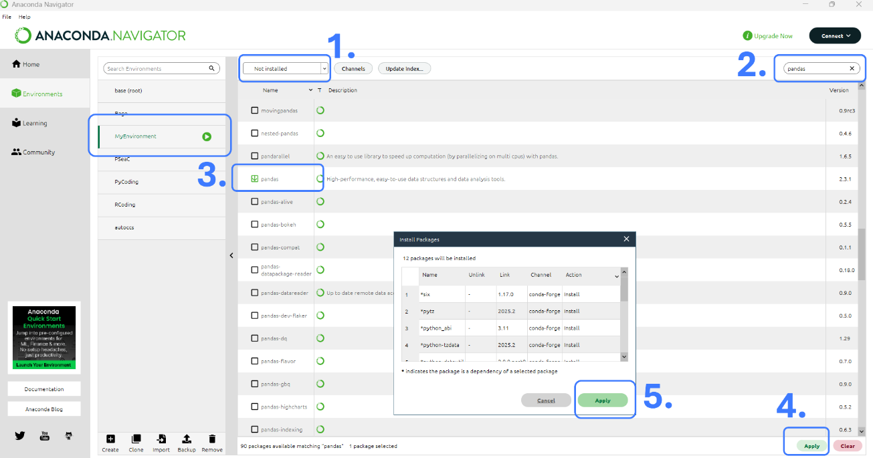
For the C2C analysis you will need the following packages:
pandas, matplotlib, olefile, ipykernel, scipy

4. There are some packages, Anaconda cannot install with the app. We must use a terminal. Go to Windows Start and search for ‘Anaconda Powershell Prompt’ (don’t use the Windows shell).
Start the Powershell. The name of the current environment is written in the brackets. Type the following in and press Enter:
conda activate environment name
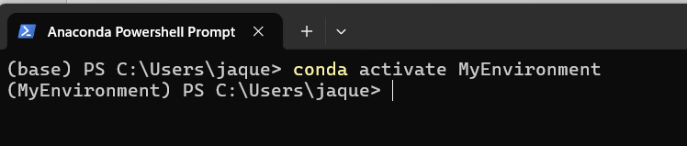
To install the package pyteomics (to read mzMl files) type in:
conda install -c bioconda pyteomics
To create ppt slides we need the package pptx. Type in:
pip install python-pptx
5. At least, we need to install the AAC package pyC2C. Since it is not an official python package, we cannot install it with Anaconda. Instead we just need to copy the directories pyC2C into the directory of our packages. Go to:
User -> anaconda3 (not the directory with dot at beginning!) -> envs -> environment name -> Lib -> site-packages
and paste the directory there.
b) Automatic installation
Alternative way, to create the anaconda environment:
2. Start Anaconda PowerShell (search for Anaconda Powershell Prompt on the Windows search bar)
3. Copy path of the environment.yml file you have downloaded from moodle (right mouse click on the file, then go to copy by path)
4. Type in PowerShell terminal: conda env create -f paste path of environment.yml
Conda will now search for all packages to install them. It can take up to some minutes. If it asks for permission, to install the packages, allow it with y
5. Start Anaconda and go to Environment on the left side. Now, there must be a new tab with C2C, if the installation in 4. was successful.

Installation of Visual Studio Code
Visual Studio Code (VSC) is a good editor for beginners to use python with Jupyter Notebooks.
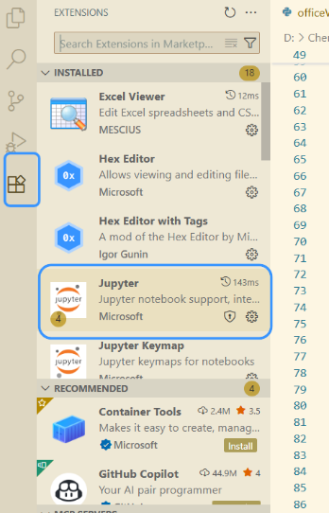
1. Download VSC: https://code.visualstudio.com/Download
2. We need a jupyter python kernel. If you open a notebook in VSC, it will normally ask you, to install the needed extensions. If not, select the symbol for extensions on the left and install ‘Jupyter’.

3. If you open an existing jupyter notebook, it normally detects the needed kernel. If not, click ‘Select Kernel’ and select your environment.
