- Copy the file filtering_wo_QC.Rmd to Documents/R/NTAWorkflow_App where today’s project was
- Start RStudio and go to File -> Open Project to open today's project.

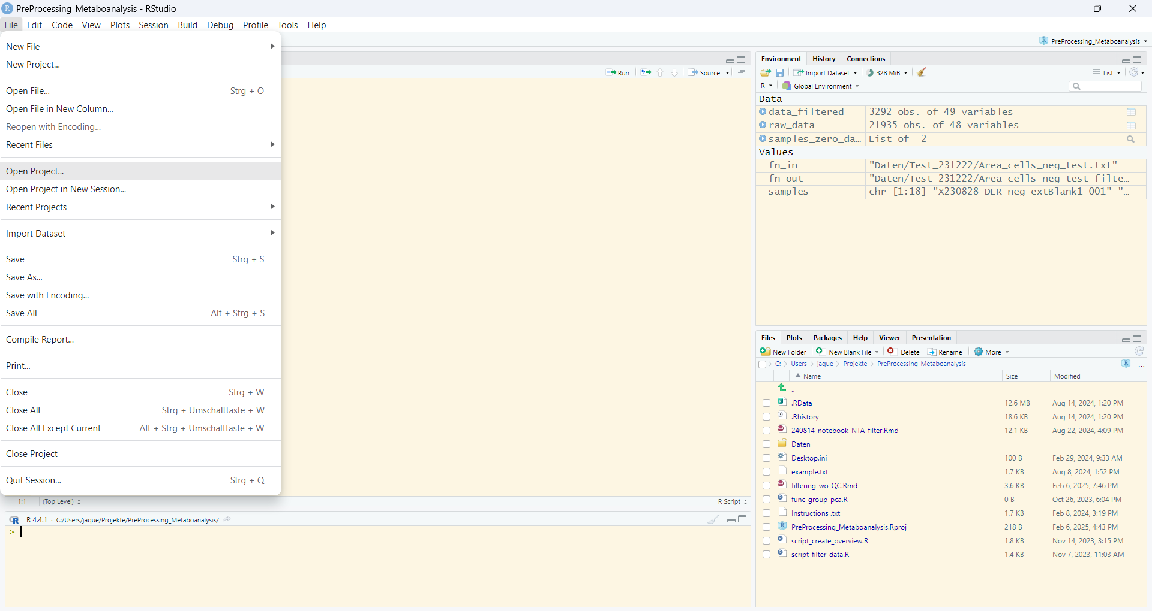
- In the right bottom window click on that .Rmd file to open it.

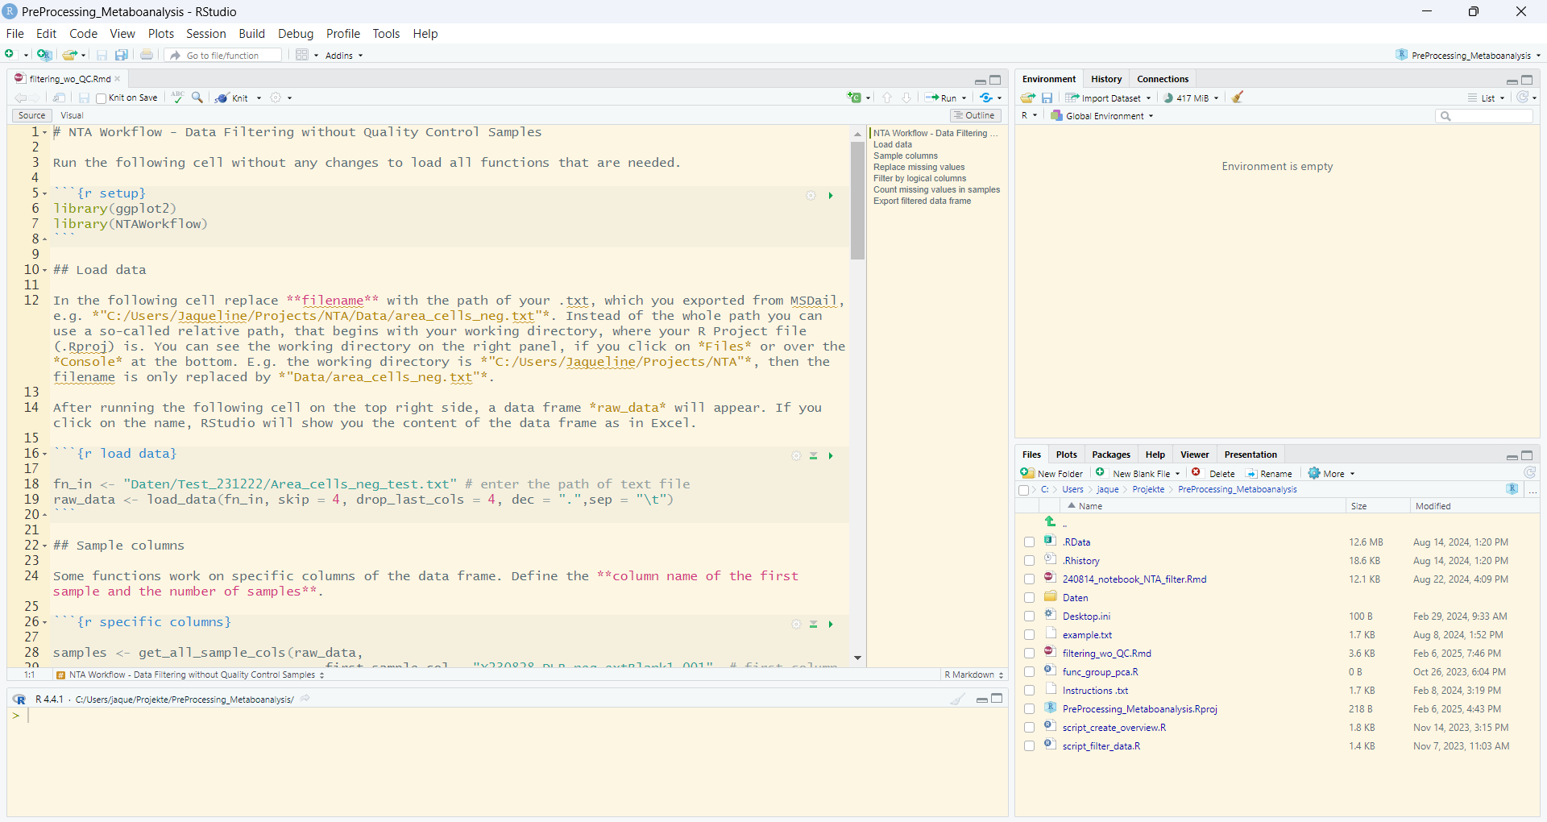
- On the upper left click on ‘visual’ to make the notebook more readable.

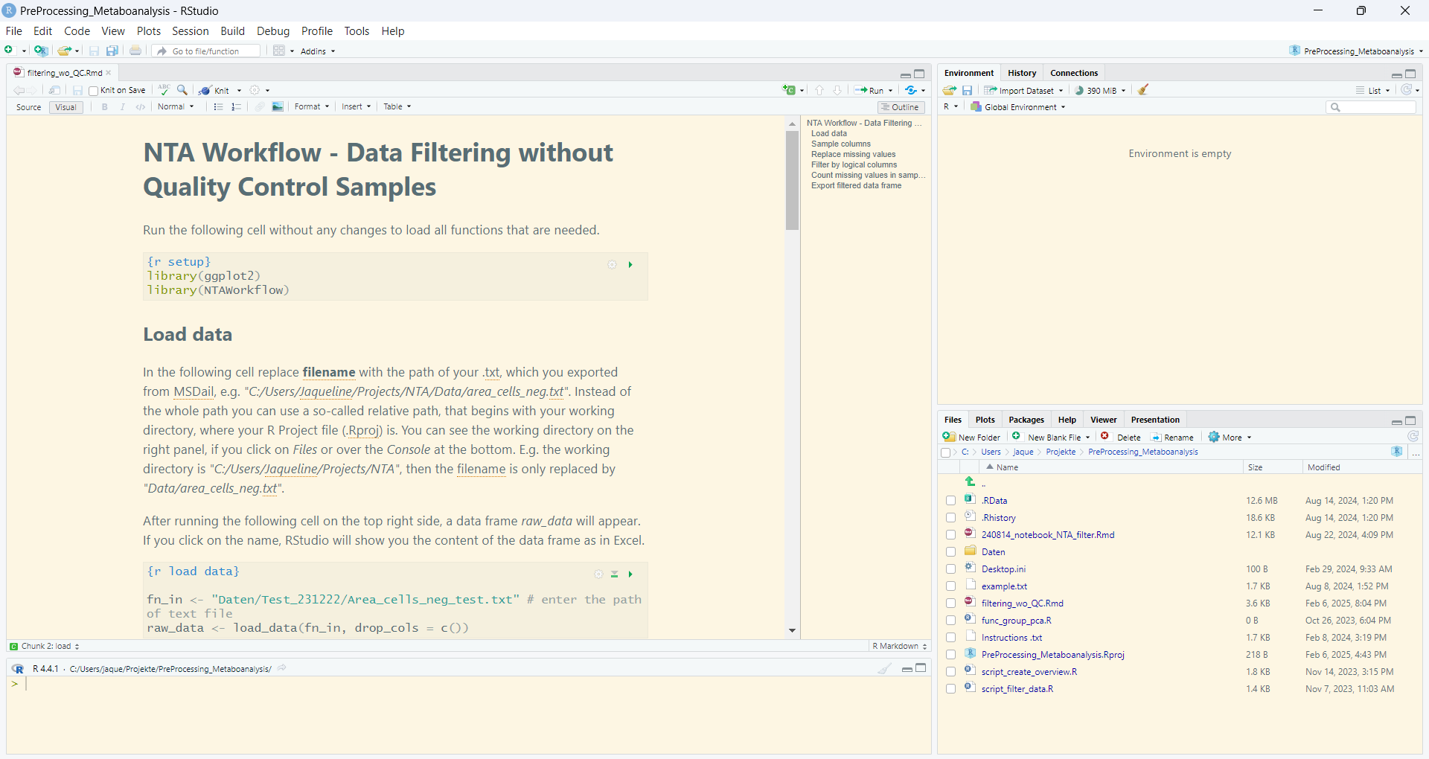
- In the gray boxes is the R code. You can run the cell by clicking on the green arrow on the right side.
- You need to change the file path in the second box. The text above the cell explains how to set the file path. If you copy the file in the directory of the project (as we did today), you only need to write the filename, e.g. “Area_2025261213.txt” with the quotes. After running this cell, you will see raw_data showing up on the right side.
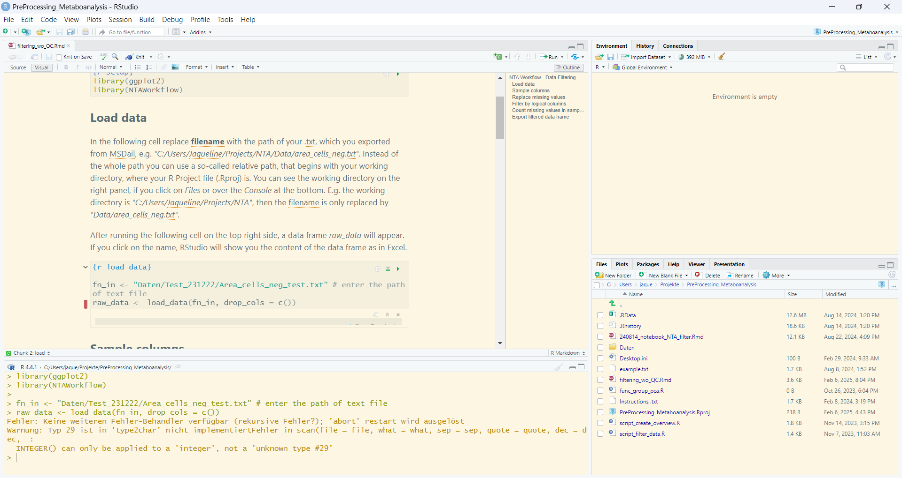
There can be an error, if you run the second cell the first time. Just ignore it and run this cell again.
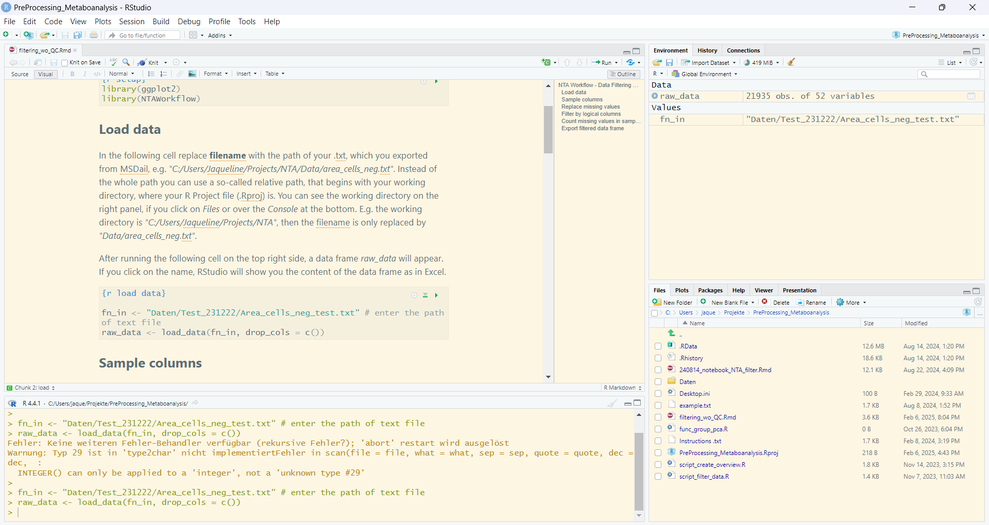
You can click on raw_data to view the data frame.
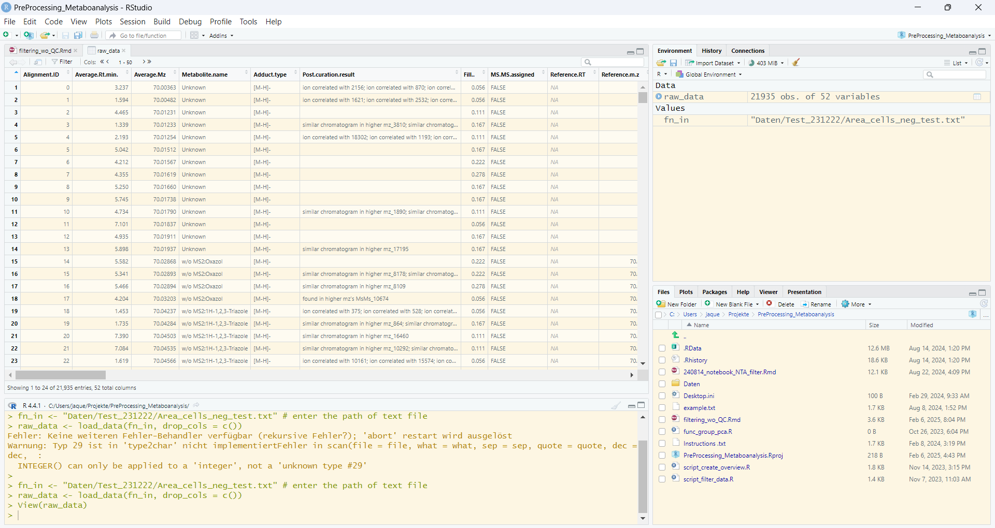
Go through all the cells to filter your data frame. In the last cell, the filtered data frame will be exported in the same directory of the raw data with and appended ‘_filtered.txt’, so you don’t need to define a new file path as we did today in the script file.
When you are finished, close RStudio and save the notebook and project.

