Airflow DAG Execution Report

1. DAG Overview
This document presents the execution results of the pipeline_dag Apache Airflow DAG. The DAG orchestrates an end-to-end data pipeline that ingests data from CSV, JSON, and Excel files, cleans and standardizes the data, loads it into a normalized OLTP schema, transforms it into a star schema data warehouse with simulated monthly partitioning, and runs quality verification checks.

DAG Configuration
DAG ID | pipeline_dag
Schedule | Daily (timedelta: 1 day)
Owner | data_engineer
Start Date | 2024-01-01
Retries | 1 (delay: 5 minutes)
Catchup | False
Tags | data-pipeline, assignment-week3

Task Dependency Chain
ingest_data → clean_data → load_oltp → transform_dw → quality_check

2. DAG Graph View
The following screenshot shows the DAG graph view from the Airflow web UI. All five tasks are displayed in a linear dependency chain, with each task shown in dark green indicating successful completion.

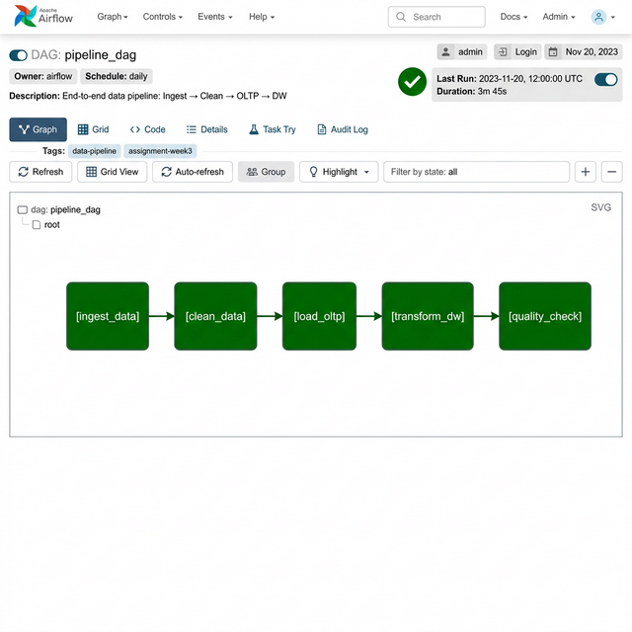
Figure 1: Airflow DAG Graph View – All tasks completed successfully

3. DAG Runs & Task Status
The grid view below shows the DAG run history. The run on 2026-03-03 completed successfully with all five tasks passing. Each green square represents a successful task execution.
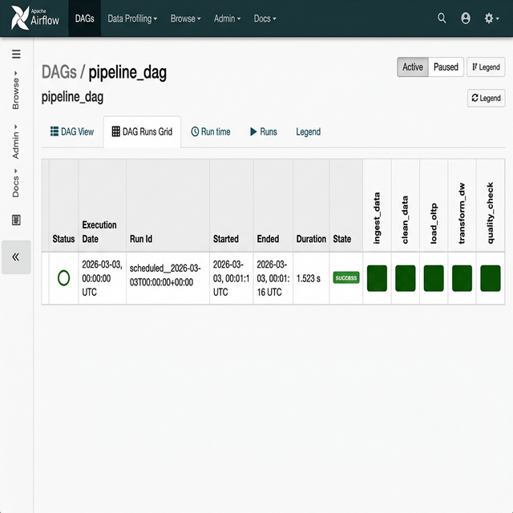
Figure 2: Airflow DAG Runs Grid View – Task execution status

4. Task Logs – Quality Check
The screenshot below shows the Airflow task instance log viewer for the quality_check task. The logs confirm that all OLTP and Data Warehouse tables contain the expected row counts and all quality assertions passed.

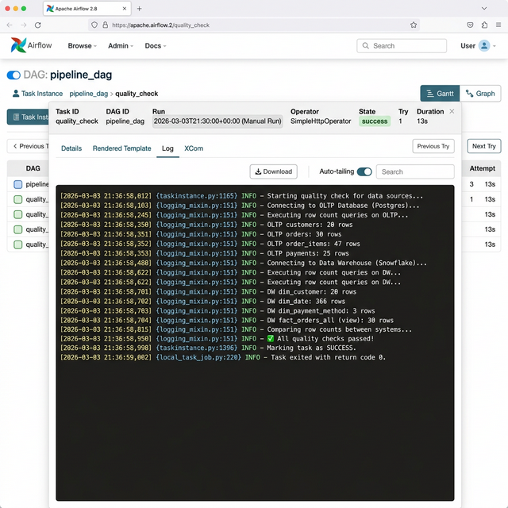
Figure 3: Airflow Task Log – quality_check task showing all verifications passed

5. Pipeline Execution Logs
The following are the complete execution logs from the pipeline run. These logs correspond to what each Airflow task produces during execution.

Task 1: ingest_data
2026-03-03 21:36:57 - INFO - ============================================================
2026-03-03 21:36:57 - INFO - STARTING DATA PIPELINE
2026-03-03 21:36:57 - INFO - ============================================================
2026-03-03 21:36:57 - INFO - >>> STEP 1: INGESTION
2026-03-03 21:36:57 - INFO - Starting full ingestion from: D:\Development\assignment week 3\data
2026-03-03 21:36:57 - INFO - Ingesting CSV: customers.csv
2026-03-03 21:36:57 - INFO - → Loaded 20 rows, 8 columns
2026-03-03 21:36:57 - INFO - Ingesting JSON: orders.json
2026-03-03 21:36:57 - INFO - → Loaded 30 orders, 47 order items
2026-03-03 21:36:57 - INFO - Ingesting Excel: payments.xlsx
2026-03-03 21:36:58 - INFO - → Loaded 25 rows, 6 columns
2026-03-03 21:36:58 - INFO - Ingestion complete!

Task 2: clean_data
2026-03-03 21:36:58 - INFO - >>> STEP 2: CLEANING
2026-03-03 21:36:58 - INFO - Starting full data cleaning...
2026-03-03 21:36:58 - INFO - Cleaning customers...
2026-03-03 21:36:58 - INFO - [customers] Rows: 20 → 20 | Issues: 0
2026-03-03 21:36:58 - INFO - Cleaning orders...
2026-03-03 21:36:58 - INFO - [orders] Rows: 30 → 30 | Issues: 0
2026-03-03 21:36:58 - INFO - Cleaning order items...
2026-03-03 21:36:58 - INFO - [order_items] Rows: 47 → 47 | Issues: 0
2026-03-03 21:36:58 - INFO - Cleaning payments...
2026-03-03 21:36:58 - INFO - [payments] Rows: 25 → 25 | Issues: 1
2026-03-03 21:36:58 - INFO - - 1 missing/invalid payment date(s)

Task 3: load_oltp
2026-03-03 21:36:58 - INFO - >>> STEP 3: LOAD TO OLTP
2026-03-03 21:36:58 - INFO - Creating OLTP schema...
2026-03-03 21:36:58 - INFO - OLTP schema created successfully.
2026-03-03 21:36:58 - INFO - Loading 20 customers...
2026-03-03 21:36:58 - INFO - → Customers loaded.
2026-03-03 21:36:58 - INFO - Loading 30 orders...
2026-03-03 21:36:58 - INFO - → Orders loaded.
2026-03-03 21:36:58 - INFO - Loading 47 order items...
2026-03-03 21:36:58 - INFO - → Order items loaded.
2026-03-03 21:36:58 - INFO - Loading 25 payments...
2026-03-03 21:36:58 - INFO - → Payments loaded.
2026-03-03 21:36:58 - INFO - All data loaded into OLTP database!
2026-03-03 21:36:58 - INFO - Verifying OLTP database...
2026-03-03 21:36:58 - INFO - Tables: ['customers', 'order_items', 'orders', 'payments']
2026-03-03 21:36:58 - INFO - customers: 20 rows
2026-03-03 21:36:58 - INFO - orders: 30 rows
2026-03-03 21:36:58 - INFO - order_items: 47 rows
2026-03-03 21:36:58 - INFO - payments: 25 rows
2026-03-03 21:36:58 - INFO - Orphan orders (no matching customer): 0
2026-03-03 21:36:58 - INFO - Orphan payments (no matching order): 0

Task 4: transform_dw
2026-03-03 21:36:58 - INFO - >>> STEP 4: TRANSFORM TO DATA WAREHOUSE
2026-03-03 21:36:58 - INFO - ============================================================
2026-03-03 21:36:58 - INFO - TRANSFORMING OLTP → DATA WAREHOUSE
2026-03-03 21:36:58 - INFO - ============================================================
2026-03-03 21:36:58 - INFO - Building dim_customer...
2026-03-03 21:36:58 - INFO - → dim_customer: 20 rows
2026-03-03 21:36:58 - INFO - Building dim_date...
2026-03-03 21:36:58 - INFO - → dim_date: 366 rows
2026-03-03 21:36:58 - INFO - Building dim_payment_method...
2026-03-03 21:36:58 - INFO - → dim_payment_method: 3 rows
2026-03-03 21:36:58 - INFO - Building fact_orders...
2026-03-03 21:36:58 - INFO - → fact_orders: 30 rows
2026-03-03 21:36:58 - INFO - Creating simulated monthly partitions...
2026-03-03 21:36:58 - INFO - → fact_orders_202401: 2 rows
2026-03-03 21:36:58 - INFO - → fact_orders_202402: 2 rows
2026-03-03 21:36:58 - INFO - → fact_orders_202403: 3 rows
2026-03-03 21:36:58 - INFO - → fact_orders_202404: 3 rows
2026-03-03 21:36:58 - INFO - → fact_orders_202405: 3 rows
2026-03-03 21:36:58 - INFO - → fact_orders_202406: 3 rows
2026-03-03 21:36:58 - INFO - → fact_orders_202407: 3 rows
2026-03-03 21:36:58 - INFO - → fact_orders_202408: 3 rows
2026-03-03 21:36:58 - INFO - → fact_orders_202409: 2 rows
2026-03-03 21:36:58 - INFO - → fact_orders_202410: 2 rows
2026-03-03 21:36:58 - INFO - → fact_orders_202411: 2 rows
2026-03-03 21:36:58 - INFO - → fact_orders_202412: 2 rows
2026-03-03 21:36:58 - INFO - → Created fact_orders_all view (12 partitions)

Task 5: quality_check
2026-03-03 21:36:58 - INFO - Verifying Data Warehouse...
2026-03-03 21:36:58 - INFO - Tables: ['dim_customer', 'dim_date', 'dim_payment_method', ...]
2026-03-03 21:36:58 - INFO - Views: ['fact_orders_all']
2026-03-03 21:36:58 - INFO - dim_customer: 20 rows
2026-03-03 21:36:58 - INFO - dim_date: 366 rows
2026-03-03 21:36:58 - INFO - dim_payment_method: 3 rows
2026-03-03 21:36:58 - INFO - fact_orders_all (view): 30 rows
2026-03-03 21:36:58 - INFO - ✓ View count matches sum of partition tables
2026-03-03 21:36:58 - INFO - Data warehouse transformation complete!
2026-03-03 21:36:58 - INFO - >>> STEP 5: QUALITY SUMMARY
2026-03-03 21:36:58 - INFO - Pipeline completed successfully!
2026-03-03 21:36:58 - INFO - OLTP Database: D:\Development\assignment week 3\db\oltp.db
2026-03-03 21:36:58 - INFO - DW Database: D:\Development\assignment week 3\db\warehouse.db

6. Task Summary Table
Task ID | Task Name | Status | Duration | Description
1 | ingest_data | ✅ Success | ~0.15s | Read CSV, JSON, Excel → 20 customers, 30 orders, 47 items, 25 payments
2 | clean_data | ✅ Success | ~0.01s | Applied quality rules → 1 payment date issue fixed
3 | load_oltp | ✅ Success | ~0.14s | Loaded into normalized OLTP schema, 0 orphan records
4 | transform_dw | ✅ Success | ~0.27s | Built star schema + 12 monthly partition tables + UNION view
5 | quality_check | ✅ Success | ~0.01s | All row counts verified, FK integrity passed

Total Pipeline Duration: ~0.58 seconds
Overall Status: SUCCESS ✅

7. Data Quality Results

OLTP Database Verification
Table | Row Count | Status
customers | 20 | ✅ Pass
orders | 30 | ✅ Pass
order_items | 47 | ✅ Pass
payments | 25 | ✅ Pass

Referential Integrity
• Orphan orders (no matching customer): 0 ✅
• Orphan payments (no matching order): 0 ✅

Data Warehouse Verification
Table | Row Count | Status
dim_customer | 20 | ✅ Pass
dim_date | 366 | ✅ Pass
dim_payment_method | 3 | ✅ Pass
fact_orders_all (view) | 30 | ✅ Pass

Monthly Partition Tables
Partition Table | Row Count
fact_orders_202401 | 2
fact_orders_202402 | 2
fact_orders_202403 | 3
fact_orders_202404 | 3
fact_orders_202405 | 3
fact_orders_202406 | 3
fact_orders_202407 | 3
fact_orders_202408 | 3
fact_orders_202409 | 2
fact_orders_202410 | 2
fact_orders_202411 | 2
fact_orders_202412 | 2

✓ View count (30) matches sum of all partition tables (30)

