Travelogram User Guide

Name: Sindhuja Sane

Email ID: [sane@umd.edu](mailto:sane@umd.edu)

Directory ID: sane

UID: 119384268

**1.Setting Up the Application.**

**Retrieve the Source Code:**

Navigate to the `Phase5` directory in the GitLab repository where the Travelogram application is hosted.

Pull the source code to your local machine using the appropriate Git commands.

**Open the Application in Visual Studio**

* Start Visual Studio 2022 Community Edition on your computer.
* From the top menu, select `File > Open > Project/Solution`.
* Navigate to the location where you pulled the source code.
* Browse and select the Travelogram solution file (ending in `.sln`).
* Click `Open`.

**Run the Application**

* After the solution loads successfully in Visual Studio, locate the `Start` or `Run` button, typically found at the top center of the window.
* Click on this button to compile and run the application.
* Once the application starts, you can interact with its features as described in the main user guide.

**2.User Registration and Login**

**Registration:**

* On the main page, click on the Register button at the top right corner.
* Fill in the required fields.
* Click on the Submit or Register button to create your user account.
* 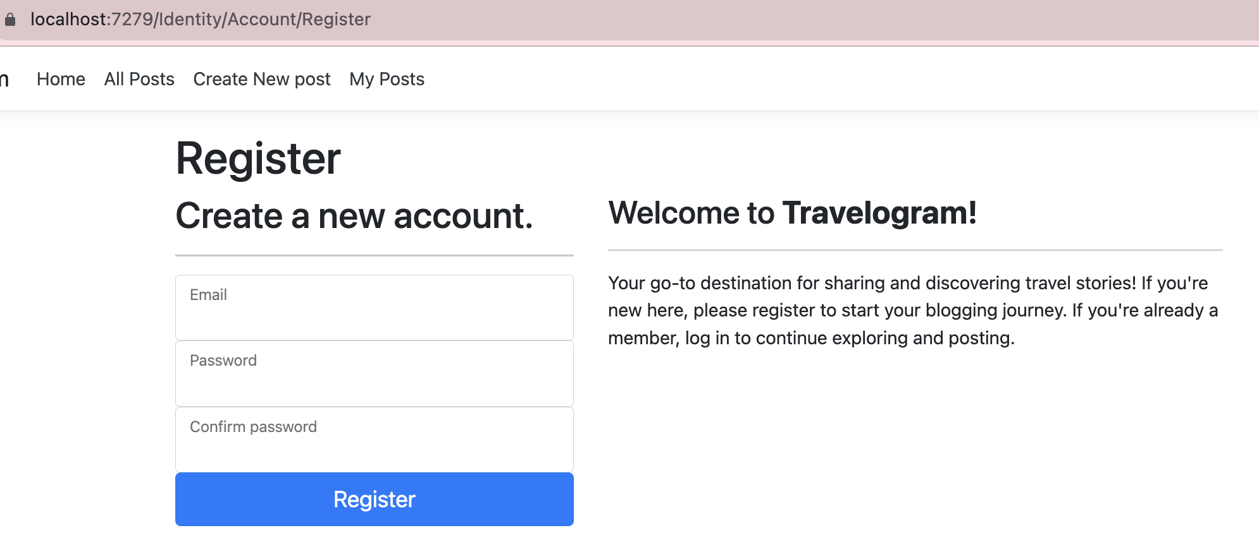

**Login:**

* Enter your registered email and password.
* Click on the Login button to access the application.

**3. Navigating the Dashboard**

Once logged in, the user will see the following options:

* **Home**: View and search for blog posts.
* **My Posts:** View or delete your own blog posts.
* **All Posts:** View, Like or Dislike all the posts by other users.
* **User Profile:** Update personal details such as email ID, Phone number and password.
* **Create Posts:** Write and publish a new blog post.
* **Logout:** Sign out from the application.

**4. My Posts**

* To view all your posts, click on My Posts.
* Here, you can see a list of all the posts you've created.
* Next to each post, there will be a Delete option, allowing you to remove any post you've created.
* 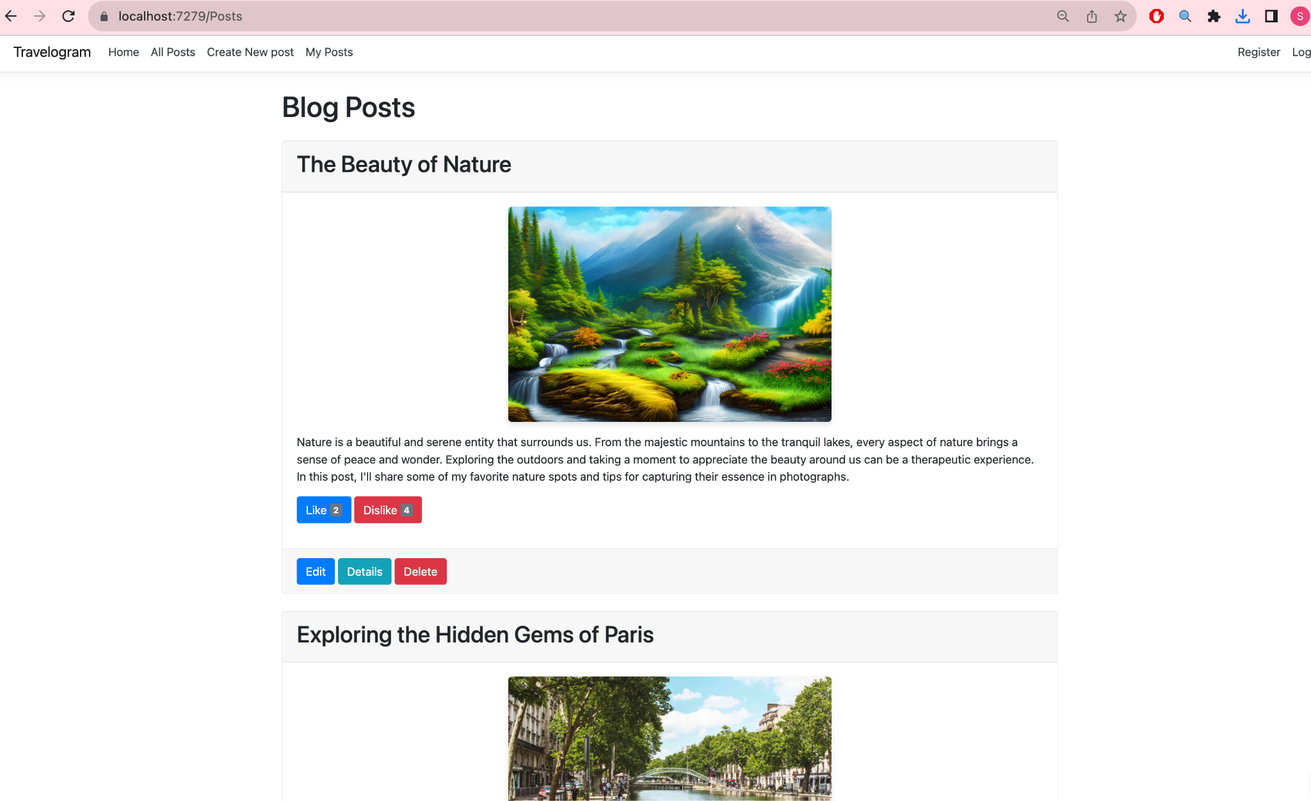

**5. Creating a Post**

* Click on the Create Posts page.
* Fill in the required fields such as title, content, and any other necessary details.
* **User File Upload:**
  + Below the content field, you'll find an option to upload images.
  + Click on the 'Upload' or 'Choose File' button.
  + Select the desired image(s) from your device. Ensure that the image format is supported (e.g., JPG, PNG, GIF).
  + Once selected, you'll see a preview of the image. If needed, you can remove the image and choose another.
* Once you're satisfied, click on the Publish or Submit button to make your post live.
* 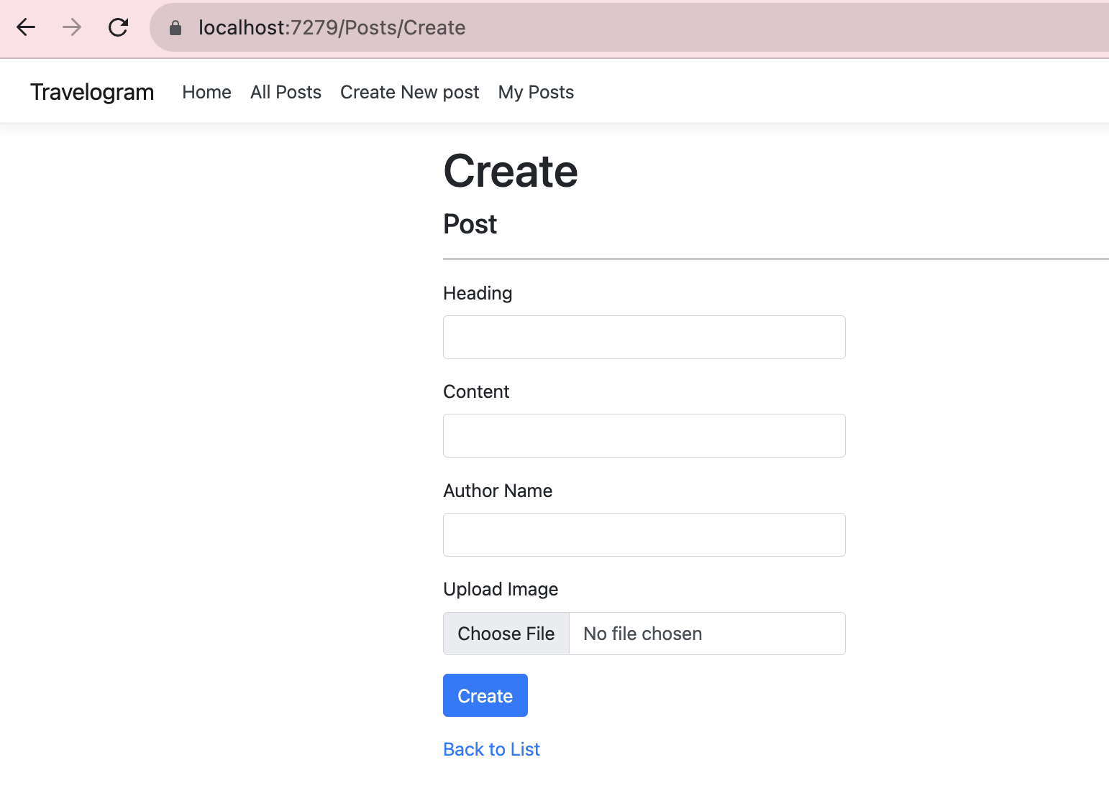

**6. Home Page and Searching for Posts**

* On the Home page, users can view various blog posts.
* To search for a specific post, use the Search functionality by entering keywords or phrases related to the post you're looking for.
* 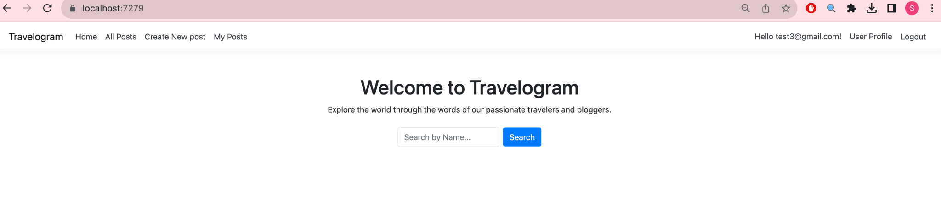

**7. Interaction with Posts**

* Users can comment on any post they find interesting. Simply type your comment and click on the Submit or Post Comment button.
* Users also have the option to delete their comments if they wish.
* **Liking and Disliking:**
  + If you appreciate a post, show your support by clicking on the Like button.
  + Alternatively, if you disagree or don't resonate with the content, you can click on the Dislike button.
* 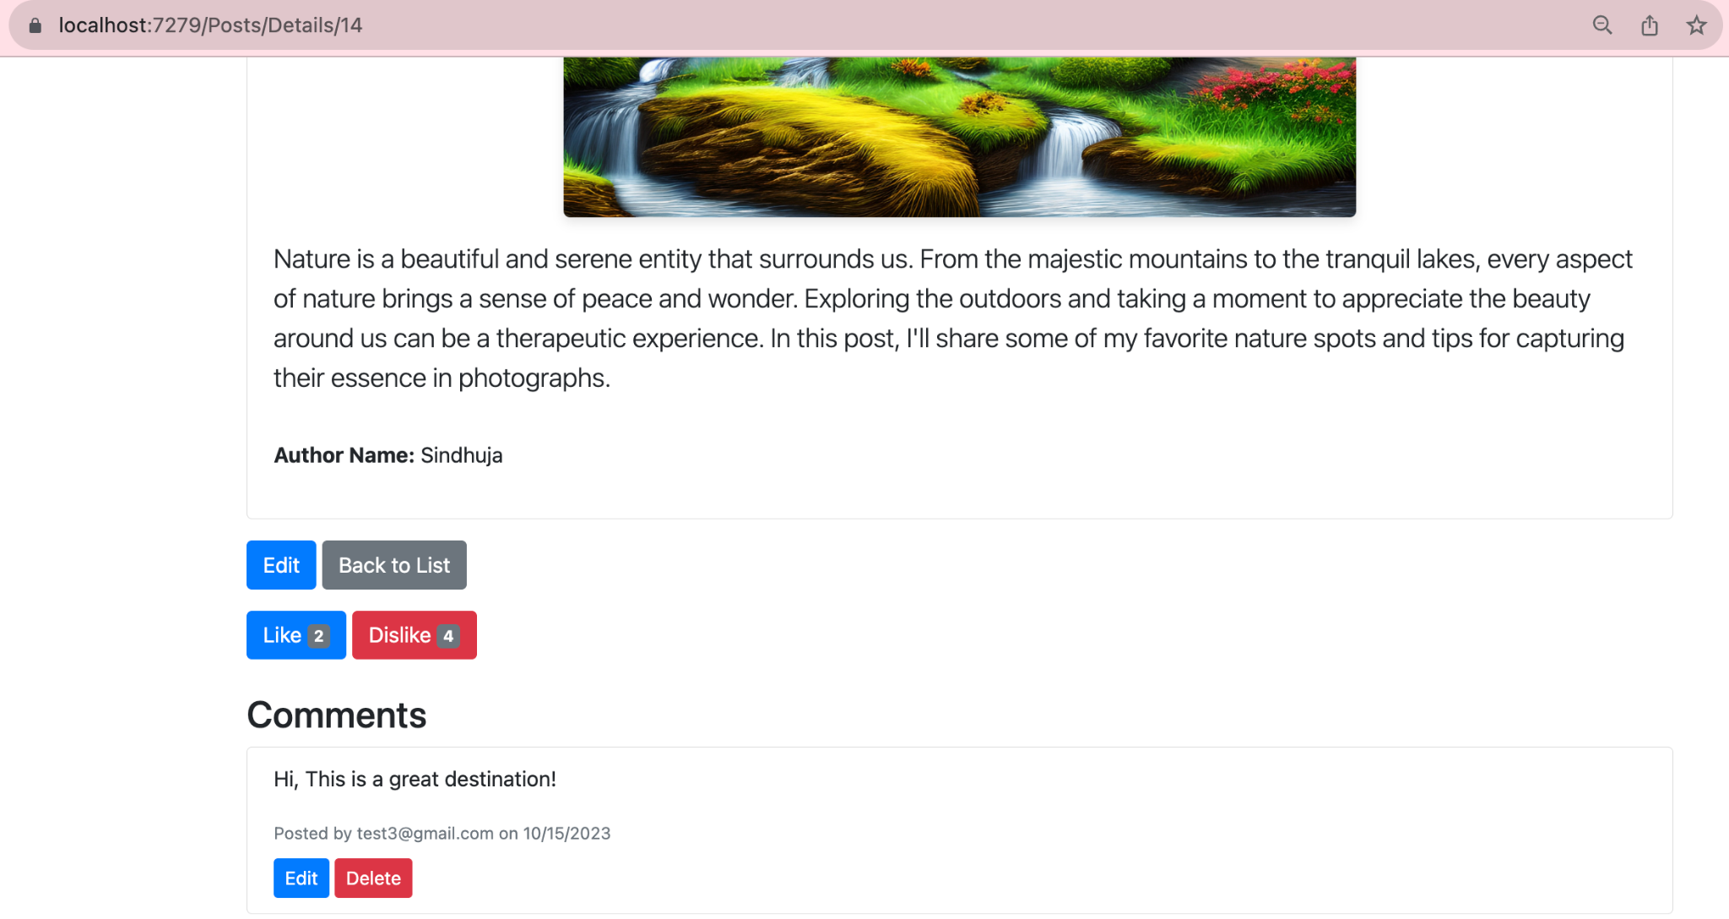

**8. Updating User Profile**

* Click on the user profile.
* **Change Email ID:**
  + To change your registered email, type in the new email address.
  + Ensure that the email address you provide is valid and accessible, as it may be used for account recovery or notifications.
* **Add/Update Phone Number:**
  + Enter your phone number, ensuring it's in the correct format (e.g., with country code if required).
* **Change Password:**
  + Locate the 'Change Password' option.
  + You'll be asked to enter your current password first for security verification.
  + Then, type in your new password. Confirm the new password by entering it again in the provided field.
  + It's recommended to use a strong password combining letters, numbers, and special characters for enhanced security.
* 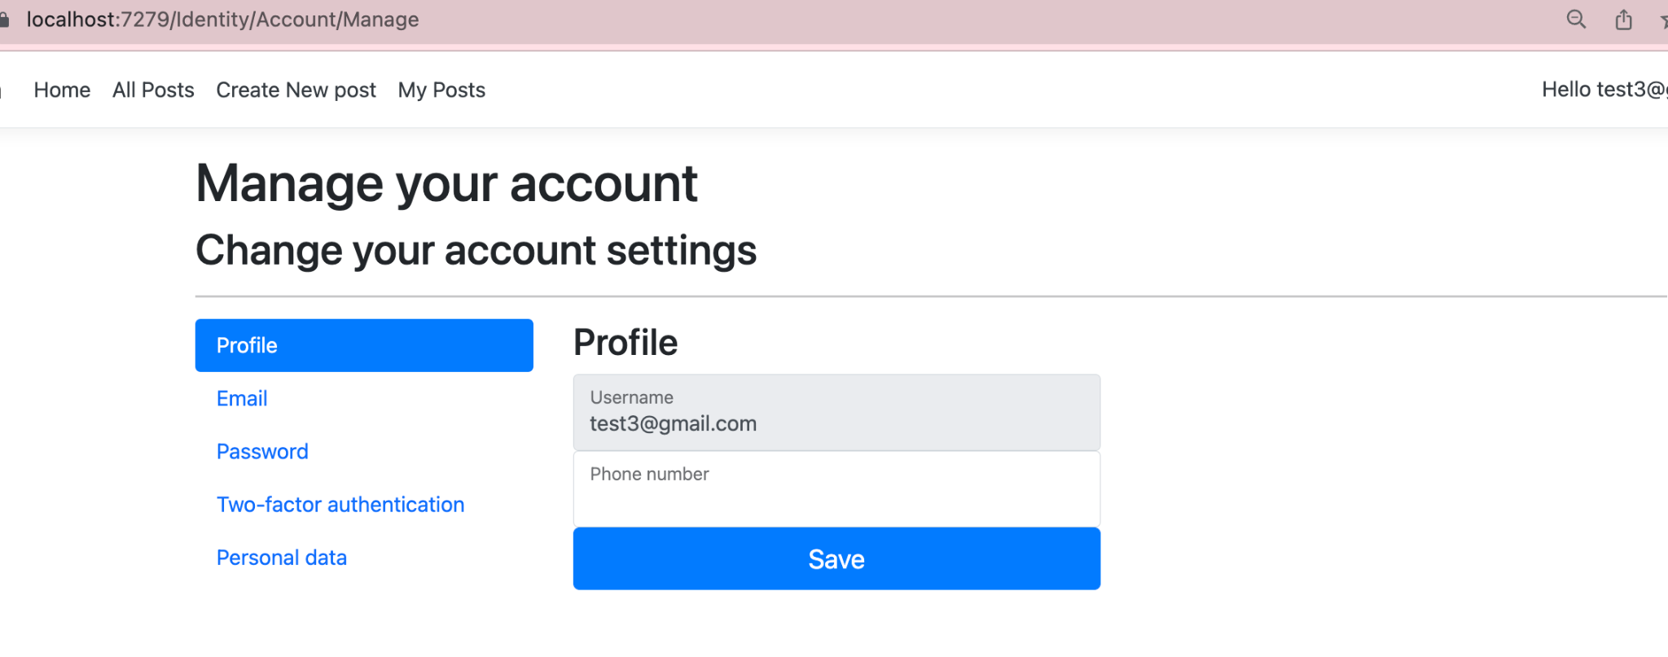

**9.Deleting a post:**

* Navigate to My Posts where you can view all the posts you've created.
* Locate the post you wish to delete. Each post might be accompanied by various options such as Edit, Like, Delete.
* Click on the Delete option. A confirmation prompt may appear, asking you to verify if you truly want to delete the post. This is to prevent accidental deletions.
* Confirm the deletion by clicking on the Delete button.
* The post will be removed from the list and will no longer be accessible to you or other users.
* 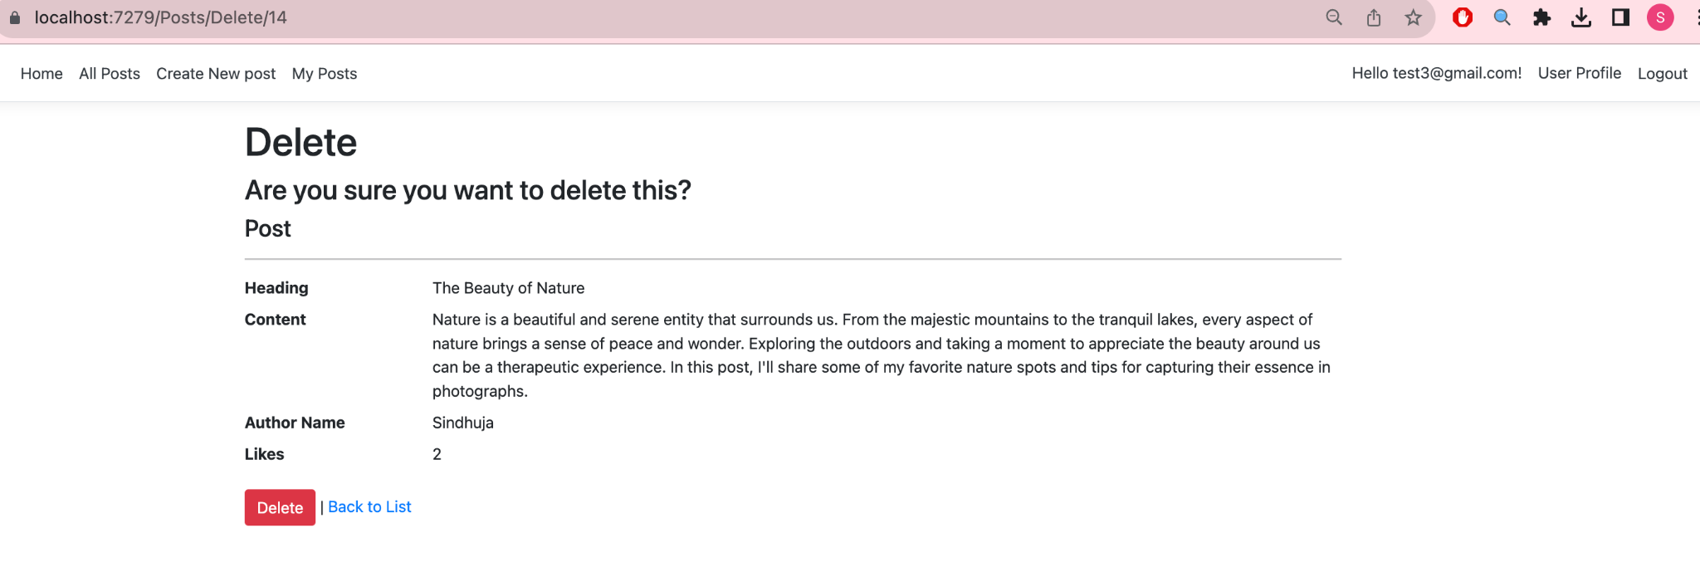

**10. Logging Out**

To sign out from the application, click on the Logout option.