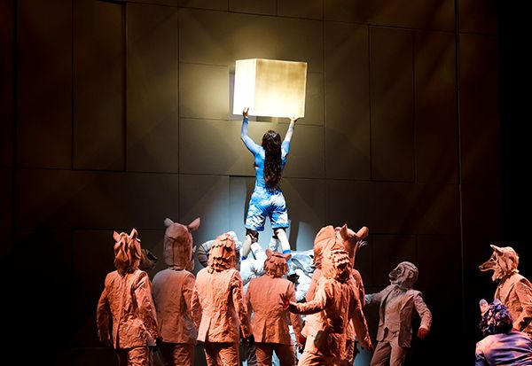

**Welcome to the Visionary World of Cirque du Soleil ECHO!**

**Did You Know?**

* Cirque du Soleil ECHO is the 20th Big Top creation from Cirque du Soleil and its 51st overall.
* The show explores themes of connection, intention, and the symbiotic unions between humans and animals.
* The mysterious CUBE at the heart of the show is essentially the size of a 2-story apartment building!

**THE WORLD IS YOURS TO CREATE**

Cirque du Soleil ECHO follows the story of an inquisitive young woman named FUTURE as she wanders into a fantasy world that explores our sacred bond with animals and nature.

When FUTURE and her best friend Ewai The Dog encounter a mysterious CUBE, they quickly learn how their actions have the power to shape and create the world we all want to live in.

Packed with vibrant characters, inspiring music, astounding lights and projections, and never-before-seen acrobatic feats, Cirque du Soleil ECHO invites you on a journey through a universe of color, wonder, and infinite possibilities.

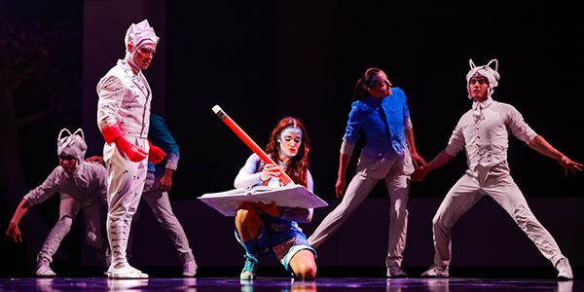

Cirque du Soleil ECHO beautifully blends story with a spectacular range of acrobatic performances, all taking place on, in, around, or throughout the mysterious CUBE. You’ll witness performances like bungee straps, banquine, icarian games, double hair suspension, slackwire, triple teeterboards, and a never-before-seen chrysalid pole structures act.



**FUELED BY THE POWER OF CHANGE**

“Cirque du Soleil ECHO is about connecting everybody together, and working together to create the world we want to live in. It’s not just a concept. It’s something I truly believe in.”

– Author-Director, Mukhtar Omar Sharif Mukhtar

# The Artists of Cirque du Soleil ECHO

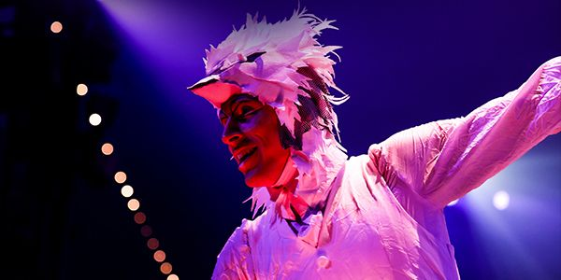

**Characters**  
  
**FUTURE** : Louana Seclet--Monchot (France)  
**Ewai The Dog** : Philippe Dupuis (Canada)  
**The CARTOGRAPHER** : Piotr Kopacz (Poland)  
**DOUBLE TROUBLE, Manipulation** : Clément Malin (France) & Caio Sorana (Italy)  
**The FOSSORIAL, Contortion & Dislocation** : Strauss Serpent (Congo)  
**FUTURE (Understudy)** : Evelyne Lamontagne (Canada)  
**Ewai The Dog (Understudy), Diabolo Manipulation** : Peng Chan (Taiwan)

**Slackwire**  
Taras Hoi (Ukraine)  
Antino Pansa (France)

**Hair Suspension**  
Charlotte O'Sullivan (Canada)  
Penelope Elena Scheidler (Austria)

**Icarian Games**  
Seife Desta Buser (Ethiopia)  
Abiy Saleamlak Negash (Ethiopia)

**Banquine/Korean Cradle**   
Taye Gebeyehu Yemam, Leader (Ethiopia)  
Sammy Mededu Mohammed (Ethiopia)  
Yared Wolde Chraga (Ethiopia)  
Asnake Shimelis Dinberu (Ethiopia)  
Abel Matiyas Disasa (Ethiopia)  
Teka Bacha Debele (Ethiopia)  
Abeselom Demeke Kebede (Ethiopia)  
Bruktawit Lijalem Wondiyfraw (Ethiopia)  
Hayder Nuredin Badeg (Ethiopia)  
Getaw Mamo Tekeda (Ethiopia)  
Getnet Feleke Ayele (Ethiopia)

**Flying Poles**  
Lucas Coelho Costa (Brazil)  
Neal Courter (USA)  
Ethan Lottman (USA)  
Ivan Tushnov (Russia)  
Iana Lebedeva (Russia)  
Denis Degtyarev (Russia)  
Lucas Matias Suarez (Argentina)

**Teeterboards**  
Aleksandr Zebrov (Russia)  
Thomas Leask (Australia)  
Campbell Clarke (Australia)  
Joseph McAdam (UK)  
Cooper Ayton (Australia)  
Luan De Souza Vieira Pretko (Brazil)  
Daniel Alejandro Aguilar Briceno (Mexico)  
Maxim Laurin (Canada)

**Musicians & Vocalists**  
Band Leader + Viola – Michael Lieberman (USA)  
Lead Female Vocalist– Edyta Krzemien (Poland)  
Male Voice + Mallets – Jonathan Stombres (USA)  
Female Voice + Keyboards – Pascale Brigitte Boilard (Canada)  
Cello + Vocals – Lizzy Munson (Canada)  
Violin + Vocals – Anna Follia Jordan (Spain)  
Percussion + Vocals – Agata Kruszewska (Poland)

**The Contemporary Stylings of Cirque du Soleil ECHO**

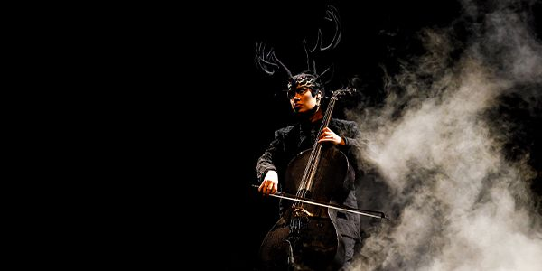

**Did You Know?**

* More than two dozen white animal heads were developed for the characters of Cirque du Soleil ECHO.
* There are 26 brightly colored outfits for Cirque du Soleil ECHO’s human characters.
* One of the makeup shades worn by FUTURE is called “Cinderella blue.”



Conceptually, the costume and makeup design for Cirque du Soleil ECHO are slick, contemporary, and clean, with fewer flourishes than most Cirque du Soleil productions.

Costume Designer Nicolas Vaudelet uses color to draw a contrast between animals and humans, While Makeup Designer Julio Cesar Da Silveira’s concepts incorporate a subtle yet powerful geometric touch to create a connection point between the two groups.

**FUTURE & THE CLOUDS**



For the protagonist FUTURE, makeup designers tested hundreds of shades of makeup before perfecting on the cloud concept, which adds an emotional touch with sparkles that appear like raindrops or tear drops.

**TWO FAMILIES CONNECTED BY CRUMPLES**

For the PAPER ANIMALS and COLOR PAPER PEOPLE, Costume Designer, Nicolas Vaudelet has clad all characters in white fabric made to resemble crumpled paper. The wrinkles give the feel that these characters’ lives are still being crafted.

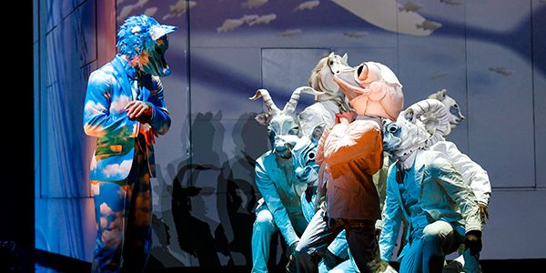

The PAPER ANIMALS wear white head to toe, and the COLOR PAPER PEOPLE wear white suits featuring a rainbow of different colors, but if you look closely, you’ll see that all of these artists are wearing the same style of suit.

**The Visionaries Behind Cirque du Soleil ECHO**

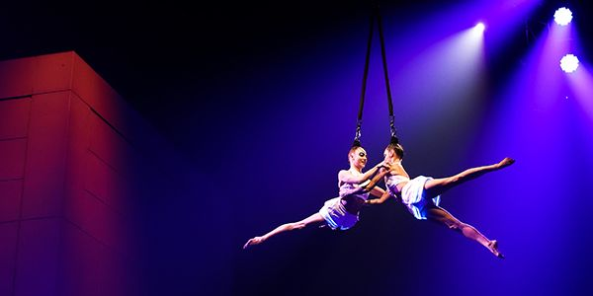

**AUTHOR-DIRECTOR – MUKHTAR OMAR SHARIF MUKHTAR**

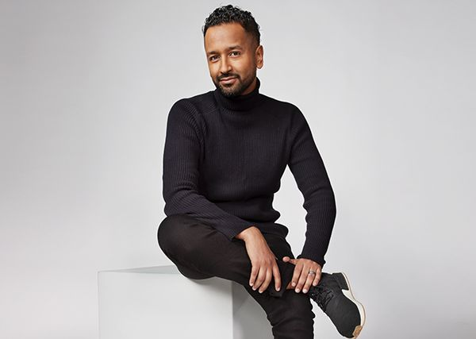

*“What really excites me most about this beautiful project is the ability to push the boundaries of what can be achieved in a Big Top setting and deliver a joyful experience, full of surprises, to millions of people around the world.”*

**CREATION DIRECTOR – CHANTAL TREMBLAY**



*“The start of Cirque is the chapiteau–the Big Top… The smell, the canvas, the leather, the sound of the bleachers, you can feel you’re on tour. You have a [close] proximity to the start of what the circus was. To do a project under the chapiteau, it’s always great to get back and feel the connection.”*

**Production Director – Serge Côté**

**Costume Designer – Nicolas Vaudelet**

**Composers – Jade Pybus, Andy Theakstone, and Hugo Montecristo**

**Music Consultant and Music Arrangements – Thierry Angers and Hugo Montecristo**

**Sound Designer – Jacques Boucher**

**Lighting Designer – Martin Labrecque**

**Projection Designer – Jérôme Delapierre**

**Human Performance Designer – Daniel Cola**

**Acrobatic Equipment and Rigging Designer – Jaque Paquin**

**Acrobatic Choreographer – John Cartin**

**Movement Choreographer – Andrew Skeels**

**Make-up Designer – Julio Cesar Da Silveira**

**Technical Director – Christian Laflamme**

**The Stage is Set**



**PREPARE TO BE FASCINATED**

* The CUBE measures 23 sq. ft (7m2) and weighs roughly 12 tons.
* It is built to track from upstage to downstage on a single central pivot, and is even designed to float.
* The roof of the CUBE contains a lightbox with 2.7 kilometers of LED strips.

**IN, ON, AND AROUND THE CUBE**

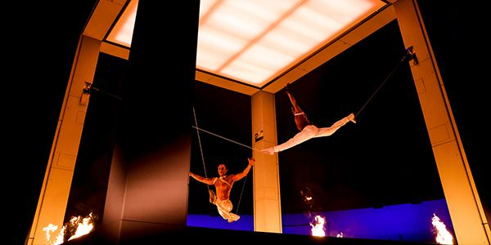

The set design of Cirque du Soleil ECHO revolves around the CUBE, a simple yet profound set piece built for a spectacular range of audio, visual, and tactile media.

At different points, it may be dismantled, stripped, and rebuilt, scaled by animals, swung from by artists, and used as a mesmerizing projection surface.

Surrounded by a stage that resembles water in a lake, every interaction with the CUBE creates a unique effect that ripples into the future.

**ONE CUBE, SO MANY DIMENSIONS**

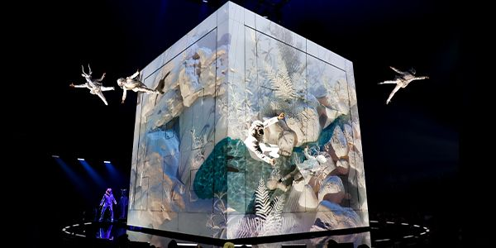

Designing the CUBE was a massive undertaking. Not only does it need to support the acrobatics and theatrical performances of the show, but it also had to meet the technical requirements of a traveling Big Top show.

There are 40 lightweight blocks that fill in the CUBE, which are made of different materials based on their use.

There are soft blocks made of foam so they can be easily dropped from various heights, while “acro blocks” are made of carbon fiber or fiberglass to support the requirements of the performers.

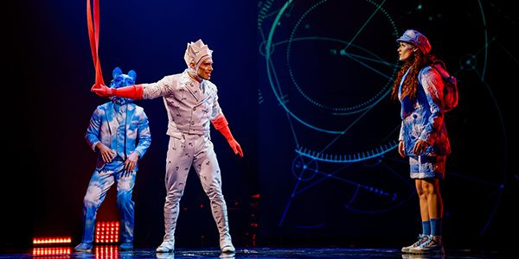

It takes 10 projectors to project imagery on the rotating CUBE and throughout the stage–the most ever for a Cirque du Soleil Big Top show.

These projectors can create 3D effects on the surface of the CUBE to appear like it’s being built and deconstructed without ever moving an inch.