Lab 7: Functions
This lab accompanies Chapter 6 of Starting Out with Programming Logic & Design.

Name: ___________________________

Lab 7.1 – Functions and Pseudocode

Critical Review

You have been coding with modules in pseudocode and functions when using Python.

You modules in pseudocode can be made into functions by returning a value.

A function is a special type of module that returns a value back to the part of the program that called it.

Most programming languages provide a library of prewritten functions that perform commonly needed tasks.

Library functions are built into the programming language and you can call them as needed. They are commonly performed tasks.

Writing Your Own Function that Returns an Integer
Step 1: A function contains three parts: a header, a body, and a return statement. The first is a function header which specifies the data type of the value that is to be returned, the name of the function, and any parameter variables used by the function to accept arguments. The body is comprised of one or more statements that are executed when the function is called. In the following space, complete the following: (Reference: Writing Your Own Functions, page 292).

- Write a function with the header named addTen.
- The function will accept an Integer variable named number.
- The function body will ask the user to enter a number and the add 10 to the number. The answer will be stored in the variable number.
- The return statement will return the value of number.

Function Integer addTen (Integer number)
Display "Enter a number:"
Input number
Set number = number + 10
Return number

Step 2: In the following space, write a function call to your function from Step 1.

Set number = addTen (number)

Writing Your Own Function that Returns a Boolean Value
Step 1: A Boolean function will either return a true or a false value. You can use these functions to test a condition. They are useful for simplifying complex conditions that are tested in decision and repetition structures. In the following space, complete the following: (Reference: Returning Boolean Values, page 305).

- Write a function named gender. The function accepts no arguments.
- The function will declare a local Boolean variable named answer, and a local String variable named type.
- The function body will ask the user to enter their gender, and store the user's input in the type variable.
- The function will determine whether the user entered "male" or "female" with an if statement.
- The return statement will return the value of answer.

Function Boolean gender()
Declare Boolean answer
Declare String type
Display "Enter your gender (male or female):"
Input type
If (type == "male") then
answer = False
Else
answer = True
End If

Return answer

Step 2: In the following space, write a function call to your function from Step 1.

Set answer = gender ()

Using Mathematical Library Function: sqrt
Step 1: The sqrt function accepts an argument and returns the square root of the argument. In the following space, complete the following: (Reference: The sqrt Function, page 307).

- Declare a variable named myNumber and a variable named squareRoot of the data type Real.
- Ask the user to enter a number of which they want to find the square root. Store the input in myNumber.
- Call the sqrt function to determine the square root of myNumber.
- Display the square root to the screen.

Declare Integer myNumber
Declare Real squareRoot
Display "Enter a number:"
Input myNumber
Set squareRoot = sqrt(myNumber)
Display "The square root is ", squareRoot

Using Formatting Functions
Step 1: Most languages provide one or more functions that format numbers in some way. A common use of formatting functions is to format numbers as currency amounts. While a specific programming language will have its own name for formatting currency, use the function currencyFormat for pseudocode. In the following space, complete the following: (Reference: Formatting Functions, page 312).

- Declare a variable named subtotal, a constant variable named tax set to the rate of .06, and a variable named total.
- Ask the user to enter the subtotal. Store the input in subtotal.
- Calculate the total as subtotal + subtotal * tax.
- Make a call to the currencyFormat function and pass it total. Display the value that is returned from the function on the screen.

Declare Real subtotal
Declare Constant Real tax = .06
Declare Real total
Display "Enter the subtotal:"
Input subtotal
Set total = subtotal + subtotal * tax
Display "The total is $", currencyFormat(total)

Lab 7.2 – Functions and Flowcharts

Critical Review

When creating a flowchart for a program that has functions, draw a separate flowchart for each function.

The starting terminal symbol usually shows the name of the function, along with any parameters that the function has.

The ending terminal symbol reads Return, followed by the value or expression being returned.

In Raptor, there are built-in procedures and functions that perform a wide variety of tasks on the programmer's behalf, saving development time and reducing the chance for errors.
Raptor's buily-in functions can return values, but modules made by the user do not have that ability.

Raptor has the following built-in functions.
basic math: rem, mod, sqrt, log, abs, ceiling, floor
trigonometry: sin, cos, tan, cot, arcsin, arcos, arctan, arccot
miscellaneous: random, Length_of

If you want to learn what each of these functions do, use the Help menu in Raptor and search for the function name.

While ceiling and floor round a number to the nearest integer, there is no function in Raptor that will round a number just to two decimal places.

The random function in Raptor takes no arguments. To generate a random integer from 1 to n, use floor((random*n) + 1). For example, you can simulate the roll of a die (random number from 1 to 6) with floor((random * 6) + 1).

This lab requires you to create the flowchart from page 285 on Using Random Numbers using the RANDOM function. Use an application such as Raptor or Visio.

Step 1: Start by reading the pseudocode on page 284 and 285 of your textbook on Using Random Numbers. In addition to simply displaying the random values, your program will also meet the following requirements:
- Allow the two players of the dice game to enter their names in variables named playerOne and playerTwo.
- Based on the random roll of the dice, your program will determine which value is higher or if they tie and declare one player a winner.
- Create structure in your program by creating the following modules:
  - An inputNames( ) module that will ask the players to enter their names
  - A rollDice( ) module that will call the RANDOM function and determine the winner. This will be done with a decision statement.
  - A displayInfo( ) module that will print the winners name to the screen.
- Additionally, your program should allow the same players to play as many times as they want.

Step 2: Start Raptor and save your document as Lab 7-2. The .rap file extension will be added automatically.

Step 3: Start by adding a comment box with the necessary variables.

Step 4: Add your loop to run multiple times and your module calls in the main module. Your flowchart might look as follows:
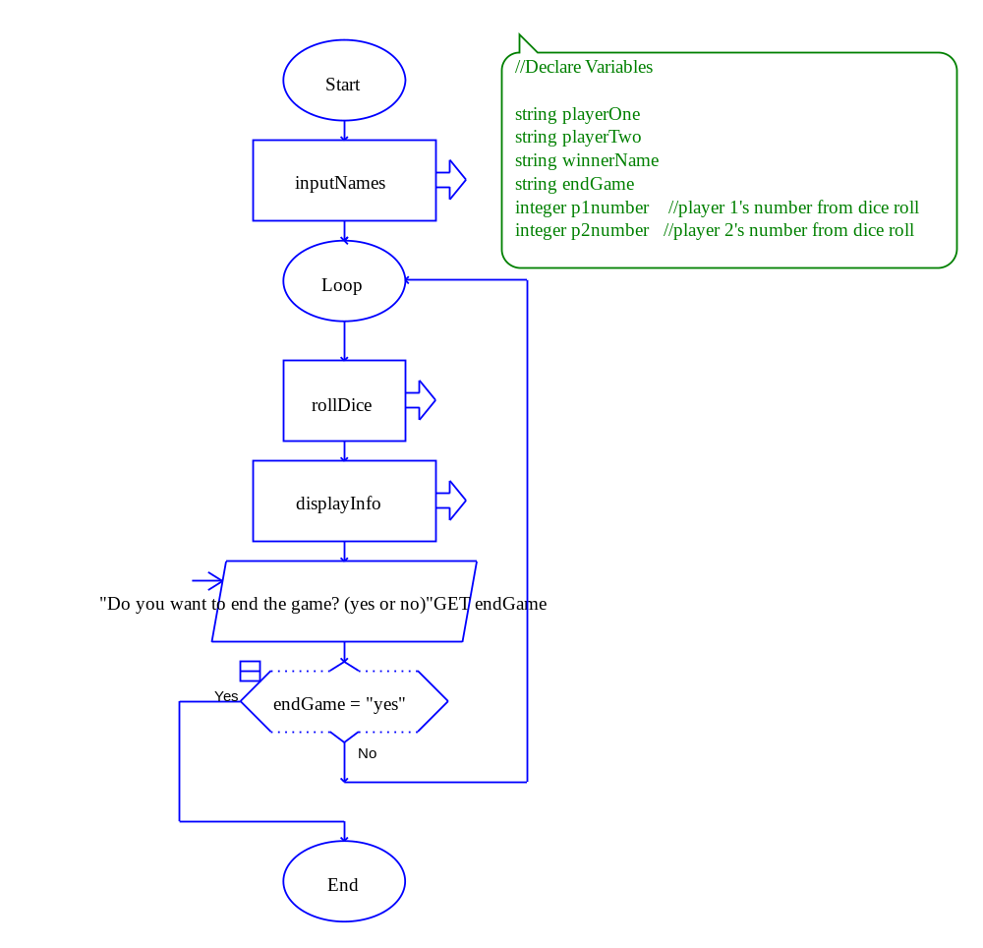
Step 5: Code the inputNames( ) module so both players can enter their name into the appropriate variable.

Step 6: Go to the rollDice( ) module and add an assignment statement. Assign p1number to whatever the RANDOM function return. The assignment box input box should look as follows:

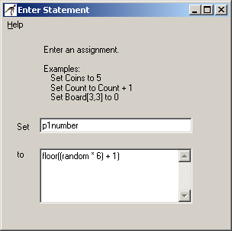

Step 7: Add a second assignment statement and do the same for p2number.

Step 8: Add a selection statement that will determine which number is larger, or if there is a tie. The best way to do this is to create a nested if else where you first check to see if p1number is equal to p2number. If so, assign winnerName equal to "TIE". If not, create a second decision to see if p1number is greater than p2number. If so, then winnerName should be set equal to playerOne and if not then winnerName should be set equal to playerTwo.

Step 9: Go to the displayInfo( ) module and print the winners name to the screen.

Step 10: Paste your finished flowchart in the space below.

Main

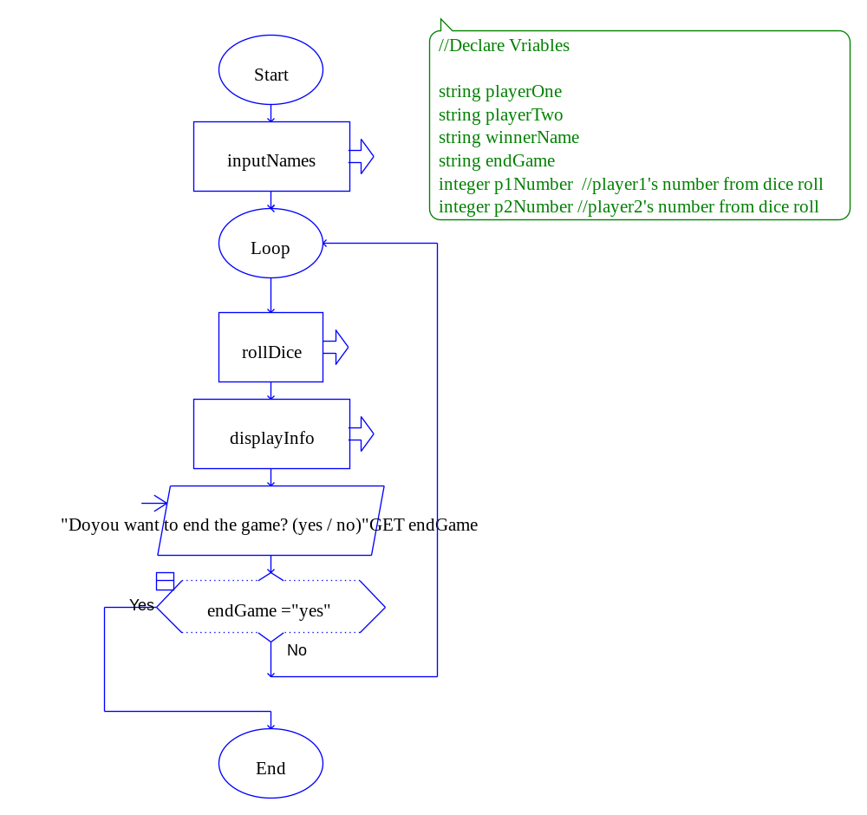

inputNames

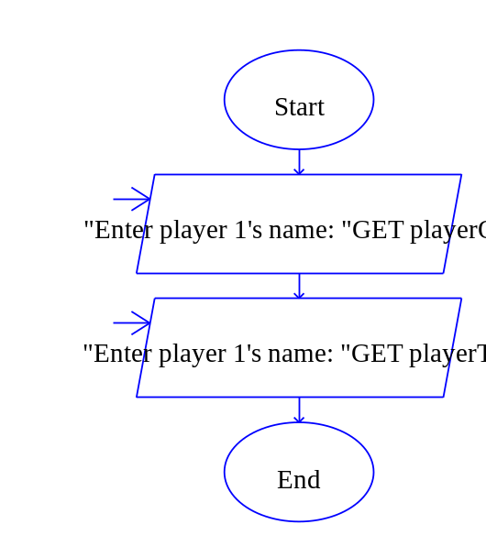
rollDice

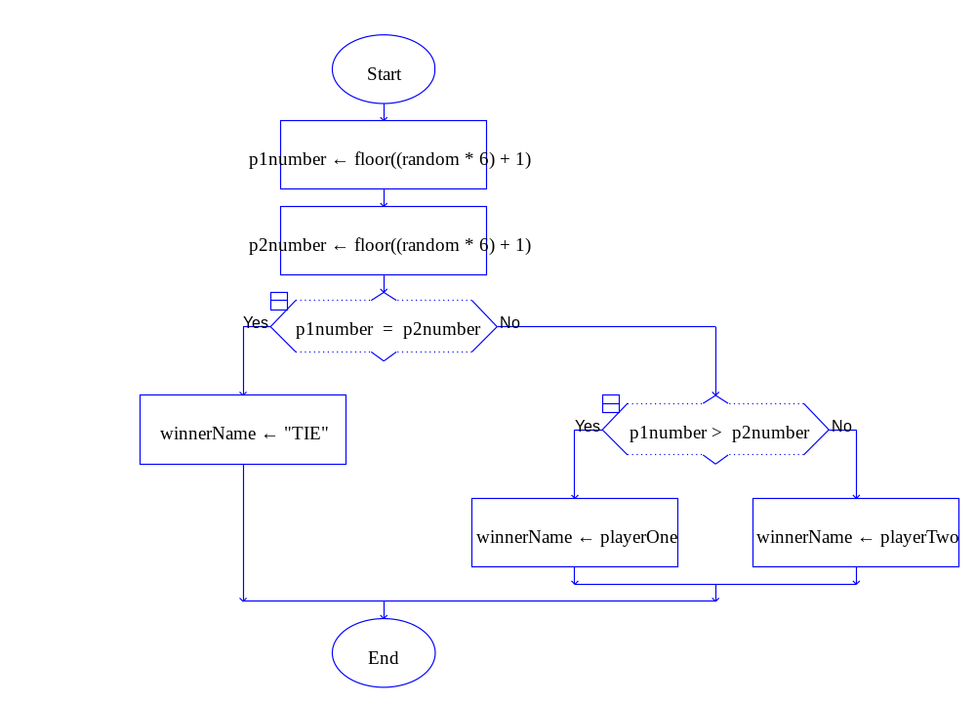

displayInfo

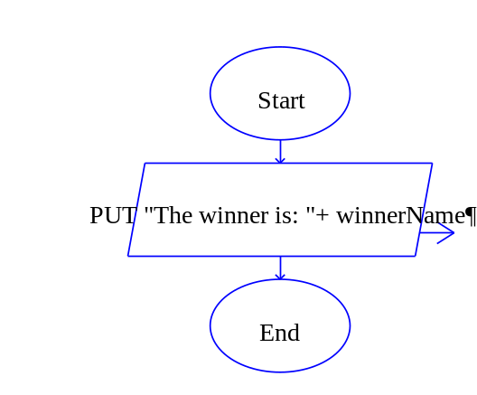

Lab 7.3 – Python Code and Random
Critical Review

A value-returning function is a function that returns a value back to the part of the program that called it. In Python, you have been using value-returning functions and those that do not.

Recall the function calls from Lab 6-4. The first call returns number back to the number variable. The second call just displays a value and there is no need to return a value.

number = getNumber(number) # value returning function
printAverage(averageScores) # function returns no value

Standard Library Functions
Python comes with a standard library of functions that have already been written for you. These functions, known as library functions, make a programmer’s job easier because they perform many of the tasks that programmers commonly need to perform. In fact, you have already used several of Python's library functions. Some of the functions that you have used are input, input, and range. Python has many other library functions.

The random Function
In order to use the random function in Python, you must import the random library. This loads the library into memory so that you can use the functions that exist within it. To do this, simply add the following line to the top of your code:
import random

One of the functions in the random library is the random.random.int( ) module. This function accepts two arguments with the first being the starting number and the second being the ending number. The following is how you would get a random number between 1 and 6.

p1number = random.randint(1, 6)

Writing your own Value-Returning Functions
We have already written our own value returning functions that return one variable to the place where the function was called.

However, you can also return more than one value in Python. The function call might look as follows:

playerOne, playerTwo = inputNames(playerOne, playerTwo)

The return statement looks as follows:

return playerOne, playerTwo

The goal of this lab is to convert the Dice Game in Lab 7.2 to Python code.

Step 1: Start the IDLE Environment for Python. Prior to entering code, save your file by clicking on File and then Save. Select your location and save this file as Lab7-3.py. Be sure to include the .py extension.

Step 2: Document the first few lines of your program to include your name, the date, and a brief description of what the program does.

Step 3: Start your program with the following code for main:

# Lab 7-3 The Dice Game
# add libraries needed

# the main function
def main():
print()

# initialize variables
playerOne,playerTwo,winnerName,endGame,p1Number,p2Number = declareVariable()

# call to inputNames
playerOne,playerTwo = inputNames(playerOne, playerTwo)

# while loop to run program again
while endProgram == 'no':

# populate variables
playerOne,playerTwo,winnerName,endGame,p1Number,p2Number = declareVariable()

# call to rollDice
winnerName = rollDice(playerOne, playerTwo, p1Number, p2Number)

# call to displayInfo
displayInfo(winnerName)

endProgram = input('Do you want to end program? (yes/no): ')

#this function gets the players names
def inputNames(playerOne, playerTwo):
playerOne = input("Enter player 1's name: ")
playerTwo = input("Enter player 2's name: ")
return playerOne, playerTwo

#this function will get the random values
def rollDice(playerOne, playerTwo, p1Number, p2Number):
p1Number = random.randint(1,6)
p2Number = random.randint(1,6)
if p1Number == p2Number:
winnerName = "TIL"
if p1Number > p2Number:
winnerName= playerOne
if p1Number < p2Number:
winnerName= playerTwo
return winnerName

#this function displays the winner
def displayInfo(winnerName):
print("The winner is: "+ winnerName)

# calls main
main()

Step 4: Under the comment for adding libraries, add the following statement:

import random

Step 5: Under the comment for initialize variables, set endProgram to ‘no’ and playerOne and playerTwo to ‘NO NAME’.

Step 6: Under the comment for making a call to inputNames, set the function call to both playerOne and playerTwo and pass both variables to the function as arguments. This must be done because both values need to be returned from the function. This is done as follows:

playerOne, playerTwo = inputNames(playerOne, playerTwo)

Step 7: Inside your while loop, set winnersName to ‘NO NAME’ and p1number and p2number to 0.

Step 8: Make a call to rollDice and pass the necessary variables needed in this function. This function should be set to the winnerName as that variable will be returned from the function. This is done as follows:

winnerName = rollDice(p1number, p2number, playerOne, playerTwo,
winnerName)

Step 9: Make a call to displayInfo and pass it winnerName.

Step 10: The next step is to write the function that will allow both players to enter their names. Write a function heading that matches your function call in Step 6, making sure to accept two arguments. The body of this function will use the input function to take in both players names, and one return statement that returns both playerOne and playerTwo variable The return statement should look as follows:

return playerOne, playerTwo

Step 11: The next function to code is the rollDice function. Write the function header to match the function call in Step 8. This function body will call the random function to determine p1number and p2number. The code should look as follows:

p1number = random.randint(1, 6)
p2number = random.randint(1, 6)

Step 12: Next, inside this function write a nested if else statement that will set winnerName to either playerOne, playerTwo, or "TIE".

Step 13: The final step in this function is to return winnerName.

Step 14: The final function to code is the displayInfo function. Write the function header to match the call made in Step 9. The body of the function should simply print the winnerName variable to the screen.

Step 15: Execute your program so that all loops work and paste the final code below

# Lab 7-3 The Dice Game
# add libraries needed
import random

# the main function
def main():
# initialize variables
playerOne = "NO NAME"
playerTwo = "NO NAME"
endProgram = "no"

# call to inputNames
playerOne,playerTwo = inputNames(playerOne, playerTwo)

# while loop to run program again
while endProgram == "no":

# populate variables
winnerName="NO NAME"
p1Number = 0
p2Number = 0

# call to rollDice
winnerName = rollDice(playerOne, playerTwo, p1Number, p2Number, winnerName)

# call to displayInfo
displayInfo(winnerName)

endProgram = input("Do you want to end the game? (yes/[no])")

# If press enter it is assumed as option “no”
if endProgram=="":
endProgram="no"

#this function gets the players names
def inputNames(playerOne, playerTwo):
playerOne = input("Enter player 1's name: ")
playerTwo = input("Enter player 2's name: ")
return playerOne, playerTwo

#this function will get the random values
def rollDice(playerOne, playerTwo, p1Number, p2Number, winnerName):

p1Number = random.randint(1,6)
p2Number = random.randint(1,6)

if p1Number == p2Number:
winnerName = "TIL"
if p1Number > p2Number:
winnerName= playerOne
if p1Number < p2Number:
winnerName= playerTwo
return winnerName

#this function displays the winner
def displayInfo(winnerName):
print("The winner is: "+ winnerName)

# calls main
main()

C#

namespace Lab_7._2
{
class Program
{
static void Main(string[] args)
{
main();
}

private static void main()
{
string playerOne = "NO NAME";
string playerTwo = "NO NAME";
string endProgram = "no";

// call to inputNames
inputNames(ref playerOne, ref playerTwo);

while (endProgram == "no")
{
// populate variables
string winnerName = "NO NAME";
int p1Number = 0;
int p2Number = 0;

// call to rollDice
rollDice(playerOne, playerTwo, ref p1Number, ref p2Number, ref winnerName);

displayInfo(winnerName);

Console.WriteLine("Do you want to end the game? (yes/[no]): ");
endProgram = Console.ReadLine();
if (endProgram =="")
{
endProgram = "no";
}
}

}

private static void inputNames(ref string playerOne, ref string playerTwo)
{

Console.WriteLine("Enter player 1's name: ");
playerOne = Console.ReadLine();

Console.WriteLine("Enter player 2's name: ");
playerTwo = Console.ReadLine();
}

private static void rollDice(string playerOne, string playerTwo, ref int p1Number, ref int p2Number, ref string winnerName)
{
var rand = new Random();

p1Number = rand.Next(1, 6);
p2Number = rand.Next(1, 6);

if (p1Number == p2Number)
{
winnerName = "TIL";
}
else if(p1Number > p2Number)
{
winnerName = playerOne;
}
else if(p1Number < p2Number)
{
winnerName = playerTwo;
}

}

private static void displayInfo(string winnerName)
{
Console.WriteLine("The winner is: " + winnerName);
}

}
}

Lab 7.4 – Programming Challenge 1 – Math Test

Write the Flowchart and Python code for the following programming problem based on the pseudocode below.

Write a program that will allow a student to enter their name and then ask them to solve 10 mathematical equations. The program should display two random numbers that are to be added, such as:

247
+ 129

The program should allow the student to enter the answer. The program should then display whether the answer was right or wrong, and accumulate the correct values. After the 10 questions are asked, calculate the average correct. Then display the student name, the number correct, and the average correct in both decimal and percentage format.

In addition to any system functions you may use, you might consider the following functions:
- A function that allows the student to enter their name.
- A function that gets two random numbers, anywhere from 1 to 500.
- A function that displays the equation and asks the user to enter their answer.
- A function that checks to see if the answer is right and accumulates the number right.
- A function that calculates the results.
- A function that displays the student name, the number right, and the average right.

Your sample output might look as follows (random numbers will be different):

Enter Student Name: Katie
What is the answer to the following equation
424
+
28
What is the sum: 472
Wrong

What is the answer to the following equation
163
+
233
What is the sum: 396
Right

What is the answer to the following equation
285
+
453
What is the sum: 688
Wrong

Etc…(through 10 iterations)

Information for student: Katie
The number right: 5
The average right is 0.50 or 50.0 %

The Pseudocode

Module main()
// Declare local variables
Declare Integer counter = 0
Declare String studentName = "NO NAME"
Declare Real averageRight = 0.0
Declare Real right = 0.0
Declare Integer number1 = 0
Declare Integer number2 = 0
Declare answer = 0.0

Set studentName = inputNames()
// Loop to run program again
While counter < 10
// calls functions
Call getNumbers(number1, number2)
Set answer = getAnswer(number1, number2, answer)
Set right = checkAnswer(number1, number2, answer, right)
Set counter = counter + 1
End While
Set averageRight = results(right, averageRight)
Call displayInfo(right, averageRight, studentName)
End Module

Function String inputNames(String studentName)
Display "Enter Student Name:"
Input studentName
Return studentName
End Function

Module getNumber(Integer Ref number1, Integer Ref number2)
Set number1 = random(1, 500)
Set number2 = random(1, 500)
End Module

Function Integer getAnswer(Integer number1, Integer number2,
Integer answer)
Display "What is the answer to the following equation"
Display number1
Display "+"
Display number2
Display "What is the sum:"
Input answer
Return answer
End Function

Function Integer checkAnswer(Integer number1, Integer number2,
Integer answer, Integer right)
If answer == number1 + number2 then
Display "Right"
Set right = right + 1
Else
Display "Wrong"
End If
Return right
End Function

Function Real results (Integer right, Real AverageRight)
Set averageRight = right / 10
Return averageRight
End Function

Module displayInfo(Integer right, Real averageRight,
String studentName)
Display "Information for student:", studentName
Display "The number right:", right
Display "The average right is:", averageRight
End Module

The Flowchart

Main
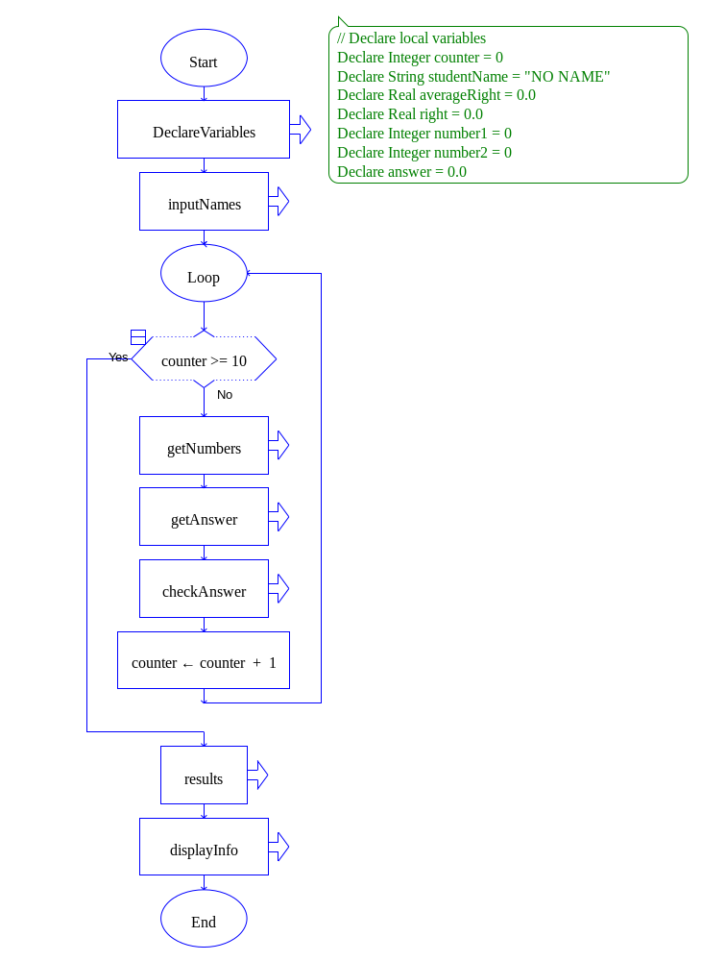

DeclareVariables
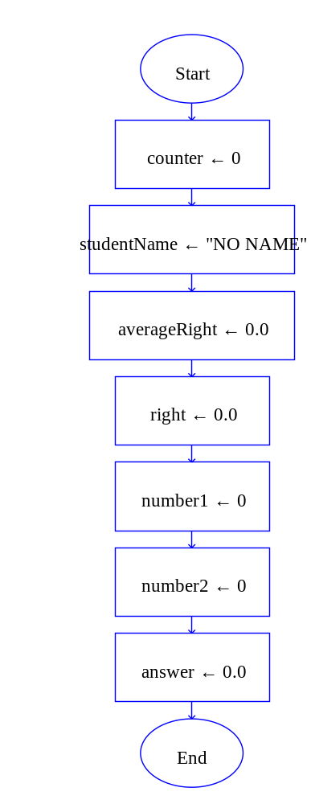
inputNames
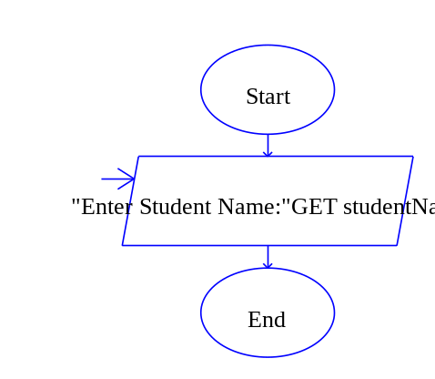
getNumbers
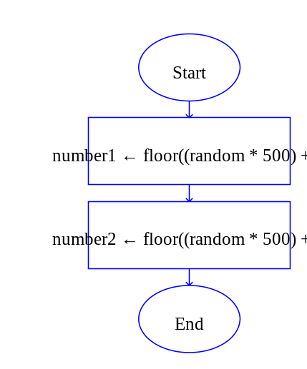

getAnswer
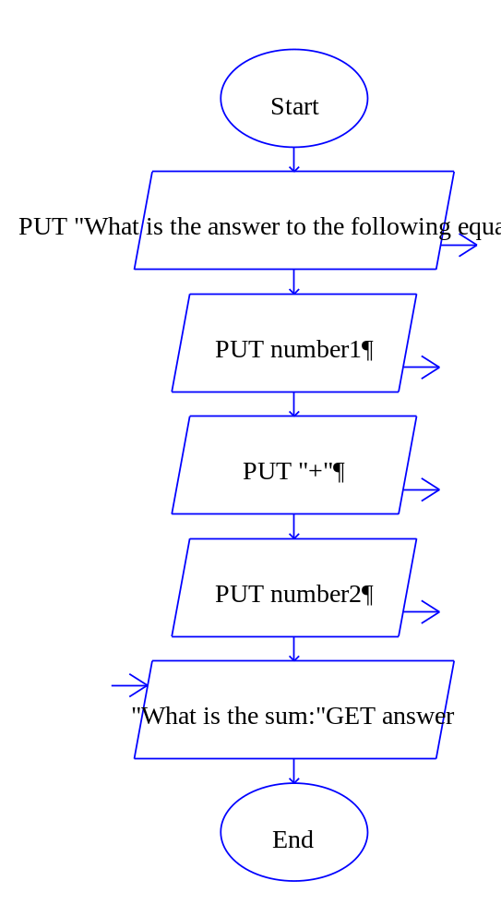

checkAnswer
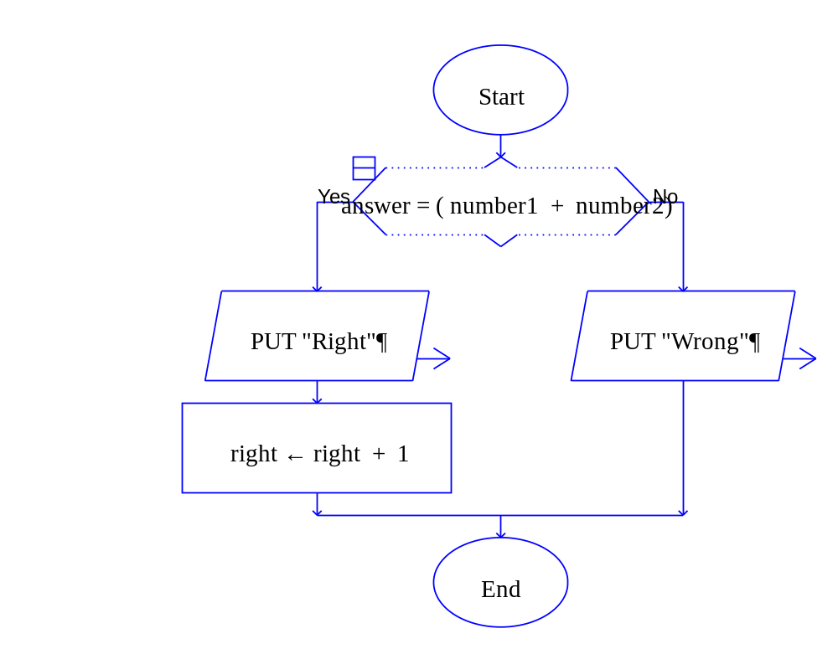

Results
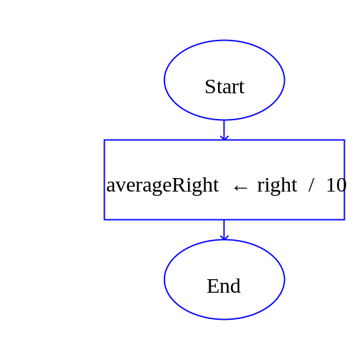

displayInfo
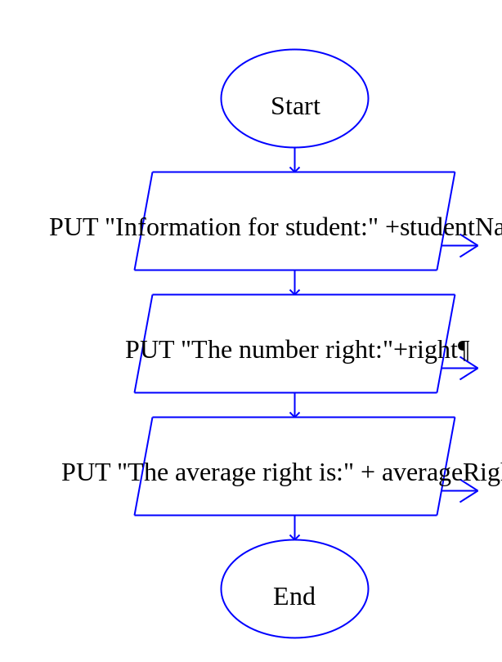

The Python Code

# Lab 7.4
#Johnny Aracena
#2020-28-11
import random

##Module main()
## // Declare local variables
## Declare Integer counter = 0 OK
## Declare String studentName = "NO NAME" OK
## Declare Real averageRight = 0.0 OK
## Declare Real right = 0.0 OK
## Declare Integer number1 = 0 OK
## Declare Integer number2 = 0 OK
## Declare answer = 0.0 OK
##
## Set studentName = inputNames() OK
## // Loop to run program again
## While counter < 10
## // calls functions
## Call getNumbers(number1, number2)
## Set answer = getAnswer(number1, number2, answer)
## Set right = checkAnswer(number1, number2, answer, right)
## Set counter = counter + 1
## End While
## Set averageRight = results(right, averageRight)
## Call displayInfo(right, averageRight, studentName)
##End Module
def main():
counter, studentName, averageRight, right, number1, number2, answer = declare()
studentName = inputNames()

while counter in range(10):
number1, number2 = getNumber(number1, number2)
answer = getAnswer(number1, number2, answer)
right = checkAnswer(number1, number2, answer, right)
counter = counter + 1

averageRight = results(right, averageRight)
displayInfo(right, averageRight, studentName)

def declare():
return 0,"NO NAME", 0.0, 0.0, 0, 0, 0.0
##Function String inputNames(String studentName)
## Display "Enter Student Name:"
## Input studentName
## Return studentName
##End Function
def inputNames():
studentName = input( "Enter Student Name:")
return studentName

##Module getNumber(Integer Ref number1, Integer Ref number2)
## Set number1 = random(1, 500)
## Set number2 = random(1, 500)
##End Module
def getNumber(number1, number2):
number1 = random.randint(1,500)
number2 = random.randint(1,500)
return number1, number2

##Function Integer getAnswer(Integer number1, Integer number2,
## Integer answer)
## Display "What is the answer to the following equation"
## Display number1
## Display "+"
## Display number2
## Display "What is the sum:"
## Input answer
## Return answer
##End Function
def getAnswer(number1, number2, answer):
print("What is the answer to the following equation: ")
print(number1)
print("+")
print(number2)
answer= int(input("What is the sum: "))
return answer

##Function Integer checkAnswer(Integer number1, Integer number2,
## Integer answer, Integer right)
## If answer == number1 + number2 then
## Display "Right"
## Set right = right + 1
## Else
## Display "Wrong"
## End If
## Return right
##End Function
def checkAnswer(number1, number2, answer, right):
sum = number1 + number2
if answer == sum:
print("Right")
right = right + 1
else:
print("Wrong")
return right

##Function Real results (Integer right, Real AverageRight)
## Set averageRight = right / 10
## Return averageRight
##End Function
def results (right, AverageRight):
AverageRight = right / 10
return AverageRight

##Module displayInfo(Integer right, Real averageRight,
## String studentName)
## Display "Information for student:", studentName
## Display "The number right:", right
## Display "The average right is:", averageRight
##End Module

def displayInfo(right, averageRight, studentName):
print("Information for student:", studentName)
print("The number right:", right)
print("The average right is:", averageRight*100,"%")

#Main function ejecution
main()

C#

namespace Lab7._2
{
class Program
{
static void Main(string[] args)
{
main();
}

private static void main()
{
int counter = 0;
string studentName = "NO NAME";
double averageRight = 0.0;
double right = 0.0;
int number1 = 0;
int number2 = 0;
double answer = 0.0;

inputName(ref studentName);

while (counter <= 10)
{
getNumbers(ref number1, ref number2);
getAnswer(number1,number2, ref answer);
checkAnswer(number1, number2, answer, ref right);

counter++;
}

results(right, ref averageRight);
displayInfo(right, averageRight, studentName);

Console.ReadLine();
}

private static void inputName(ref string studentName)
{
Console.WriteLine("Enter Student Name: ");
studentName = Console.ReadLine();
}

private static void getNumbers(ref int number1, ref int number2)
{
var rand = new Random();
number1 = rand.Next(1,500);
number2 = rand.Next(1,500);
}

private static void getAnswer( int number1, int number2, ref double answer)
{
Console.WriteLine("What is the answer to the following equation: ");
Console.WriteLine(number1);
Console.WriteLine("+");
Console.WriteLine(number2);
Console.WriteLine("What is the sum: ");
answer = Convert.ToDouble(Console.ReadLine());
}

private static void checkAnswer(int number1, int number2, double answer, ref double right)
{
double sum = number1 + number2;
if (answer == sum ){
Console.WriteLine("Right");
right = right + 1;
}
else
{
Console.WriteLine("Wrong");
}

}

private static void results(double right, ref double averageRight)
{
averageRight = right / 10;

}

private static void displayInfo(double right, double averageRight, string studentName)
{

Console.WriteLine("Information for student:" + studentName);
Console.WriteLine("The number right:" + right);
Console.WriteLine("The average right is:" + averageRight * 100 + "%");
}
}
}

