Lab 9: Arrays
This lab accompanies Chapter 8 of Starting Out with Programming Logic & Design.

Name: ___________________________

Lab 9.1 – Arrays and Pseudocode

Critical Review

An array allows you to store a group of items of the same data type together in memory.

A variable stores just a single value, and oftentimes can be cumbersome to work with when your program has similar values.

Values stored in an array are called elements. Each element has a subscript that makes it unique.

An array is defined as follows:

Declare Integer numbers[10]

Integer defines the type of numbers that can be stored, numbers is the name of the array, and [10] is how many numbers can be stored.

In most languages, the first element is assigned the subscript of 0, so the above array actually runs from 0 to 9.

Constant variables can also be used to declare the size of an array.

Constant Integer SIZE = 5
Declare Integer numbers[SIZE] = 847, 1238, 48, 123, 840

Elements in the array

847 | 1238 | 48 | 123 | 840
0 | 1 | 2 | 3 | 4

Subscript or Index starting a 0

Loops are generally used to step through an array. This can be done using any type of loop and for any process such as filling, calculating, searching, sorting, or outputting elements of the array.

This lab examines the various ways of working with arrays by writing pseudocode. Read the following programming problem prior to completing the lab.

The American Red Cross wants you to write a program that will calculate the average pints of blood donated during a blood drive. The program should take in the number of pints donated during the drive, based on a seven hour drive period. The average pints donated during that period should be calculated and displayed. Additionally, the highest and the lowest number of pints donated should be determined and displayed. Write a loop around the program to run multiple times.

Step 1: Declare the following variables:

- An array named pints of the data type Real of size 7
- A variable named totalPints of the data type Real
- A variable named averagePints of the data type Real initialized to 0
- A variable named highPints of the data type Real initialized to 0
- A variable named lowPints of the data type Real initialized to 0

Module main()
//Declare local variables
Declare String again = “no”
Declare Real pints[7]
Declare Real totalPints = 0
Declare Real averagePints = 0
Declare Real highPints = 0
Declare Real lowPints = 0
While again == “no”
//module calls below

Display “Do you want to run again: yes or no”
Input again
End While
End Module

Step 2: Write a module call to a module named getPints that passes the pints array. Additionally, write a module header named getPints that accepts the pints array. (Reference: Passing an Array as an Argument to a Function, page 295).

//Module call
Call getPints (pints)

//Module header
Module getPints(Real pints[ ])
Step 3: Write a for loop that runs 7 times using the counter variable. Inside the for loop, allow the user to enter values into the array. (Reference: Using a Loop to Step Through an Array, page 273).

Declare Integer counter = 0
For counter = 0 to 6
Display “Enter pints collected:”
Input pints[counter]
End For

Step 4: Write a function call to a module named getTotal that passes the pints array and the totalPints variable. Additionally, write a function header named getTotal that accepts the pints array and the totalPints variable.

//Function call
totalPints = getTotal(pints, totalPints)

//Function header
Function getTotal(Real pints[ ], Real totalPints)

Step 5: Write a for loop that runs 7 times using the counter variable. Inside the for loop, total up the values of the array and store in the variable totalPints. Also, return the correct variable from the function. (Reference: Totaling the Values in an Array, page 289).

Declare Integer counter = 0
Set totalPints = 0
For counter = 0 to 6
Set totalPints = totalPints + pints[counter]
End For

Return totalPints

Step 6: Write a function call to a module named getAverage that passes the totalPints variable and the averagePints variable. Additionally, write a function header named getAverage that accepts the totalPints variable and the averagePints variable.

//Function call
averagePints = getAverage(totalPints, averagePints)

//Function header
Function getAverage(Real totalPints, Real averagePints)

Step 7: Write a statement that will calculate the average pints donated over the drive period. Also, return the correct variable from the function. (Reference: Averaging the Values in an Array, page 290).

averagePints = totalPints / 7

Return averagePints

Step 8: Write a function call to a module named getHigh that passes the highPints variable and the pints array. Additionally, write a function header named getHigh that accepts the highPints variable and the pints array.

//Function call
highPints = getHigh (highPints, pints)

//Function header
Function getHigh (Real highPints, Real pints[ ])

Step 9: Write the code that will determine the highest value in an array. Also, return the correct variable from the function. (Reference: Finding the Highest Value in an Array, page 291).

Set highPints = pints[0]
Set index = 1
For index = 1 to 6
If pints[index] > highPints Then
Set highPints = pints [index]
End If
End For

Return highPints

Step 10: Write a function call to a module named getLow that passes the lowPints variable and the pints array. Additionally, write a function header named getLow that accepts the lowPints variable and the pints array.

//Function call
lowPints = getLow(lowPints, pints)

//Function header
Function getLow(Real lowPints, Real pints[ ])

Step 11: Write the code that will determine the highest value in an array. Also, return the correct variable from the function. (Reference: Finding the Lowest Value in an Array, page 293).

Set lowPints = pints[0]
Set index = 1
For index = 1 to 6
If pints [index] < lowPints Then
Set lowPints = pints [index]
End If
End For

Return lowPints

Step 12: Write a module call to a module named displayInfo. Pass the necessary variable to the functions that are needed to display the averagePints, the highPints, and the lowPints. Also, write the module header that accepts the same variables.

//Module call
Call displayInfo(averagePints, highPints, lowPints)

//Module header
Module displayInfo(Real averagePints, Real highPints, Real lowPints)
Lab 9.2 – Checking the Work

Using the program from Lab 9.1, complete the following checks for a better understanding of your work.

Step 1: Imagine the following number of pints were entered into the array.

Element | 34 | 39 | 25 | 18 | 43 | 31 | 12
Index | 0 | 1 | 2 | 3 | 4 | 5 | 6

Step 2: Recall Step 5 of Lab 9.1 that accumulates the pints collected.

Declare Integer counter = 0
Set totalPints = 0
For counter = 0 to 6
Set totalPints = totalPints + pints[counter]
End For

Step 3: Complete the following chart by writing what the counter and the totalPints value stores on each iteration of the loop.

Counter | totalPints
0 | 34
1 | 73
2 | 98
3 | 116
4 | 159
5 | 190
6 | 202

Step 4: Recall Step 9 from Lab 9.1 that determines the high value.

Set highPints = pints[0]
Set index = 1
For index = 1 to 6
If pints[index] > highPints Then
Set highPints = pints[index]
End If
End For

Step 5: Complete the following chart by writing what the highPints and the pints array value stores on each iteration of the loop. Also conclude whether it will be True or False.

Pints | highPints | True or False
39 | 34 | TRUE
25 | 39 | FALSE
18 | 39 | FALSE
43 | 39 | TRUE
31 | 43 | FALSE
12 | 43 | FALSE

Step 6: Recall Step 11 from Lab 9.1 that determines the low value.

Set lowPints = pints[0]
Set index = 1
For index = 1 to 6
If pints[index] < lowPints Then
Set lowPints = pints[index]
End If
End For

Step 7: Complete the following chart by writing what the lowPints and the pints array value stores on each iteration of the loop. Also conclude whether it will be True or False.

Pints | lowPints | True or False
39 | 34 | FALSE
25 | 34 | TRUE
18 | 25 | TRUE
43 | 18 | FALSE
31 | 18 | FALSE
12 | 18 | TRUE

Lab 9.3 – Arrays and Flowchart

Critical Review

Arrays in Raptor are defined as follows:

arrayName[SIZE]

Size can either be a variable that is declared, or a specific number such as 10.

Array indices in Raptor start at 1. This is different than what is explained in the textbook, and also in Python.

This lab requires you to create a flowchart for the blood drive program in Lab 9.1. Use an application such as Raptor or Visio.

Step 1: Start Raptor and save your document as Lab 9-3. The .rap file extension will be added automatically.

Step 2: Start by adding a comment box with the necessary variables.

Step 3: Add your loop to run multiple times and your module calls in the main module.

Step 4: Add the getPints( ) module in main. Go to the getPints() module and add the following inside the module:
- Add an assignment statement that sets counter to 1. Remember, counter has to be set to one because Raptor arrays must start at 1, not 0.
- Add a loop that runs as long as counter is less than 7. Remember, this should be written as counter > 7 because if yes, then the loop ends.
- Add an input statement that asks the user to enter number of pints, storing the answer in the array. The input should be entered as below.
- Add an assignment statement that will increment counter by 1.

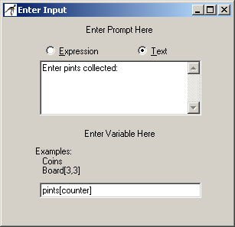
Step 5: Add the getTotal( ) module in main. Go to the getTotal() module and add the following inside the module:
- Add an assignment statement that sets counter back to 1.
- Add an assignment statement that sets totalPints to 0.
- Add a loop that runs 7 times.
- Add an assignment statement that accumulates the value of the array. The input should be as below:
- Add an assignment statement that will increment counter by 1.

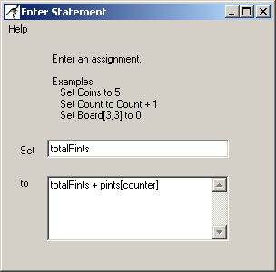

Step 6: Add the getAverage( ) module in main. Go to the getAverage() module and add the following inside the module:
- Add an assignment statement that sets counter back to 1.
- Add an assignment statement that sets averagePints to totalPints divided by 7.

Step 7: Add the getHigh( ) module in main. Go to the getHigh() module and add the following inside the module:
- Add an assignment statement that sets counter to 2. This refers to the second location in the array.
- Add an assignment statement that sets highPints to the 1 index of the pints array.
- Add a loop that iterates 7 times.
- Inside the loop, add a selection statement that determines if pints in the counter location is greater than highPints.
- If that is true, then set highPints to pints in the counter location.
- Increment counter by 1.

Step 8: Add the getLow( ) module in main. Go to the getLow() module and add the following inside the module:
- Add an assignment statement that sets counter to 2. This refers to the second location in the array.
- Add an assignment statement that sets lowPints to the 1 index of the pints array.
- Add a loop that iterates 7 times.
- Inside the loop, add a selection statement that determines if pints in the counter location is less than lowPints.
- If that is true, then set lowPints to pints in the counter location.
- Increment counter by 1.

Step 9: Add the displayInfo( ) module in main. Go to the display() module and add the following inside the module:
- Display the averagePints variable
- Display the highPints variable
- Display the lowPints variable

Step 10: Using the following input values, check your results. If there are errors, verify steps 1 through 10.

Element | 34 | 39 | 25 | 18 | 43 | 31 | 12

Output should be as follows:

The average pints collected: 28.8571
The highest amount was: 43
The lowest amount was: 12

Step 11: Paste your finished flowchart in the space below.

#MAIN

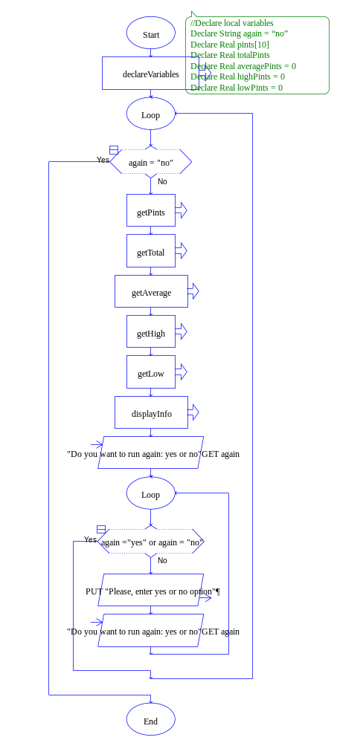
#declareVariables
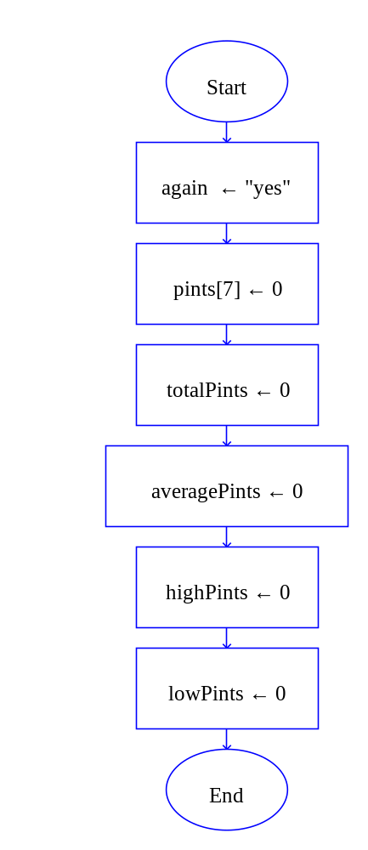

#getPints

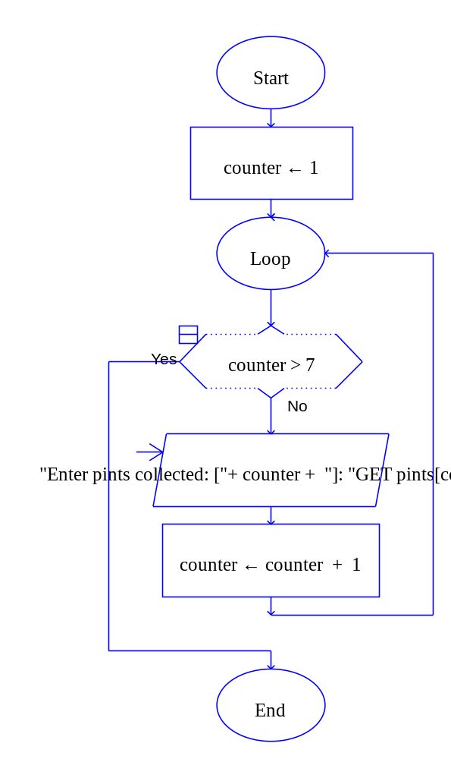

#getTotal

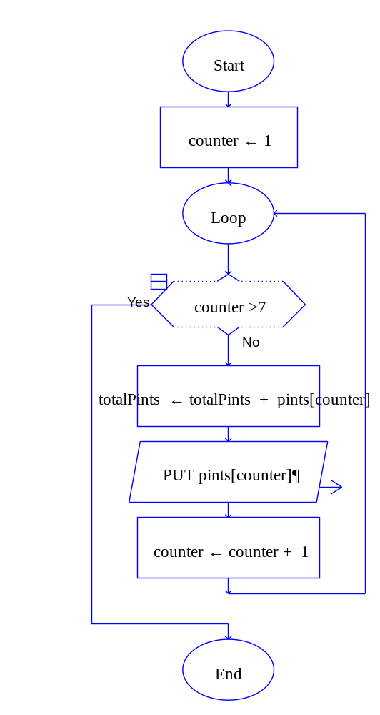

#getAverage

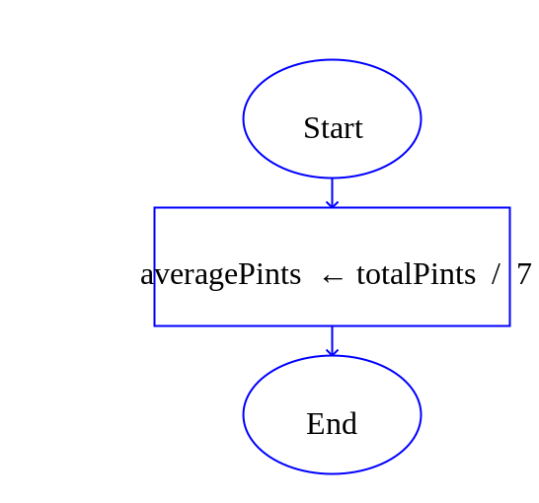

#getHigh

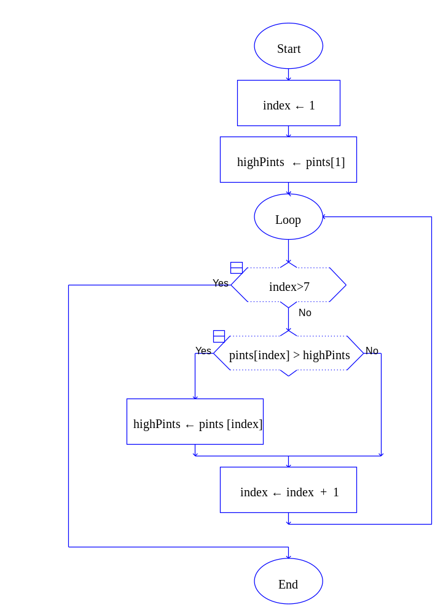

#getLow

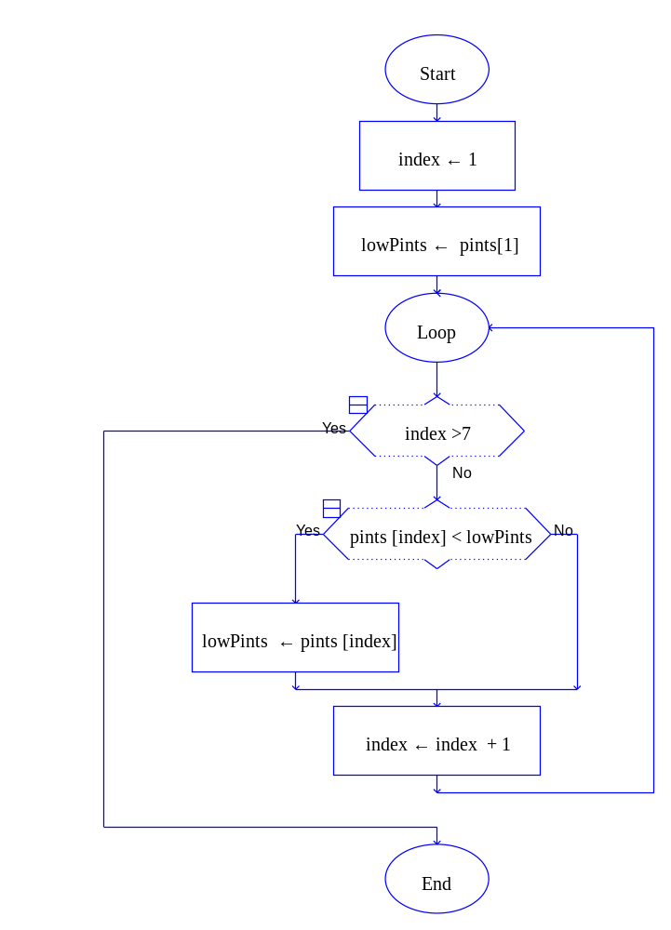
#displayInfo

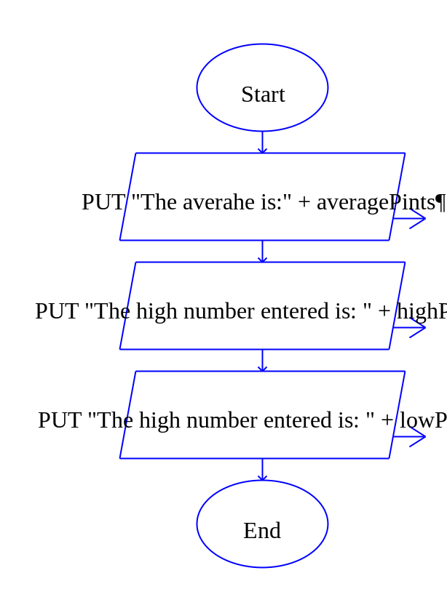
Lab 9.4 – Arrays and Python Code
Critical Review

In Python, arrays are native objects called lists.

List index starts at 0 (unlike Raptor).

The following is a method used when you know the elements of the array.

even_numbers = [2, 4, 6, 8, 10]
You can use the print statement to display an entire list, as shown here:

print(even_numbers)

The following is a method used when you do not know what the elements should be, but you know the size.

numbers = [0] * 5

A loop can also be used to print the elements of the array. An example is as follows:

//A for in loop
for n in numbers:
print(n)

//A while loop
index = 0
while index < 5:
print(numbers [index])
index = index + 1

The goal of this lab is to convert the blood drive program from Lab 9.1 to Python code.

Step 1: Start the IDLE Environment for Python. Prior to entering code, save your file by clicking on File and then Save. Select your location and save this file as Lab9-4.py. Be sure to include the .py extension.

Step 2: Document the first few lines of your program to include your name, the date, and a brief description of what the program does.

Step 3: Start your program with the following code for main:

#Lab 9-4 Blood Drive

#the main function
def main():
endProgram = 'no'
print()
while endProgram == 'no':
print()
# declare variables

# function calls

endProgram = input('Do you want to end program? (Enter no or yes): ')
while not (endProgram == 'yes' or endProgram == 'no'):
print('Please enter a yes or no')
endProgram = input('Do you want to end program? (Enter no or yes): ')

#the getPints function

#the getTotal function

#the getAverage function

#the getHigh function

#the getLow function

#the displayInfo function

# calls main
main()

Step 4: Under the documentation for declaring variables, declare your variables and initialize them to 0. The array/list should be declared as follows:

pints = [0] * 7

Step 5: Write a function call to the getPints function and pass it pints. The function will return pints, so set it equal to the function call. This should be done as follows:

pints = getPints(pints)

Step 6: Under the documentation for the getPints function, write a while or a for in loop that will allow the user to enter pints into the array. This function might be written as follows.

#the getPints function
def getPints(pints):
counter = 0
while counter < 7:
pints[counter] = int(input('Enter pints collected: '))
counter = counter + 1
return pints

Step 7: Write a function call to the getTotal function and pass it pints and totalPints. This function should be set to the totalPints variable since it will be returned from the function. The call might look as follows:

totalPints = getTotal(pints, totalPints)

Step 8: Under the documentation for the getTotal function, add the following statements:
- Initialize counter back to 0
- Add a while loop that runs 7 iterations and includes:
  - Accumulate totalPints by setting totalPints = totalPints + pints[counter]
  - Increment counter
- Return totalPints

Step 9: Write a function call to the getAverage function and pass it totalPints and averagePints. This function should be set to the averagePints variable since it will be returned from the function. The call might look as follows:

averagePints = getAverage(totalPints, averagePints)

Step 10: Under the documentation for the getAverage function, add the following statements:
- A statement that will calculate averagePints as totalPints / 7
- Return averagePints

Step 11: Write a function call to the getHigh function and pass it pints and highPints. This function should be set to the highPints variable since it will be returned from the function. The call might look as follows:

highPints = getHigh(pints, highPints)

Step 12: Under the documentation for the getHigh function, add the following statements:
- Initialize highPints to pints[0]
- Set counter to 1
- Write a while loop that runs 7 iterations and includes:
  - An if statement that checks to see if pints[counter] > highPints
    - If it is true, set highPints to pints[counter]
  - Increment counter by 1
- Return highPints
- Be careful to watch your indentation on this function.

Step 13: Write a function call to the getLow function and pass it pints and lowPints. This function should be set to the lowPints variable since it will be returned from the function. The call might look as follows:

lowPints = getLow(pints, lowPints)

Step 14: Under the documentation for the getLow function, add the following statements:
- Initialize lowPints to pints[0]
- Set counter to 1
- Write a while loop that runs 7 iterations and includes:
  - An if statement that checks to see if pints[counter] < lowPints
    - If it is true, set lowPints to pints[counter]
  - Increment counter by 1
- Return lowPints
- Be careful to watch your indentation on this function.

Step 15: Write a function call to the displayInfo function and pass it averagePints, highPints, and lowPints.

Step 16: Under the documentation for the displayInfo function, write the statements that will do the following:
- Display the average pints donated
- Display the highest number of pints donated
- Display the lowest number of pints donated

Step 17: Run your program and check against the following output. If there are errors, go back through the steps to troubleshoot.

Enter pints collected: 43
Enter pints collected: 25
Enter pints collected: 64
Enter pints collected: 35
Enter pints collected: 19
Enter pints collected: 37
Enter pints collected: 46
The average number of pints donated is 38.4285714286
The highest pints donated is 64
The lowest pints donated is 19

Do you want to end program? (Enter no or yes): yes

Step 18: Execute your program so that it works and paste the final code below

##Lab 9-4 Blood Drive
## Johnny Aracena
## 09-12-2020
## Calculate average, maximun and minimiun of array numbers

#the main function
def main():
endProgram = 'no'
print()
while endProgram == 'no':
print()
# declare variables
pints = [0] * 7
totalPints = 0
averagePints = 0
highPints = 0
lowPints = 0

# function calls
pints = getPints(pints)
totalPints = getTotal(pints, totalPints)
averagePints = getAverage(totalPints, averagePints)
highPints = getHigh(pints, highPints)
lowPints = getLow(pints, lowPints)
displayInfo(averagePints, highPints, lowPints )

endProgram = input('Do you want to end program? (Enter no or yes): ')
while not (endProgram == 'yes' or endProgram == 'no'):
print('Please enter a yes or no')
endProgram = input('Do you want to end program? (Enter no or yes): ')

#the getPints function
def getPints(pints):
counter = 0
while counter < 7:
pints[counter] = int(input('Enter pints collected: '))
counter = counter + 1
return pints

#the getTotal function
def getTotal(pints, totalPints):
counter = 0
while counter < 7:
totalPints = totalPints + pints[counter]
counter = counter + 1
return totalPints

#the getAverage function
def getAverage (totalPints,averagePints):
averagePints = totalPints / 7
return averagePints

#the getHigh function
def getHigh(pints, highPints):
highPints = pints[0]
counter = 1
while counter < 7:
if pints[counter] > highPints:
highPints = pints[counter]
counter = counter + 1
return highPints

#the getLow function
def getLow(pints, lowPints):
lowPints = pints[0]
counter = 1
while counter < 7:
if pints[counter] < lowPints:
lowPints = pints[counter]
counter = counter + 1
return lowPints

#the displayInfo function
def displayInfo(averagePints, highPints, lowPints):
print("The average number of pints donated is " , averagePints)
print("The highest pints donated ", highPints )
print("The lowest pints donated " , lowPints)

# calls main
main()

Lab 9.5 – Programming Challenge 1 -- Going Green

Write the Flowchart, and Python code for the following programming problem based on the pseudocode below.

Last year, a local college implemented rooftop gardens as a way to promote energy efficiency and save money. Write a program that will allow the user to enter the energy bills from January to December for the year prior to going green. Next, allow the user to enter the energy bills from January to December of the past year after going green. The program should calculate the energy difference from the two years and display the two years worth of data, along with the savings.

Hints: Create three arrays of size 12 each. The first array will store the first year of energy costs, the second array will store the second year after going green, and the third array will store the difference. Also, create a string array that stores the month names. These variables might be defined as follows:

notGreenCost = [0] * 12
goneGreenCost = [0] * 12
savings = [0] * 12
months = ['January', 'February', 'March', 'April', 'May',
'June', 'July', 'August', 'September', 'October',
'November', 'December']

Your sample output might look as follows:

Enter NOT GREEN energy costs for January
Enter now -->789
Enter NOT GREEN energy costs for February
Enter now -->790
Enter NOT GREEN energy costs for March
Enter now -->890
Enter NOT GREEN energy costs for April
Enter now -->773
Enter NOT GREEN energy costs for May
Enter now -->723
Enter NOT GREEN energy costs for June
Enter now -->759
Enter NOT GREEN energy costs for July
Enter now -->690
Enter NOT GREEN energy costs for August
Enter now -->681
Enter NOT GREEN energy costs for September
Enter now -->782
Enter NOT GREEN energy costs for October
Enter now -->791
Enter NOT GREEN energy costs for November
Enter now -->898
Enter NOT GREEN energy costs for December
Enter now -->923
-------------------------------------------------

Enter GONE GREEN energy costs for January
Enter now -->546
Enter GONE GREEN energy costs for February
Enter now -->536
Enter GONE GREEN energy costs for March
Enter now -->519
Enter GONE GREEN energy costs for April
Enter now -->493
Enter GONE GREEN energy costs for May
Enter now -->472
Enter GONE GREEN energy costs for June
Enter now -->432
Enter GONE GREEN energy costs for July
Enter now -->347
Enter GONE GREEN energy costs for August
Enter now -->318
Enter GONE GREEN energy costs for September
Enter now -->453
Enter GONE GREEN energy costs for October
Enter now -->489
Enter GONE GREEN energy costs for November
Enter now -->439
Enter GONE GREEN energy costs for December
Enter now -->516

-------------------------------------------------

SAVINGS
_____________________________________________________
SAVINGS NOT GREEN GONE GREEN MONTH
_____________________________________________________

$ 243 $ 789 $ 546 January

$ 254 $ 790 $ 536 February

$ 371 $ 890 $ 519 March

$ 280 $ 773 $ 493 April

$ 251 $ 723 $ 472 May

$ 327 $ 759 $ 432 June

$ 343 $ 690 $ 347 July

$ 363 $ 681 $ 318 August

$ 329 $ 782 $ 453 September

$ 302 $ 791 $ 489 October

$ 459 $ 898 $ 439 November

$ 407 $ 923 $ 516 December

Do you want to end program? (Enter no or yes): yes

The Pseudocode

Module main()
//Declare local variables
Declare endProgram = “no”
While endProgram == “no”
Declare Real notGreenCost[12]
Declare Real goneGreenCost[12]
Declare Real savings[12]
Declare String months[12] = “January”, “February”, “March”, “April”, “May”, “June”, “July”, “August”, “September”, “October”, “November”, “December”

//function calls
getNotGreen(notGreenCost, months)
getGoneGreen(goneGreenCost, months)
energySaved(notGreenCost, goneGreenCosts, savings)
displayInfo(notGreenCost, goneGreenCosts, savings, months)

Display “Do you want to end the program? Yes or no”
Input endProgram
End While
End Module

Module getNotGreen(Real notGreenCost[], String months[])
Set counter = 0
While counter < 12
Display “Enter NOT GREEN energy costs for”, months[counter]
Input notGreenCosts[counter]
Set counter = counter + 1
End While
End Module

Module getGoneGreen(Real goneGreenCost[], String months[])
Set counter = 0
While counter < 12
Display “Enter GONE GREEN energy costs for”, months[counter]
Input goneGreenCosts[counter]
Set counter = counter + 1
End While
End Module

Module energySaved(Real notGreenCost[], Real goneGreenCost[], Real savings[])
Set counter = 0
While counter < 12
Set savings[counter] = notGreenCost[counter] – goneGreenCost[counter]
Set counter = counter + 1
End While
End Module
Module displayInfo(Real notGreenCost[], Real goneGreenCost[], Real savings[], String months[])
Set counter = 0
While counter < 12
Display “Information for”, months[counter]
Display “Savings $”, savings[counter]
Display “Not Green Costs $”, notGreenCost[counter]
Display “Gone Green Costs $”, goneGreenCost[counter]
End While
End Module

The Flowchart

#MAIN

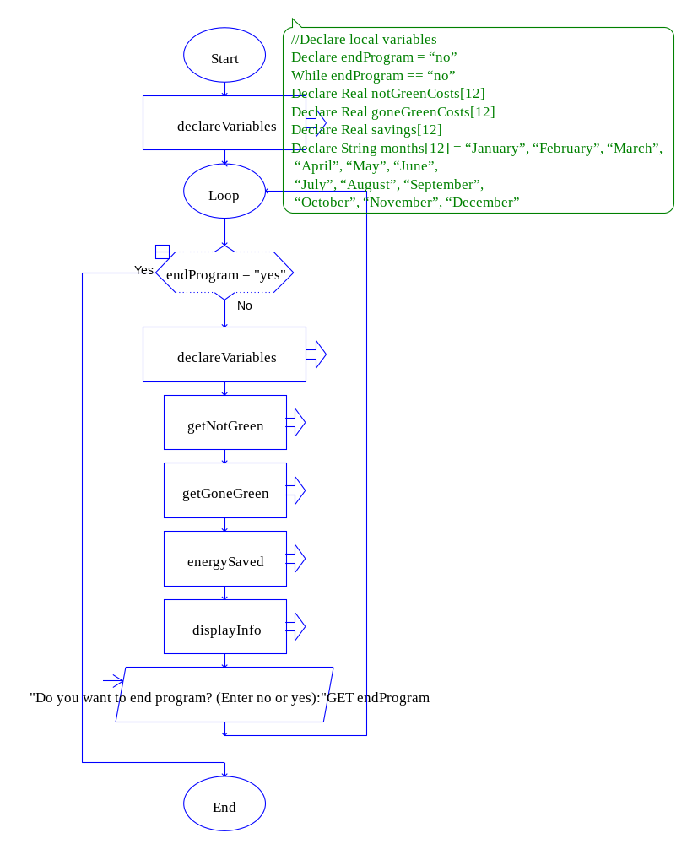

#DECLAREVARIABLES

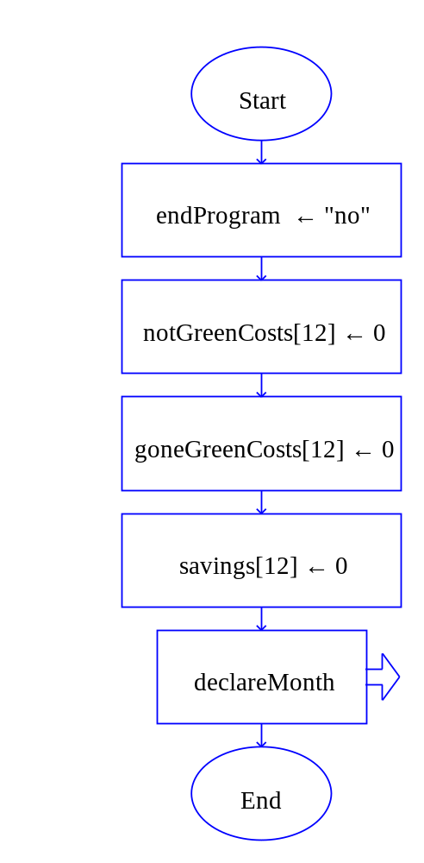

#GETNOTGREEN
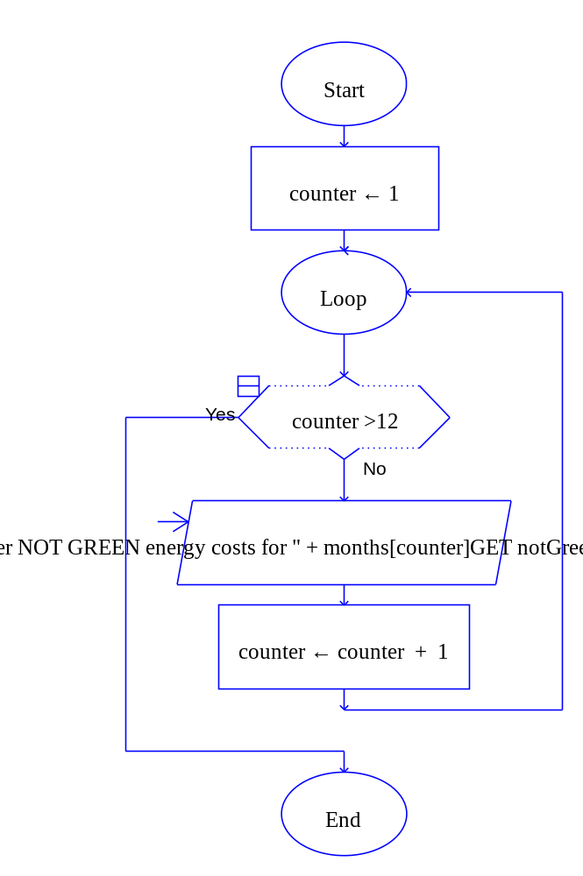

#GETGONEGREEN

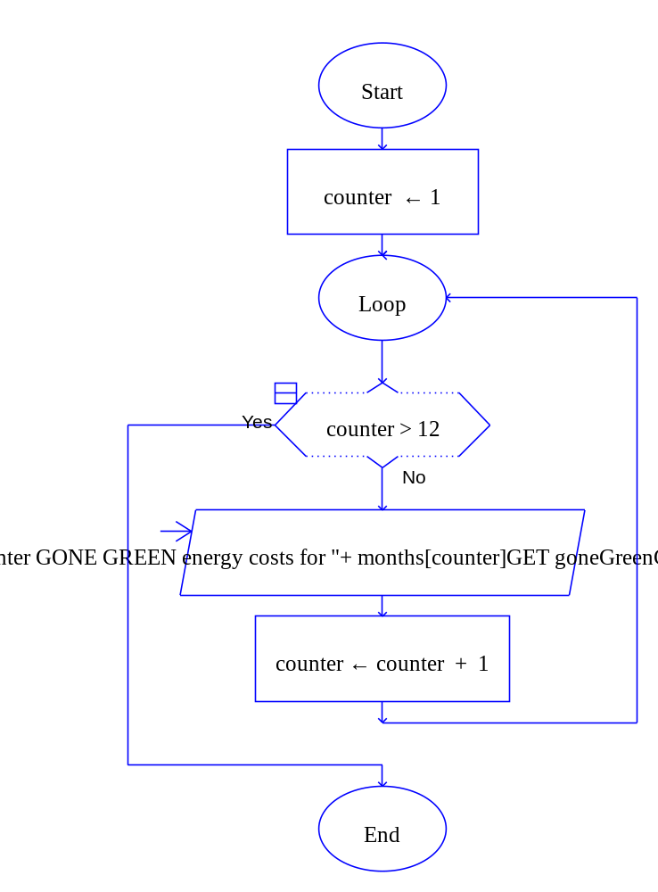

#ENERGYSAVED

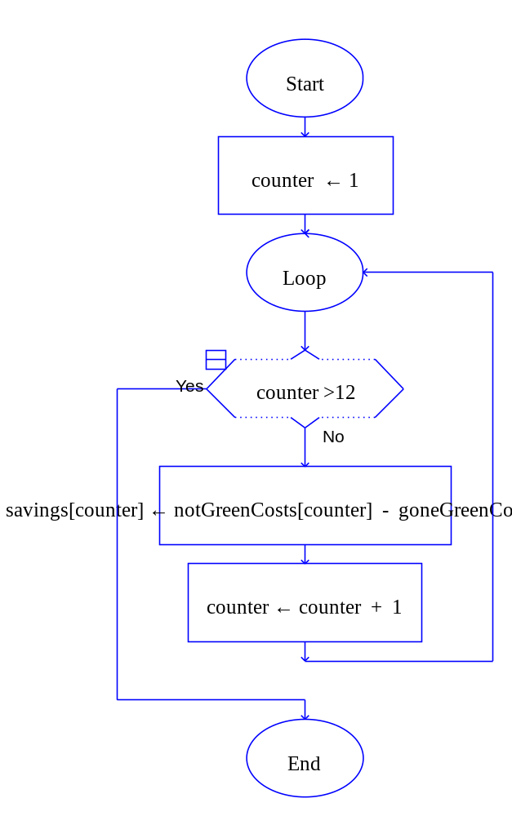

#DISPLAYINFO

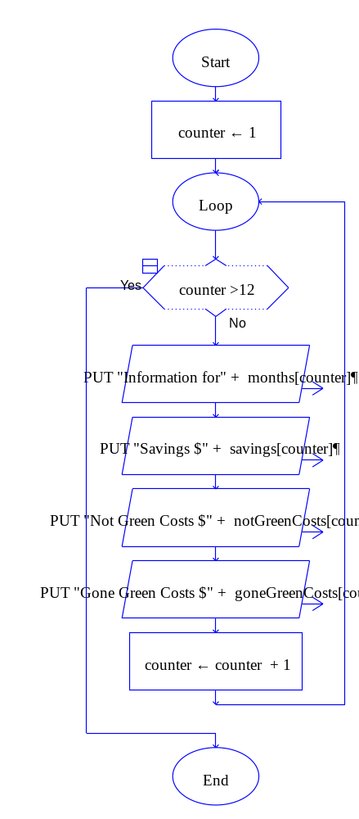
#DECLAREMONTH

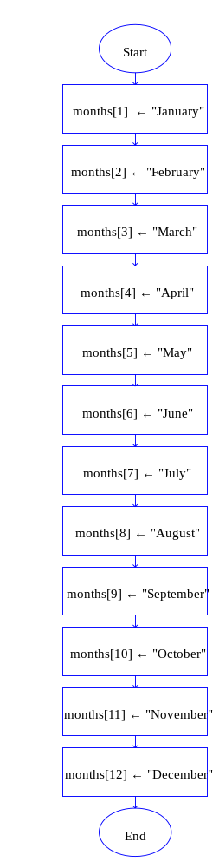

The Python Code

## Johnny Aracena
## 09-12-2020
## Energy Efficiency calculator

##Module main()
## //Declare local variables
## Declare endProgram = "no"
## While endProgram == "no"
## Declare Real notGreenCost[12]
## Declare Real goneGreenCost[12]
## Declare Real savings[12]
## Declare String months[12] = "January", "February", "March", "April", "May", "June", "July", "August", "September", "October", "November", "December"
##
## //function calls
## getNotGreen(notGreenCost, months)
## getGoneGreen(goneGreenCost, months)
## energySaved(notGreenCost, goneGreenCosts, savings)
## displayInfo(notGreenCost, goneGreenCosts, savings, months)
##
## Display "Do you want to end the program? Yes or no"
## Input endProgram
## End While
##End Module
def main():
endProgram = "no"
notGreenCosts = [0] * 12
goneGreenCosts = [0] * 12
savings = [0] * 12
months = ["January", "February", "March", "April", "May", "June", "July", "August", "September", "October", "November", "December"]
while endProgram == "no":
notGreenCosts = getNotGreen(notGreenCosts, months)
goneGreenCosts = getGoneGreen(goneGreenCosts, months)
savings = energySaved(notGreenCosts, goneGreenCosts, savings)
displayInfo(notGreenCosts, goneGreenCosts, savings, months)

endProgram = input("Do you want to end the program? Yes or no: ")

##Module getNotGreen(Real notGreenCost[], String months[])
## Set counter = 0
## While counter < 12
## Display "Enter NOT GREEN energy costs for", months[counter]
## Input notGreenCosts[counter]
## Set counter = counter + 1
## End While
##End Module
def getNotGreen(notGreenCosts, months):
counter = 0
while counter < 12:
notGreenCosts[counter]= int(input("Enter NOT GREEN energy costs for: " + months[counter]+ ": " ))
counter= counter +1
return notGreenCosts
##Module getGoneGreen(Real goneGreenCost[], String months[])
## Set counter = 0
## While counter < 12
## Display "Enter GONE GREEN energy costs for", months[counter]
## Input goneGreenCosts[counter]
## Set counter = counter + 1
## End While
##End Module
def getGoneGreen(goneGreenCosts, months):
counter = 0
while counter < 12:
goneGreenCosts[counter]= int(input("Enter GONE GREEN energy costs for: " + months[counter]+ ": " ))
counter= counter +1
return goneGreenCosts
##Module energySaved(Real notGreenCost[], Real goneGreenCost[], Real savings[])
## Set counter = 0
## While counter < 12
## Set savings[counter] = notGreenCost[counter] – goneGreenCost[counter]
## Set counter = counter + 1
## End While
##End Module
def energySaved(notGreenCosts, goneGreenCosts, savings):
counter = 0
while counter < 12:
savings[counter] = notGreenCosts[counter] - goneGreenCosts[counter]
counter= counter +1
return savings

##Module displayInfo(Real notGreenCost[], Real goneGreenCost[], Real savings[], String months[])
## Set counter = 0
## While counter < 12
## Display "Information for", months[counter]
## Display "Savings $", savings[counter]
## Display "Not Green Costs $", notGreenCost[counter]
## Display "Gone Green Costs $", goneGreenCost[counter]
## End While
##End Module
def displayInfo(notGreenCosts, goneGreenCosts, savings, months):
counter = 0
while counter < 12:
print ("Information for ", months[counter])
print ("Savings $ ", savings[counter])
print ("Not Green Costs $ ", notGreenCosts[counter])
print ("Gone Green Costs $ ", goneGreenCosts[counter])
counter= counter +1

#Main
main()

