Hands-On Practice 1: Configure vertical navigation

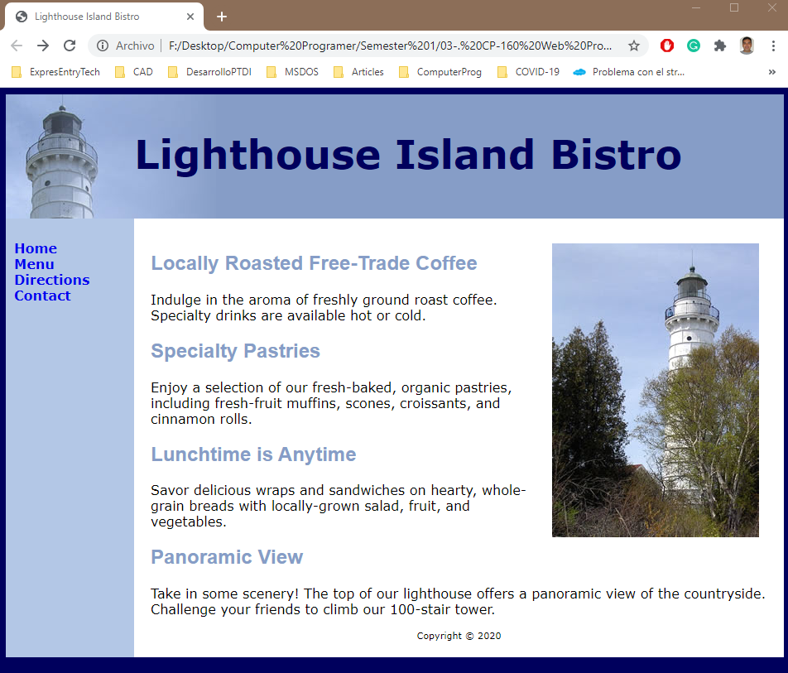

Hands-On Practice 2: Configure horizontal navigation

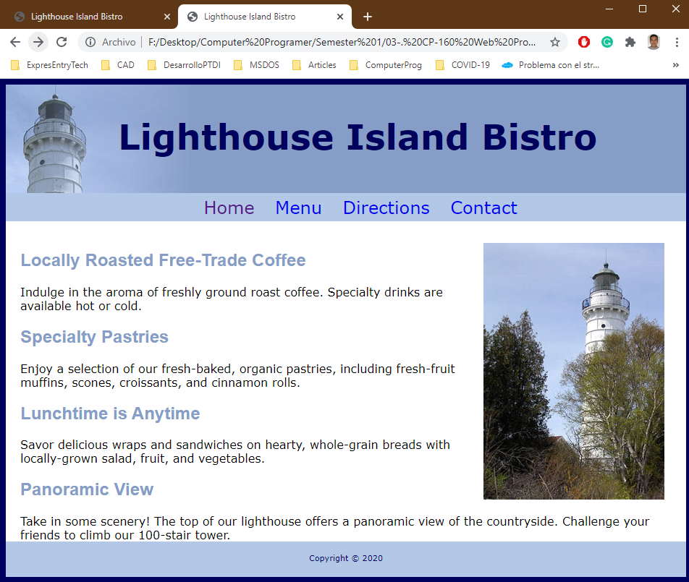

Hands-On Practice 3: Configure two columns

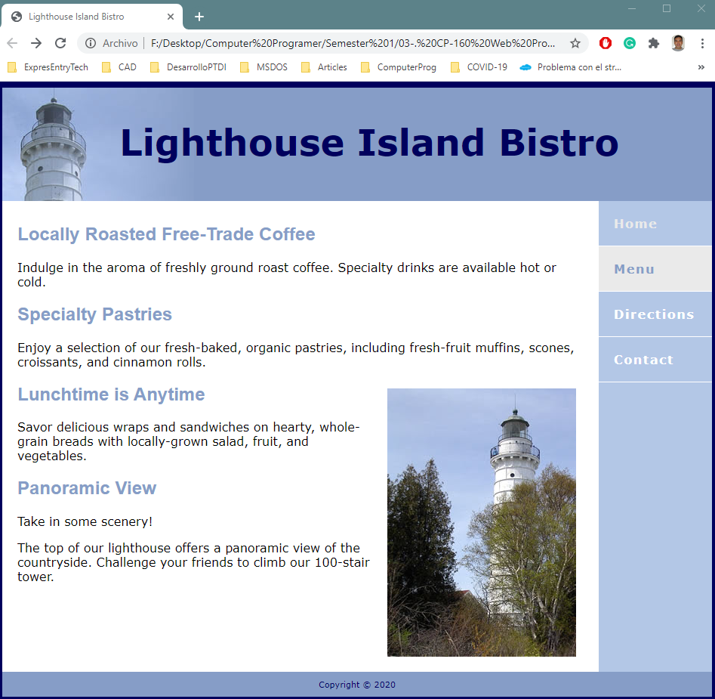

Hands-On Practice 4: Configure for optimal screen display and printing

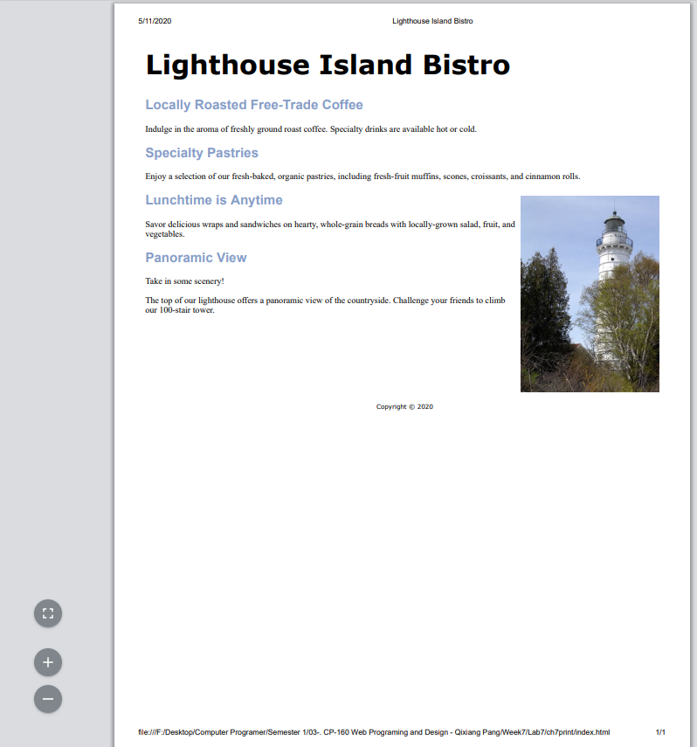

Hands-On Practice 5: Practice with positioning and create an interactive image gallery

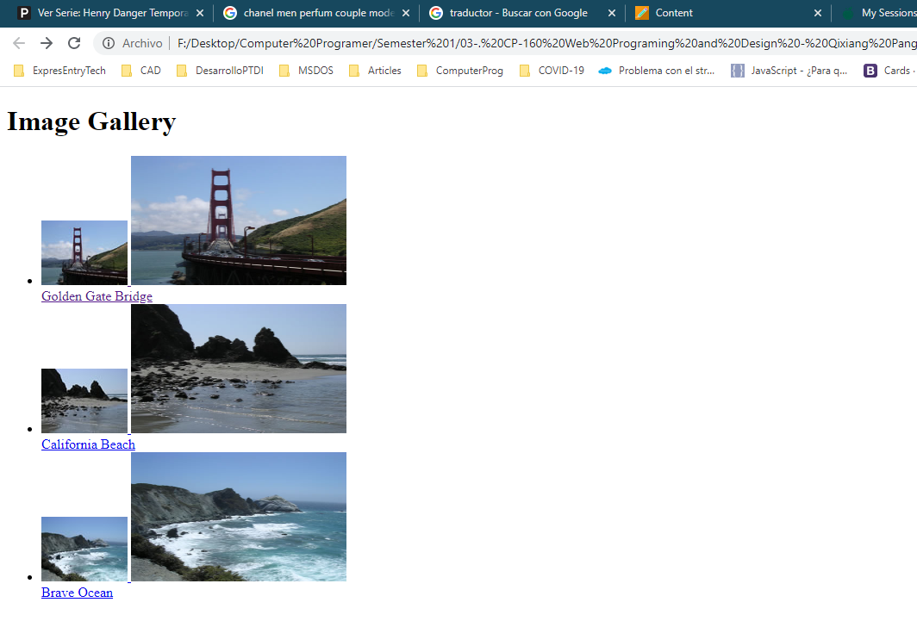

Final gallery result

