Hands-On Practice 1: Configure a table

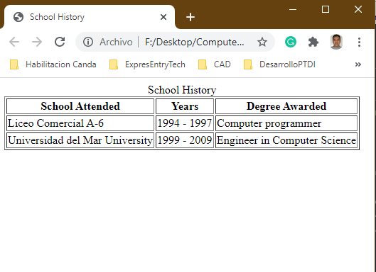

Hands-On Practice 2: Configure an informational table using CSS

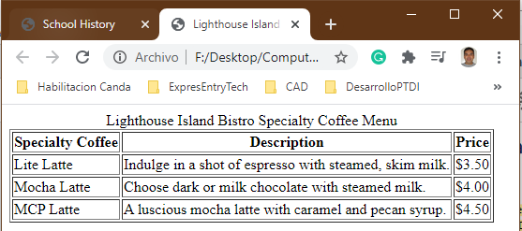

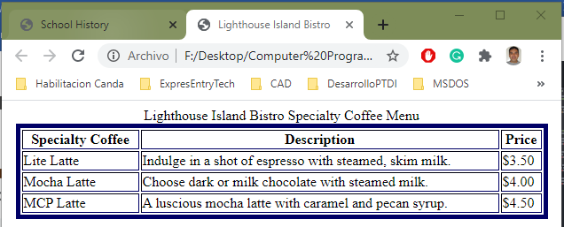

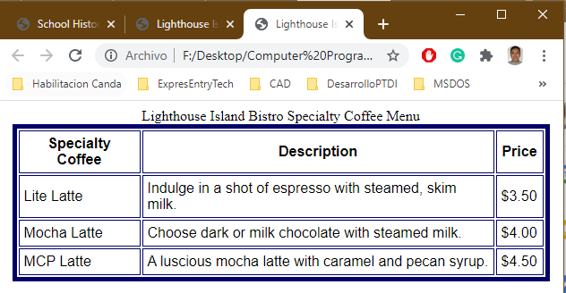

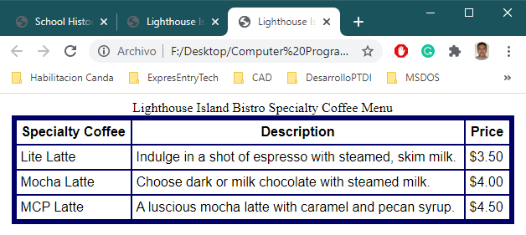

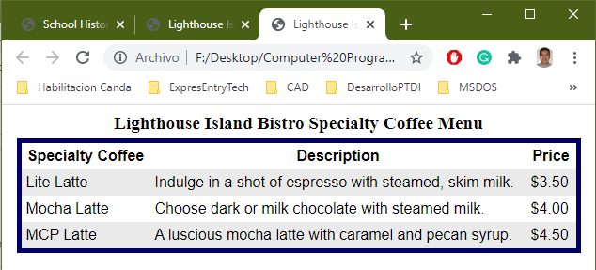

Hands-On Practice 3: Code a form

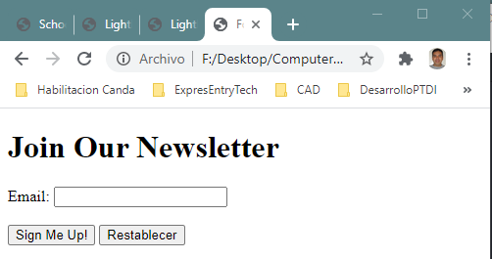

Hands-On Practice 4: Create a contact form

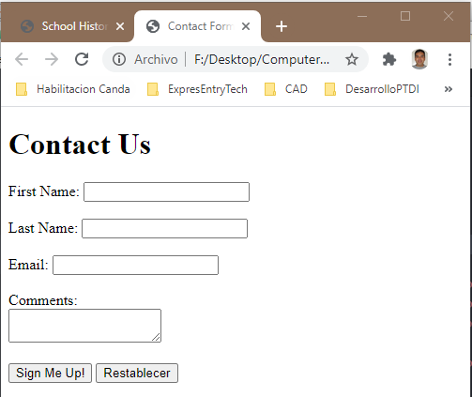

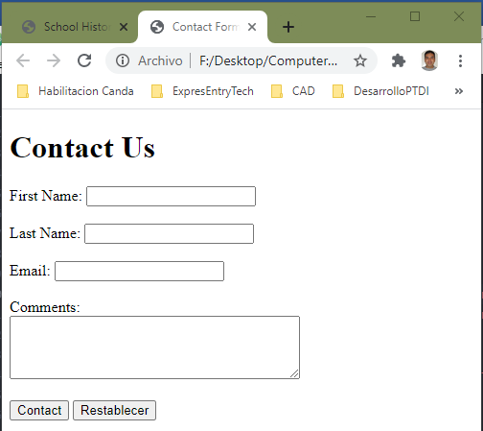

Hands-On Practice 5: Style a form with CSS

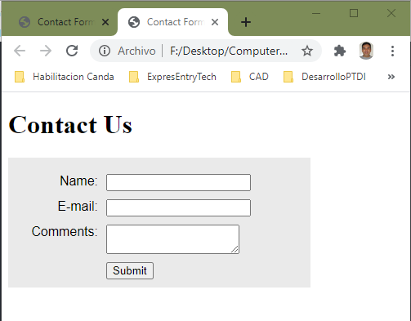

1. Create a one-paragraph conclusion of what you have learned during the lab today.

This week I learned how to create tables, and format on them using CSS. Also, I learned how to use a form for data entry and we created a contact form with html and css.

2. Write the HTML code for a three-column table to describe the courses you are taking this semester. The columns should contain the course number, course name, and instructor name. The first row of the table should use th tags and contain descriptive headings for the columns. Use the table row grouping tags <thead> and <tbody> in your table.

<!DOCTYPE html>

<html lang="en">

<head>

<meta charset="utf-8">

<title>Course List</title>

<style>

table {

margin: auto;

border: 2px solid #000000;

width: 600px;

border-spacing: 0;

}

td,th {

padding: 5px;

border: 1px solid #000000;

}

</style>

</head>

<body>

<table>

<thead>

<tr>

<th>Curse Number</th>

<th>Curse Name</th>

<th>Instructor Name</th>

</tr>

</thead>

<tbody>

<tr>

<td>CP160</td>

<td>Web Programming and Design</td>

<td>Keving Pang</td>

</tr>

<tr>

<td>CP180</td>

<td>Instroduction to Database</td>

<td>Arif Raza</td>

</tr>

<tr>

<td>CP150</td>

<td>Operating System</td>

<td>Daniel Kaukinen</td>

</tr>

</tbody>

</table>

</body>

</html>

3. Write the code to create a text box named username that will accept the user name of web page visitors. The text box should allow a maximum of 30 characters to be entered.

<!DOCTYPE html>

<html lang="en">

<head>

<meta charset="utf-8">

<title>Course List</title>

<style>

</style>

</head>

<body>

<form class="" action="index.html" method="post">

Username: <input type="text" name="userName" maxlength="30" max=30><br><br>

<input type="submit">

</form>

</body>

</html>