Assignment 5: Hierarchical Clustering

Jared Bartee

2023-11-29

# Step 1: Data Preprocessing

# Load the data

cereals_data <- read.csv("Cereals.csv")  
head(cereals_data)

## name mfr type calories protein fat sodium fiber carbo  
## 1 100%_Bran N C 70 4 1 130 10.0 5.0  
## 2 100%_Natural_Bran Q C 120 3 5 15 2.0 8.0  
## 3 All-Bran K C 70 4 1 260 9.0 7.0  
## 4 All-Bran_with_Extra_Fiber K C 50 4 0 140 14.0 8.0  
## 5 Almond_Delight R C 110 2 2 200 1.0 14.0  
## 6 Apple_Cinnamon_Cheerios G C 110 2 2 180 1.5 10.5  
## sugars potass vitamins shelf weight cups rating  
## 1 6 280 25 3 1 0.33 68.40297  
## 2 8 135 0 3 1 1.00 33.98368  
## 3 5 320 25 3 1 0.33 59.42551  
## 4 0 330 25 3 1 0.50 93.70491  
## 5 8 NA 25 3 1 0.75 34.38484  
## 6 10 70 25 1 1 0.75 29.50954

# Drop mfr & type columns

cereals_data <- cereals_data[-c(2,3)]  
cereals_data

## name calories protein fat sodium fiber  
## 1 100%_Bran 70 4 1 130 10.0  
## 2 100%_Natural_Bran 120 3 5 15 2.0  
## 3 All-Bran 70 4 1 260 9.0  
## 4 All-Bran_with_Extra_Fiber 50 4 0 140 14.0  
## 5 Almond_Delight 110 2 2 200 1.0  
## 6 Apple_Cinnamon_Cheerios 110 2 2 180 1.5  
## 7 Apple_Jacks 110 2 0 125 1.0  
## 8 Basic_4 130 3 2 210 2.0  
## 9 Bran_Chex 90 2 1 200 4.0  
## 10 Bran_Flakes 90 3 0 210 5.0  
## 11 Cap'n'Crunch 120 1 2 220 0.0  
## 12 Cheerios 110 6 2 290 2.0  
## 13 Cinnamon_Toast_Crunch 120 1 3 210 0.0  
## 14 Clusters 110 3 2 140 2.0  
## 15 Cocoa_Puffs 110 1 1 180 0.0  
## 16 Corn_Chex 110 2 0 280 0.0  
## 17 Corn_Flakes 100 2 0 290 1.0  
## 18 Corn_Pops 110 1 0 90 1.0  
## 19 Count_Chocula 110 1 1 180 0.0  
## 20 Cracklin'_Oat_Bran 110 3 3 140 4.0  
## 21 Cream_of_Wheat_(Quick) 100 3 0 80 1.0  
## 22 Crispix 110 2 0 220 1.0  
## 23 Crispy_Wheat_&_Raisins 100 2 1 140 2.0  
## 24 Double_Chex 100 2 0 190 1.0  
## 25 Froot_Loops 110 2 1 125 1.0  
## 26 Frosted_Flakes 110 1 0 200 1.0  
## 27 Frosted_Mini-Wheats 100 3 0 0 3.0  
## 28 Fruit_&_Fibre_Dates,_Walnuts,_and_Oats 120 3 2 160 5.0  
## 29 Fruitful_Bran 120 3 0 240 5.0  
## 30 Fruity_Pebbles 110 1 1 135 0.0  
## 31 Golden_Crisp 100 2 0 45 0.0  
## 32 Golden_Grahams 110 1 1 280 0.0  
## 33 Grape_Nuts_Flakes 100 3 1 140 3.0  
## 34 Grape-Nuts 110 3 0 170 3.0  
## 35 Great_Grains_Pecan 120 3 3 75 3.0  
## 36 Honey_Graham_Ohs 120 1 2 220 1.0  
## 37 Honey_Nut_Cheerios 110 3 1 250 1.5  
## 38 Honey-comb 110 1 0 180 0.0  
## 39 Just_Right_Crunchy__Nuggets 110 2 1 170 1.0  
## 40 Just_Right_Fruit_&_Nut 140 3 1 170 2.0  
## 41 Kix 110 2 1 260 0.0  
## 42 Life 100 4 2 150 2.0  
## 43 Lucky_Charms 110 2 1 180 0.0  
## 44 Maypo 100 4 1 0 0.0  
## 45 Muesli_Raisins,_Dates,_&_Almonds 150 4 3 95 3.0  
## 46 Muesli_Raisins,_Peaches,_&_Pecans 150 4 3 150 3.0  
## 47 Mueslix_Crispy_Blend 160 3 2 150 3.0  
## 48 Multi-Grain_Cheerios 100 2 1 220 2.0  
## 49 Nut&Honey_Crunch 120 2 1 190 0.0  
## 50 Nutri-Grain_Almond-Raisin 140 3 2 220 3.0  
## 51 Nutri-grain_Wheat 90 3 0 170 3.0  
## 52 Oatmeal_Raisin_Crisp 130 3 2 170 1.5  
## 53 Post_Nat._Raisin_Bran 120 3 1 200 6.0  
## 54 Product_19 100 3 0 320 1.0  
## 55 Puffed_Rice 50 1 0 0 0.0  
## 56 Puffed_Wheat 50 2 0 0 1.0  
## 57 Quaker_Oat_Squares 100 4 1 135 2.0  
## 58 Quaker_Oatmeal 100 5 2 0 2.7  
## 59 Raisin_Bran 120 3 1 210 5.0  
## 60 Raisin_Nut_Bran 100 3 2 140 2.5  
## 61 Raisin_Squares 90 2 0 0 2.0  
## 62 Rice_Chex 110 1 0 240 0.0  
## 63 Rice_Krispies 110 2 0 290 0.0  
## 64 Shredded_Wheat 80 2 0 0 3.0  
## 65 Shredded_Wheat_'n'Bran 90 3 0 0 4.0  
## 66 Shredded_Wheat_spoon_size 90 3 0 0 3.0  
## 67 Smacks 110 2 1 70 1.0  
## 68 Special_K 110 6 0 230 1.0  
## 69 Strawberry_Fruit_Wheats 90 2 0 15 3.0  
## 70 Total_Corn_Flakes 110 2 1 200 0.0  
## 71 Total_Raisin_Bran 140 3 1 190 4.0  
## 72 Total_Whole_Grain 100 3 1 200 3.0  
## 73 Triples 110 2 1 250 0.0  
## 74 Trix 110 1 1 140 0.0  
## 75 Wheat_Chex 100 3 1 230 3.0  
## 76 Wheaties 100 3 1 200 3.0  
## 77 Wheaties_Honey_Gold 110 2 1 200 1.0  
## carbo sugars potass vitamins shelf weight cups rating  
## 1 5.0 6 280 25 3 1.00 0.33 68.40297  
## 2 8.0 8 135 0 3 1.00 1.00 33.98368  
## 3 7.0 5 320 25 3 1.00 0.33 59.42551  
## 4 8.0 0 330 25 3 1.00 0.50 93.70491  
## 5 14.0 8 NA 25 3 1.00 0.75 34.38484  
## 6 10.5 10 70 25 1 1.00 0.75 29.50954  
## 7 11.0 14 30 25 2 1.00 1.00 33.17409  
## 8 18.0 8 100 25 3 1.33 0.75 37.03856  
## 9 15.0 6 125 25 1 1.00 0.67 49.12025  
## 10 13.0 5 190 25 3 1.00 0.67 53.31381  
## 11 12.0 12 35 25 2 1.00 0.75 18.04285  
## 12 17.0 1 105 25 1 1.00 1.25 50.76500  
## 13 13.0 9 45 25 2 1.00 0.75 19.82357  
## 14 13.0 7 105 25 3 1.00 0.50 40.40021  
## 15 12.0 13 55 25 2 1.00 1.00 22.73645  
## 16 22.0 3 25 25 1 1.00 1.00 41.44502  
## 17 21.0 2 35 25 1 1.00 1.00 45.86332  
## 18 13.0 12 20 25 2 1.00 1.00 35.78279  
## 19 12.0 13 65 25 2 1.00 1.00 22.39651  
## 20 10.0 7 160 25 3 1.00 0.50 40.44877  
## 21 21.0 0 NA 0 2 1.00 1.00 64.53382  
## 22 21.0 3 30 25 3 1.00 1.00 46.89564  
## 23 11.0 10 120 25 3 1.00 0.75 36.17620  
## 24 18.0 5 80 25 3 1.00 0.75 44.33086  
## 25 11.0 13 30 25 2 1.00 1.00 32.20758  
## 26 14.0 11 25 25 1 1.00 0.75 31.43597  
## 27 14.0 7 100 25 2 1.00 0.80 58.34514  
## 28 12.0 10 200 25 3 1.25 0.67 40.91705  
## 29 14.0 12 190 25 3 1.33 0.67 41.01549  
## 30 13.0 12 25 25 2 1.00 0.75 28.02576  
## 31 11.0 15 40 25 1 1.00 0.88 35.25244  
## 32 15.0 9 45 25 2 1.00 0.75 23.80404  
## 33 15.0 5 85 25 3 1.00 0.88 52.07690  
## 34 17.0 3 90 25 3 1.00 0.25 53.37101  
## 35 13.0 4 100 25 3 1.00 0.33 45.81172  
## 36 12.0 11 45 25 2 1.00 1.00 21.87129  
## 37 11.5 10 90 25 1 1.00 0.75 31.07222  
## 38 14.0 11 35 25 1 1.00 1.33 28.74241  
## 39 17.0 6 60 100 3 1.00 1.00 36.52368  
## 40 20.0 9 95 100 3 1.30 0.75 36.47151  
## 41 21.0 3 40 25 2 1.00 1.50 39.24111  
## 42 12.0 6 95 25 2 1.00 0.67 45.32807  
## 43 12.0 12 55 25 2 1.00 1.00 26.73451  
## 44 16.0 3 95 25 2 1.00 1.00 54.85092  
## 45 16.0 11 170 25 3 1.00 1.00 37.13686  
## 46 16.0 11 170 25 3 1.00 1.00 34.13976  
## 47 17.0 13 160 25 3 1.50 0.67 30.31335  
## 48 15.0 6 90 25 1 1.00 1.00 40.10596  
## 49 15.0 9 40 25 2 1.00 0.67 29.92429  
## 50 21.0 7 130 25 3 1.33 0.67 40.69232  
## 51 18.0 2 90 25 3 1.00 1.00 59.64284  
## 52 13.5 10 120 25 3 1.25 0.50 30.45084  
## 53 11.0 14 260 25 3 1.33 0.67 37.84059  
## 54 20.0 3 45 100 3 1.00 1.00 41.50354  
## 55 13.0 0 15 0 3 0.50 1.00 60.75611  
## 56 10.0 0 50 0 3 0.50 1.00 63.00565  
## 57 14.0 6 110 25 3 1.00 0.50 49.51187  
## 58 NA NA 110 0 1 1.00 0.67 50.82839  
## 59 14.0 12 240 25 2 1.33 0.75 39.25920  
## 60 10.5 8 140 25 3 1.00 0.50 39.70340  
## 61 15.0 6 110 25 3 1.00 0.50 55.33314  
## 62 23.0 2 30 25 1 1.00 1.13 41.99893  
## 63 22.0 3 35 25 1 1.00 1.00 40.56016  
## 64 16.0 0 95 0 1 0.83 1.00 68.23588  
## 65 19.0 0 140 0 1 1.00 0.67 74.47295  
## 66 20.0 0 120 0 1 1.00 0.67 72.80179  
## 67 9.0 15 40 25 2 1.00 0.75 31.23005  
## 68 16.0 3 55 25 1 1.00 1.00 53.13132  
## 69 15.0 5 90 25 2 1.00 1.00 59.36399  
## 70 21.0 3 35 100 3 1.00 1.00 38.83975  
## 71 15.0 14 230 100 3 1.50 1.00 28.59278  
## 72 16.0 3 110 100 3 1.00 1.00 46.65884  
## 73 21.0 3 60 25 3 1.00 0.75 39.10617  
## 74 13.0 12 25 25 2 1.00 1.00 27.75330  
## 75 17.0 3 115 25 1 1.00 0.67 49.78744  
## 76 17.0 3 110 25 1 1.00 1.00 51.59219  
## 77 16.0 8 60 25 1 1.00 0.75 36.18756

# Convert the names of breakfast cereals to row names

rownames(cereals_data) <- cereals_data$name

#Drop the name column

cereals_data <- cereals_data[-c(1)]  
cereals_data

## calories protein fat sodium fiber carbo  
## 100%_Bran 70 4 1 130 10.0 5.0  
## 100%_Natural_Bran 120 3 5 15 2.0 8.0  
## All-Bran 70 4 1 260 9.0 7.0  
## All-Bran_with_Extra_Fiber 50 4 0 140 14.0 8.0  
## Almond_Delight 110 2 2 200 1.0 14.0  
## Apple_Cinnamon_Cheerios 110 2 2 180 1.5 10.5  
## Apple_Jacks 110 2 0 125 1.0 11.0  
## Basic_4 130 3 2 210 2.0 18.0  
## Bran_Chex 90 2 1 200 4.0 15.0  
## Bran_Flakes 90 3 0 210 5.0 13.0  
## Cap'n'Crunch 120 1 2 220 0.0 12.0  
## Cheerios 110 6 2 290 2.0 17.0  
## Cinnamon_Toast_Crunch 120 1 3 210 0.0 13.0  
## Clusters 110 3 2 140 2.0 13.0  
## Cocoa_Puffs 110 1 1 180 0.0 12.0  
## Corn_Chex 110 2 0 280 0.0 22.0  
## Corn_Flakes 100 2 0 290 1.0 21.0  
## Corn_Pops 110 1 0 90 1.0 13.0  
## Count_Chocula 110 1 1 180 0.0 12.0  
## Cracklin'_Oat_Bran 110 3 3 140 4.0 10.0  
## Cream_of_Wheat_(Quick) 100 3 0 80 1.0 21.0  
## Crispix 110 2 0 220 1.0 21.0  
## Crispy_Wheat_&_Raisins 100 2 1 140 2.0 11.0  
## Double_Chex 100 2 0 190 1.0 18.0  
## Froot_Loops 110 2 1 125 1.0 11.0  
## Frosted_Flakes 110 1 0 200 1.0 14.0  
## Frosted_Mini-Wheats 100 3 0 0 3.0 14.0  
## Fruit_&_Fibre_Dates,_Walnuts,_and_Oats 120 3 2 160 5.0 12.0  
## Fruitful_Bran 120 3 0 240 5.0 14.0  
## Fruity_Pebbles 110 1 1 135 0.0 13.0  
## Golden_Crisp 100 2 0 45 0.0 11.0  
## Golden_Grahams 110 1 1 280 0.0 15.0  
## Grape_Nuts_Flakes 100 3 1 140 3.0 15.0  
## Grape-Nuts 110 3 0 170 3.0 17.0  
## Great_Grains_Pecan 120 3 3 75 3.0 13.0  
## Honey_Graham_Ohs 120 1 2 220 1.0 12.0  
## Honey_Nut_Cheerios 110 3 1 250 1.5 11.5  
## Honey-comb 110 1 0 180 0.0 14.0  
## Just_Right_Crunchy__Nuggets 110 2 1 170 1.0 17.0  
## Just_Right_Fruit_&_Nut 140 3 1 170 2.0 20.0  
## Kix 110 2 1 260 0.0 21.0  
## Life 100 4 2 150 2.0 12.0  
## Lucky_Charms 110 2 1 180 0.0 12.0  
## Maypo 100 4 1 0 0.0 16.0  
## Muesli_Raisins,_Dates,_&_Almonds 150 4 3 95 3.0 16.0  
## Muesli_Raisins,_Peaches,_&_Pecans 150 4 3 150 3.0 16.0  
## Mueslix_Crispy_Blend 160 3 2 150 3.0 17.0  
## Multi-Grain_Cheerios 100 2 1 220 2.0 15.0  
## Nut&Honey_Crunch 120 2 1 190 0.0 15.0  
## Nutri-Grain_Almond-Raisin 140 3 2 220 3.0 21.0  
## Nutri-grain_Wheat 90 3 0 170 3.0 18.0  
## Oatmeal_Raisin_Crisp 130 3 2 170 1.5 13.5  
## Post_Nat._Raisin_Bran 120 3 1 200 6.0 11.0  
## Product_19 100 3 0 320 1.0 20.0  
## Puffed_Rice 50 1 0 0 0.0 13.0  
## Puffed_Wheat 50 2 0 0 1.0 10.0  
## Quaker_Oat_Squares 100 4 1 135 2.0 14.0  
## Quaker_Oatmeal 100 5 2 0 2.7 NA  
## Raisin_Bran 120 3 1 210 5.0 14.0  
## Raisin_Nut_Bran 100 3 2 140 2.5 10.5  
## Raisin_Squares 90 2 0 0 2.0 15.0  
## Rice_Chex 110 1 0 240 0.0 23.0  
## Rice_Krispies 110 2 0 290 0.0 22.0  
## Shredded_Wheat 80 2 0 0 3.0 16.0  
## Shredded_Wheat_'n'Bran 90 3 0 0 4.0 19.0  
## Shredded_Wheat_spoon_size 90 3 0 0 3.0 20.0  
## Smacks 110 2 1 70 1.0 9.0  
## Special_K 110 6 0 230 1.0 16.0  
## Strawberry_Fruit_Wheats 90 2 0 15 3.0 15.0  
## Total_Corn_Flakes 110 2 1 200 0.0 21.0  
## Total_Raisin_Bran 140 3 1 190 4.0 15.0  
## Total_Whole_Grain 100 3 1 200 3.0 16.0  
## Triples 110 2 1 250 0.0 21.0  
## Trix 110 1 1 140 0.0 13.0  
## Wheat_Chex 100 3 1 230 3.0 17.0  
## Wheaties 100 3 1 200 3.0 17.0  
## Wheaties_Honey_Gold 110 2 1 200 1.0 16.0  
## sugars potass vitamins shelf weight cups  
## 100%_Bran 6 280 25 3 1.00 0.33  
## 100%_Natural_Bran 8 135 0 3 1.00 1.00  
## All-Bran 5 320 25 3 1.00 0.33  
## All-Bran_with_Extra_Fiber 0 330 25 3 1.00 0.50  
## Almond_Delight 8 NA 25 3 1.00 0.75  
## Apple_Cinnamon_Cheerios 10 70 25 1 1.00 0.75  
## Apple_Jacks 14 30 25 2 1.00 1.00  
## Basic_4 8 100 25 3 1.33 0.75  
## Bran_Chex 6 125 25 1 1.00 0.67  
## Bran_Flakes 5 190 25 3 1.00 0.67  
## Cap'n'Crunch 12 35 25 2 1.00 0.75  
## Cheerios 1 105 25 1 1.00 1.25  
## Cinnamon_Toast_Crunch 9 45 25 2 1.00 0.75  
## Clusters 7 105 25 3 1.00 0.50  
## Cocoa_Puffs 13 55 25 2 1.00 1.00  
## Corn_Chex 3 25 25 1 1.00 1.00  
## Corn_Flakes 2 35 25 1 1.00 1.00  
## Corn_Pops 12 20 25 2 1.00 1.00  
## Count_Chocula 13 65 25 2 1.00 1.00  
## Cracklin'_Oat_Bran 7 160 25 3 1.00 0.50  
## Cream_of_Wheat_(Quick) 0 NA 0 2 1.00 1.00  
## Crispix 3 30 25 3 1.00 1.00  
## Crispy_Wheat_&_Raisins 10 120 25 3 1.00 0.75  
## Double_Chex 5 80 25 3 1.00 0.75  
## Froot_Loops 13 30 25 2 1.00 1.00  
## Frosted_Flakes 11 25 25 1 1.00 0.75  
## Frosted_Mini-Wheats 7 100 25 2 1.00 0.80  
## Fruit_&_Fibre_Dates,_Walnuts,_and_Oats 10 200 25 3 1.25 0.67  
## Fruitful_Bran 12 190 25 3 1.33 0.67  
## Fruity_Pebbles 12 25 25 2 1.00 0.75  
## Golden_Crisp 15 40 25 1 1.00 0.88  
## Golden_Grahams 9 45 25 2 1.00 0.75  
## Grape_Nuts_Flakes 5 85 25 3 1.00 0.88  
## Grape-Nuts 3 90 25 3 1.00 0.25  
## Great_Grains_Pecan 4 100 25 3 1.00 0.33  
## Honey_Graham_Ohs 11 45 25 2 1.00 1.00  
## Honey_Nut_Cheerios 10 90 25 1 1.00 0.75  
## Honey-comb 11 35 25 1 1.00 1.33  
## Just_Right_Crunchy__Nuggets 6 60 100 3 1.00 1.00  
## Just_Right_Fruit_&_Nut 9 95 100 3 1.30 0.75  
## Kix 3 40 25 2 1.00 1.50  
## Life 6 95 25 2 1.00 0.67  
## Lucky_Charms 12 55 25 2 1.00 1.00  
## Maypo 3 95 25 2 1.00 1.00  
## Muesli_Raisins,_Dates,_&_Almonds 11 170 25 3 1.00 1.00  
## Muesli_Raisins,_Peaches,_&_Pecans 11 170 25 3 1.00 1.00  
## Mueslix_Crispy_Blend 13 160 25 3 1.50 0.67  
## Multi-Grain_Cheerios 6 90 25 1 1.00 1.00  
## Nut&Honey_Crunch 9 40 25 2 1.00 0.67  
## Nutri-Grain_Almond-Raisin 7 130 25 3 1.33 0.67  
## Nutri-grain_Wheat 2 90 25 3 1.00 1.00  
## Oatmeal_Raisin_Crisp 10 120 25 3 1.25 0.50  
## Post_Nat._Raisin_Bran 14 260 25 3 1.33 0.67  
## Product_19 3 45 100 3 1.00 1.00  
## Puffed_Rice 0 15 0 3 0.50 1.00  
## Puffed_Wheat 0 50 0 3 0.50 1.00  
## Quaker_Oat_Squares 6 110 25 3 1.00 0.50  
## Quaker_Oatmeal NA 110 0 1 1.00 0.67  
## Raisin_Bran 12 240 25 2 1.33 0.75  
## Raisin_Nut_Bran 8 140 25 3 1.00 0.50  
## Raisin_Squares 6 110 25 3 1.00 0.50  
## Rice_Chex 2 30 25 1 1.00 1.13  
## Rice_Krispies 3 35 25 1 1.00 1.00  
## Shredded_Wheat 0 95 0 1 0.83 1.00  
## Shredded_Wheat_'n'Bran 0 140 0 1 1.00 0.67  
## Shredded_Wheat_spoon_size 0 120 0 1 1.00 0.67  
## Smacks 15 40 25 2 1.00 0.75  
## Special_K 3 55 25 1 1.00 1.00  
## Strawberry_Fruit_Wheats 5 90 25 2 1.00 1.00  
## Total_Corn_Flakes 3 35 100 3 1.00 1.00  
## Total_Raisin_Bran 14 230 100 3 1.50 1.00  
## Total_Whole_Grain 3 110 100 3 1.00 1.00  
## Triples 3 60 25 3 1.00 0.75  
## Trix 12 25 25 2 1.00 1.00  
## Wheat_Chex 3 115 25 1 1.00 0.67  
## Wheaties 3 110 25 1 1.00 1.00  
## Wheaties_Honey_Gold 8 60 25 1 1.00 0.75  
## rating  
## 100%_Bran 68.40297  
## 100%_Natural_Bran 33.98368  
## All-Bran 59.42551  
## All-Bran_with_Extra_Fiber 93.70491  
## Almond_Delight 34.38484  
## Apple_Cinnamon_Cheerios 29.50954  
## Apple_Jacks 33.17409  
## Basic_4 37.03856  
## Bran_Chex 49.12025  
## Bran_Flakes 53.31381  
## Cap'n'Crunch 18.04285  
## Cheerios 50.76500  
## Cinnamon_Toast_Crunch 19.82357  
## Clusters 40.40021  
## Cocoa_Puffs 22.73645  
## Corn_Chex 41.44502  
## Corn_Flakes 45.86332  
## Corn_Pops 35.78279  
## Count_Chocula 22.39651  
## Cracklin'_Oat_Bran 40.44877  
## Cream_of_Wheat_(Quick) 64.53382  
## Crispix 46.89564  
## Crispy_Wheat_&_Raisins 36.17620  
## Double_Chex 44.33086  
## Froot_Loops 32.20758  
## Frosted_Flakes 31.43597  
## Frosted_Mini-Wheats 58.34514  
## Fruit_&_Fibre_Dates,_Walnuts,_and_Oats 40.91705  
## Fruitful_Bran 41.01549  
## Fruity_Pebbles 28.02576  
## Golden_Crisp 35.25244  
## Golden_Grahams 23.80404  
## Grape_Nuts_Flakes 52.07690  
## Grape-Nuts 53.37101  
## Great_Grains_Pecan 45.81172  
## Honey_Graham_Ohs 21.87129  
## Honey_Nut_Cheerios 31.07222  
## Honey-comb 28.74241  
## Just_Right_Crunchy__Nuggets 36.52368  
## Just_Right_Fruit_&_Nut 36.47151  
## Kix 39.24111  
## Life 45.32807  
## Lucky_Charms 26.73451  
## Maypo 54.85092  
## Muesli_Raisins,_Dates,_&_Almonds 37.13686  
## Muesli_Raisins,_Peaches,_&_Pecans 34.13976  
## Mueslix_Crispy_Blend 30.31335  
## Multi-Grain_Cheerios 40.10596  
## Nut&Honey_Crunch 29.92429  
## Nutri-Grain_Almond-Raisin 40.69232  
## Nutri-grain_Wheat 59.64284  
## Oatmeal_Raisin_Crisp 30.45084  
## Post_Nat._Raisin_Bran 37.84059  
## Product_19 41.50354  
## Puffed_Rice 60.75611  
## Puffed_Wheat 63.00565  
## Quaker_Oat_Squares 49.51187  
## Quaker_Oatmeal 50.82839  
## Raisin_Bran 39.25920  
## Raisin_Nut_Bran 39.70340  
## Raisin_Squares 55.33314  
## Rice_Chex 41.99893  
## Rice_Krispies 40.56016  
## Shredded_Wheat 68.23588  
## Shredded_Wheat_'n'Bran 74.47295  
## Shredded_Wheat_spoon_size 72.80179  
## Smacks 31.23005  
## Special_K 53.13132  
## Strawberry_Fruit_Wheats 59.36399  
## Total_Corn_Flakes 38.83975  
## Total_Raisin_Bran 28.59278  
## Total_Whole_Grain 46.65884  
## Triples 39.10617  
## Trix 27.75330  
## Wheat_Chex 49.78744  
## Wheaties 51.59219  
## Wheaties_Honey_Gold 36.18756

# Find the amount of missing values and then omit them

sum(is.na(cereals_data))

## [1] 4

cereals_data <- na.omit(cereals_data)  
sum(is.na(cereals_data))

## [1] 0

# Step 2: Hierarchical Clustering

# Normalize the data

normalized_cereals <- scale(cereals_data[, -1])

# Use the Euclidean distance measure

cereals_euclidean <- dist(normalized_cereals, method = "euclidean")  
plot(cereals_euclidean)

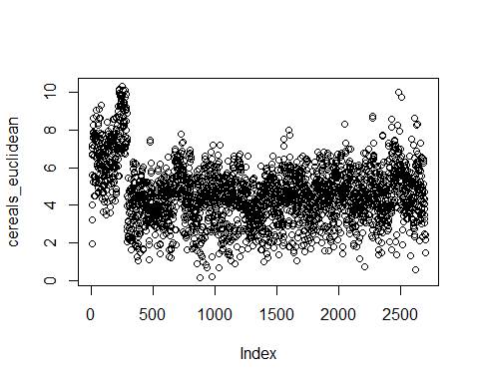

CC1 <- hclust(cereals_euclidean)  
plot(CC1, cex = 0.5, hang = -1)

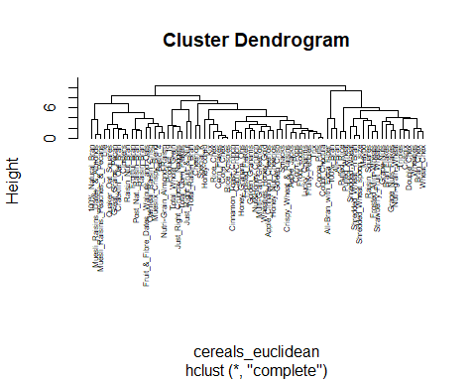 # Use Agnes

library(cluster)  
library(stats)  
Cereal_Single <- agnes(normalized_cereals, method = "single")  
Cereal_Complete <- agnes(normalized_cereals, method = "complete")  
Cereal_average <- agnes(normalized_cereals, method = "average")  
Cereal_Ward <- agnes(normalized_cereals, method = "ward")

print(Cereal_Single$ac)

## [1] 0.5892187

print(Cereal_Complete$ac)

## [1] 0.8347316

print(Cereal_average$ac)

## [1] 0.7677452

# Ward appears to be the best method

print(Cereal_Ward$ac)

## [1] 0.9021306

# Apply hierarchical clustering with Ward’s method & Visualize for Ward’s method

pltree(Cereal_Ward,main = "Dendrogram of agnes: Ward")

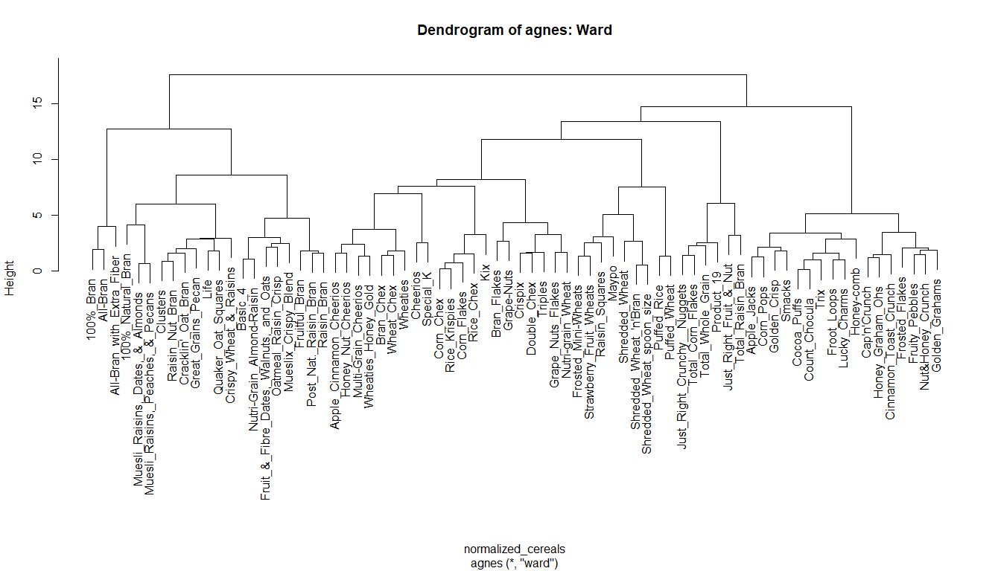

plot(Cereal_Ward)

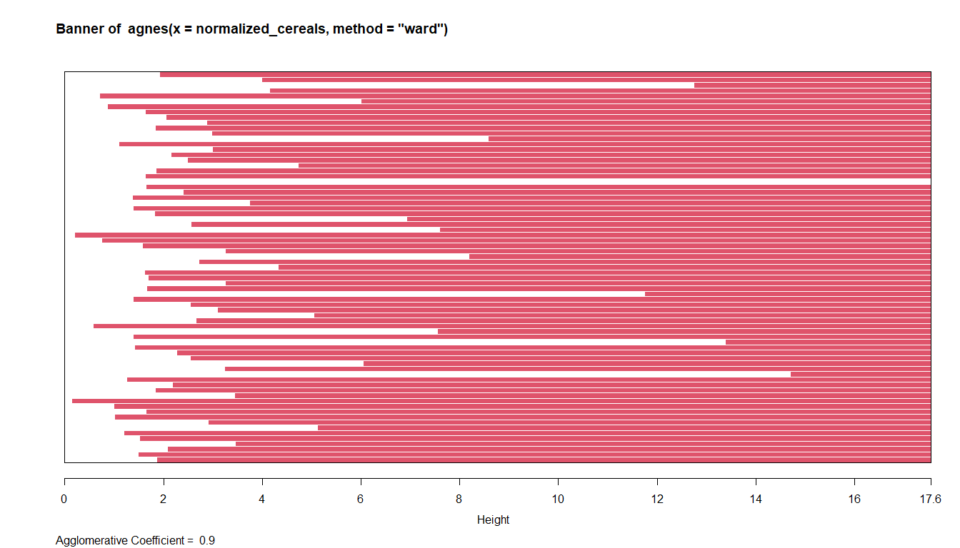

rect.hclust(Cereal_Ward, k = 5, border = 1:5) # I would choose 5 clusters.  
abline(h = 5, col = 'red')

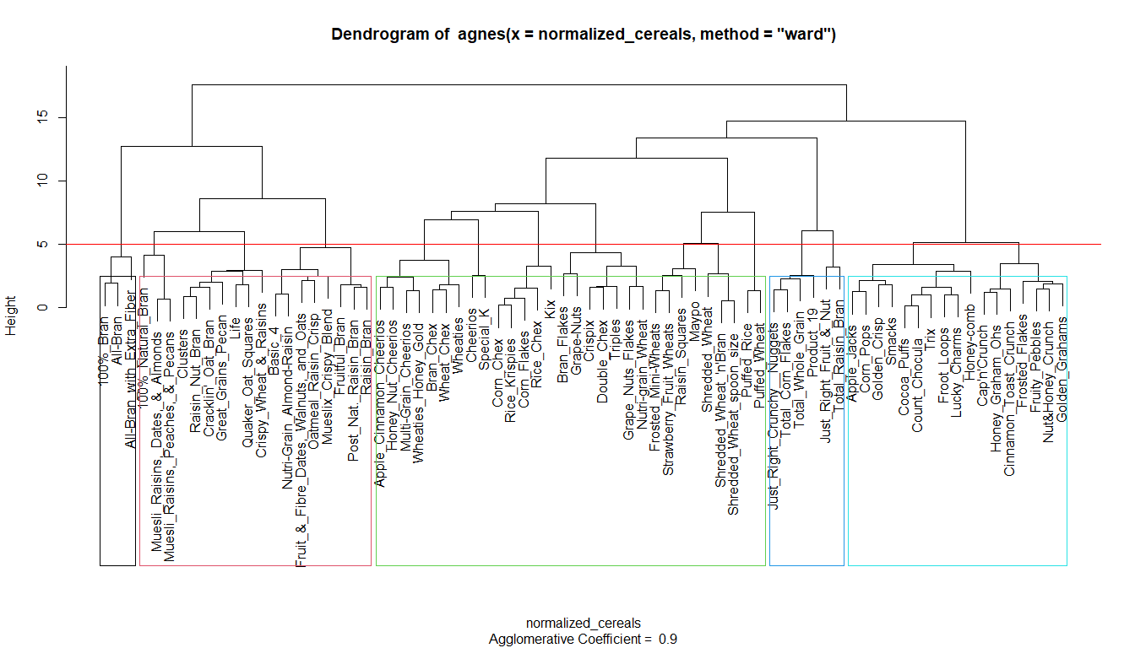

# Step 3: Cluster Stability and Healthy Cereals

# Create cluster partitions A and B

set.seed(123)  
partition_A <- sample(1:2, nrow(normalized_cereals), replace = TRUE)  
partition_B <- 3 - partition_A

# Fit cluster on partition A

cluster_A <- cutree(Cereal_Ward, k = 5) # Assuming 4 clusters, adjust as needed

# Calculate centroids of clusters in partition A

library(dplyr)

## Warning: package 'dplyr' was built under R version 4.3.2

##   
## Attaching package: 'dplyr'

## The following objects are masked from 'package:stats':  
##   
## filter, lag

## The following objects are masked from 'package:base':  
##   
## intersect, setdiff, setequal, union

# Combine partition_A, cluster_A, and normalized_cereals for easier processing

combined_data <- cbind(partition = partition_A, cluster = cluster_A)  
combined_data_df <- as.data.frame(combined_data)

# Calculate centroids of clusters in partition A

cluster_A_centroids <- combined_data_df %>%  
 group_by(cluster) %>%  
 summarise_all(mean) %>%  
 select(-partition)

# Calculate distances between partition B records and centroids from partition A

distances_to_centroids <- apply(normalized_cereals[partition_B, ], 1, function(record) {  
 apply(cluster_A_centroids, 1, function(centroid) {  
 sqrt(sum((record - centroid)^2))  
 })  
})

# Assign clusters to partition B based on minimum distances

cluster_B <- apply(distances_to_centroids, 2, which.min)

# Assess cluster consistency

consistency <- sum(cluster_A == cluster_B) / length(cluster_B)

# Identify healthy cereals cluster

# Let’s assume ‘healthy’ cereals have low sugar and high fiber

healthy_cereals_cluster <- cluster_A[which(cereals_data$sugars < 5 & cereals_data$fiber > 5)]

# Print the results

cat("Cluster Consistency:", consistency, "\n")

## Cluster Consistency: 0.04054054

cat("Healthy Cereals Cluster:", healthy_cereals_cluster, "\n")

## Healthy Cereals Cluster: 1