STA 220 — Activity 3.1: Card 1
Mercer Liberty Caucus · posted to social media, October 2026
“Every other town in New Jersey tightened its belt – not Ewing! In real dollars, Ewing’s municipal tax per resident is the same as it was in 2016 while the typical NJ town cut 9%. #Ewing #CutSpending”

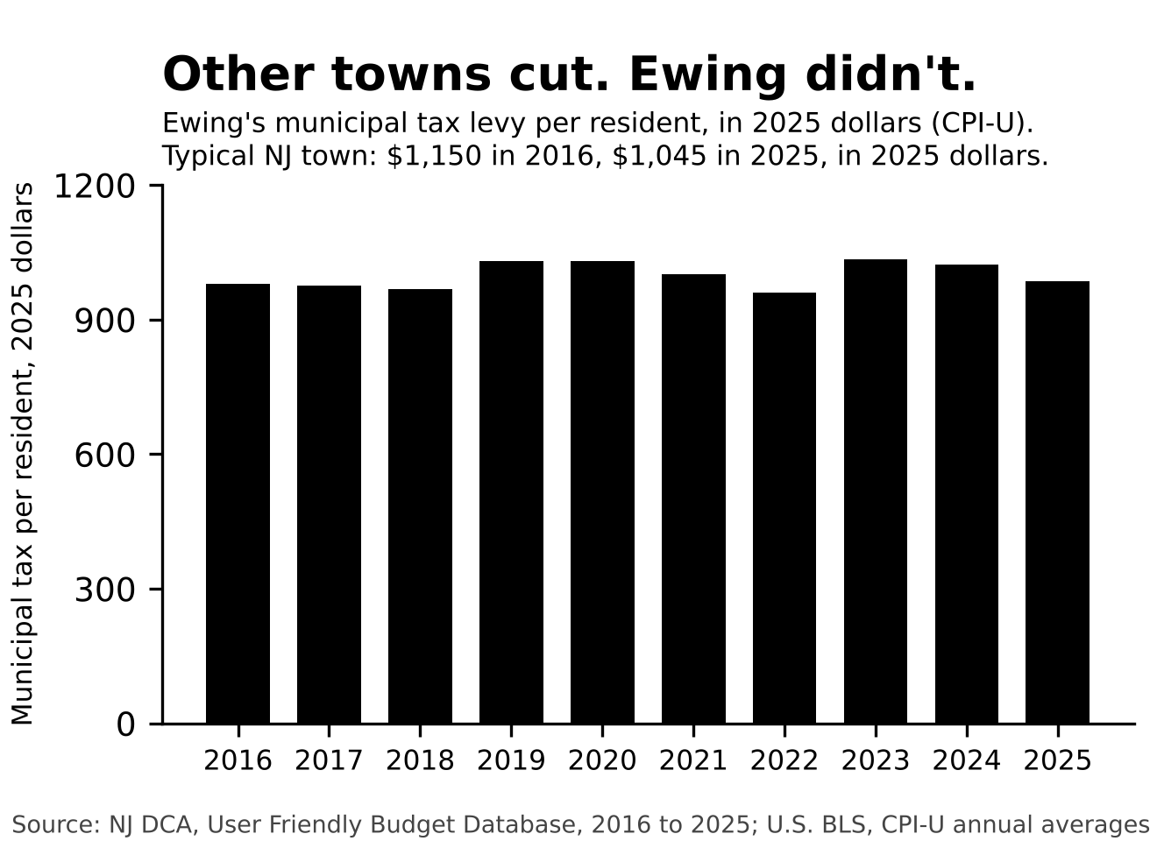
Questions
1. Show the math for how the graphic used the variables below to calculate spending per resident in 2025 dollars for 2016 and 2025. Did they properly adjust for inflation?
2. What is the real change per resident, 2016 to 2025, in percent? What is the unadjusted change per resident? Which one did the post use?
3. The typical NJ town went from $1,150 to $1,045 per resident in 2025 dollars. Compute that change in percent, and compare it to Ewing’s.
4. List what this graphic did right: the axis, the units, the years, the benchmark, the source. Is anything still missing that a voter would want before deciding Ewing “never tightened its belt”?
Numbers you need
Year | Municipal levy ($) | Residents | CPI-U
2016 | 26,018,361 | 35,652 | 240.007
2025 | 35,326,316 | 35,858 | 321.943

UFB column: Local Tax for Municipal Purposes, the municipal-purpose property tax levy. It leaves out school and county taxes.

Benchmark: the median NJ municipality’s levy per resident, in 2025 dollars, was $1,150 in 2016 and $1,045 in 2025 (n ranged from 520 to 545 towns each year).
STA 220 — Activity 3.1: Card 2
Hamilton Taxpayers First · posted to social media, October 2026
“Hamilton’s municipal taxes have nearly DOUBLED since 2016. $63 million then, $118 million now. Where did it all go?! Elect responsible people! #Hamilton #Election2026”
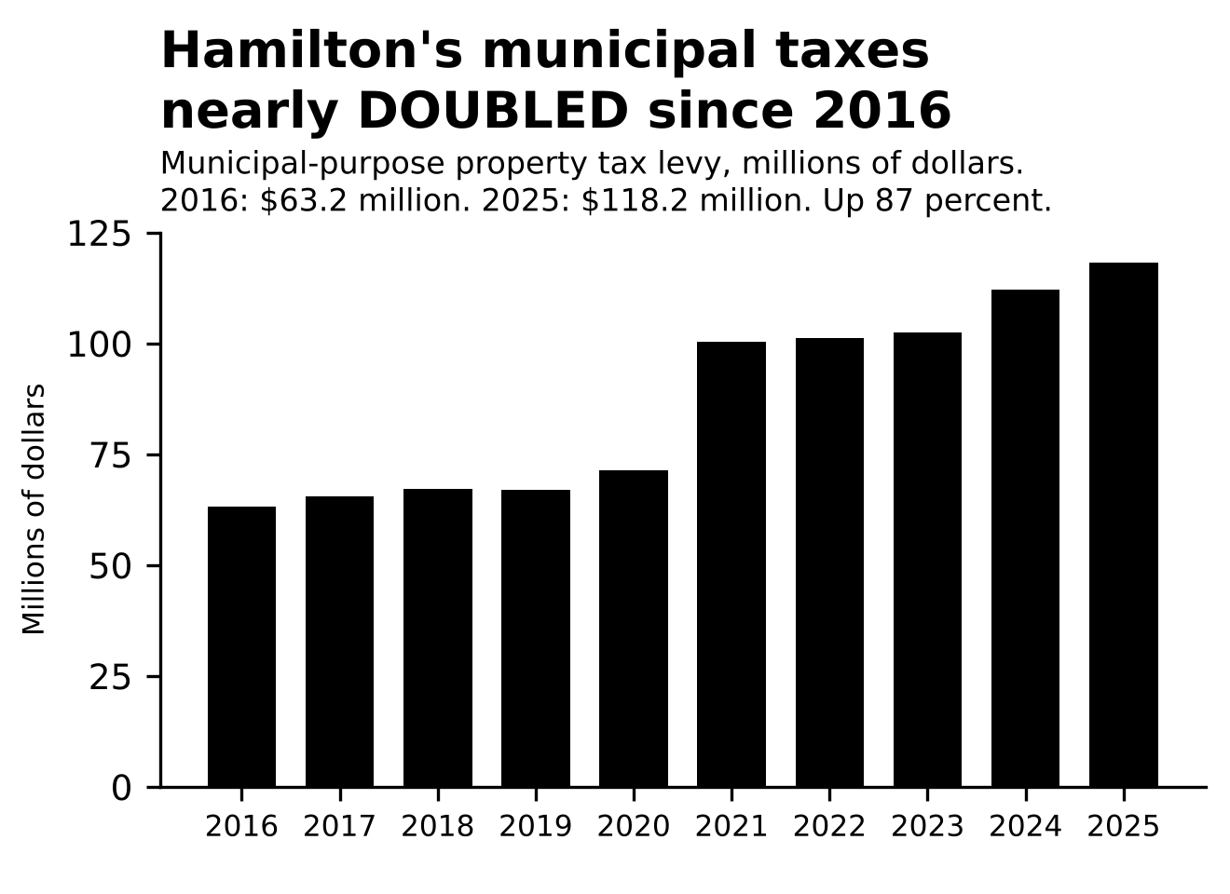
Questions
1. Compute the change in the levy from 2016 to 2025 in the dollars of each year. Show your work. Is the post’s 87% right?
2. Put the 2016 levy into 2025 dollars with the CPI table, then compute the real change. Then do it per resident. Does this change your conclusion?
3. Look at 2020 to 2021. The levy jumps from $71.4 million to $100.3 million in one year. In the same year the township’s full-time firefighters go from 0 to 136. What happened? (Hint: Identify and reference at least 1 actual news source.)
4. Imagine we started our comparison in 2021 instead. Compute the real, per-resident change from 2021 to 2025. Show all your work. What is the fair headline now?
Numbers you need
Year | Municipal levy ($) | Residents | Full-time firefighters
2016 | 63,220,951 | 87,541 | 0
2020 | 71,408,678 | 92,297 | 0
2021 | 100,289,508 | 92,297 | 136
2025 | 118,235,767 | 93,911 | 137

UFB column: Local Tax for Municipal Purposes.
Benchmark: the median NJ municipality’s levy per resident fell about 8% in real terms from 2016 to 2025 (505 towns with both years).
STA 220 — Activity 3.1: Card 3
Smaller Government Mercer · posted to social media, October 2026
“Ewing has more cops per resident than any other town in Mercer County but still more crime! We need to get rid of the Police Unions and GO PRIVATE!! #Private Law Enforcement #Ewing”
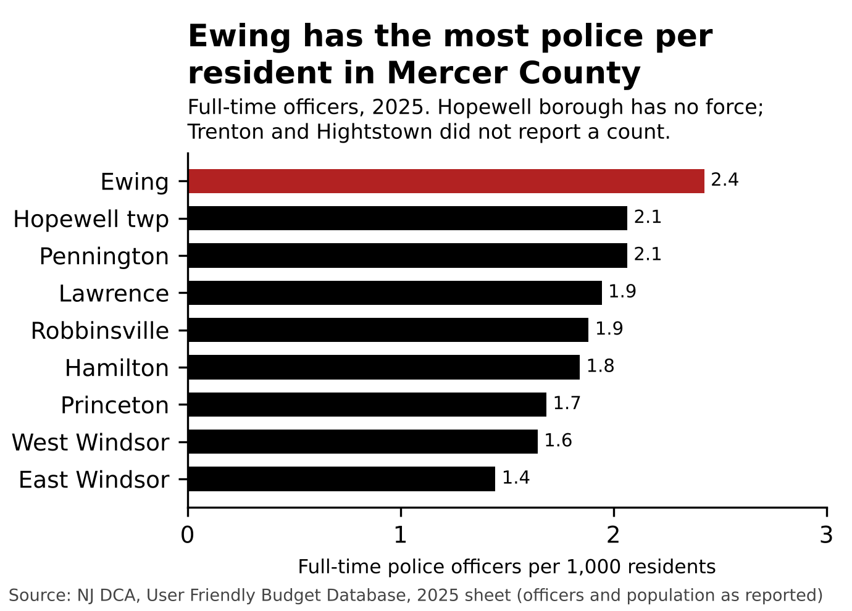
Questions
1. Compute full-time officers per 1,000 residents for Ewing, Hamilton, and East Windsor. Show your work. Do you get the chart’s 2.4, 1.8, and 1.4?
2. The median NJ municipality with its own force has 2.4 officers per 1,000 residents (413 towns). Where does Ewing fall statewide? Does the title survive that benchmark?
3. Compute the police personnel cost per officer for Ewing and for Princeton. The median NJ town spends about $190,000 per officer. Which town pays more per officer? What does this suggest about the argument to “go private”?
4. List what the graphic did right. Then say what a voter would need to know before deciding whether 2.4 is too many. What is the comparison that matters, and what does the chart not show?
Numbers you need
Town (2025) | Residents | Full-time officers | Police personnel cost ($)
Ewing | 35,858 | 87 | 13,820,258
Hamilton | 93,911 | 173 | 36,510,572
Princeton | 31,445 | 53 | 10,347,014
East Windsor | 30,436 | 44 | 7,524,857

UFB columns: Police Officer Personnel Costs, number of full-time employees and total personnel cost. Hopewell borough reports 0 officers (perhaps an accounting error, or the budget is reported somewhere else?); Trenton and Hightstown did not report.
Benchmarks: median NJ town, 2.4 officers per 1,000 residents and about $190,000 per officer.
STA 220 — Activity 3.1: Card 4
Smaller Government Mercer · posted to social media, October 2026
“Ewing’s police payroll is the fattest in the county. $13.8 MILLION! Completely dwarfs the efficient force in East Windsor! Mayor Steinmann has GOT TO GO!! #Ewing #Bloat #Corruption”
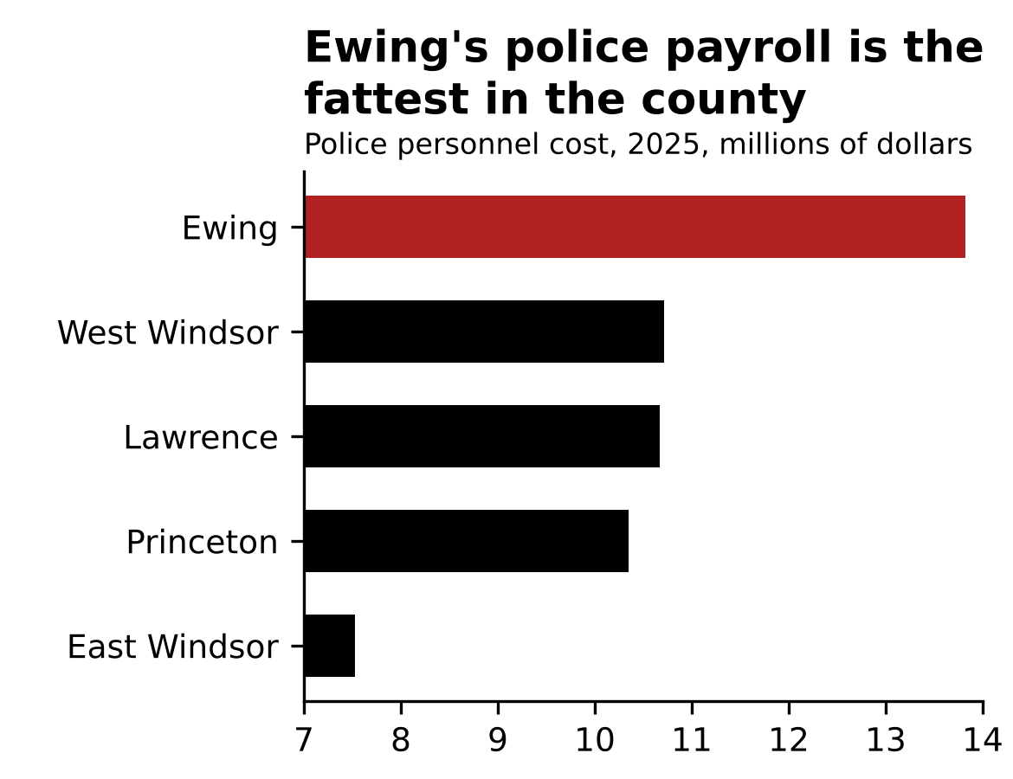
Questions
1. The axis runs from 7 to 14. By what percent is Ewing’s cost larger in the data? By what percent is its bar longer? What is the lie factor?
2. Which Mercer towns are missing from a chart titled “fattest in the county”? For example, how would adding Hamilton’s bar change the takeaway for the reader?
3. Compute cost per resident and cost per officer for Ewing and Princeton. Does this change the takeaway for the reader?
4. Per officer, where does Ewing rank among the nine Mercer towns with a force? (The nine per-officer figures, in dollars: Ewing 158,854; Pennington 163,654; Lawrence 169,360; Hopewell Twp 170,977; East Windsor 171,019; Robbinsville 186,838; Princeton 195,227; West Windsor 202,128; Hamilton 211,044.) What does the post get backwards?
Numbers you need
Town (2025) | Residents | Full-time officers | Police personnel cost ($)
Ewing | 35,858 | 87 | 13,820,258
Princeton | 31,445 | 53 | 10,347,014
East Windsor | 30,436 | 44 | 7,524,857
Hamilton (not on the chart) | 93,911 | 173 | 36,510,572
UFB columns: Police Officer Personnel Costs. “Personnel cost” is base pay plus overtime, pension, health benefits, and employment taxes. Benchmark: median NJ town, about $190,000 per officer.
STA 220 — Activity 3.1: Card 6
West Windsor Taxpayer Watch · posted to social media, October 2026
“West Windsor is sitting on a $13.4 MILLION surplus. That is a quarter of its whole revenue. Our seniors are struggling TODAY! Give it back!! #WestWindsor #LowerTaxes”

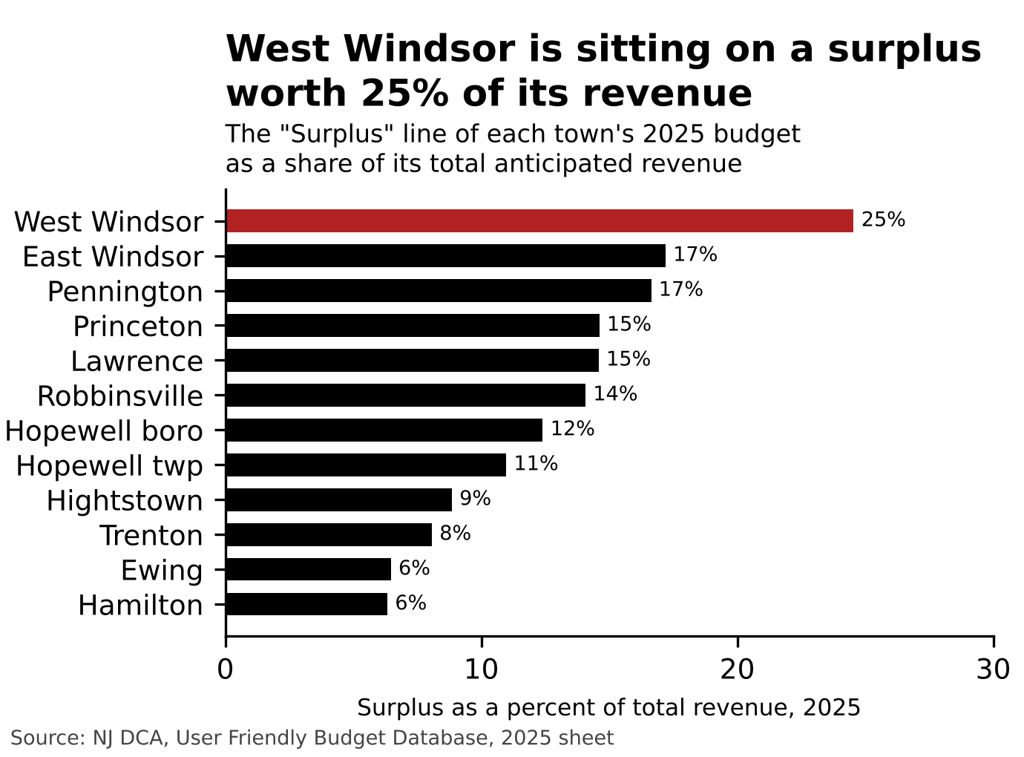
Questions
1. Compute surplus as a percent of total revenue for West Windsor, Ewing, and Princeton. The median NJ municipality is about 12%.
2. Now read the line below from the codebook. Is surplus being presented fairly in the graphic? Why or why not?
3. Should you adjust these numbers for population size? Why or why not?
4. There is a reasonable critique here. What is it and what would you need to see to make that claim honestly?
Numbers you need
Town (2025) | Surplus used as revenue ($) | Total anticipated revenue ($) | Surplus as percent
West Windsor | 13,425,000 | 54,696,589
Ewing | 4,475,000 | 69,210,637
Princeton | 12,725,000 | 87,115,751

UFB glossary, word for word: Surplus — “Surplus used as revenue in the budget.” It is the part of last year’s leftover fund balance that the town put into this year’s budget to pay for things. The money the town is actually holding is the fund balance, which is not in this table. Benchmark:
median NJ municipality, surplus about 12% of revenue (549 towns).
STA 220 — Activity 3.1: Card 7
Ewing Budget Watch · posted to social media, October 2026
“Ewing’s debt per resident has nearly TRIPLED since 2016: $593 then, $1,634 now. Who is going to pay that back? You are! #Ewing #Debt”

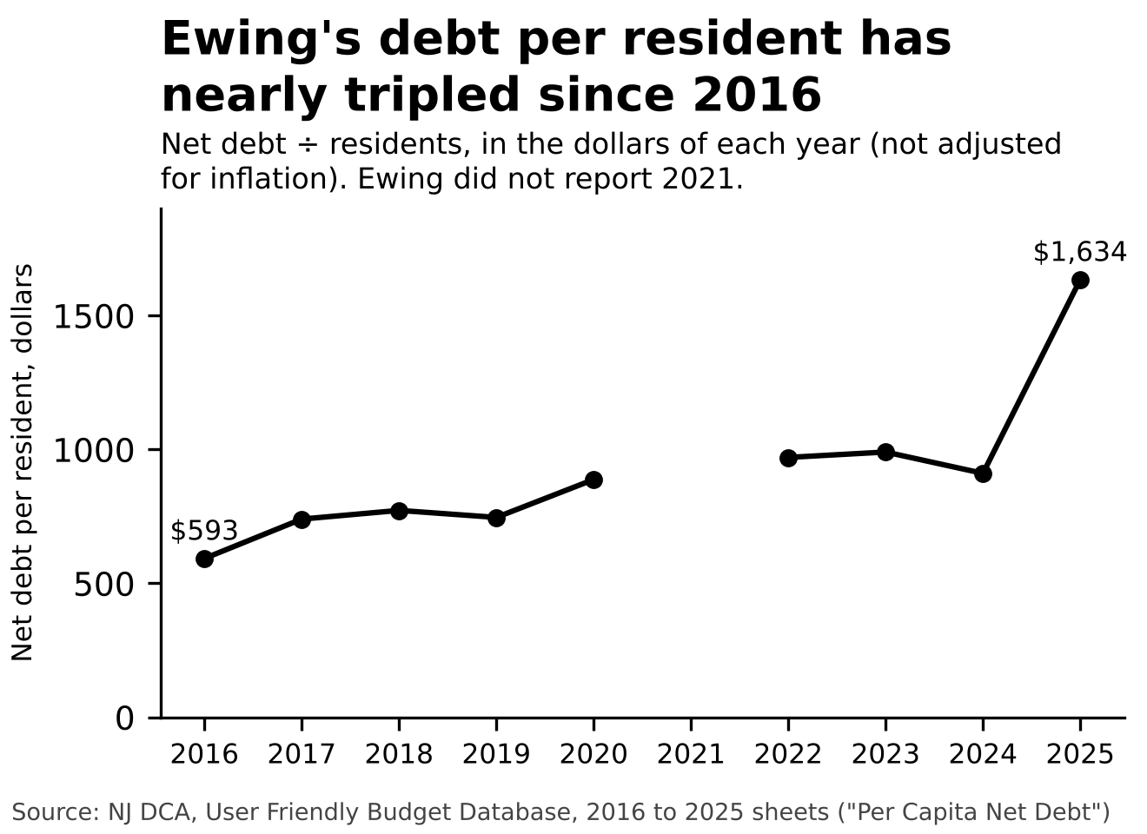
Questions
1. Compute the change from 2016 to 2025 in nominal dollars. Is “nearly tripled” correct?
2. Put the 2016 figure into 2025 dollars with the CPI table, then compute the real change. Does the claim survive inflation? (The typical NJ town’s net debt per resident fell about 10% in real terms over the same years.)
3. Most of the rise is one jump: $911 in 2024 to $1,634 in 2025. What would you ask the town about that year to better understand if the decisions made were responsible?
4. The median NJ municipality carries $1,345 of net debt per resident; Ewing’s net debt is 1.36% of its property valuation, and state law caps municipal net debt at 3.5% of valuation. Does the chart become more or less alarming with those two benchmarks?
Numbers you need
Year | Net debt per resident ($) | CPI | Real debt per resident ($)
2016 | 593 | 240.007
2024 | 911 | 313.689
2025 | 1,634 | 321.943

UFB column: Per Capita Net Debt (net debt divided by population). Ewing reported nothing for 2021. Benchmarks: median NJ municipality $1,345 per resident in 2025 (517 towns); net debt as a share of equalized valuation is capped at 3.5% by state law.
STA 220 — Activity 3.1: Card 8
Hamilton Taxpayers First · posted to social media, October 2026
“Hamilton’s council costs more than THREE TIMES what Ewing’s does. Big government starts at the top! They dare to raise taxes on us and give themselves a pay raise?! #Corruption #Hamilton”

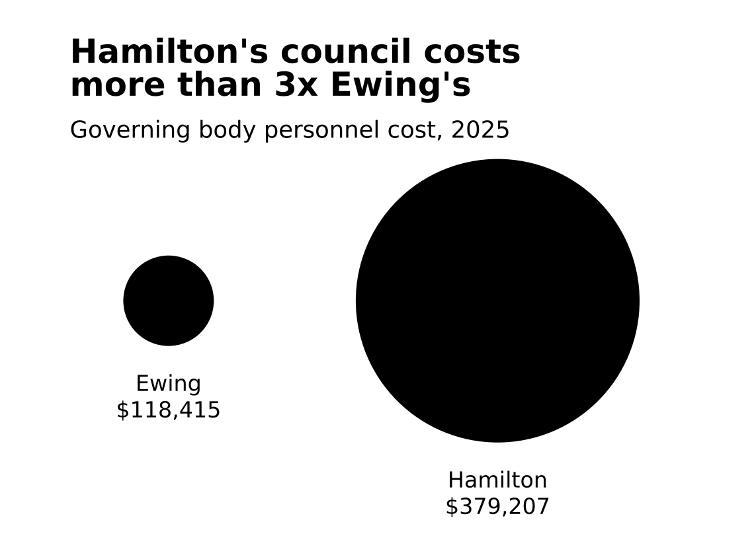
Questions
1. The designer made each circle’s width match the cost. How many times as wide is Hamilton’s circle as Ewing’s? Now calculate and compare the areas of the circle. What is the lie factor?
2. Compute governing-body cost per resident for both towns. How different are they? Does this change your takeaway?
3. Compute each as a share of the town’s general budget. About how many cents of every budget dollar is spent on the governing body? Does this change your takeaway?
4. Both towns report one full-time and five part-time members of the governing body. What else would you need to know before calling this “big government”? What would the honest graphic look like?
Numbers you need
Town (2025) | Governing body cost ($) | Residents | General budget ($)
Ewing | 118,415 | 35,858 | 58,126,366
Hamilton | 379,207 | 93,911 | 172,541,321

UFB column: Governing Body Personnel Costs, total personnel cost (pay plus benefits for the mayor and council). Both towns report 1 full-time and 5 part-time governing-body members.

