Finding drive times with Google Maps
STA 220, Activity 3.1 · Data for Everyday Life · Updated October 22, 2026
Find the drive time from TCNJ to each town’s police headquarters, then keep the towns within 20 minutes.

Before you start
You need google.com/maps and the addresses in data/police_hq_addresses.xlsx (column hq_address). Record one row per town. The first row is an example.
Town | Police HQ address | Typical low (min) | Typical high (min) | Miles | Day and time set
Lawrence township | 2211 Lawrenceville Road, Lawrenceville, NJ 08648 | 6 | 9 | 4.6 | Thu, 8:00 AM

Step 1: Find the police headquarters
Search [Town] Police Department, NJ. Copy the address (lower box).
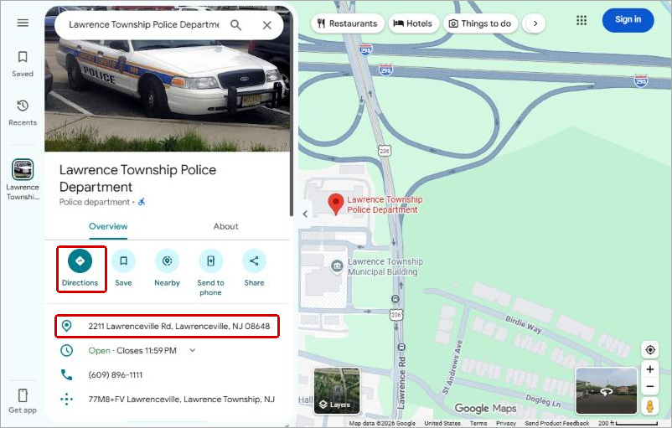
Figure 1. Enhanced and annotated by Claude AI.
Check the county: New Jersey has two Hamilton, Hopewell, Lawrence, and Mansfield townships.

Step 2: Start directions from TCNJ
Click Directions. Type The College of New Jersey, pick Pennington Road, Ewing, and choose the car icon.
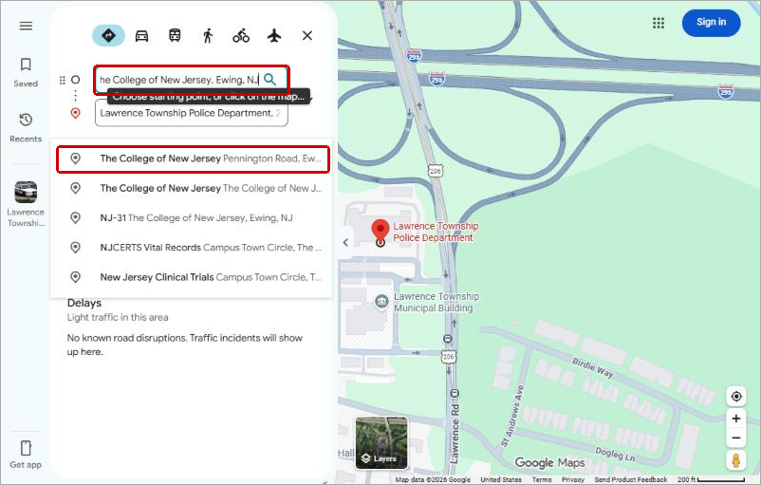
Figure 2. Enhanced and annotated by Claude AI.

Step 3: Read the drive time
The top route shows the time and miles (right box). Don’t record it yet: Leave now (left box) uses this minute’s traffic.
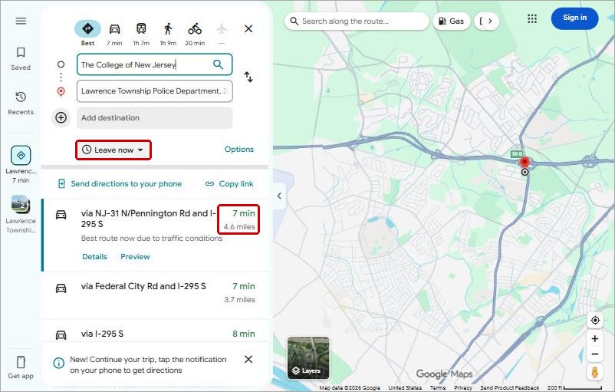
Figure 3. Enhanced and annotated by Claude AI.

Step 4: Set one departure time
Click Leave now, then Depart at.
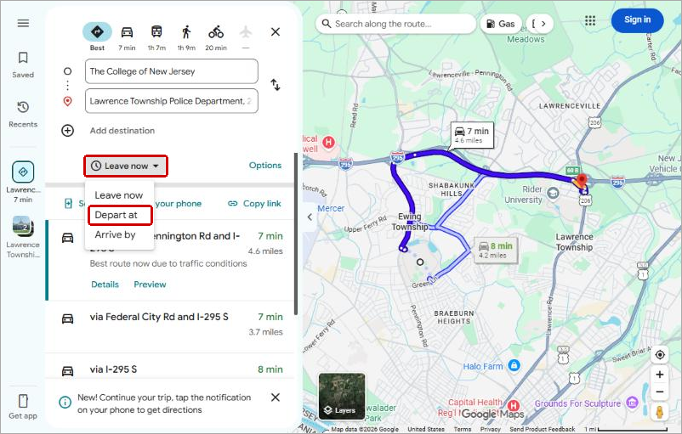
Figure 4. Enhanced and annotated by Claude AI.
Pick one weekday and time (we used 8:00 AM) and use it for every town. Record the low, the high, and the miles from the top route.
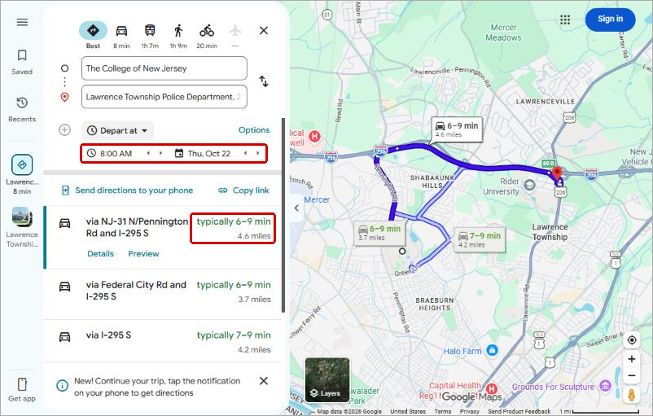
Figure 5. Enhanced and annotated by Claude AI.

Step 5: Repeat, then decide
- For each town, change only the destination. Keep the start and the departure time.
- Before you look at your results, decide: does a town count if its typical high is 20 minutes or less, or its low?
- For towns that pass, average salary = pol_base_pay ÷ pol_ft in data/ufb_2026_police.csv. Skip towns with part-time officers.
- The benchmark is the median of those averages (=MEDIAN() in Excel or Sheets).
Google includes typical traffic; OpenStreetMap, which our R script uses, assumes empty roads. Expect Google to run higher (Lawrence: 6.5 minutes in OpenStreetMap, typically 6–9 in Google).

