Finding drive times with OpenStreetMap
STA 220, Activity 3.1 · Data for Everyday Life · Updated October 22, 2026
This is what 05_drive_times.R does, done by hand in a web browser with free tools and no R. You turn each police headquarters address into latitude and longitude, then ask OpenStreetMap’s routing engine (OSRM) how long the drive from TCNJ takes.

Before you start
You need a web browser, a spreadsheet (Excel or Google Sheets), and the addresses in data/police_hq_addresses.xlsx. Add two empty columns to the spreadsheet, lat and lon, and one for the drive time.
Every point on a map is two numbers:
 | What it measures | TCNJ | Sign near Trenton
Latitude | North–south | 40.2712 | positive (north of the equator)
Longitude | East–west | −74.7829 | negative (west of Greenwich)
Watch the order. The openstreetmap.org search boxes want latitude, longitude. The OSRM web address in Part 3 wants longitude,latitude. Flip them and you get a point in Antarctica or an error.

Part 1: Turn each address into coordinates
The Census Bureau’s free geocoder turns a street address into latitude and longitude.
- Go to geocoding.geo.census.gov, open Find Locations, and choose Address.
- Paste one address into One Line Address, leave the benchmark as Public_AR_Current, and click Get Results.
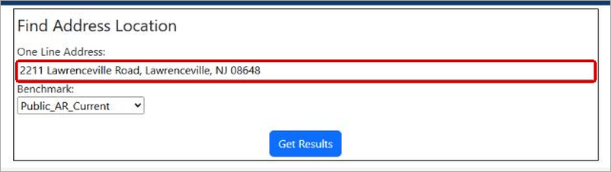
Figure 1. Enhanced and annotated by Claude AI.
- Under the results, copy the two coordinates into your spreadsheet. X is longitude (−74.7318 for Lawrence) and Y is latitude (40.2821). Check that the Matched Address is the one you sent.
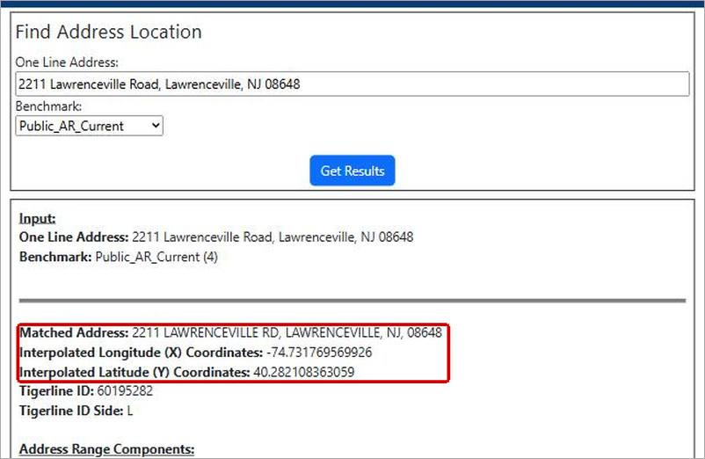
Figure 2. Enhanced and annotated by Claude AI.
Many addresses at once (optional). Choose Find Locations → Address Batch instead and upload a CSV with every address. Click the page’s sample CSV file link first and copy its layout exactly. The results come back as a file with a coordinates column, longitude first.
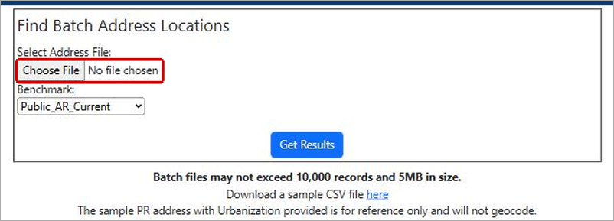
Figure 3. Enhanced and annotated by Claude AI.
No match? Try another spelling (Road vs Rd, Route 130 vs US Hwy 130) or a nearby address on the same property. The Census couldn’t find two of our 19. For South Brunswick (540 Ridge Road), searching the address on nominatim.openstreetmap.org worked. For Mansfield (3135 Route 206), OpenStreetMap didn’t have the street number either, so we used its point for the township municipal building on US 206. Both sets of coordinates are in the lat_osm and lon_osm columns of the spreadsheet.

Part 2: One drive time at a time on openstreetmap.org
- Go to openstreetmap.org and click the arrow button next to the search box (red box).
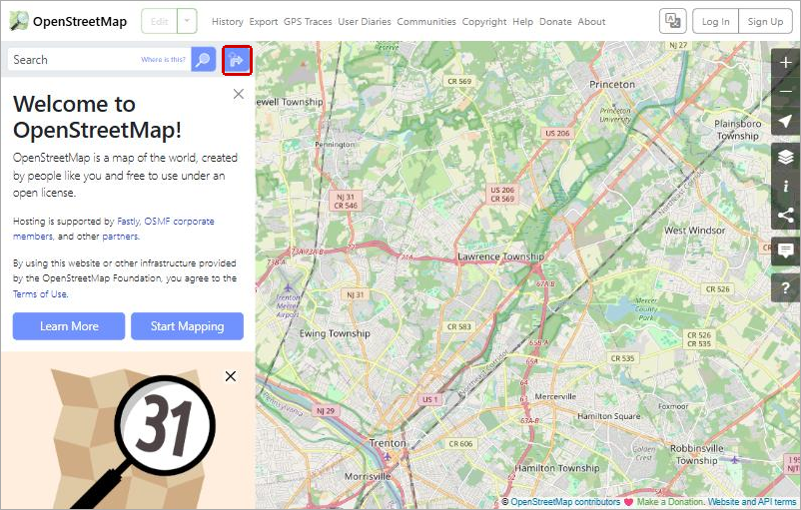
Figure 4. Enhanced and annotated by Claude AI.
- Click the car icon and leave the engine on OSRM (top red box). OSRM is the same engine the R script uses.
- In From, type TCNJ as 40.2712, -74.7829. In To, type the headquarters as latitude, longitude, for example 40.282108, -74.731770 for Lawrence. Press Enter. OpenStreetMap swaps in a nearby street name once it finds the points.
- Read the line under Directions (bottom red box): Distance: 7.2km. Time: 0:06. Time is hours:minutes, so 0:06 is 6 minutes. The gear icon at the right of that line switches kilometers to miles.
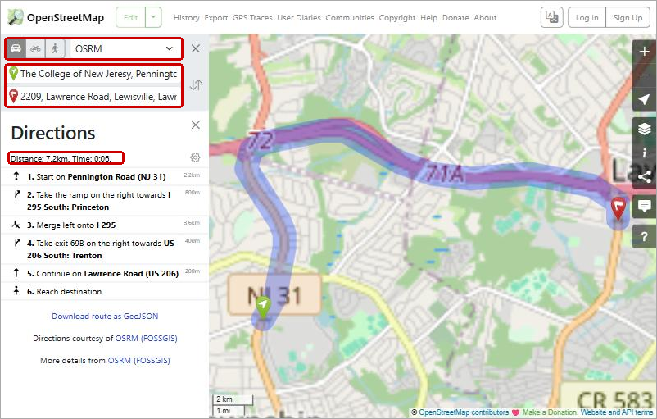
Figure 5. Enhanced and annotated by Claude AI.
You can type addresses into From and To instead of coordinates, but OpenStreetMap’s address search misses many street numbers. Coordinates from Part 1 are more reliable. The page shows whole minutes only; Part 3 gives the seconds.

Part 3: Every town in one request (OSRM table)
OSRM’s table service takes a list of points in a web address and returns the drive time from the first point to all the others. This is the request 05_drive_times.R sends.
- Build the address. It is https://router.project-osrm.org/table/v1/driving/, then the points separated by semicolons, each written longitude,latitude, with TCNJ first, then ?sources=0 (count from TCNJ only). For Ewing, Lawrence, and Hopewell Township:
https://router.project-osrm.org/table/v1/driving/-74.7829,40.2712;-74.801714,40.279036;-74.731770,40.282108;-74.812804,40.309003?sources=0
- With many towns, let the spreadsheet build it. If latitude is in column K and longitude in column L, put =L2&","&K2 in M2 and fill down, then join the column with =TEXTJOIN(";", TRUE, M2:M20). Paste TCNJ’s -74.7829,40.2712; in front.
- Paste the whole address into your browser’s address bar and press Enter. The answer is plain text (JSON). Find "durations" (red box).
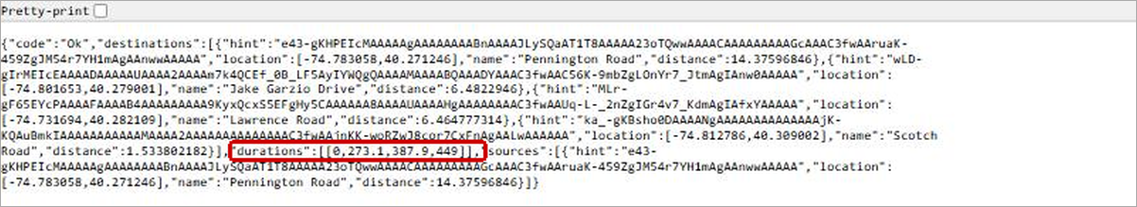
Figure 6. Enhanced and annotated by Claude AI.
- The numbers are seconds, in the same order as your points. The first is TCNJ to itself (0), so skip it. Divide the rest by 60:
Town | Seconds | Minutes
Ewing township | 273.1 | 4.6
Lawrence township | 387.9 | 6.5
Hopewell township | 449 | 7.5
To get the numbers into a spreadsheet, copy what is inside the brackets, paste it into one cell, and use Data → Text to Columns (Excel) or Data → Split text to columns (Google Sheets) on the commas. Add &annotations=duration,distance to the end of the address to get distances too, in meters (divide by 1,609.344 for miles).
This is a free shared server, so send a handful of requests, not hundreds.

Part 4: Check your work, then use the times
- Spot-check one town both ways. Lawrence is 387.9 seconds (6.5 minutes) in the table and 0:06 on the openstreetmap.org page. Those agree; the page just shows whole minutes.
- Check the pins. Paste a town’s latitude, longitude into the openstreetmap.org search box. If the pin isn’t on the police station, the address or the order of the numbers is wrong.
- Know what the number means. OSRM assumes empty roads at the speed limit, so a rush-hour drive takes longer. Google Maps’ “typically” range includes traffic and usually runs higher (Lawrence: typically 6–9 minutes at 8:00 AM).
- Decide the cutoff before you look. Write down what you’ll do with a town at 20.1 minutes before you see one.
Then keep the towns within 20 minutes, find each one’s average base pay per full-time officer (pol_base_pay ÷ pol_ft in data/ufb_2026_police.csv, skipping towns with part-time officers), and take the median of those averages as the benchmark.

