Islamabad Parks & Recreational Facilities GIS
Assignment 2 – Option 4 | PostgreSQL + PostGIS, Node.js/Express, Leaflet
GitHub link: https://github.com/jararhaider2004/parks-gis

Workflow
- Create database in pgAdmin and enable PostGIS.
- Create spatial table parks with Point geometry (SRID 4326).
- Insert 20 records.
- Run SQL queries (retrieve, filter, count, update, spatial).
- Build Express API returning JSON.
- Build Leaflet website with search, add, edit, delete.
- Test validation and data persistence.

Part A – pgAdmin Steps

Step 1: Create database parks_db
CREATE DATABASE parks_db;
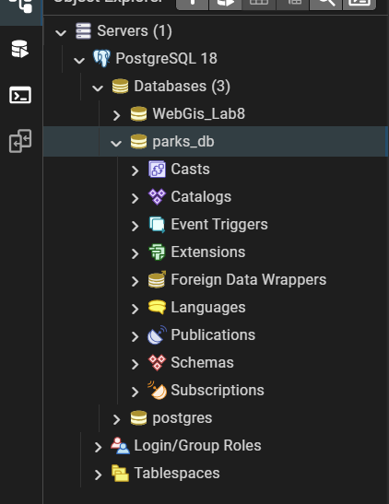

Step 2: Enable PostGIS
CREATE EXTENSION IF NOT EXISTS postgis;
SELECT PostGIS_Version();
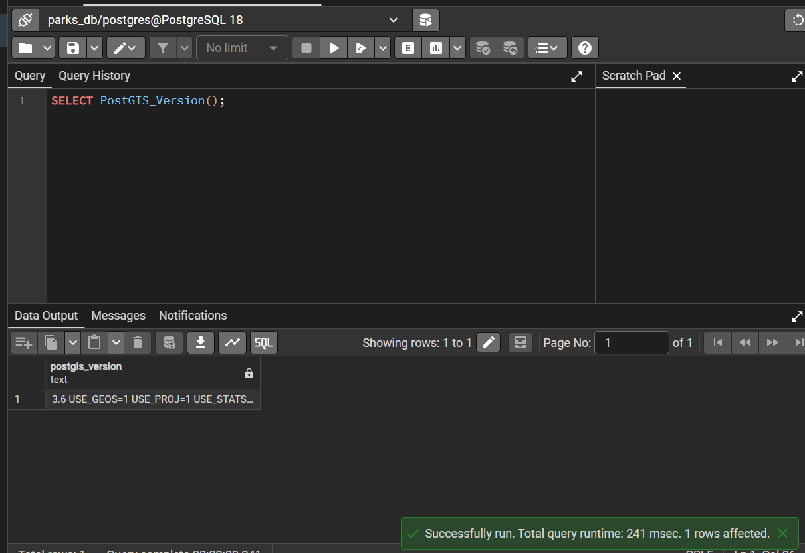

Step 3: Spatial table parks (6 columns incl. geom)
CREATE TABLE parks (
id SERIAL PRIMARY KEY,
name VARCHAR(100) NOT NULL,
type VARCHAR(30) NOT NULL,
sector VARCHAR(20) NOT NULL,
status VARCHAR(20) DEFAULT 'Open',
geom GEOMETRY(Point, 4326) NOT NULL
);
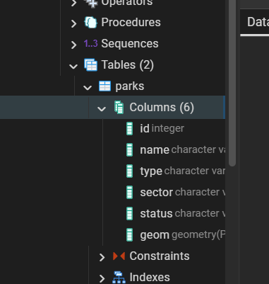

Step 4: Count records (20 inserted)
SELECT COUNT(*) FROM parks;
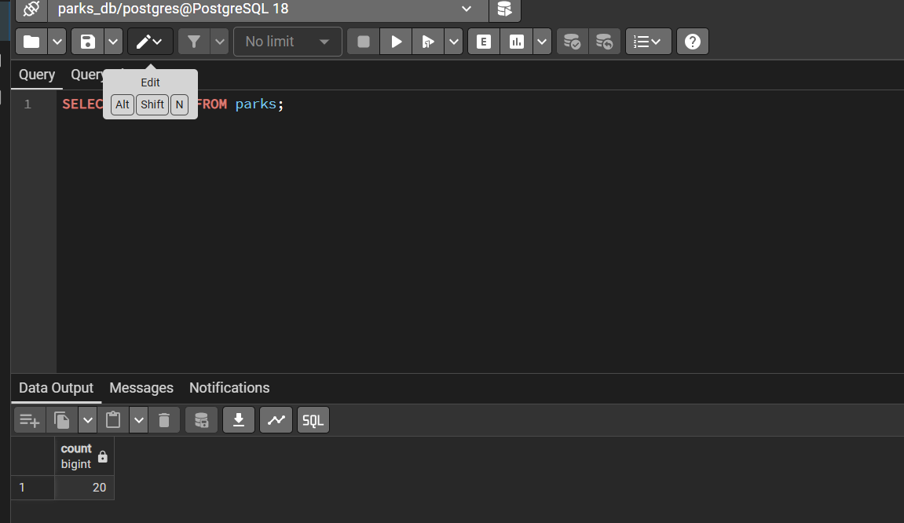

Step 5: Retrieve records
SELECT id, name, type, sector, ST_X(geom) lng, ST_Y(geom) lat FROM parks;
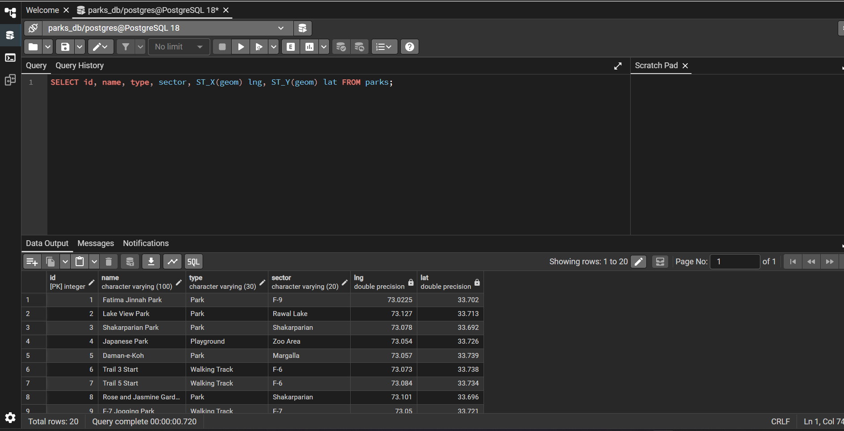

Step 6: Filter records
SELECT * FROM parks WHERE type = 'Park' AND sector = 'F-9';
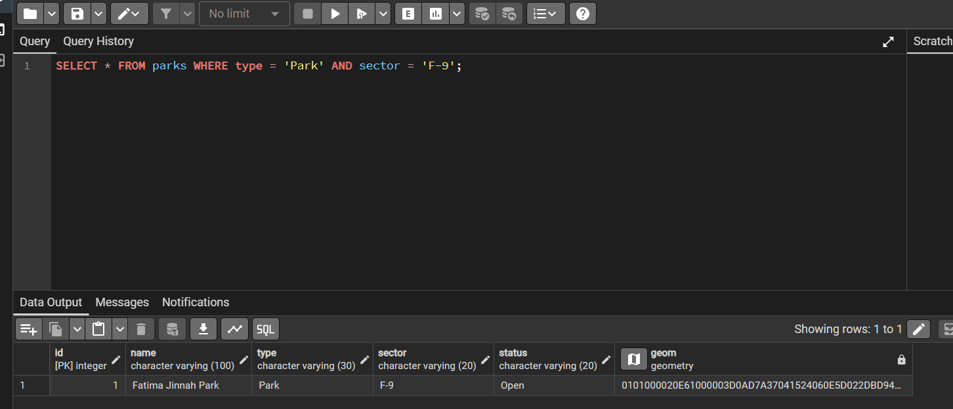

Step 7: Count by type
SELECT type, COUNT(*) FROM parks GROUP BY type;
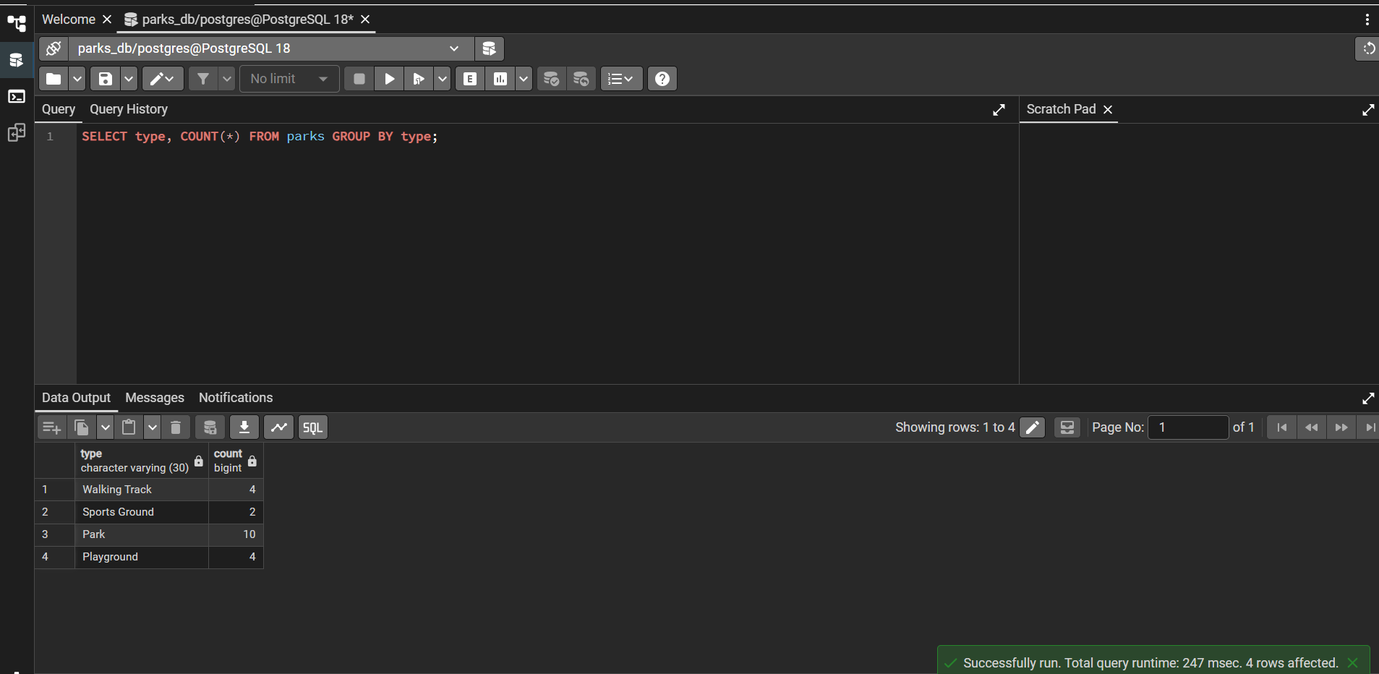

Step 8: Update record
UPDATE parks SET status = 'Open' WHERE id = 1;
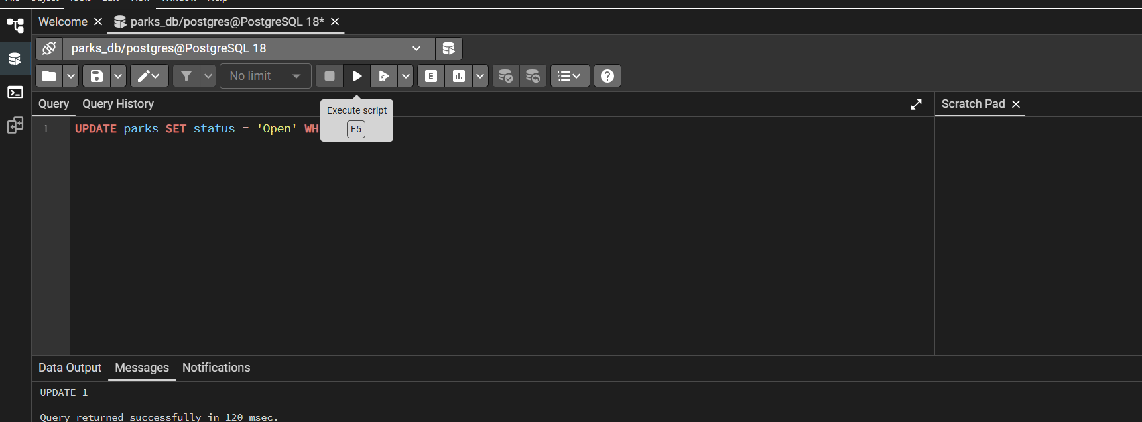

Step 9: Spatial query: parks within 3 km
SELECT name FROM parks WHERE ST_DWithin(geom::geography,
ST_MakePoint(73.0225,33.7020)::geography, 3000);
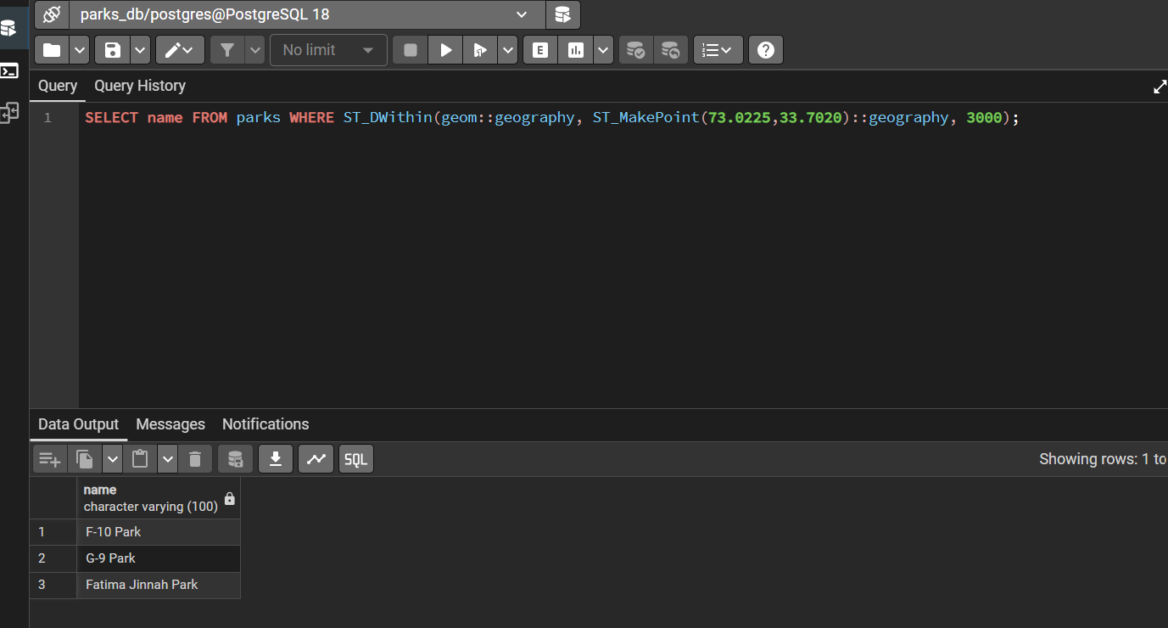

Step 10: Geometry column
SELECT name, geom FROM parks;
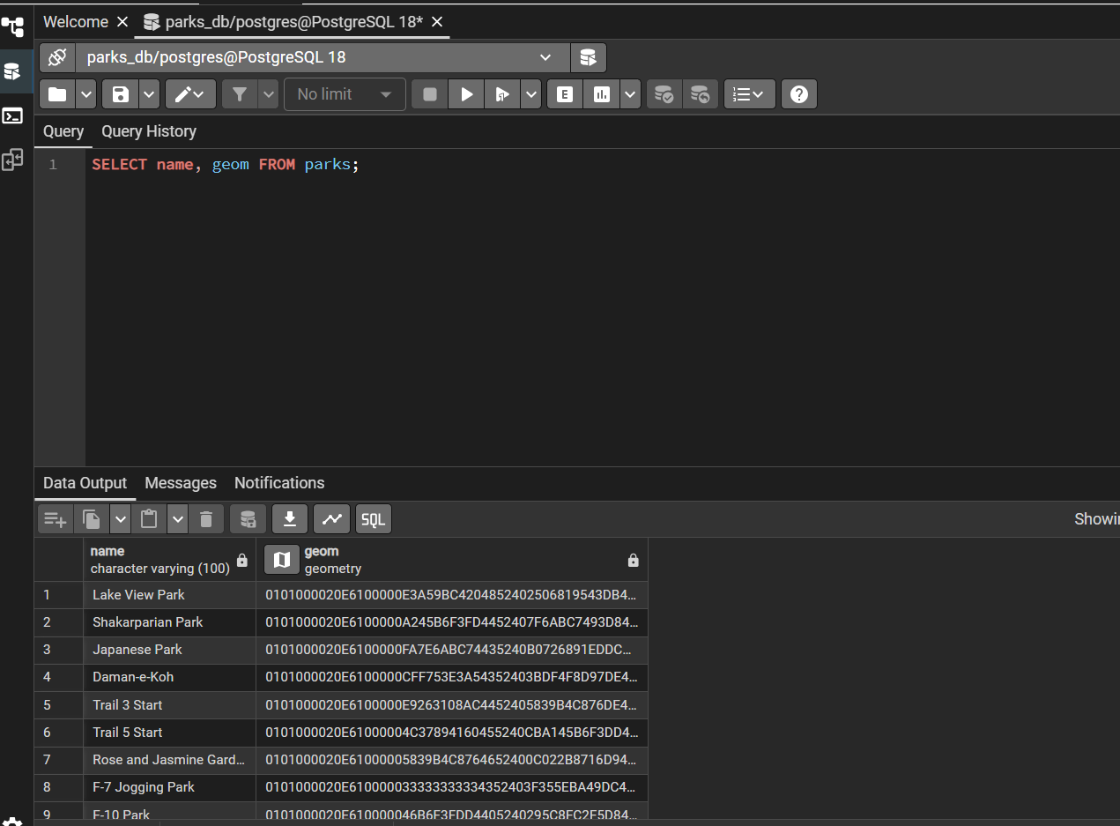

Part B – Backend API
npm install
npm start
Endpoints: GET /api/parks?type=&sector= | POST /api/parks | PUT /api/parks/:id | DELETE /api/parks/:id
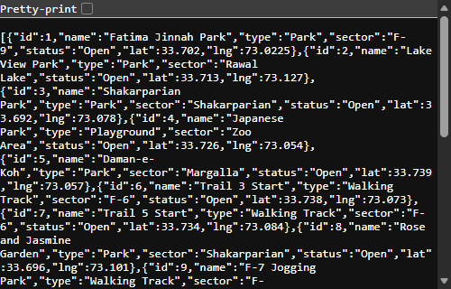
API at localhost:3000/api/parks returns records as JSON.

Part C – Website
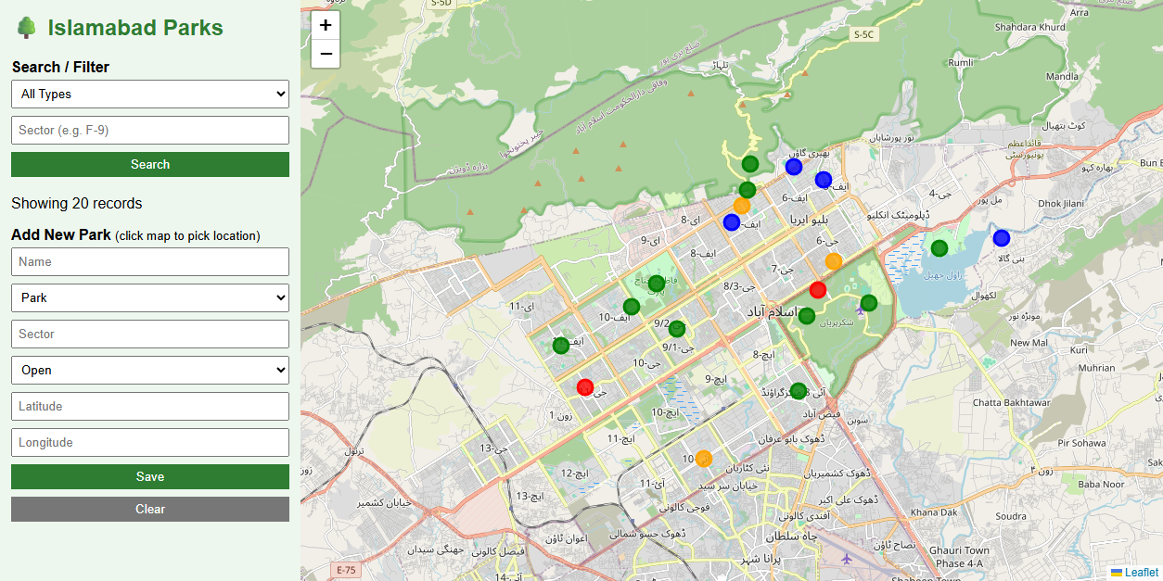
Main map: 20 parks from PostgreSQL, coloured by type.
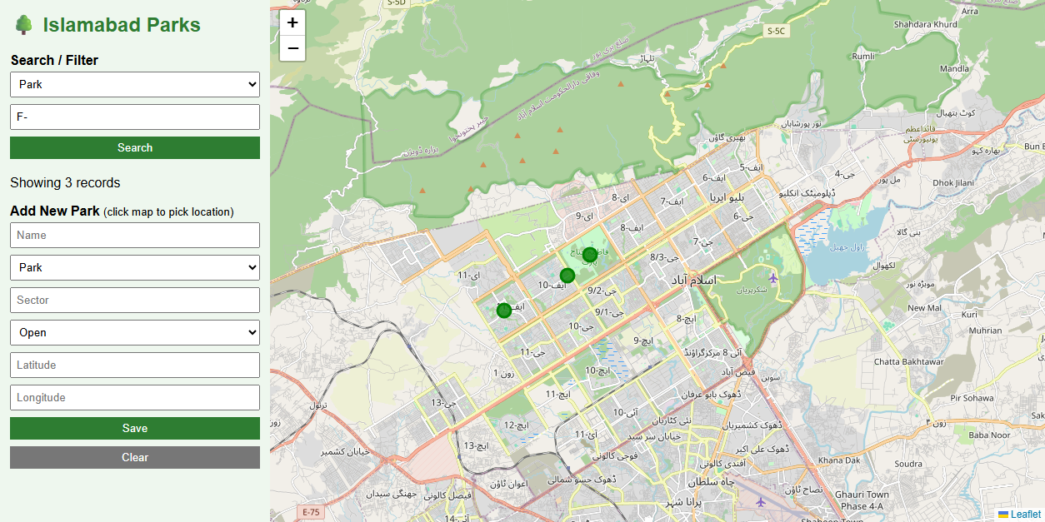
Filter by type and sector.
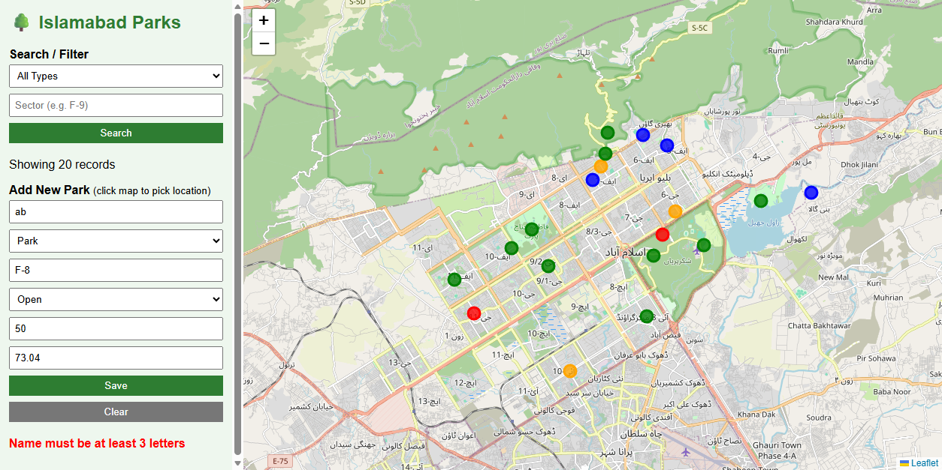
Validation rejects invalid input.
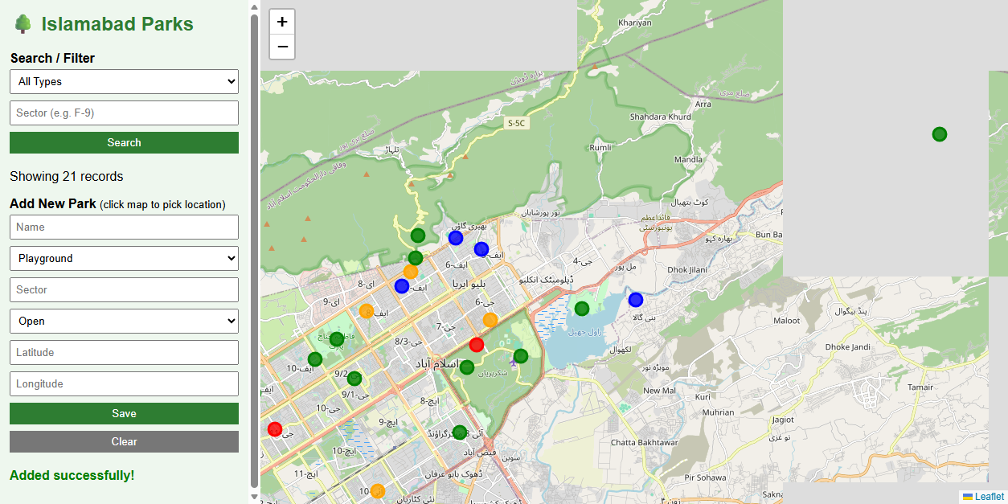
New record added through the form.
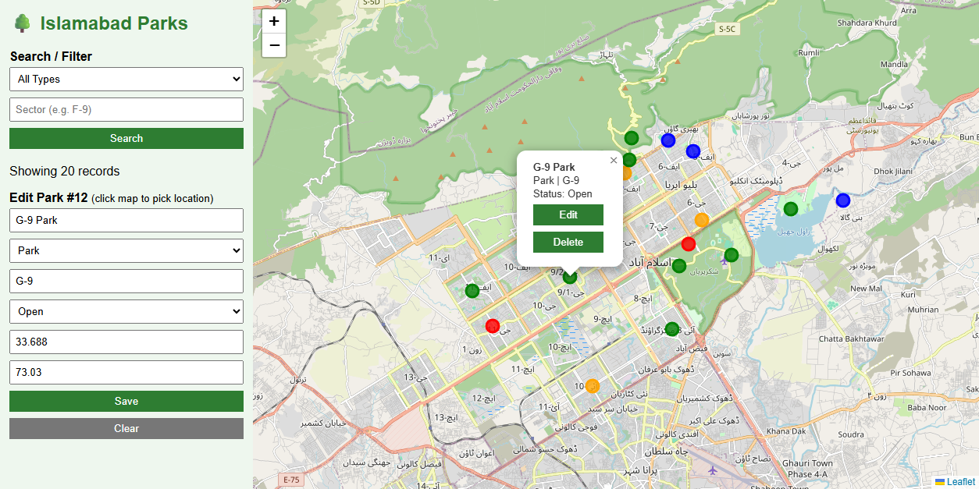
Edit form filled from a marker.
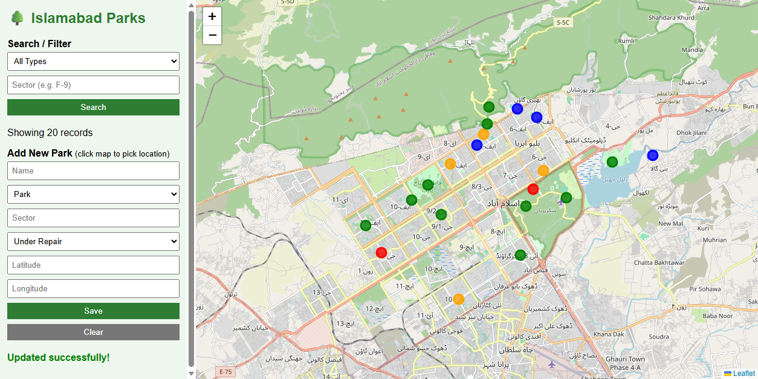
G-9 Park status updated to Under Repair.
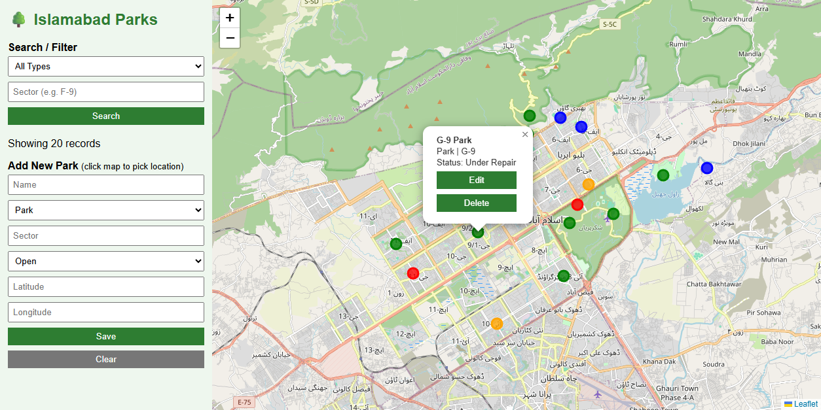
After refresh the change is still there.

Persistence check in pgAdmin
SELECT * FROM parks WHERE id = 12;
