Jason Archer

MECE 5397

Project A – Poisson Equation APc1-6

Abstract

The given Poisson equation was solved using two iterative methods, Gauss-Seidel and Successive Over-Relaxation. Based on the discretizations used, the solutions will possess second-order accuracy. A grid converge study was conducted and N=160 nodes added to both the x and y axes was found to be sufficient for convergence with a tolerance of 10-3 relative error. Based on contour plots and the average value of the matrix u, both methods were found to converge to the same result. Next, the discretizations for the two Neumann boundary conditions were changed to first order. The results for these first-order iterative solutions did not converge to the same value at N=160 nodes, indicating the pronounced effect of the order dropping from second to fist order. The method of manufactured solutions was utilized taking u=cos(2*x)*cos(2*y). The iterative solutions were accurate to the exact solution to less than 10-8. The formal order of error was computed to be 1.99, indicating that the discretization for both iterative solutions is indeed second order. Selecting ω=1.9 for the Successive Over-Relaxation method proved to drastically reduce the number of iterations required for the solution to converge. For N=160, the total number of iterations required dropped from more than 33000 for Gauss-Seidel to less than 2200 for Successive Over-Relaxation. Lastly, the solution was modified to F=0. The result is that the middle of the domain shifted upward toward zero. In conclusion, the results indicate a strong convergence both iterative methods to the correct solution. The spatial order of error was confirmed to be 2. The manufactured solution produced results very similar to the exact solution, indicating that the iterative methods are indeed performing as they should.

Mathematical Statement of the Problem

This report will seek to solve the Poisson equation

$\frac{∂^{2}u}{∂x^{2}}$ + $\frac{∂^{2}u}{∂y^{2}}= -F\left(x,y\right)$

where F(x,y) = sin($\frac{π(x-a_{x})}{b_{x}-a_{x}}$)*cos($\frac{π}{2}$*(2 $\frac{y-a_{y}}{b_{y}-a_{y}}$ +1))

The equation is subject to the following boundary conditions:

${\frac{∂u}{∂x}|}_{x=a_{x}}$ = 0

${\frac{∂u}{∂x}|}_{x=b_{x}}$ = 0

U(x,y= $a_{y}$) = ${(x-a_{x})}^{2}*$ sin($\frac{π(x-a_{x})}{{2(b}_{x}-a_{x})}$)

U(x,y= $b_{y}$) = [cos(π(x- $a_{x}$))-1]*cosh($b_{x}-x)$

where $a_{x}$ = $a_{y}$ = -π and $b_{x}$ = $b_{y}$ = π.

Discretized Versions of the Equations

The discretization of the Poisson equation will take the form of

+ = -F(x,y)

where j is the index of the point on the x-axis, k is the index of the point on the y-axis, and n refers to the iteration.

The boundary conditions where x= $a_{x}$ and x= $b_{x}$ can be discretized as

$$\frac{u_{j+1,k}^{n}- u_{j-1,k}^{n}}{2Δx}$$

Using this discretization will allow the error to remain of order $Δx^{2}$ rather than only Δx. As a result of using the ghost nodes, the discretization at the boundaries where will be

+ = -F(x,y)

when x= $a_{x}$ and

+ = -F(x,y)

when x= $b_{x}$.

Description of the Numerical Method

The Poisson equation will be solved utilizing two methods, Gauss-Seidel and Successive Over-Relaxation. The initial value of the matrix u will consist of zeros except at the boundaries where y= $a_{y}$ and y= $b_{y}$. The boundary conditions given for those values of y allow for the exact value of u to be calculated. This means that the exact value of u must be computed at every node and at the boundaries where x= $a_{x}$ and x= $b_{x}$.

The codes will perform iterations of the Gauss-Seidel and Successive Over-Relaxation methods until the greatest difference at any given point from one iteration to the next is less than ${10}^{-8}$. This should ensure that the solution has reached a point very close to its final value. Using the discretization of the Poisson equation, solving with the Gauss-Seidel method will look like:

Create initial u matrix with values at y= $a_{y}$ and y= $b_{y}$ known and zeros elsewhere.

Save this u matrix as another matrix, v

While error < ${10}^{-8}$

for k=2:M+1

for j=1:N+2

$u_{j,k}^{n+1}=$ (Δ $x^{2}u_{j,k-1}^{n+1}$ + Δ $x^{2}u_{j,k+1}^{n}+Δy^{2}u_{j-1,k}^{n+1}+Δy^{2}u_{j+1,k-1}^{n}+$ $Δx^{2}Δy^{2}F(x,y)$) / (2*($Δx^{2}+Δy^{2}))$

end

end

Determine maximum relative error between v and u

Save the new u matrix as v

end

M is the number of nodes added to the y-axis and N is the number of nodes added to the x-axis. Due to the boundary conditions being known for k=1 and k=M+2, these values do not need to be computed as part of the main computational loop. These two for loops will run until the difference at any point (node or boundary) from one iteration to the next is less than 10-8. This will indicate that the computed u matrix is very close to reaching its final value.

The Successive Over-Relaxation method is very similar:

Create initial u matrix with values at y= $a_{y}$ and y= $b_{y}$ known and zeros elsewhere.

Save this u matrix as another matrix, v

While error < ${10}^{-8}$

for k=2:M+1

for j=1:N+2

$u_{j,k}^{n+1}=$ ω*(Δ $x^{2}u_{j,k-1}^{n+1}$ + Δ $x^{2}u_{j,k+1}^{n}+Δy^{2}u_{j-1,k}^{n+1}+Δy^{2}u_{j+1,k-1}^{n}+$ $Δx^{2}Δy^{2}F(x,y)$) / (2*( $Δx^{2}+Δy^{2}))$- (ω-1) $u_{j,k}^{n}$

*

end

end

Determine maximum relative error between v and u

Save the new u matrix as v

end

A count of the number of iterations that must be used for each method will be taken. The Successive Over-Relaxation method should require significantly fewer iterations to achieve a final value than for the Gauss-Seidel method.

Technical Specifications of the Computer

Processor: Pentium Dual Core CPU T4400 @ 2.20 GHz

Operating System: Windows 7 Home

64 bit operating system

Ram: 2.00 GB

L2 Cache Size: 1024 kB

L3 Cache Size: 8192 kB

Results

Figures 1 and 2 contain surface plots of the resulting u matrices for the Gauss-Seidel and Successive Over-Relaxation methods. The unknown function u is dominated primarily by the area near (-π, π). The given boundary at y= π gives the plots most of their shape. The other point of interest lies at (π, -π). The slight elevation of this boundary point results in a contour sloping down until the middle of the domain. The similarity of both plots suggests strong agreement between the two iterative methods. This does not independently suggest that the solutions are accurate, but rather that both methods converge to the same solution.

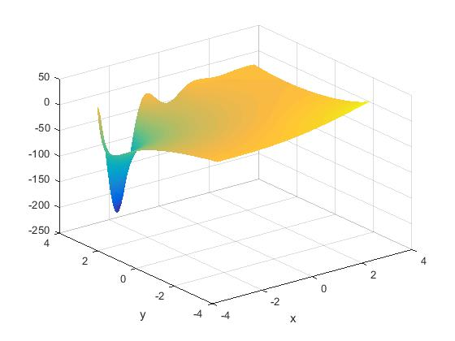

Figure 1. Surface Plot Using the Gauss-Seidel Method



Figure 2. Surface Plot Using the Successive Over-Relaxation Method

Both the maximum and minimum values for the given problem occur at the boundaries. Furthermore, they do not change based on the number of iterations or mesh size. Therefore, the average value of all points of the mesh was chosen as the parameter to be examined for the grid convergence study. The study began with N=10 nodes added to both the x and y axes and doubled for each subsequent iteration of the study.

A tolerance of 10-3 was chosen as the threshold for the relative error between the current and previous iteration. The relative error from N=80 to N=160 nodes was found to be 4.91*10-4, indicating 160 nodes sufficient for grid convergence. Figure 1 shows the average value at all points of matrix U as the value of N was doubled. The average value converges to approximately -14.88, further indicating that converge has been reached at N=160.

Figure 3. Average Value of the U Matrix vs. Total Nodes in the Mesh

In order to evaluate the effect of the number of points used for the discretization, the two iterative solutions were changed to approximate the two Neumann boundary conditions with only first order accuracy using the discretization

$$\frac{u_{j,k}^{n}- u_{j-1,k}^{n}}{Δx}$$

Figures 4 and 5 show the contour plots of the resulting solutions using the Gauss-Seidel method. The main area of visual interest is the variation of the -80 contour line near the top left of the plots. This shows that there is some variation of the first-order solution along the x=-π boundary. Examining the average value of the u matrix, the average value of the u matrix was found to be -14.8734 for both second-order solutions. This shows the convergence of both solutions when selecting N=160 nodes. The first-order accurate case for the Gauss-Seidel method had an average value of -14.7629. This demonstrates that the first-order accuracy case is, on average, slightly higher which is seen in the discrepancy of the -80 contour line between the two plots.

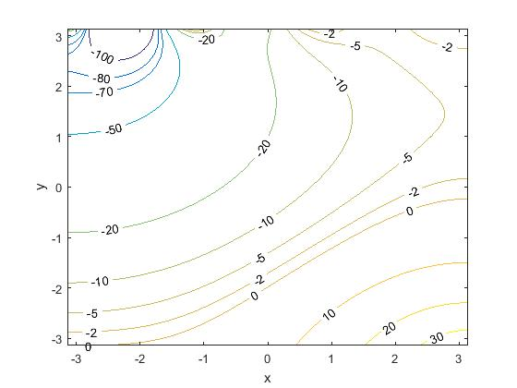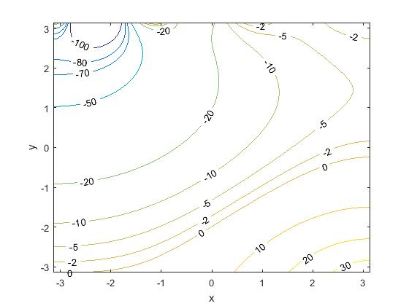

Figures 4 and 5. Contour Plots of the Gauss-Seidel Method with First-Order (left) and Second-Order (right) Spatial Accuracy

Figures 6 and 7 show the contour plots of the solutions using the Successive Over-Relaxation method with first-order and second-order accuracy. The results are similar for the Gauss-Seidel method. Once again, there is a difference in the -80 contour line in the first-order approximation. This shows that some of the points near the (-π, π) boundary are higher than for the second-order approximation. Another noticeable difference is that the far right edge of the -5 contour line, near the (2.8, 1.5) point, has shifted to the left. This means that the nodes in this area have slightly higher values than for the second-order approximation. In total, this first-order Successive Over-Relaxation method has an average u value of -14.7178, higher than both second-order approximations and the first-order Gauss-Seidel approximation.

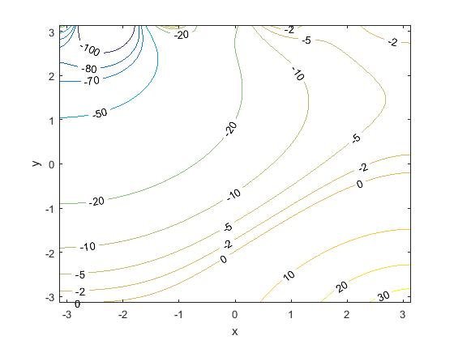

Figures 6 and 7. Contour Plots of the Successive Over-Relaxation Method with First-Order (left) and Second-Order (right) Spatial Accuracy

Table 1 summarizes the average values of u for each iterative method and order of accuracy. The averages were the same to at least six significant digits for the second-order cases while the same for only three significant digits for the first-order approximations. When performing the grid convergence study, the average value of u was the same for both iterative methods regardless of N size (N=20, 40, 80, 160, and 320). This means that the second-order approximations are the same for at least six significant digits regardless of grid size. The larger error introduced by the first-order approximation of the Neumann boundary conditions means that these solutions will be less accurate. The larger error is also noticeable in how the two methods are affected differently. The results would seem to indicate that the first-order error affects the Successive Over-Relaxation more than Gauss-Seidel. The speed of the Successive Over-Relaxation method is a benefit when the error is second-order. However, at first-order error, it results in an even less accurate solution.

Table 1

Average Value of u for Varying Iterative Methods and Orders of Accuracy

|  |  |  |  |  |
| --- | --- | --- | --- | --- |
| Method | Gauss-Seidel | | Successive Over-Relaxation | |
| Order | First | Second | First | Second |
| Average u Value | -14.7629 | -14.8734 | -14.7178 | -14.8734 |

The method of manufactured solutions was utilized to validate the code as well as determine the order of spatial accuracy. The equation u=cos(D*x)*cos(H*y) was selected (Figure 8). Based on the problem statement, F= (D2 + H2)*cos(D*x)*cos(H*y). The L2 error was computed for both the Gauss-Seidel and Successive Over-Relaxation methods for increasing number of nodes added to the x and y axes. The values of D and H were chosen to both be 2 for testing.

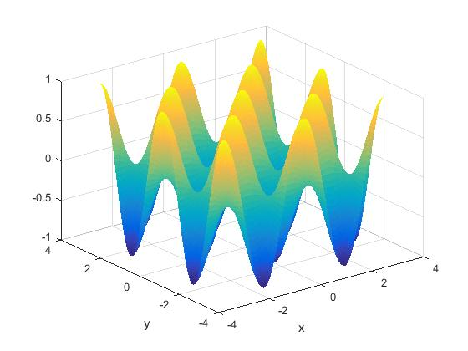

Figure 8. Surface Plot of the Exact Solution of the Manufactured Solution

Like for the given problem, the manufactured solution was solved by both iterative methods until the maximum difference at any point between iterations was less than 10-8. Comparing the u matrices for the manufactured solutions using both methods, the largest difference between the two was 8.9728*10-9. This indicates that both methods converge to the same solution. The computed L2 norms for both methods were identical to at least 5 significant digits for all five node conditions. Figures 9-11 show contour plots of the exact solution and approximations using both iterative methods to solve the manufactured solution. The plots are visually indistinguishable, illustrating the strong convergence of both iterative solutions to the exact solution.

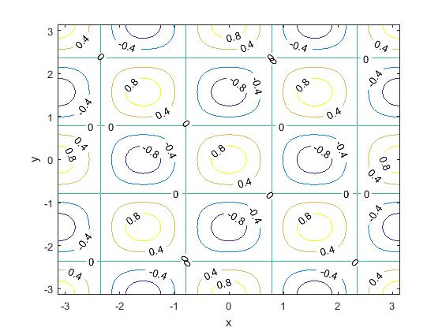

Figure 9. Contour Plot of the Exact Solution of the Manufactured Solution

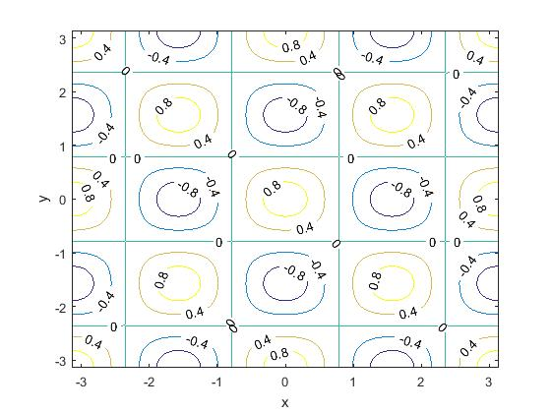

Figure 10. Contour Plot of the Gauss-Seidel Approximation of the Manufactured Solution



Figure 11. Contour Plot of the Successive Over-Relaxation Approximation of the Manufactured Solution

Table 2 shows the clear trend of the L2 error decreasing as more nodes are added to both axes. Figure 12 shows the log of the L2 error plotted against the log of Δx. Based on the trendline of this plot, the code for both methods is second order accurate in space. Using this data, the formal order of accuracy was computed using the L2 errors for the N=20 and N=40 conditions. This value was determined to be 1.99.

Table 2

L2 Error for Doubling Nodes on X and Y Axes

|  |  |  |  |  |
| --- | --- | --- | --- | --- |
| Nodes | Δx | L2 Norm | log Δx | log L2 Norm |
| 20 | 0.2992 | 0.0139 | -0.524 | -1.8571 |
| 40 | 0.1532 | 0.0035 | -0.8146 | -2.4561 |
| 80 | 0.0776 | 8.8138 x 10-4 | -1.1103 | -3.0548 |
| 160 | 0.0390 | 2.2145 x 10-4 | -1.4086 | -3.6547 |
| 320 | 0.0196 | 5.5518 x 10-5 | -1.7083 | -4.2556 |

Figure 12. log(L2 error) vs log (Δx) for the Successive Over-Relaxation Method

Using the Successive Over-Relaxation method should require fewer iterations to achieve convergence than with the Gauss-Seidel method. Using the Successive Over-Relaxation method, a value of ω between 1 and 2 should be chosen to increase convergence. It is expected that ω close to 2 should achieve the highest convergence. Table 3 shows the number of iterations needed to reach convergence (relative difference at any point <10-8 between two iterations) utilizing the method of manufactured solutions. As expected, ω=1.9 gave the fastest convergence and saved a significant number of iterations and time as opposed to the Gauss-Seidel method.

Table 3

Number of Iterations Required for Manufactured Solution for Nx=Ny=160

|  |  |  |  |  |  |
| --- | --- | --- | --- | --- | --- |
| Method | Successive Over-Relaxation | | | | Gauss-Seidel |
| ω | 1.9 | 1.7 | 1.5 | 1.3 | N/A |
| Count | 2150 | 6774 | 12228 | 19059 | 33741 |

Both iterative methods were run again with the value of the function F changed to zero. Figures 13 and 14 show surface plots of the resulting u matrices. The overall shape of both solutions are the same and are both very similar to their counterparts when F was the original function. In general, the points near the middle of the domain are higher for F=0.

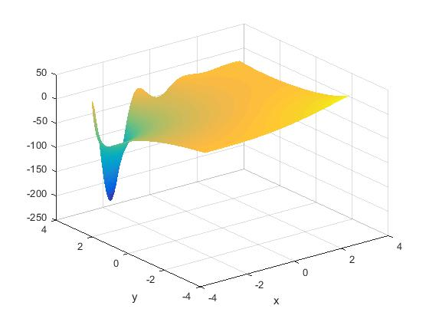

Figure 13. Surface Plot Using the Gauss-Seidel Method with F=0



Figure 14. Surface Plot Using the Successive Over-Relaxation Method with F=0

Figures 15 and 16 compare the contour plots for the Gauss-Seidel for the original F function and F=0. Figure 16 shows that the contour lines along the x=- π and x=π boundaries have shifted upward, indicating that the u values near the middle of the plot are higher than for the original F function. Figures 17 and 18 compare the contour plots for the Successive Over-Relaxation method for the original F function and F=0. This method shows the same behavior as the Gauss-Seidel method. The average u value for both methods with F=0 was found to be -13.5190. This is in agreement with the contour plots showing that the value of u near the middle of the plot increases when F=0.

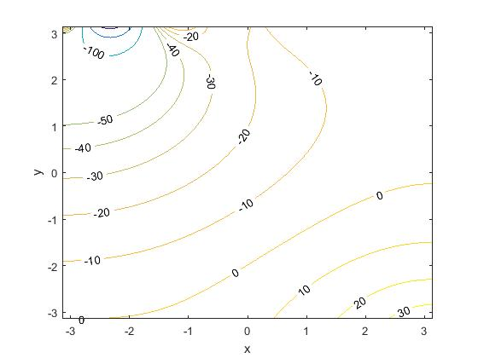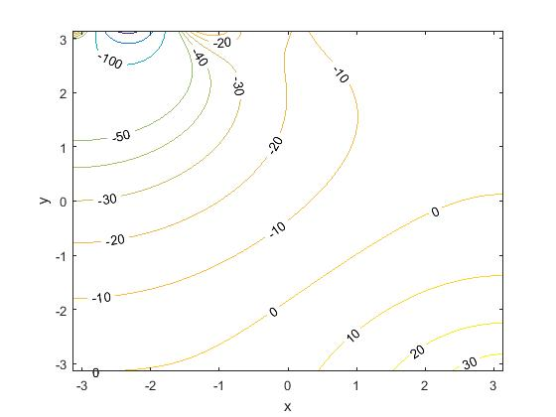

Figures 15 and 16. Contour Plots of the Gauss-Seidel Method with and the original F function (left) and F=0 (right)



Figures 17 and 18. Contour Plots of the Successive Over-Relaxation Method with and the original F function (left) and F=0 (right)