Translate

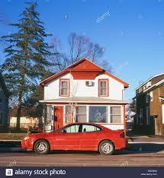

Tem um carro vermelho em frente de casa.

THERE IS X THERE ARE

* **There is** only one bedroom in my house

There is not only one bedroom in my house

Is there only one bedroom in my house?

* **There are** 20 students in my classroom

There are not 20 students in my classroom

Are there 20 students in my classroom?

Como ficam as frases na forma negativa?

E como ficam as frases na forma interrogativa?

How many TVs are there in your house?

How can I aswer?

Yes, there is/ are

No there isn´t/ aren´t

**Activity**

1.Complete com there is or there are.

1. There is a big tree in the garden.
2. There is a good film on TV tonight.
3. There are some big trees in the garden.
4. There are a lot of accidents on this road.
5. There are 11 players in a football team.

f. There is coffee on the floor.

g.There is a cat on the roof.

h. There are computers in that room.

i. There is money in my bag._

j. There are seven billion people living on this planet.

k.There is a train at 10.20.

l. There are nine planets in the solar system.

m.There are thirty days in september.



9 eggs

1 water Mellon

1 grape

4 water bottles

2 sodas

3 milks

1 pineapple

1 chicken

1 apple juice

3 tomatoes

3 fish

9 cans

1 pumpkin

https://cursodeingles.online/2019/01/there-be-to-have/