AHB to Memory (Internal Memory)

Introduction
This AHBLite module decodes hex into 7 seg display. There are two versions of the decoder. The basic version has 4 registers: Base + 0, Base + 4, Base +8, Base + C. Each register takes in on nibble and displays that in the respective seven segment display. The V1 version of the module has only one 16 bit register and display the hex value of that register in the 4 seven segment display. The address of the register is Base + 0x00.

The module is set for common anode display but you can change the source code for common cathode display type.

Functional Overview

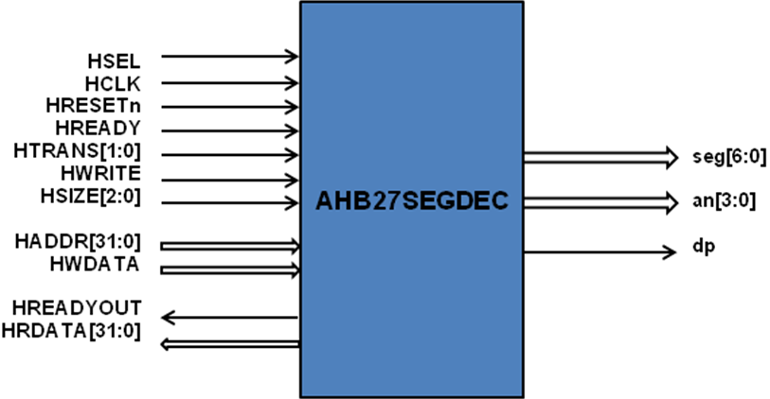

Register Overview (Base Version)

Address | Type | Width | Reset Value | Name | Description
Base + 0x00 | Read/  Write | 4 | 0xA | Digit1 | Data for Segment 1
Base + 0x04 | Read/  Write | 4 | 0xB | Digit2 | Data for segment 2
Base + 0x08 | Read/  Write | 4 | 0xC | Digit3 | Data for segment 3
Base + 0x0C | Read/  Write | 4 | 0xD | Digit4 | Data for segment 4

Register Overview (Version V1)

Address | Type | Width | Reset Value | Name | Description
Base + 0x00 | Read/  Write | 16 | 0x1234 | Data | Data for Segment 1 = data[3:0]  Data for Segment 2 = data[7:4]  Data for Segment 3 = data[11:8]  Data for Segment 4 = data[15:12]

