AHB to APB Bridge

Introduction
The AHB2APB Bridge is an Advanced Microcontroller Bus Architecture (AMBA) conversion bridge that converts the protocol from AMBA High-performance Bus Lite (AHB-Lite) to Advanced Peripheral Bus (APB). This allows AHB-Lite masters, such as the Cortex-M0 DesignStart, to communicate with APB slaves.

Functional Overview
To see more on how the two bus protocols are different see their respective specification documents.
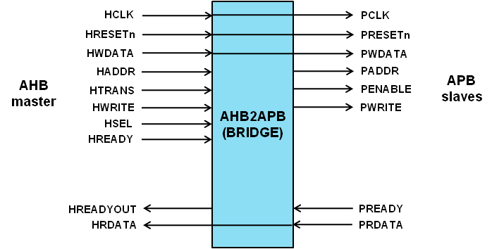

Programmer Model
Check the spec sheets on specific APB peripherals for their respective sub-addresses.

Signal Descriptions
Table 2-5 AHB to APB bridge signal overview
Name | Type | Source/  Destination | Description
HCLK | Input | AHB | Global clock signal
HRESETn | Input | AHB | Global reset signal active LOW
HADDR[31:0] | Input | AHB | AHB address bus
HTRANS[1:0] | Input | AHB | AHB transfer type indication
HWRITE | Input | AHB | Indicates transfer direction
HWDATA[31:0] | Input | AHB | Write data bus
HSEL | Input | AHB | Select signal for AHB2APB Bridge
HREADY | Input | AHB | Indicates previous AHB transfer is complete
PRDATA | Input | APB Slaves | Read data bus from APB Slaves
PREADY | Input | APB Slaves | APB slaves use this to extend an APB transfer
HRDATA | Output | AHB | AHB read data bus sent to AHB master
HREADYOUT | Output | AHB | Tells AHB master when transfers have completed
PWDATA[31:0] | Output | APB Slaves | APB write data bus.
PENABLE | Output | APB Slaves | Indicates second and subsequent cycles of an APB transfer
PADDR | Output | APB Slaves | APB address bus
PWRITE | Output | APB Slaves | Direction. Indicates write access when HIGH and read access when LOW
PCLK | Output | APB Slaves | APB clock signal
PRESETn | Output | APB Slaves | APB reset signal active LOW

APB Dummy1

Introduction
This peripheral is a simple example of how devices read and write using the APB protocol. This is a great peripheral to look at for someone interested in developing APB peripherals. In combination with the APB specification documents it is a great way to learn how the protocol works in the most basic sense.

Functional Overview
This peripheral has a single read/write register called DUMMY1.
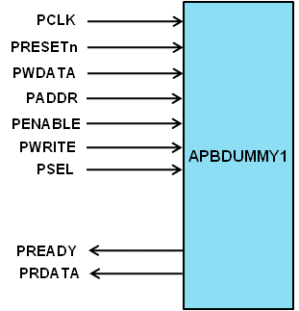

Programmer’s Model
This peripheral has a single 4-bit register DUMMY1[3:0].

Signal Overview
Table 4-8 APB Dummy1 signal overview
Name | Type | Source/  Destination | Description
PRDATA[31:0] | Output | APB Bridge | Read data bus from APB Slaves
PREADY | Output | APB Bridge | APB slaves use this to extend an APB transfer
PWDATA[31:0] | Input | APB Bridge | APB write data bus.
PENABLE | Input | APB Bridge | Indicates second and subsequent cycles of an APB transfer
PADDR | Input | APB Bridge | APB address bus
PWRITE | Input | APB Bridge | Direction. Indicates write access when HIGH and read access when LOW
PCLK | Input | APB Bridge | APB clock signal
PRESETn | Input | APB Bridge | APB reset signal active LOW
PSEL | Input | APB Bridge | APB select signal for APB Dummy1

