AHB Dummy1

Introduction
The first AHB Dummy is a simple example of how to create a peripheral that can interact with the AHB-Lite protocol. This is a great starting point for someone looking to develop their own AHB-Lite peripherals for the Cortex-M0. In combination with the AHB-Lite specification document, it is also a good way to understand how the protocol works.

Functional Overview
This Dummy peripheral has a single register that holds a value when written to and returns the value of the register when read.
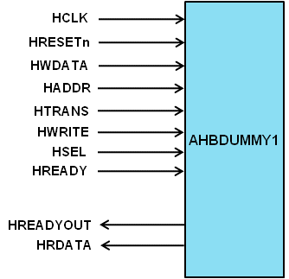

Programmer’s Model
Any write to this peripheral will write to the 4-bit DUMMY1 register.

Signal Overview
Table 4-5 AHB Dummy1 signal overview
Name | Type | Source/  Destination | Description
HCLK | Input | AHB | Global clock signal
HRESETn | Input | AHB | Global reset signal active LOW
HADDR[31:0] | Input | AHB | Timer address bus
HTRANS[1:0] | Input | AHB | Timer transfer type indication
HWRITE | Input | AHB | Indicates transfer direction
HWDATA[31:0] | Input | AHB | Write data bus
HSEL | Input | AHB | Select signal for AHB Dummy1
HREADY | Input | AHB | Indicates previous AHB transfer is complete
HRDATA | Output | AHB | AHB read data bus sent to AHB master
HREADYOUT | Output | AHB | Tells AHB master when transfers have completed

