AHB Dummy2

Introduction
The second AHB dummy is a more complicated peripheral that shows how wait states can be implemented if necessary for more complex functions. This peripheral was designed to show some of the other features of the AHB-Lite protocol without being overly complicated.

Functional Overview
This peripheral has four different registers. Each register waits for a different number of cycles when written to. Reads will return the current value of the addressed register.
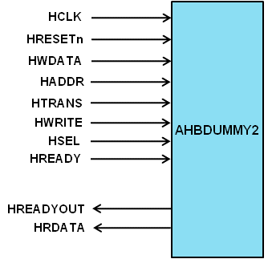

Programmer’s Model
Table 4-6 AHB Dummy2 registers
Address | Type | Width | Reset Value | Name | Description
Timer base +  0x00 | Read/  Write | 32 | 0x00000000 | d_reg1 | Register with 0 wait cycles
Timer base +  0x04 | Read/  Write | 32 | 0x00000000 | d_reg2 | Register with 4 wait cycles
Timer base +  0x08 | Read/  Write | 32 | 0x00000000 | d_reg3 | Register with 8 wait cycles
Timer base +  0x0C | Read/  Write | 32 | 0x00000000 | d_reg4 | Register with 12 wait cycles

Signal Overview
Table 4-7 AHB Dummy2 signal overview
Name | Type | Source/  Destination | Description
HCLK | Input | AHB | Global clock signal
HRESETn | Input | AHB | Global reset signal active LOW
HADDR[31:0] | Input | AHB | Timer address bus
HTRANS[1:0] | Input | AHB | Timer transfer type indication
HWRITE | Input | AHB | Indicates transfer direction
HWDATA[31:0] | Input | AHB | Write data bus
Table 4-7 AHB Dummy2 signal overview (cont.)

Name | Type | Source/  Destination | Description
HSEL | Input | AHB | Select signal for AHB Dummy2
HREADY | Input | AHB | Indicates previous AHB transfer is complete
HRDATA | Output | AHB | AHB read data bus sent to AHB master
HREADYOUT | Output | AHB | Tells AHB master when transfers have completed

