AHB General Purpose Input/Output (GPIO)

Introduction
This is an AHB peripheral that provides sixteen programmable inputs or outputs controlled through software. Since there are only seven available switches and LEDs on the Nexys2 board only the first seven bits of the GPIO are mapped to the board to start. The inputs and outputs can be remapped to the FX2 connector, but were done this way originally for instant visual feedback.

Functional Overview
Data direction register
Data direction is controlled by the data direction register. A LOW signal on the data direction register signifies INPUT and a HIGH signal signifies OUTPUT.
Data register
The data register holds the values of the inputs or outputs of the GPIO. Writing to the register will change the value of the output registers. The bits specified as input are controlled by the Nexys2 board’s switches.
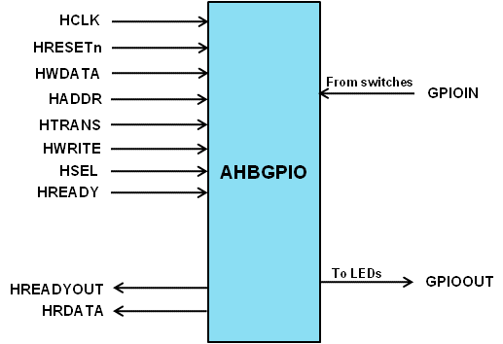

Programmer’s Model
Table 3-2 GPIO registers
Address | Type | Width | Reset Value | Name | Description
GPIO base +  0x00 | Read/  Write | 16 | 0x0000 | gpio_data | Stores the value of the GPIO data
GPIO base +  0x04 | Read/  Write | 16 | 0x0000 | gpio_data_dir | LOW indicates INPUT  HIGH indicates OUTPUT

Signal Overview
Table 3-3 GPIO signal overview
Name | Type | Source/  Destination | Description
HCLK | Input | AHB | Global clock signal
HRESETn | Input | AHB | Global reset signal active LOW
HADDR[31:0] | Input | AHB | Timer address bus
HTRANS[1:0] | Input | AHB | Timer transfer type indication
HWRITE | Input | AHB | Indicates transfer direction
HWDATA[31:0] | Input | AHB | Write data bus
HSEL | Input | AHB | Select signal for AHB GPIO
HREADY | Input | AHB | Indicates previous AHB transfer is complete
HRDATA | Output | AHB | AHB read data bus sent to AHB master
HREADYOUT | Output | AHB | Tells AHB master when transfers have completed
GPIOIN[15:0] | Input | Nexys2 Board | Controls the value of gpio_data register bits set as input
GPIOOUT[15:0] | Output | Nexys2 Board | Output equal to the value of gpio_data register

