AHB PS/2 keyboard

Introduction
This peripheral takes input data from a PS/2 keyboard and translates the data received into seven bit ASCII code. Using the interrupt handler for the keyboard, the peripheral can be programmed to write text to the VGA. This peripheral can also be used to send data across the UART to another computer by programming the keyboard interrupt handler.

Functional Overview
The keyboard functionality of this peripheral is limited to ACII characters, numbers, and symbols. Function keys such as ctrl, alt, caps lock, tab, arrow keys, and the f keys will not work. Instead they will generate an asterisk character to show that the input is unknown.
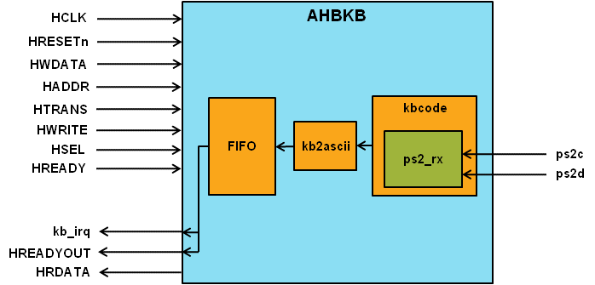

Programmer’s Model
The keyboard system will drive the kb_irq interrupt signal HIGH when the FIFO buffer is not empty.
If there is no data to be read on the FIFO and a read is asserted the peripheral will drive its HREADYOUT signal LOW and wait for input from the keyboard.

Signal Overview
Table 3-5 AHB keyboard signal overview
Name | Type | Source/  Destination | Description
HCLK | Input | AHB | Global clock signal
HRESETn | Input | AHB | Global reset signal active LOW
HADDR [31:0] | Input | AHB | AHB address bus
HTRANS [1:0] | Input | AHB | AHB transfer type indication
HWRITE | Input | AHB | Indicates transfer direction
HWDATA [31:0] | Input | AHB | Write data bus
HSEL | Input | AHB | Select signal for AHB KB
HREADY | Input | AHB | Indicates previous AHB transfer is complete
HRDATA | Output | AHB | AHB read data bus sent to AHB master
HREADYOUT | Output | AHB | Tells AHB master when transfers have completed
kb_irq | Output | Cortex-M0 | Interrupt signal driven HIGH when there is data to be read
ps2d | Input | PS/2 | PS/2 data signal
ps2c | Input | PS/2 | PS/2 clock signal

