AHB to On Board SRAMFLASH (Nexys3)

Introduction
This module converts AHB transactions into asynchronous SRAM & FLASH transactions. In Nexys3 we have PSRAM in place of SRAM. The peripheral can address upto 16MB. Signal FlashAtZero decides whether SRAM or Flash is mapped at zero. The source can be easily edited if you want to map the entire SRAM or Flash to use the whole 16 MB of the address space.

Functional Overview

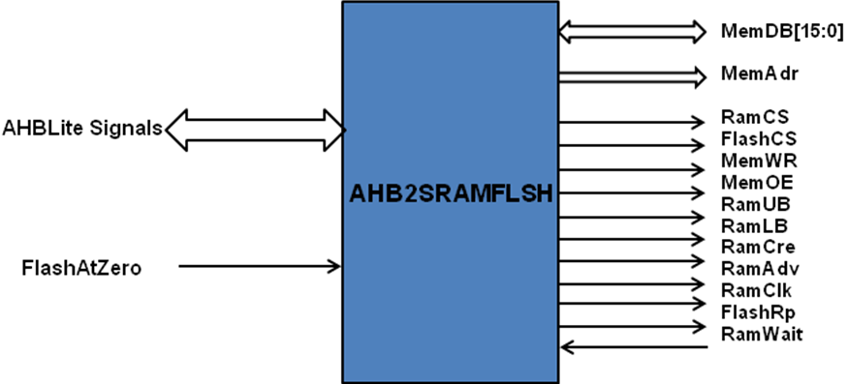

Programmer’s Model

FlashATZero = 0 | Start Address | End Address
PSRAM | 0x00_0000 | 0x7F_FFFF | PSRAM as Boot Memory
FLASH | 0x80_0000 | 0xFF_FFFF

FlashATZero = 1 | Start Address | End Address
FLASH | 0x00_0000 | 0x7F_FFFF | FLASH as Boot Memory
PSRAM | 0x80_0000 | 0xFF_FFFF

