AHB Timer
This peripheral contains acts as a timer for the system. It contains programmable registers to alter the operation mode of the timer as the programmer sees fit. When the timer’s value gets to zero an interrupt is generated. This peripheral was designed with the ability to act as a timer for context switching in a multitasking program in mind.

Introduction

Functional Overview
Free Running Mode
In this mode the timer will load the initial value of the load register, generate an interrupt when value reaches zero then continue to count from the maximum value of the register.
Periodic Mode
In this mode the timer will load the initial value of the load register, generate an interrupt when the value reaches zero then reload the load register and continue counting down. This generates a periodic interrupt signal.
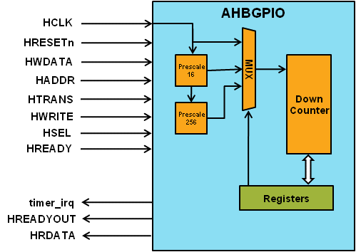

Programmer’s Model
Table 4-1 AHB Timer registers
Address | Type | Width | Reset Value | Name | Description
Timer base +  0x00 | Read/  Write | 32 | 0x00000000 | load | Timer start value and restart value in periodic mode
Timer base +  0x04 | Read | 32 | 0x00000000 | value | Timer value
Timer base +  0x08 | Read/  Write | 4 | 0x0 | control | Time control register to set mode, enable, and prescale value
Timer base +  0x0C | Read/  Write | 1 | 0 | clear | Timer clear register clears the interrupt signal

Register Descriptions
load[31:0]
The load register is what the value register is loaded to when the timer is first enabled. If the timer is in periodic mode the value register is reset to the load register after it reaches zero.
value[31:0]
The value register stores the current value of the timer. When the value register reaches zero an interrupt is asserted and the register is reset to either its maximum value (free running mode) or the value of load (periodic mode).
control[3:0]
The control register changes the operation mode of the timer in the following ways
Prescaling
The first two bits of the control register control how much the system clock is prescaled. The following table shows the different bit combinations and prescaled values.

Table 4-2 Timer prescale values
control[3:2] | Prescaled amount
00 | 1
01 | 16
1x | 256
Mode
The two different modes are controlled by the second bit of the control register.
Table 4-3 Timer operation mode values
control[1] | Operation mode
0 | Free Running
1 | Periodic
Enable
The enable signal is controlled by control[0]. When driven HIGH the timer will start operation and continue running until the signal is driven LOW. When the signal is low the timer halts operation where it is until enable driven HIGH again.
clear
When driven HIGH the clear signal sets the value of the timer interrupt to 0.

Signal Overview
Table 4-4 AHB Timer signal overview
Name | Type | Source/  Destination | Description
HCLK | Input | AHB | Global clock signal
HRESETn | Input | AHB | Global reset signal active LOW
HADDR[31:0] | Input | AHB | Timer address bus
HTRANS[1:0] | Input | AHB | Timer transfer type indication
HWRITE | Input | AHB | Indicates transfer direction
HWDATA[31:0] | Input | AHB | Write data bus
HSEL | Input | AHB | Select signal for AHB Timer
Table 4-4 AHB Timer signal overview (cont.)
Name | Type | Source/  Destination | Description
HREADY | Input | AHB | Indicates previous AHB transfer is complete
HRDATA | Output | AHB | AHB read data bus sent to AHB master
HREADYOUT | Output | AHB | Tells AHB master when transfers have completed
timer_irq | Output | AHB | Signals when the value register reaches 0

