AHB Universal Asynchronous Receiver/Transmitter (UART)

Introduction
This is a peripheral designed to communicate using the Nexys2 board’s RS-232 serial port. It is able to translate data between parallel and serial forms. The UART can be used for communication between the Cortex-M0 DS and another computer that has a serial port connection. This module does not have programmable settings for baud rate, number of stop bits, or inclusion of a parity bit to keep the peripheral simple. As an exercise, features such as variable baud rate, variable number of stop bits, and inclusion of parity bit can be implemented.

Functional Overview
This UART peripheral has the following settings and is not configurable.
Baud rate: 19200
Parity: None
Stop bits: 1
The UART uses an over sampling procedure to send and receive data from the RS-232 port. The UART also uses two FIFOs as buffers for both send and receive data. If the receive FIFO is empty and a read request is sent the UART will drive HREADYOUT LOW and wait for data before continuing. If the transfer FIFO becomes full the UART will also drive HREADYOUT LOW and wait for the FIFO to become not full before continuing.
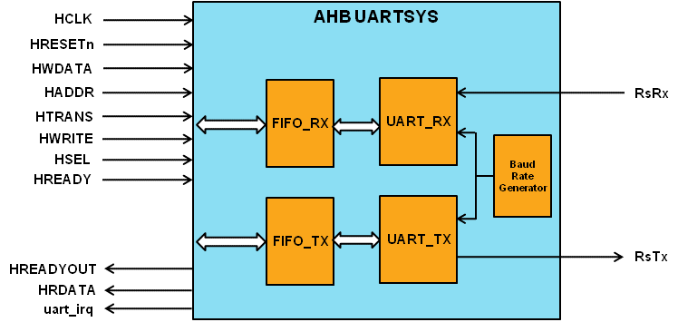

Programmer’s Model
The UART generates an interrupt, which is driven HIGH whenever there is data to be read on the receiving FIFO. The interrupt is mapped to the third bit of the Cortex-M0 irq signal. The interrupt is cleared when the data is read.

Signal Overview
Table 3-1 UART signal overview
Name | Type | Source/  Destination | Description
HCLK | Input | AHB | Global clock signal
HRESETn | Input | AHB | Global reset signal active LOW
HADDR[31:0] | Input | AHB | Timer address bus
HTRANS[1:0] | Input | AHB | Timer transfer type indication
HWRITE | Input | AHB | Indicates transfer direction
HWDATA[31:0] | Input | AHB | Write data bus
HSEL | Input | AHB | Select signal for AHB UART
HREADY | Input | AHB | Indicates previous AHB transfer is complete
HRDATA | Output | AHB | AHB read data bus sent to AHB master
HREADYOUT | Output | AHB | Tells AHB master when transfers have completed
RsRx | Input | RS-232 | Receive data coming from the RS-232 port
RsTx | Output | RS-232 | Transfer data from the UART to the RS-232 port
uart_irq | Output | Cortex-M0 | UART interrupt driven HIGH when there is data to be read

