AHB Video Graphics Array (VGA)

Introduction
The AHB VGA system is a combination of multiple modules used to generate a text console over the VGA port of the Nexys2 board. It consists of a VGA synchronizer and a console generator, which includes dual port synchronous RAM for storing data and a ROM for text display. The Nexys2 board gives only eight bits for color, three for red, three for green, and two for blue giving it the ability to display 256 different colors. The peripheral is set to display in standard VGA resolution of 640x480.

Functional Overview
VGA Synchronization
The VGA synchronization module uses the VGA standard resolution of 640x480. It contains a mod-2 counter to generate a clock of 25 MHz, which is close to the pixel rate of 25.2 MHz needed for a 60 Hz refresh rate. It uses this clock to generate the vertical and horizontal synchronization outputs as well as the x and y pixel locations for drawing.
VGA Console
The console portion of the VGA system uses a tile scheme to make font display easier as well as reduce the memory required to store display data. The screen size is converted to a grid of 80x30 8x16 pixel tiles, with each tile able to display one character. The pixel mapping for each character is stored in the font ROM as a bit map. The dual port RAM stores the seven bit ASCII value of each tile. The return key or new line character (‘\n’) will create a new line on the console and move all lines up if the cursor is already on the last line. A backspace will insert a blank where the cursor is currently and move it backwards one tile, but not to the previous line.
VGA Image
The image generation of the VGA system allows 256x128 pixels at the top right of the screen to be set to a specified color. This can be done by writing 8-bit color data in the form RRRGGGBB to a specific pixel of this area. The pixels are mapped starting with the top left of the image area and ending with the bottom right. Any image will be shown behind text generated by the console.
NOTE: The image display capabilities have been enhanced in the current Verilog design, but conceptually nothing has changed. Refer to Verilog files.

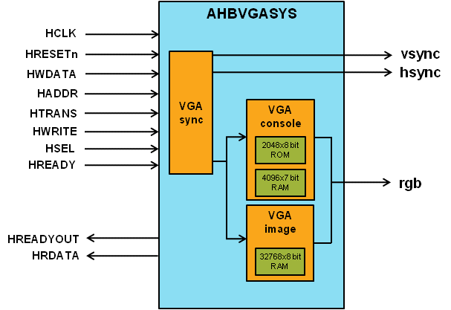

Programmer’s Model
Table 3-4 AHB VGA Memory Map
Address | Description
VGA base + 0x00 | Writes to the current location of the cursor.
0x55A00000-0x55A20000 | 256x128 image area at the top right of the screen. 0x59A00000 is the top left of the area and 0x59A2000 is the bottom right. HADDR[16:2] = YYYYYYYXXXXXXXX where X and Y are the horizontal and vertical pixel offset respectively.
Note: Currently all of the video memory is on the FPGA chip itself. As an exercise it could be moved to PSRAM.

Signal Overview
Table 3-4 AHB VGA signal overview
Name | Type | Source/  Destination | Description
HCLK | Input | AHB | Global clock signal
HRESETn | Input | AHB | Global reset signal active LOW
HADDR [31:0] | Input | AHB | AHB address bus
HTRANS [1:0] | Input | AHB | AHB transfer type indication
HWRITE | Input | AHB | Indicates transfer direction
HWDATA [31:0] | Input | AHB | Write data bus
HSEL | Input | AHB | Select signal for AHB VGA
HREADY | Input | AHB | Indicates previous AHB transfer is complete
HRDATA | Output | AHB | AHB read data bus sent to AHB master
HREADYOUT | Output | AHB | Tells AHB master when transfers have completed
hsync | Output | VGA Port | The horizontal synchronization signal sent to the VGA port
vsync | Output | VGA Port | The vertical synchronization signal sent to the VGA port
rgb [7:0] | Output | VGA Port | This contains the data for the red, green, and blue value of each pixel. It is in the format RRRGGGBB

