**Precision six-axis inertial navigation module specification**

**1 product description**

This six-axis module uses advanced digital filtering technology (Kalman filter), can effectively reduce the measurement noise, improve the measurement accuracy.

The module integrates motion engine DMP, and obtain quaternion to get the current attitude. Attitude measurement accuracy of 0.01 degrees, high stability, performance and even better than some of the professional inclinometer!

This module uses high-precision six-axis gyro accelerometer MPU6050, read the measurement data MPU6050 by a processor and output via the serial port, eliminating the need for users to develop their own MPU6050 complex I2C protocol, and careful PCB layout and processes ensure MPU6050 Receive external interference minimum, the highest precision measurement.

**2 Performance parameters**

1. Voltage: 3V ~ 6V
2. Current: <10mA
3. Volume: 17.8mm X 17.8mm Weight: 1.1g
4. Pad pitch: up and down 100mil (2.54mm), left and right 600mil (15.24mm)
5. Measuring dimensions: Acceleration: 3-dimensional angular velocity: 3-dimensional attitude angle: 3-dimensional
6. Range: Acceleration: ± 16g, angular velocity: ± 2000 ° / s.
7. Resolution: Acceleration: 6.1e-5g, the angular velocity: 7.6e-3 ° / s.
8. Stability: acceleration: 0.01g, angular velocity 0.05 ° / s.
9. Attitude Stability Measurement: 0.01 °.
10. Data output frequency 100Hz (baud rate 115200) / 20Hz (baud rate 9600). 11, data interface: Serial (TTL level), I2C (directly connected MPU6050, no attitude output)

10, baud rate 115200kps / 9600kps.

**3 Pin Description:**

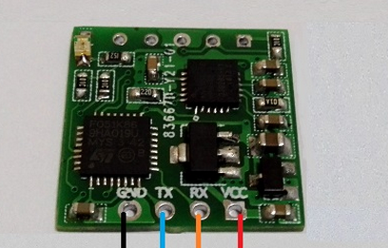

|  |  |
| --- | --- |
| name | Features |
| VCC | Power module, 3.3V, or 24 V input |
| RX | Serial data input, TTL level |
| TX | Serial data output, TTL level |
| GND | Ground negative electrode |

**4 Hardware connection method**

**4.1 With the computer**

Connected to a computer, you need USB to TTL level serial port module. Recommend the following USB to serial module.

USB serial module connection 6050 module approach is: USB serial module + 5V, TXD, RXD, GND connection

VCC 6050 module, RX, TX, GND. Note TXD and RXD cross.

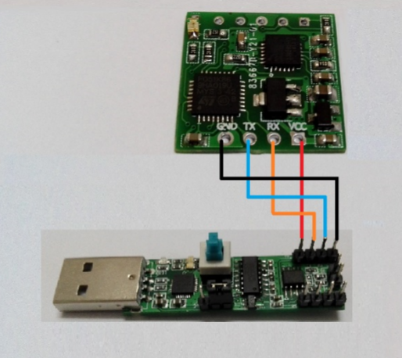

**Even SCM 4.2**

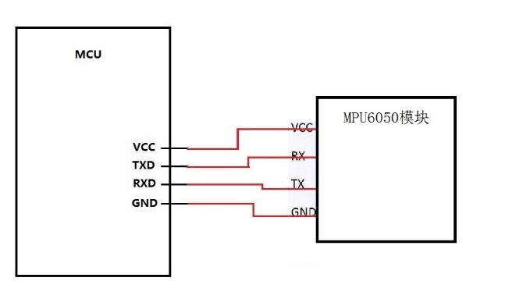

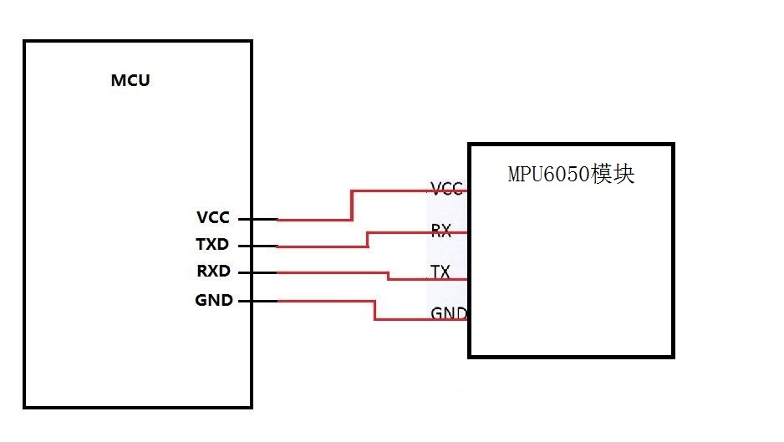

**4.3 MCU microcontroller connected to output debug information.**

Typically, serial MCU resources are relatively tight, there is only a single-chip serial port, and debugging through serial output debug information, then the MCU'sTX pin can be connected to the USB-to-serial module RX,

TX 6050 on the RX module is connected to MCU pins, so that both can receive data 6050 MCU module, and can output debugging information. Just MCU can not output the serial command to the 6050 module, but the module is configured are can be powered down to save, and calibration can then third seconds after power on automatically, usually without sending any command to work.

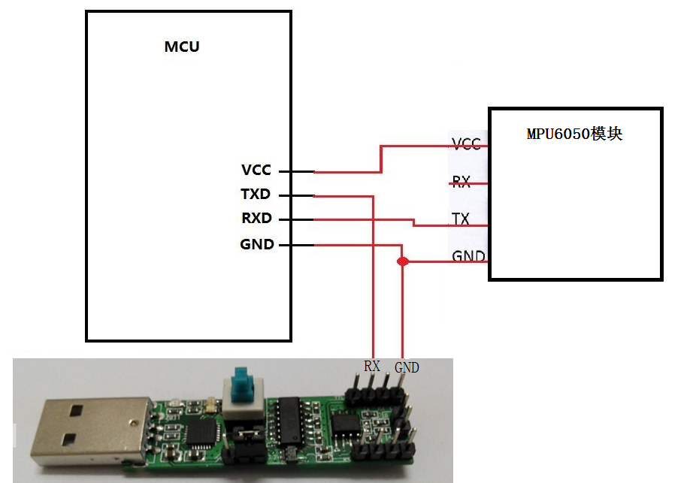

**4.4 communication module with the microcontroller with the PC monitor.**

If you need to receive data 6050 output module in MCU while using the PC monitor the current data, USB to serial module can be connected to the module's RX TX pin and common ground can be.

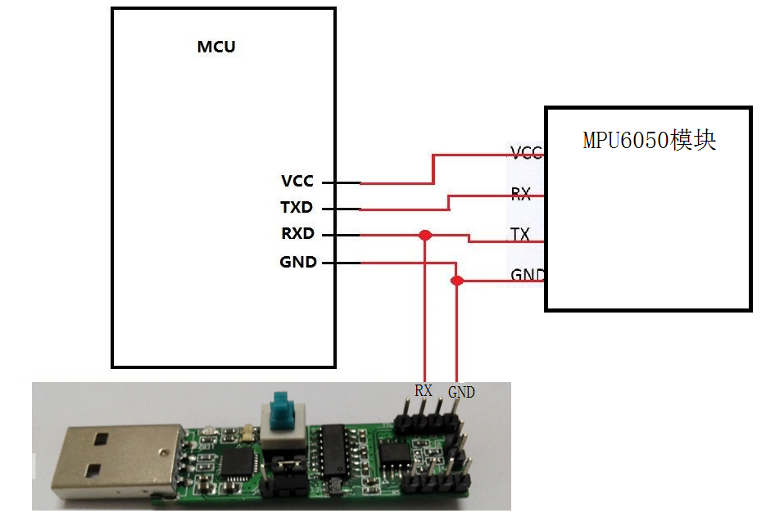

**5 letter of agreement**

Level: TTL-level (non-RS232 level, when the module is connected to the wrong RS232 level could cause damage to the modules) Baud rate: 115200/9600, 1 stop bit, parity bit 0.

**5.1 Host computer to the module**

|  |  |  |
| --- | --- | --- |
| Instruction content | Features | Remarks |
| Lt; / RTI & gt; | Angle initialization | The Z-axis angle to zero |
| 0x61 | Using the serial port, disable I2C | Power-down save, it is recommended to use the host computer to modify |
| 0x62 | Disable the serial port, using the I2C interface | Power-down save, it is recommended to use the host computer to modify |
| 0x63 (‘c’) | 115200 baud rate, frame rate100Hz | Power-down save, it is recommended to use the host computer to modify |
| 0x64 (‘d’) | 9600 baud rate, frame rate20Hz | Power-down save, it is recommended to use the host computer to modify |

Description:

1. module after power required to remain stationary inside the module MCU will perform automatic calibration module when stationary (elimination of gyro drift), after the calibration angle Z axis will be re-initialized to 0, Z axis angle output is 0 , Can be regarded as the signal that the automatic calibration completes.

2. The factory default settings using the serial port baud rate 115200, frame rate 100Hz. Configuration can be configured through the host computer software, because all configuration is saved, so only need to configure once.

**5.2 module first bit machine:**

Module sends first bit machine each frame of data is divided into three packets, each packet acceleration, angular velocity and angle bag package, 3

Packet sequence output. 115200 baud rate when every 10ms output a data baud rate of 9600 when every 50ms output a data.

**5.2.1 Acceleration Output:**

|  |  |  |
| --- | --- | --- |
| The data number | Data content | meaning |
| Lt; / RTI & gt; | 0x55 (‘U’) | Baotou |
| 1 | 0x51 (‘Q’) | Identify this package is the acceleration package |
| 2 | AxL | X-axis acceleration low byte |
| 3 | AxH | X-axis acceleration high byte |
| 4 | AyL | y-axis acceleration low byte |
| 5 | AyH | y-axis acceleration high byte |
| 6 | AzL | z-axis acceleration low byte |
| 7 | AzH | z-axis acceleration high byte |
| 8 | TL | Temperature low byte |
| 9 | TH | Temperature high byte |
| 10 | Sum | Checksum |

Acceleration calculation formula:

ax=((AxH<<8)|AxL)/32768*16g (g is the gravitational acceleration, preferably 9.8m/s2)

ay=((AyH<<8)|AyL)/32768*16g (g of acceleration of gravity, it is desirable 9.8m/s2)

az=((AzH<<8)|AzL)/32768*16g (g is the gravitational acceleration, the desirability of 9.8m/s2) temperature calculation formula:

T=((TH<<8)|TL) /340+36.53 ℃

Checksum:

Sum = 0x55 + 0x51 + AxH + AxL + AyH + AyL + AzH + AzL + TH + TL

**5.2.2 Angular velocity output:**

|  |  |  |
| --- | --- | --- |
| The data number | Data content | meaning |
| Lt; / RTI & gt; | 0x55 (‘U’) | Baotou |
| 1 | 0x52 (‘R’) | Identifies this package as angular velocity packets |
| 2 | WxL | X-axis angular velocity low byte |
| 3 | WxH | X-axis acceleration high byte |
| 4 | WyL | y-axis acceleration low byte |
| 5 | WyH | y-axis acceleration high byte |
| 6 | WzL | z-axis acceleration low byte |
| 7 | WzH | z-axis acceleration high byte |
| 8 | TL | Temperature low byte |
| 9 | TH | Temperature high byte |
| 10 | Sum | Checksum |

Angular velocity calculation formula:

wx=((wxH<<8)|wxL)/32768*2000(°/s)

wy=((wyH<<8)|wyL)/32768*2000(°/s)

wz=((wzH<<8)|wzL)/32768*2000(°/s)

temperature calculation formula:

T=((TH<<8)|TL) /340+36.53 ℃

Checksum:

Sum = 0x55 + 0x52 + wxH + wxL + wyH + wyL + wzH + wzL + TH + TL

**5.2.3 Angle Output:**

|  |  |  |
| --- | --- | --- |
| The data number | Data content | meaning |
| Lt; / RTI & gt; | 0x55 (‘U’) | Baotou |
| 1 | 0x53 (‘S’) | Identifies this package as an angle package |
| 2 | RollL | X axis angle low byte |
| 3 | RollH | X axis angle high byte |
| 4 | PitchL | y-axis angle of the low byte |
| 5 | PitchH | y-axis angle high byte |
| 6 | YawL | z axis angle low byte |
| 7 | YawH | z axis angle high byte |
| 8 | TL | Temperature low byte |
| 9 | TH | Temperature high byte |
| 10 | Sum | Checksum |

Angular velocity calculation formula:

Roll angle (x-axis) Roll = ((RollH << 8 ) | RollL) / 32768 * 180 (°)

pitch angle (y-axis) Pitch = ((PitchH << 8 ) | PitchL) / 32768 * 180 (°)

yaw angle (z-axis) yaw = ((YawH << 8 ) | YawL) / 32768 * 180 (°) temperature is calculated:

T = ((TH << 8) | TL) /340+36.53 ℃

Checksum:

Sum = 0x55 + 0x53 + RollH + RollL + PitchH + PitchL + YawH + YawL + TH + TL

Note:

1. Attitude angle coordinate system used to place the settlement day for the Northeast coordinate system, the positive direction of the module, as shown to the left of the X-axis, Y-axis forward, up the Z axis. Euler angle rotation sequence represents a coordinate system is defined as when the attitude is zyx, which is to turnaround the z-axis, y-axis and then turn around and then turn around the x-axis.
2. Although the roll angle in the range of ± 180 degrees, but in fact the coordinate rotation sequence is ZYX, representing the attitude of the time, the pitch angle(Y axis) in the range of only ± 90 degrees, after more than 90 degrees will be converted to less than 90 degrees, X-axis while allowing an angle greater than 180degrees. Detailed principles please own Baidu Euler angle and gesture that the relevant information.
3. Since the three-axis is coupled only at small angles will show when independent changes in the attitude of a large angle when the coupling angle will change, for example, when the X-axis close to 90 degrees, even if only the attitude around the X axis, Y-axis Angle will also follow a larger change, which is the Euler angle of attitude that inherent problems.

**6 Use the host computer**

Select the correct serial port

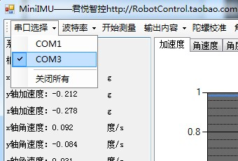

Under normal circumstances, choose the right serial port can see the data.

If you need to configure the baud rate, click

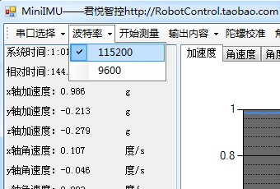Point to start measurement, stop the measurement, select whether to use the serial output data.

The gyro calibration button is used to calibrate the gyro null and remains stationary during 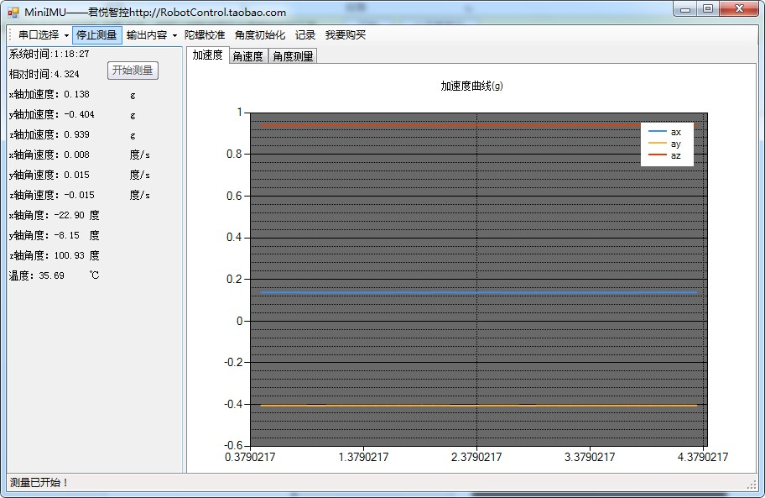calibration.

Angle initialization data for the Z-axis so that the angle of zero.

The Point Record button saves the data as a file

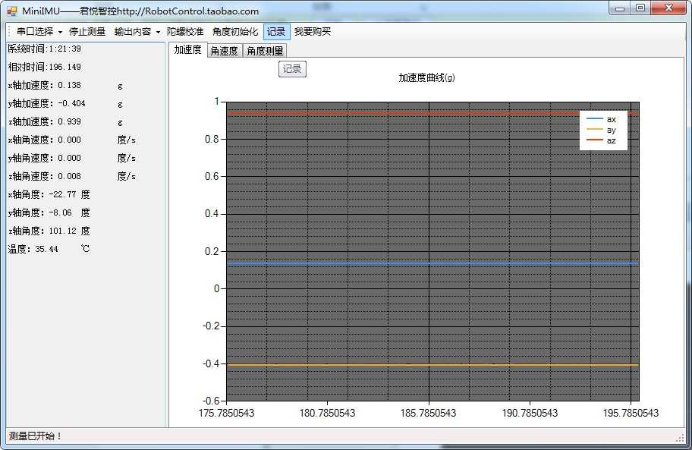

Save the file in the host computer program directory:

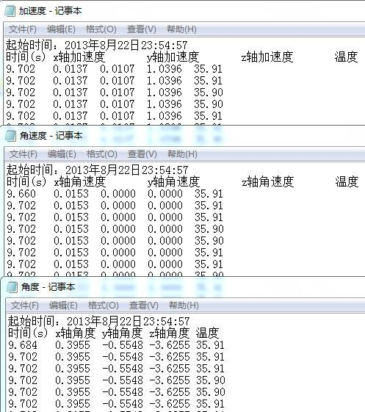

Data can be imported into Exel or Matlab for analysis. In the Matlab environment to run PC root directory

"Matlab drawing .m" file, you can draw a graph of the data.



 

 