CCIThink: A Department Information Chatbot for CCIT Students
IMRaD research manuscript · Revised draft
Boncajes, Rhian Jared D.
Marcos, Maricar N.
Carandang, Jamie Pearl U.
CCIT, FAITH Colleges
Principles of Artificial Intelligence and Data Science
November 2026 · Draft for author review

Abstract
This project developed CCIThink, a web-based chatbot that helps students find information about the College of Computing and Information Technology (CCIT) at FAITH Colleges. The chatbot uses a supplied collection of 218 frequently asked questions (FAQs). Its topics include academic programs, scholarships, faculty, curricula, subject prerequisites, student organizations and college events. A question classifier was trained to suggest which FAQ matches a student's question. The dataset contained 1,808 labeled questions: 936 for training, 436 for choosing the model settings, and 436 for testing the selected model. Training questions came from the supplied database. Validation and test questions were written with AI assistance and fixed before the experiment. Four settings of the Naive Bayes classifier were compared. The selected model correctly classified 364 of 436 test questions, giving 83.5% accuracy and a macro F1 score of 0.833. These results apply to the constructed dataset, rather than to actual student use. The chatbot also checks whether the source supports an answer and asks for details when a question is unclear. The project demonstrates a working student information prototype. Evaluation with independently written student questions and confirmation of current department information are recommended before wider use.
Keywords: department chatbot; frequently asked questions; Naive Bayes; text classification; student information

Introduction

Background of the study
Students may need information about their programs, scholarships, subjects, faculty and college activities. Department documents can contain this information, but students must still find the part that answers their question. CCIThink was developed to provide another way of searching the supplied CCIT information through a simple chat interface. This project did not measure existing staff workload or student waiting times. Its purpose was to build and evaluate the chatbot, rather than to claim that it had already improved department services.
The project also applies the topics covered in Principles of Artificial Intelligence and Data Science. These include preparing a dataset, examining its contents, training a model and checking its results (Final project: AI-powered data analysis and prediction system, n.d.). In this study, the model's task is to choose an FAQ label for a question. For example, a question about BSCS internship hours should be linked to the FAQ about that requirement. The model suggests a label; the department information still comes from the stored source answer.

Objectives
The general objective was to develop a department chatbot with a trainable question classifier. The specific objectives were to prepare labeled examples for the 218 FAQs, check the quality of the dataset, compare four model settings, measure the selected model's performance, and prevent unclear or unsupported questions from receiving an arbitrary answer.
- How accurately does the selected model classify the constructed test questions?
- Which of the four model settings performs best on the validation questions?
- What errors and limitations need to be considered when using the classifier in the chatbot?

Related concepts and scope
Naive Bayes is a method for classifying text based on patterns in word counts. It was chosen because its calculations can be implemented and explained in Python without a large pretrained model (Scikit-learn developers, n.d.-b). Accuracy and macro F1 were used to describe its performance (Scikit-learn developers, n.d.-a). These references explain the methods; the project implements its own count-based classifier rather than using scikit-learn to train it.
CCIThink is limited to the supplied CCIT knowledge. It does not access private student records, calculate grades, complete enrollment transactions or confirm that a policy is still current. The present evaluation uses prepared questions, not a survey or a study involving student participants. It is intended as a final-project prototype that the authors can demonstrate and explain.

Methods

Development approach and data source
The study involved building the software and testing it locally. Each question was treated as one data example. No participants were recruited. The current knowledge base was imported from the user-supplied database_v3.json file, which contains 218 FAQs and alternative versions of their questions (CCIT knowledge database, n.d.). Original answers were retained. Checking the import confirmed that the text was copied correctly; it did not independently verify department policies or staff assignments. Some records have a specific academic year, which must remain clear in answers.
The question dataset contains six columns: an example ID, the question, its correct FAQ label, its assigned split, its language and its origin. Only question text is used as model input. The FAQ label is the expected output. Names of files, answers and other metadata are not used as question features. All 1,808 examples in the current dataset are English.
Table 1. Current dataset allocation
Purpose | Number of questions | Origin
Training | 936 | Supplied FAQ titles and alternative questions
Validation | 436 | Two AI-authored questions per FAQ
Testing | 436 | Two different AI-authored questions per FAQ
Total | 1808 | 218 FAQ labels
The supplied questions provided between three and eight training examples per FAQ. One overlapping question about CCIT Camp was assigned to its specific Camp FAQ instead of the general activities FAQ. The newly written validation and test examples were stored separately before the first experiment. Validation questions were used to choose the model settings. Test questions were reserved for the final measurement and were not changed after the results were inspected. Because the new questions were AI-authored and sometimes use similar sentence patterns, they are not an independent sample of real student questions.

Data preparation
The dataset loader checks that required values are present, labels are known, and questions are within the allowed length. It also checks for repeated questions. If the same question has different labels or appears in more than one split, processing stops so the problem can be corrected. Text is converted to a consistent format by standardizing letter case, spaces and common punctuation. Program abbreviations, numbers and words such as “not” are retained because they can affect meaning. The process records unusually long questions but keeps them when they are valid.

Training and model selection
The model learns how often words occur in questions assigned to each FAQ. It then uses those counts to compare possible labels for a new question. Two input formats were tested: individual words (unigrams), and individual words together with neighboring word pairs (unigrams and bigrams). Each format was tested with smoothing values of 1.0 and 0.5. Smoothing gives a small allowance to word combinations that did not occur during training, instead of treating them as impossible.
Only the training questions were used to learn word patterns. The four settings were compared on the same validation set. The setting with the highest validation macro F1 was selected. The selected model was then evaluated on the test set without being trained again on validation or test examples. A simple comparison method always predicted the most common training label. This comparison shows what can be achieved without using the words in a question.

Evaluation and chatbot checks
Accuracy is the percentage of test questions assigned to the correct FAQ. Macro F1 summarizes precision and recall while giving equal weight to each FAQ label. Precision concerns whether predictions for a label are correct; recall concerns whether questions belonging to that label are found. Reporting both accuracy and macro F1 helps describe performance across the different topics. A confusion matrix records which labels were mistaken for one another.
Classifier testing is separate from testing the chat application. Before answering, the chatbot checks the question's topic and the details needed to identify a source. For example, “prerequisites” alone should lead to a request for the subject and program. A representative lookup should use the named roster and the requested program or year, rather than a general description of the organization. Short forms such as “reps” and “prereqs” are handled by application rules. Questions that request unavailable details receive a fallback response. The trained model only assists ranking after these checks; a high model score is not proof that an answer is supported.

Responsible use
The system does not require private student records. Optional AI answer generation sends the question and selected source text to the configured external provider. This service was not used to calculate the classifier results. Department facts and permission to distribute the source should be checked before public use. AI assistance was used in implementation, example writing and drafting this paper. The named authors must review and understand the work before submission.

Results

Dataset checks
All 1,808 input questions passed the dataset checks and were retained. No rows were removed for missing information, invalid values or duplicate questions. The loader standardized the formatting of all rows. Question lengths ranged from 2 to 28 words or number tokens, with an average of 12.38. Nine unusually long questions were retained. Training counts differ across labels because the supplied FAQs contain different numbers of alternative questions. These counts describe the prepared dataset, not the frequency of questions asked by students.
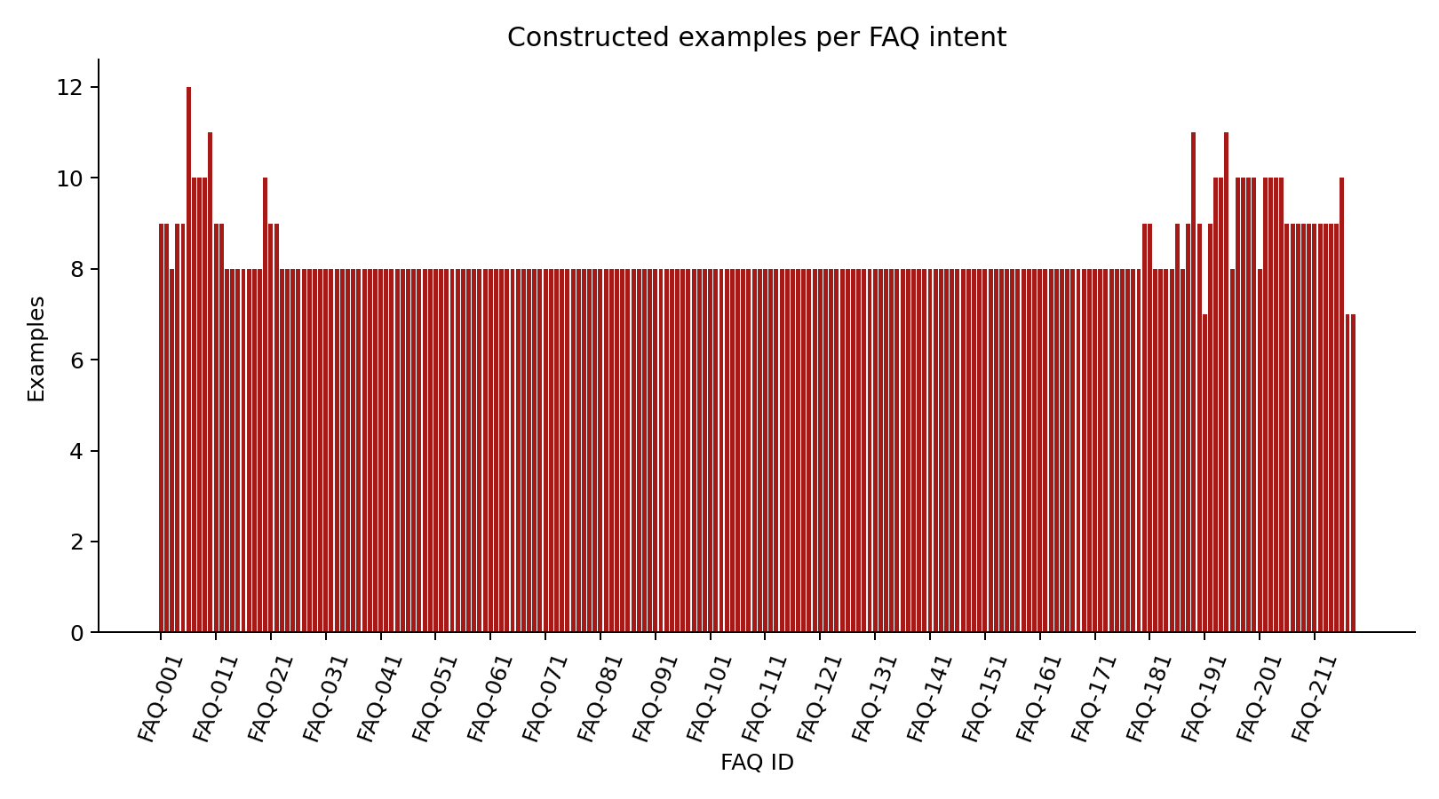
Figure 1. Examples per FAQ label. The counts reflect dataset preparation, not student demand.
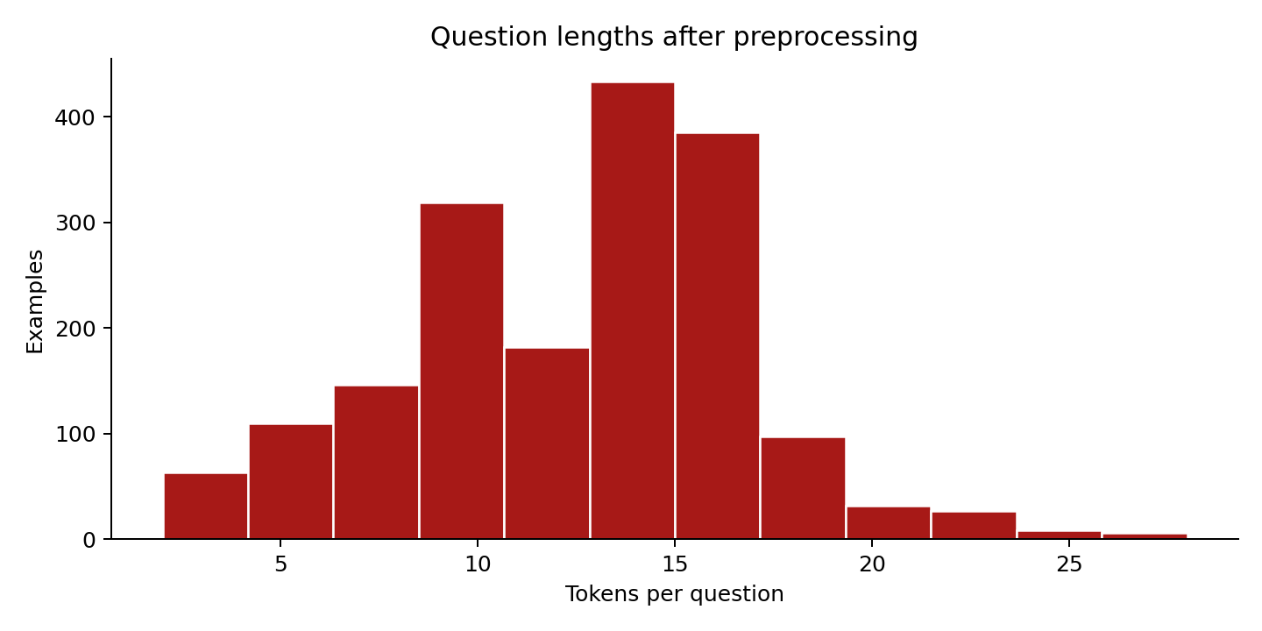
Figure 2. Question lengths after text formatting was standardized.

Validation and test performance
Table 2. Comparison using validation questions only
Model setting | Correct / total | Accuracy | Macro F1
Unigrams / smoothing=1 | 357/436 | 81.9% | 0.815
Unigrams / smoothing=0.5 | 366/436 | 83.9% | 0.838
Uni+bigrams / smoothing=1 | 281/436 | 64.4% | 0.696
Uni+bigrams / smoothing=0.5 | 286/436 | 65.6% | 0.706
The individual-word model with smoothing 0.5 performed best on validation, correctly classifying 366 of 436 questions. Its validation macro F1 was 0.838. The word-pair settings did not improve validation performance in this experiment. This result supports the selected setting for this dataset, but does not show that individual words will always work better for other question collections.
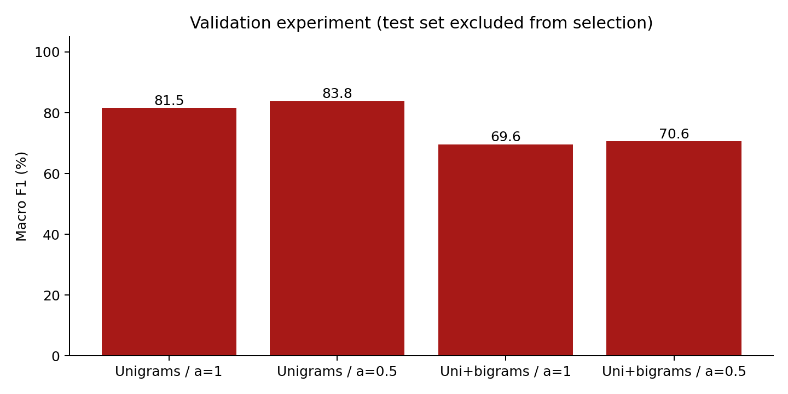
Figure 3. Validation macro F1 for the four model settings. The test set did not determine the winner.
On the separate test set, the selected model classified 364 of 436 questions correctly. This gives 83.5% accuracy and a macro F1 of 0.833. The always-predict-one-label comparison achieved 0.5% accuracy. There were 72 incorrect test predictions. The full prediction list and error records are saved with the project.
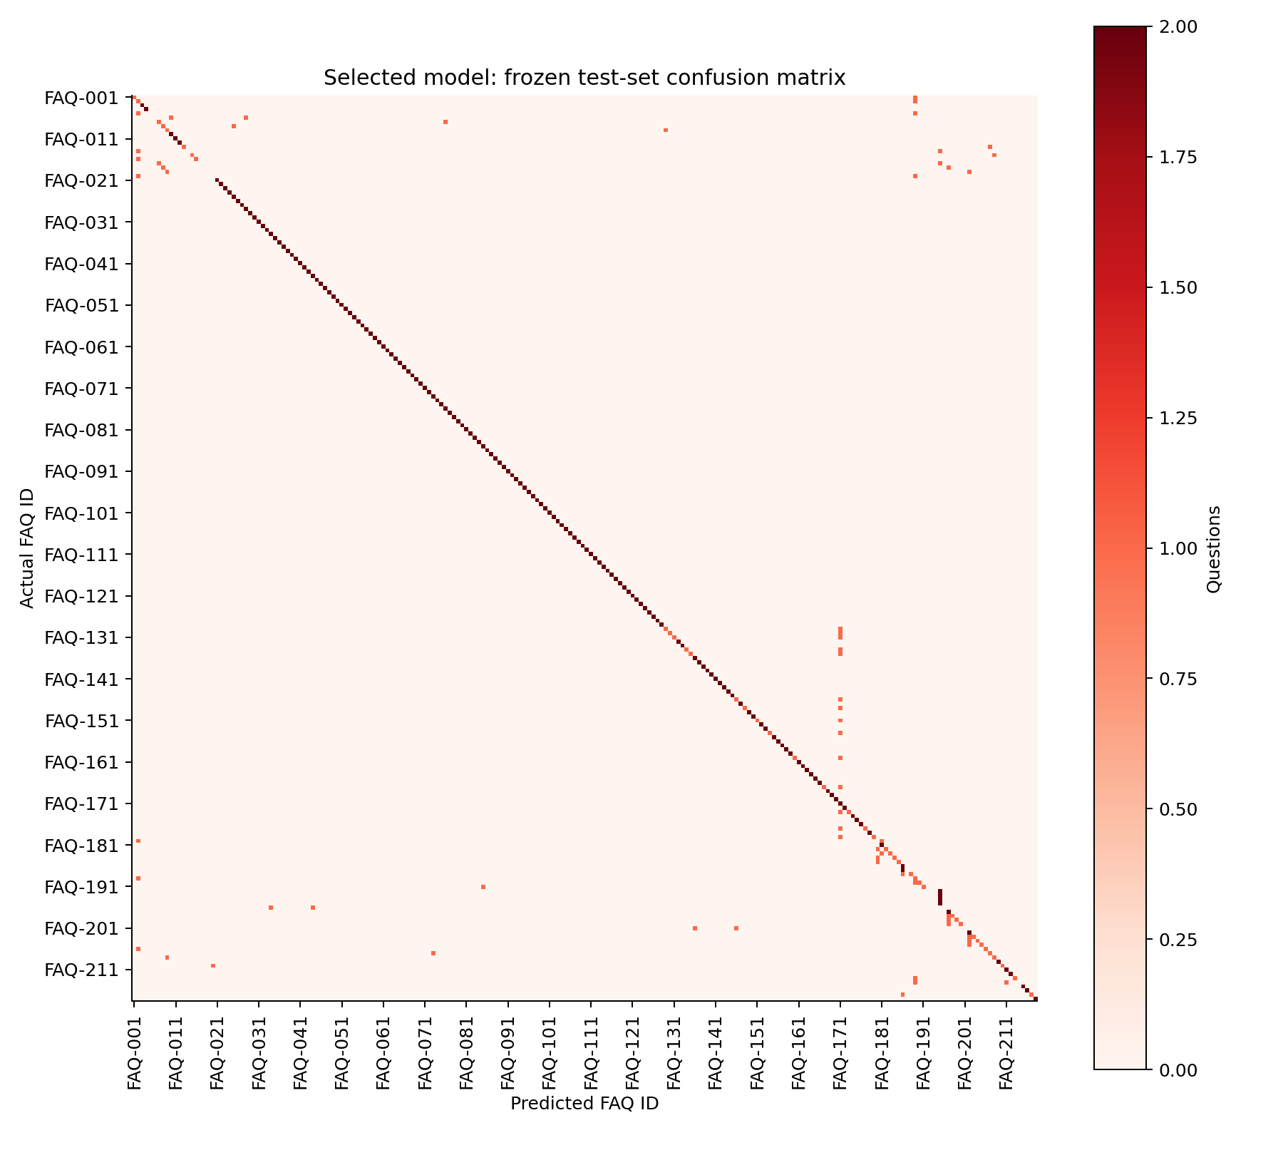
Figure 4. Actual and predicted FAQ labels on the test set. Marks away from the diagonal indicate mistakes.
Errors included confusion between curriculum years, similar prerequisite topics, and broad questions that were assigned to a more specific FAQ. Software tests also checked input handling, source selection, clarification and conversation follow-ups. Browser checks exercised the chat interface on mobile and desktop sizes. These checks help identify software problems; they do not measure student satisfaction or establish the accuracy of every possible conversation.

Discussion

Meaning of the findings
The first research question is answered by the test result of 83.5% accuracy. The second is answered by the validation comparison, which favored individual words with smoothing 0.5. The third concerns the mistakes and limits of using this result in a chatbot. Although the model performed better than the simple comparison method, its 72 test errors show that it should not decide answers on its own.
Finding the right FAQ and giving reliable information are related but different tasks. A model can select the wrong FAQ, and even a correctly selected source may contain an outdated policy. The chatbot therefore needs both careful source selection and department review. Clarification rules are especially useful for short questions that omit the subject, program or year. They cannot guarantee that every unclear question will be recognized, so errors should continue to be recorded.

Limitations and recommendations
Each FAQ has only two test questions. This is too small to make strong claims about an individual topic. The examples were not independently labeled by students or department staff, and related wording may remain across the splits. All current examples are English, so the results do not establish performance on Filipino or Taglish. The project also did not measure response-time improvements, staff workload, student satisfaction or use under real deployment conditions.
The next step should be to collect independently written student questions with appropriate permission, ask reviewers to check their labels, and prepare a new test set. More examples should cover difficult curriculum distinctions, abbreviated wording, typos and questions outside the database. New evaluation questions are needed before making a fresh accuracy claim after further training changes. Department representatives should also confirm the dates and contents of the stored information.

Conclusion
CCIThink demonstrates how a department chatbot can combine a stored FAQ collection, a trainable question classifier and rules for handling unclear requests. The current model covers 218 FAQ labels and achieved 83.5% accuracy on 436 constructed test questions. The project provides a working final-project prototype and a repeatable way to examine its results. Its findings support further development, rather than a claim that it is already reliable for all student questions. Independent student evaluation and updated department verification remain necessary.

References
CCIT knowledge database. (n.d.). database_v3.json [User-supplied department FAQ collection; institutional accuracy not independently confirmed].
Final project: AI-powered data analysis and prediction system. (n.d.). [Unpublished course handout, Principles of Artificial Intelligence and Data Science].
Scikit-learn developers. (n.d.-a). Metrics and scoring: Quantifying the quality of predictions. Scikit-learn user guide. https://scikit-learn.org/stable/modules/model_evaluation.html
Scikit-learn developers. (n.d.-b). Naive Bayes. Scikit-learn user guide. https://scikit-learn.org/stable/modules/naive_bayes.html

Appendix: Reproducing the experiment
Repository: https://github.com/jared-boncajes/CCIT_Chatbot. The active dataset is data/question_dataset_v3.csv and the fixed validation and test questions are in data/question_holdouts_v3.json. The original 22-FAQ experiment is retained separately in research/results; it is not the experiment reported in this revised paper.
python -m pip install -r requirements-research.txt
python tools/build_question_dataset_v3.py
python analyze.py --dataset data/question_dataset_v3.csv --output-dir research/results-v3
python tools/build_imrad.py
These commands should be run in an activated virtual environment from the project folder. The report, trained model, charts and test predictions are saved in research/results-v3. To use the chatbot without an external AI key, set CHAT_MODE=faq in .env and run python app.py. The analysis page shows the current results. Repeating the same experiment is a check of reproducibility, not a new independent evaluation.

