Jared Hess
Math 431
Exam2 Take Home

1)

%a
subplot(2,2,1)
ezplot('x^2',[-1,1])

%b
subplot(2,2,2)
ezplot('x^3 - x',[-2,2])

%c
subplot(2,2,3)
%ezsurf('x^2 + y^2',[-2,2],[-2,2])
[X,Y] = meshgrid(linspace(-2,2))
Z = X.^2 + Y.^2;
surfc(X,Y,Z)

%d
subplot(2,2,4)
%ezmesh('x^2 + y^2',[-2,2],[-2,2])
meshc(X,Y,Z)

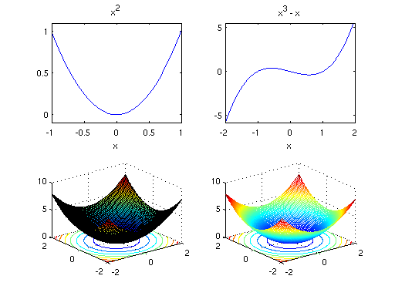

2)
function [output] = prob2(A,b)

if (size(A,1) == size(A,2))
output = inv(A) * b;
else
output = A\b;
end%if

end%function

3)
numUsers=3;
numItems=3;
total = [];

for user=1:numUsers
for item=1:numItems
disp(['User: ',num2str(user)])
A(user,item)=input(['Quantity of item ',num2str(item), ': ']);
end%for
total(user,1)=input('Total Cost: ');
end

result = A\total;
disp('Costs: ')
for item=1:numItems
disp(['Item',num2str(item),': ',num2str(result(item))])
end%for

4)
hold on;

X = [-1,0,1,2]
Y = [1,0,1,2]

interp=polyfit(X,Y,length(X))

scatter(X,Y);

plot(linspace(min(X),max(X)),polyval(interp,linspace(min(X),max(X))));

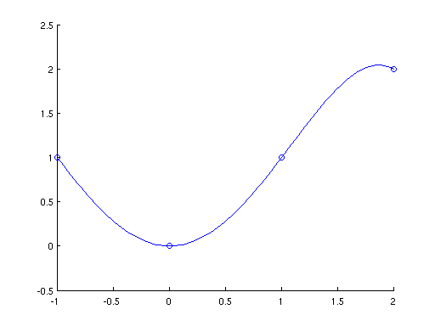
5)
hold on;
%a
x=linspace(-3,3);
dx=linspace(-2,2,6);
dy=dx.^3.-dx;

y=lagrange(dx,dy,x);

scatter(dx,dy);
plot(x,y);

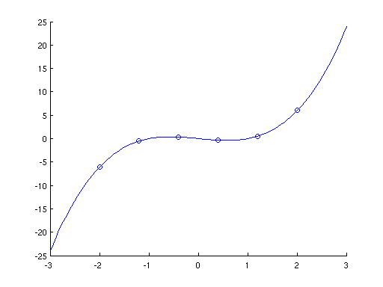

%b
x=linspace(-3,3);
dx=linspace(-2,2,6);
dy=dx.^3-dx+.5*rand(1,6);

%c
y=lagrange(dx,dy,x);
plot(x,y);
plot(x,(x.^3-x));
scatter(dx,dy);

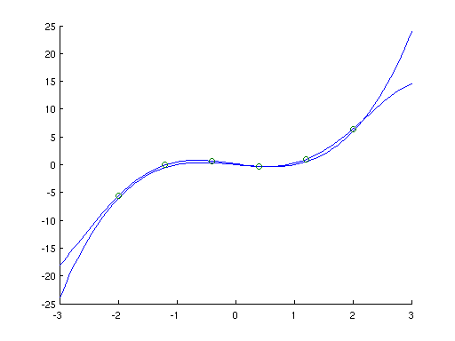

%d
x=linspace(-3,3);
dx=linspace(-2,2,16);
dy=dx.^3-dx+.5*rand(1,16);
y=lagrange(dx,dy,x);
plot(x,y);
plot(x,(x.^3-x));
scatter(dx,dy);

