JARED MURPHY DATA SCIENTIST

[jared.m.murphy@protonmail.com](mailto:jared.m.murphy@protonmail.com) (904) 502-0547

/in/jared-m-murphy/  jared-m-murphy/

 10910 Queens Blvd Apt 7J, Forest Hills, NY 1

# SUMMARY



EDUCATION

**Springboard Data Science Career Track** Mar. 2020 - Jan. 2021



**University of North Florida** June 2013 - Aug. 2015

# SKILLS

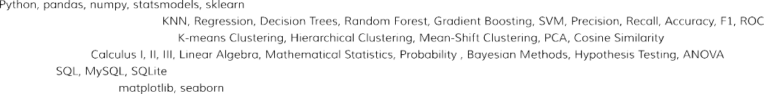DATA SCIENCE:

MACHINE LEARNING: SUPERVISED LEARNING: MACHINE LEARNING: UNSUPERVISED LEARNING: MATHEMATICS AND STATISTICS:

RELATIONAL DATABASES:

DATA VISUALIZATION WITH PYTHON:

# PROJECTS

Excess Deaths Due to Covid-19 May 2020 - Nov. 2020



Bitcoin: A Technical Analysis Nov. 2020 - Jan. 2021

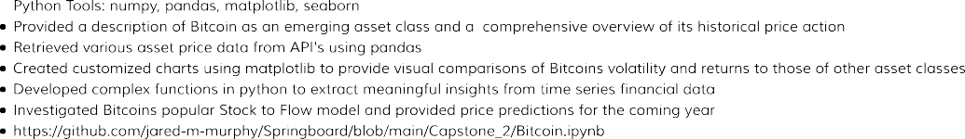

# EMPLOYMENT

**Self-Employed**, *Carpenter/Residential Painter*, Hudson Valley, NY Oct. 2016 - Current

*High School Equivalency Instructor*, Dutchess Community College, Poughkeepsie, NY Mar. 2016 - Oct. 2016



*Sales Associate*, DSW, Jacksonville, FL Aug. 2010 - Aug. 2015

# AWARDS

**Graduated Summa Cum Laude**, *University of North Florida* Aug. 2015

**Inducted into Pi Mu Epsilon Mathematics Honors Society**, *Florida Eta Chapter* Aug. 2015

# VOLUNTEERING

**Kunzang Palchen Ling (Buddhist Center)**, *Carpenter/General Contractor* Jan. 2016 - Sept. 2019 Red Hook, NY