Asgn 3 Report
Spadaro, Jared
CSC321 6/7/17
Dr. Nico

The Smashme Vulnerability
As documented in the assignment writeup, the vulnerability of smashme is a buffer overflow, meaning that the length of user-inputted data is not checked and therefore the buffer used to contain this data could extend beyond the space set aside for it. In smashme, this buffer is a local variable to the function prompt(), and as such it is placed on the stack temporarily while prompt() is running. Directly after this buffer on the stack is the return address, the location to which control of the program will shift after prompt() is finished running. If one designs a user input string correctly, they can override the original return address and get the program to run some other code instead. In this case, that “other code” is the function uncalled().

The Attack String
In order to correctly override the return address on the stack of the executable, we need to place it in exactly the right spot. To find out what this spot is, we run objdump on the smashme executable and discover the memory address of uncalled(), as well as the amount of space set aside on the stack for our buffer. As we stated before, while prompt() is running, the stack will look like the following:

Buffer (40 bytes)
Return Address (4 bytes)

The buffer size of 40 bytes was discovered via objdump. It is 10 bytes more than was asked for originally (likely OS alignment padding). So, now we know how to design our attack string: 40 bytes of garbage followed by 4 bytes of the return address that we want to insert. The program configure generates this string for us by printing 40 x’s followed by 4 bytes of our new return address, in little-endian byte order (the bytes are printed as characters and as such appear on the screen as garbage).

Screenshot
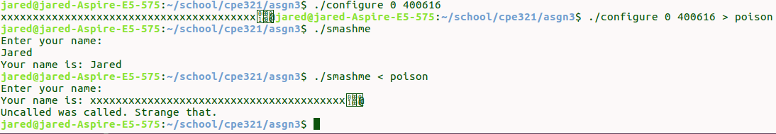
The following screenshot demonstrates the attack:

