Due on 10/2, submit in hard copy

Besides answering the questions given in the textbook, please provide extra information per request.

Chapter 3
2.(a) (15%) Please use the schematic symbols on page 594.
12. (15%)
19. (15%)
20. (15%) Describe what these ICs are.

Additional questions:

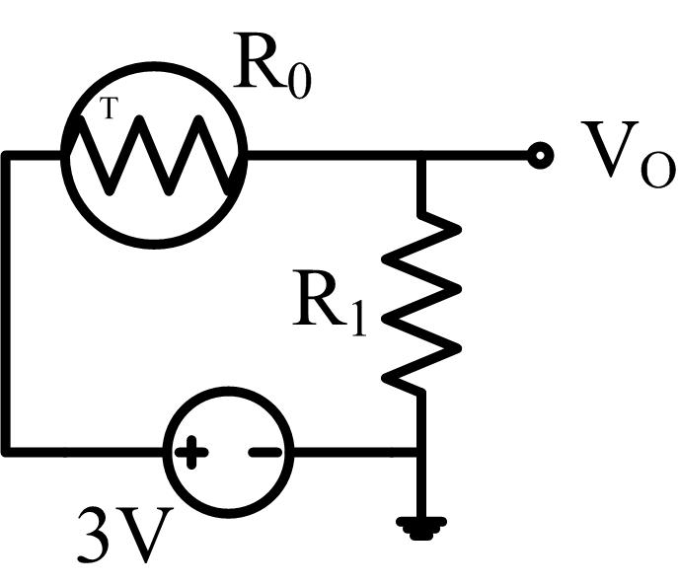
i) (10%) The resistance of a thermistor changes according to the temperature. In the right circuit, the resistance function of the thermistor is R₀ = 10000 + 60*T (Ω). The other resistor is R₁ = 10000 (Ω). The output voltage on R₁ is
Vo = 3 * R₁ / (R₀ + R₁).
a) If the room temperature T = 70ºF, what is Vo?
b) If Vo = 1.339V, what is the room temperature?

ii) (10%) Assume the resistance function of the thermistor R₀ is a nonliner function, and is stored as a table (shown below) in the memory of an embedded system. Each row of the table is the resistance at a specific Fahrenheit degree.
a) How many bytes are needed in minimum for each row to record both the temperature and the resistance.
b) How many bytes of memory are needed to store the complete table.

Temperature | Resistance
-50 | 8000
-49 | ...
... | ...
0 | 10000
... | ...
199 | ...
200 | 20000

iii) (10%) Use a INA2128 chip to produce the signal y=5+26*x, where x is the input and y is the output.
(a) Make a schematic of the circuit, and show the value of the components used in the schematic. The manual of the chip is in TRACS. Try to read the manual and find the information you need.
(b) Explain your schematic. For example, if you find a figure or a formula in the manual that helps you make the schematic, you should cite the figure or the formula in the explanation of your schematic and explain what help you get from it.

iv) (10%) A single-page summary of one video talk submitted on 9/18.

