Project Member:

Jared Bumgardner

Note:

The program refuses to send jpg’s but serves html just fine.

I could not establish a connection when running the server on the linux lab (& the client on my machine). I suspect I was using the wrong IP address for the server.

Compilation:

The program was compiled and tested on my local machine.

Type ./make to compile ‘client.exe’ & ‘server.exe’.

Type ./make clean to clean up

Running:

After producing the ‘client.exe’ and ‘server.exe’ using ./make,

Run the server using ‘./server <portNo>’ or ‘./server’

<portNo> refers to the port number to be used to communicate with the client.

<portNo> defaults to 60001 if left empty.

Run the client using ‘./client <ServerIpAddress> <PortNumber>’

<ServerIpAddress> is assumed known by the user.

Both arguments are required.

Example Run:

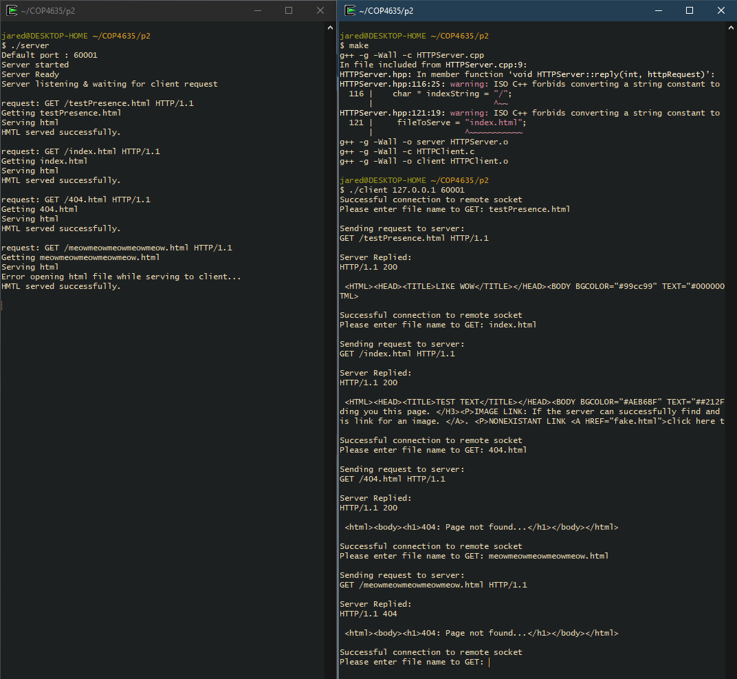

WHOLE SCREEN: 