Upon navigating to “localhost/plp5/dbCreator.php”:

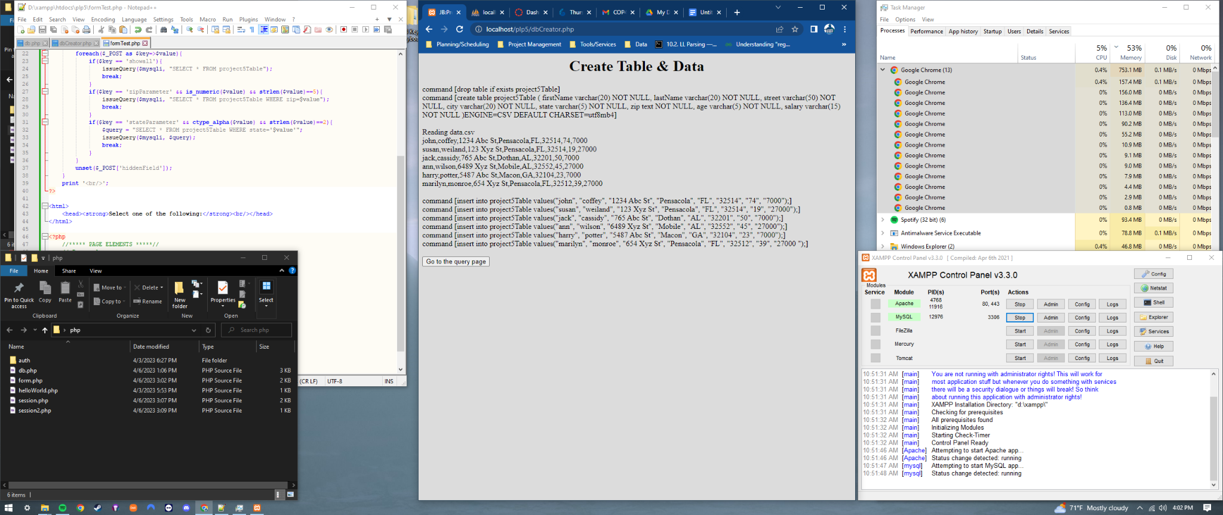

After clicking “Go to the query page”:

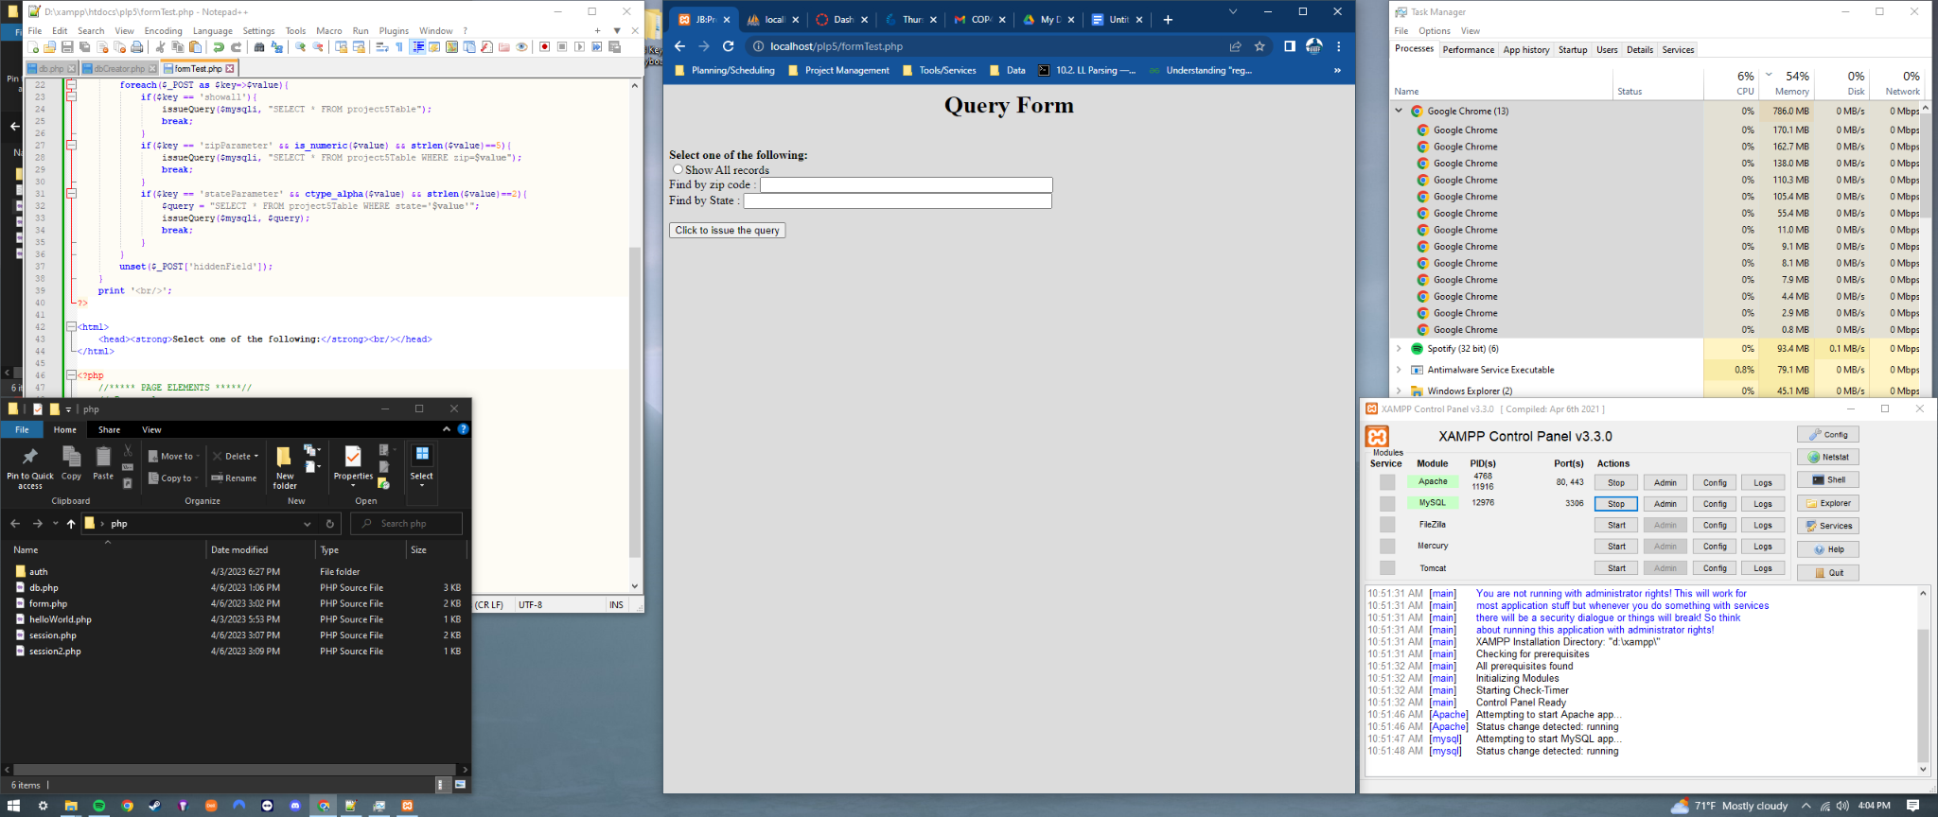

After clicking “Show All records” then “Click to issue the query”:

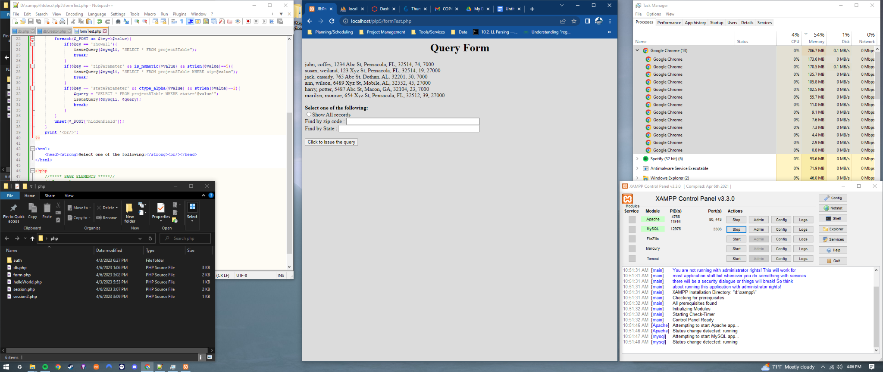

After entering “32514” into zip code field then clicking “Click to issue the query”:

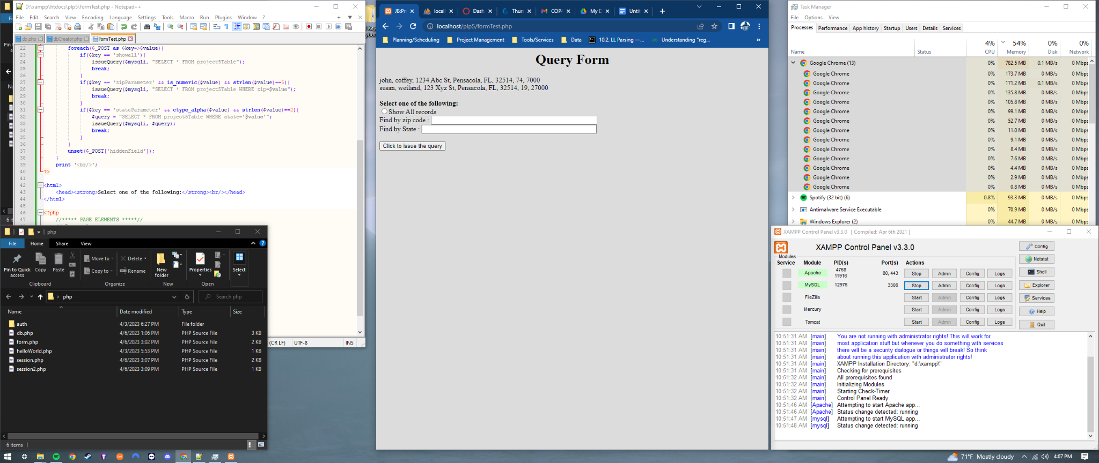

After entering “al” or “AL” into state field then clicking “Click to issue the query”:

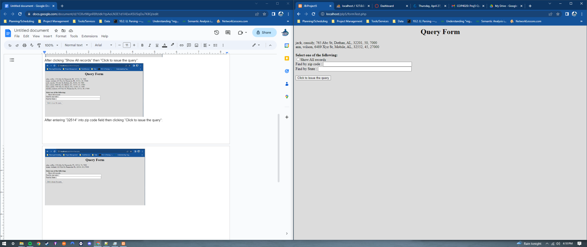

After clicking “Show All records”, entering “32514” into zip, & “FL” into state then clicking “Click to issue the query”:

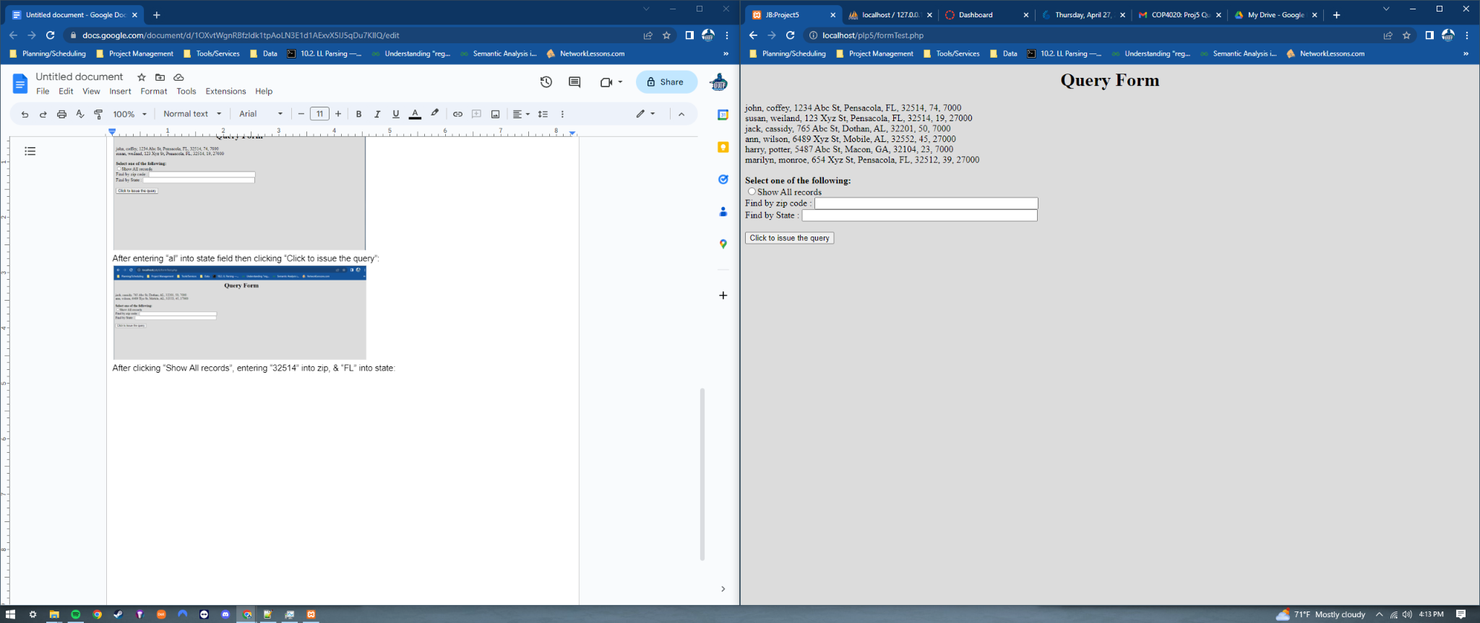

Issuing the query after

entering “adsfdas”, “3256634234”, or “123” into zip:

OR

After entering “FLa”, “123”, or “f” into state:

