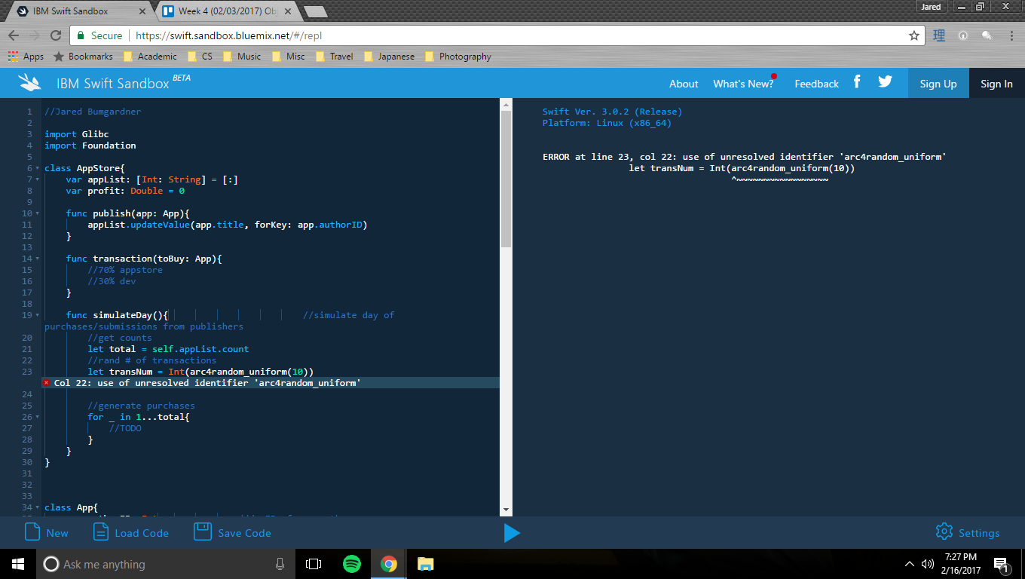

arc4random_uniform function did not work in available IBM playground. Submission acceptance to the appstore & day/transaction simulations handled poorly in other, available ways.

Sorry ☹