CSC 222 Homework No. 1

1) Five System Services/features and examples:

i) A user interface, such as a command console or a Graphical User Interface

ii) Process Management, which is used to determine, in multiuser systems, in which order processes are given access to the processor and for how long

iii) Memory Management, such as allocating RAM to programs and tracking which programs are using which locations in memory

iv) File Storage, often using a hierarchical system of directories.

v) Protection from harmful processes, which may attempt to access volatile memory locations

2) Two ways to obtain system services:

i) command line

ii) graphics interface (often, just click the executable file)

3) command: ls -l | more
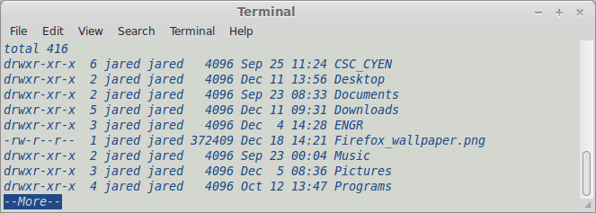
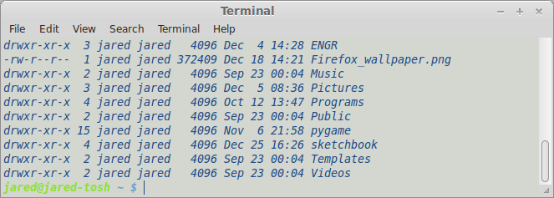
4) Linux/Unix can search directories recursively if no search path is given. The command 'find' can also do this.

5) When a command is entered in the shell, the shell parses the command, searches for the specified executable, and begins a new process. The shell sleeps while the program is running, wakes up when the program is terminates, and waits for the user's next command.

6) Redirection is changing ouput or input to and from a program. By default, stdin is used for input and stdout is used for output, while stderr is used to send error messages. Input and output can be changed using the characters < and >.

7) Suspend process mynumber:
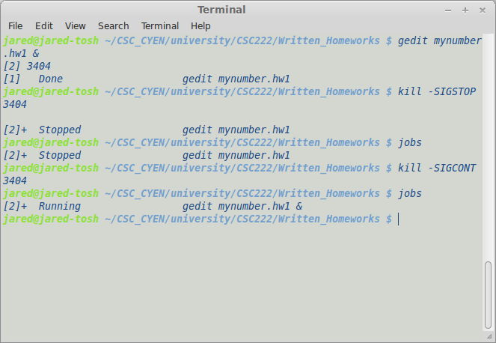
8) The original file permission shows that I can both read and write to this file. After I change the file permissions, I am only able to read and can no longer make changes to the file.
