Question 1
The design of the cloud-based content delivery will show the flow of data between the databases, local storage, and the remote storages. When Shancag receives the videos invitation and connects to the cloud storage to view the content, the remote cloud storage they connect to becomes their local storage. In this orchestration, the local cloud can be made a remote cloud depending on the distance and ease of access of the stored data to prevent jitters. A Software Defined Network is created to effect this and enable smooth viewing of content. When Shancang shares the videos to thor connections in New York, the remote cloud in New York will become the local cloud to those who will be viewing the videos from there. The diagram below illustrates the Virtual Network Function architecture that will be used.

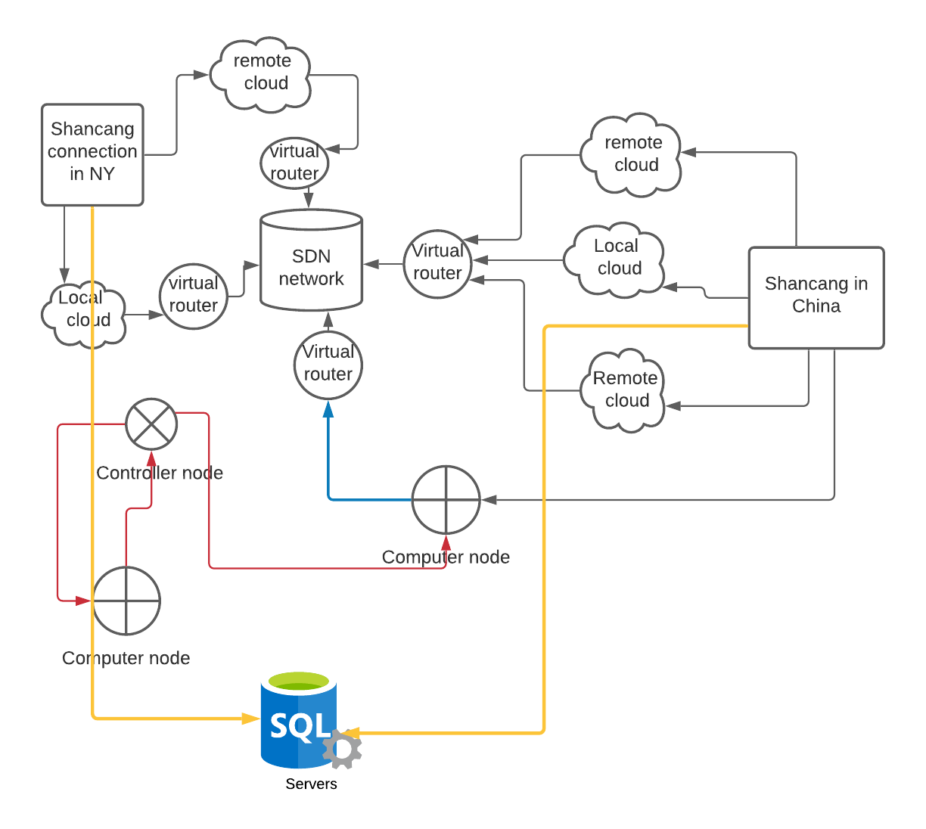

Question 2

- Vital sign monitoring: IoT technology can be utilized to monitor the patient's vital signs such as body temperature, blood pressure, and the heartbeat rate.
- Smart plugs: IoT technology can be used to cut off devices from power when they are not being used.
- Voice controllers: using voice commands and intermediary applications such as Alex to turn curtains, lights, and other things off and on.
- Security: smart technology can be used as smart locks.
- Getting the door: smart cameras can be installed to enable the patients to see who is ringing the doorbell when it goes off.
B.
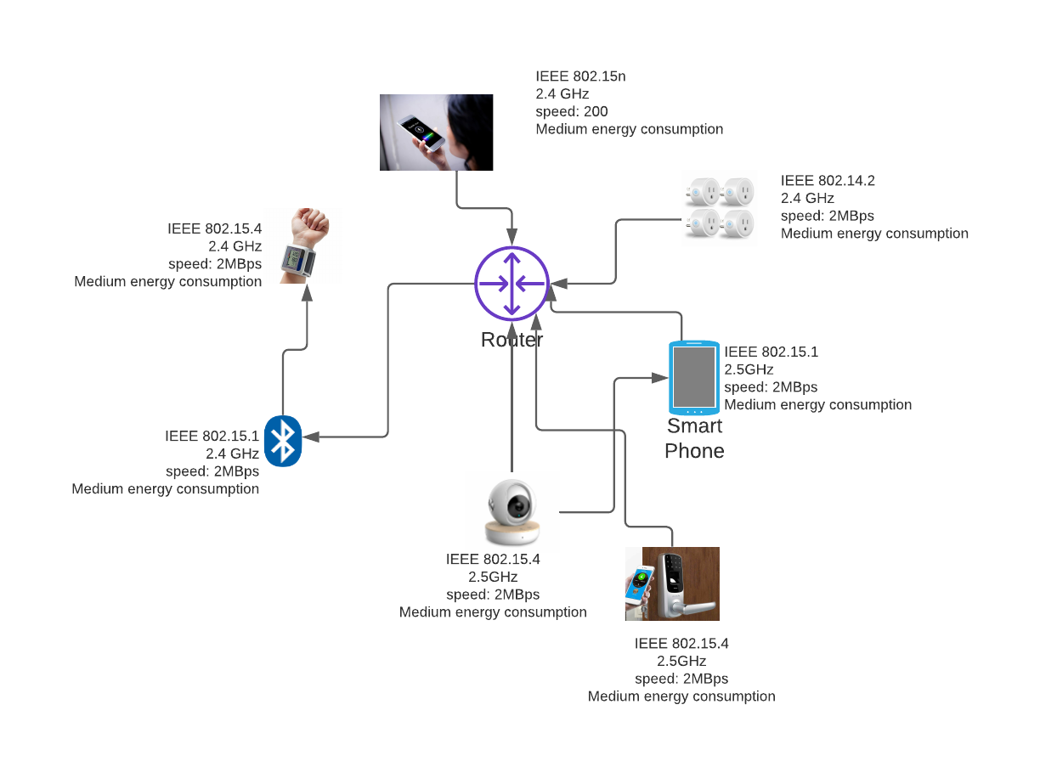

- Alex controls the music, temperature and lights using voice commands by using the WiFi as the connecting point.
- The smart camera will connect to the phone through the WiFi.
- The phone will connect to the WiFi to get all the data.

Question 3
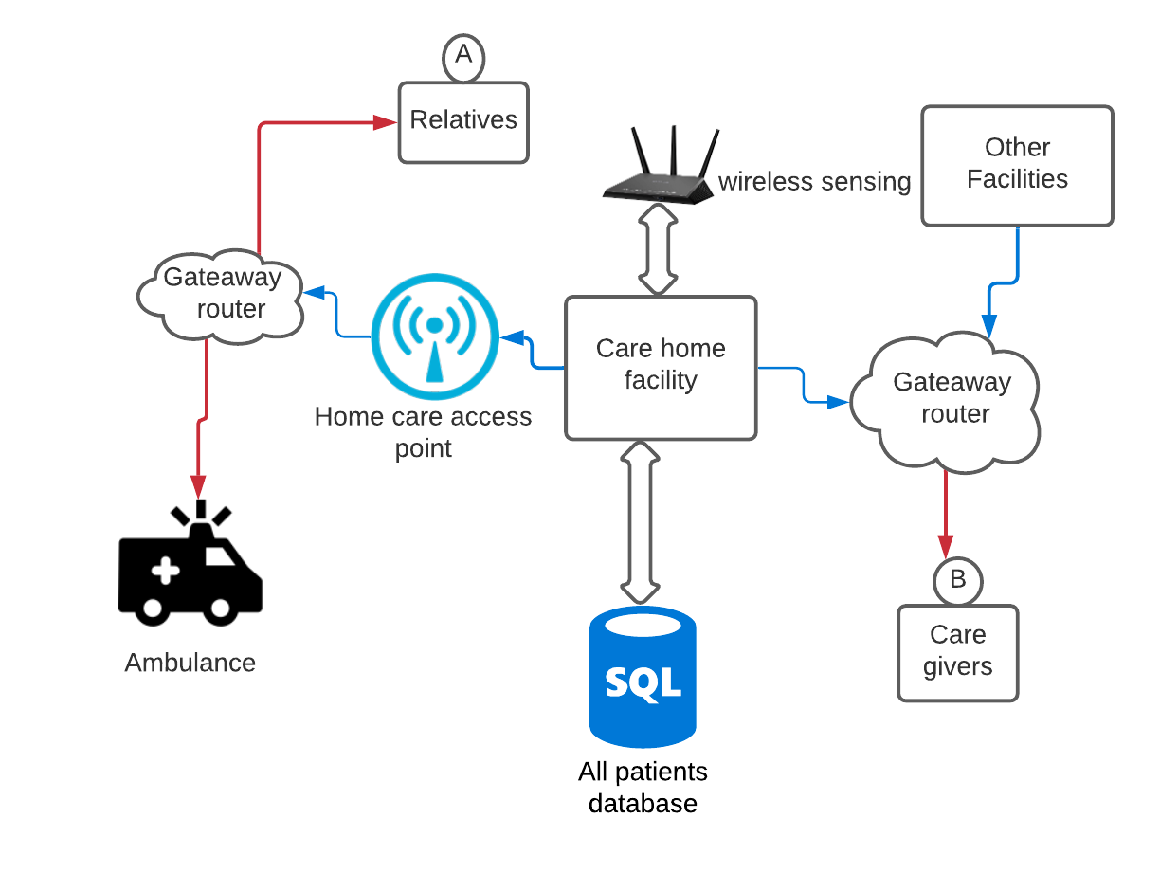
- The sensing devices, especially the ones that are wearable by the patients, are connected by a local node to the database containing all the information on the patients.
- The relatives shall be accessing the patients details using a connection by a gateway router which will connect to the care home database for authentication and validation of the relatives.
- All the database data shall be made available to other medical facilities by a gateway router and the data will also be available to the ambulance team by a getaway connection to enable access on the go.
- The data that will be transferred shall be in the form of payloads which will have a string value of the details. It will be transported using MQTT (Message Telemetry Transport) protocol in different applications. In this form, the information can be accessed by other services and will not be only limited to Java Messaging Service.

