Scenario: Checkout Book

|  |  |  |  |
| --- | --- | --- | --- |
|  | **Comment** | **System Event** | **Response** |
|  | Fetch Role legal value list | _persistentData.findRoles() | "Borrower"  "Librarian"  "Administrator"  "Management" |
|  | Validate user is authorized for this role, and start the session | createSession("Tom", "CPSC 462 Rocks!", "Borrower") | Borrower Session started |
|  | Fetch functionality options for this role | sessionControl->getCommands() | "Return Book"  "Checkout Book"  "Pay Fines"  "Help" |
|  | Fetch a list of books available (not implemented) | executeCommand(“Get Available Books”) | A list of books in the library not checkout by anyone |
|  | Check the book out to the current session’s user | executeCommand("Checkout Book", "Applied UML and Patterns", "Larman", "0-13-148906-2") | Title "Applied UML and Patterns" checkout by "Tom" |
|  | End session | signoff() | System exists |



createSession -> login

return actual session

what can it do? get collection of strings

executeCommand, pass in a command

Static View

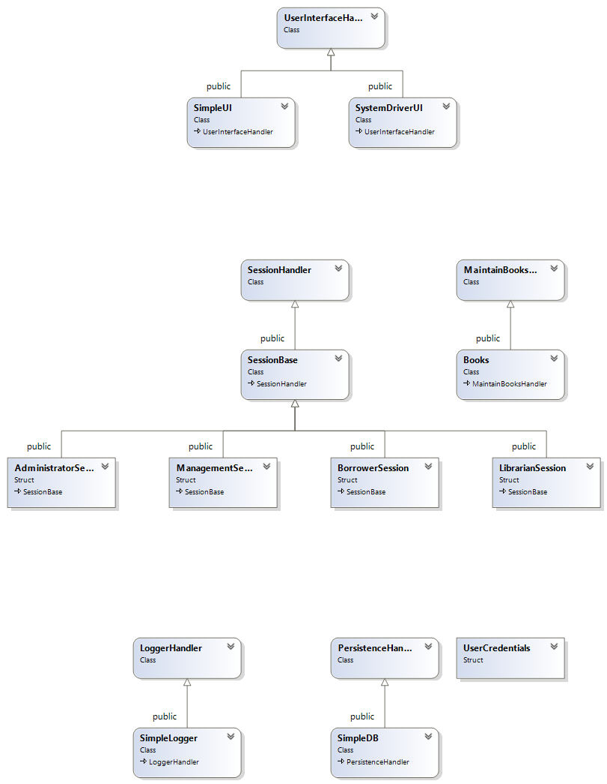

UI

Layer

Domain

Layer

Technical  
Services

Layer

File and layer dependencies

Notice the only access to a lower layer is through the interface, and that only the interface of the lower layer is visible to the upper layers.

1. main()
2. UI Layer
3. Domain Layer
4. Technical Services Layer

