ICT602
MOBILE TECHNOLOGY
SEMESTER MARCH - AUGUST 2026


SYSTEM NAME: MakanMana
GROUP NAME: Manoi

Prepared By:
Name | Student ID
DANIAL AMYRUL BIN ABDULLAH | 2025302127
JARED IAN ANAK DENNIS | 2025156655
ALEC XANDER ANAK LAWRENCE | 2025159029
IBNUR HISYAM BIN MUHAMMAD | 2025124815

Prepared For:
Dr. [Lecturer's Name]
Submission Date: 20 July 2026

ABSTRACT
MakanMana is an Android mobile application developed to help users discover nearby cafes, restaurants, and local food stalls. The application addresses the difficulty of finding suitable food places, especially for students, tourists, and visitors who are unfamiliar with an area. Users normally need to use several different applications to search for locations, menus, ratings, reviews, and directions. MakanMana combines these functions into one mobile application.
The application uses GPS location services and Google Maps to identify nearby food places and provide navigation. It also allows users to view food locations, filter results, save favourite places, use a decision spinner to automatically pick a place, capture and upload food photographs with descriptions and star ratings, and receive notifications when arriving at a destination or when a highly-rated food place is nearby. Firebase is used for authentication and as the online database for storing application information. The application is designed to make food discovery easier, faster, and more convenient while supporting local food businesses and encouraging community participation.

TABLE OF CONTENTS
Right-click here and choose 'Update Field' to generate the Table of Contents.

CHAPTER 1 INTRODUCTION

1.1 Project Background
Finding a suitable place to eat can be difficult, especially for students, tourists, and visitors who are unfamiliar with their surroundings. Although many cafes, restaurants, and local food stalls are available, some of them may be difficult to discover because they are not widely promoted or are located away from popular areas.
Users may also need to search through several different applications to obtain information about food locations, menus, ratings, reviews, and navigation. This makes the food-searching process more complicated and time-consuming.
To address this issue, MakanMana is proposed as an Android food and cafe discovery application. It combines nearby food discovery, filtering, ratings and reviews, Google Maps navigation, food image uploads, and location-based notifications in one platform.

1.2 Problem Statement

1.2.1 Difficulty in Discovering Hidden Food Places
Users may find it difficult to discover hidden cafes and local food stalls. These places may not receive enough online promotion, even when they offer good food and services. As a result, users may miss suitable food places located near them.

1.2.2 Food Information Is Scattered
Information about food locations, menus, reviews, ratings, and directions may be available in different applications. Users must move between multiple platforms to obtain complete information, making the searching process inconvenient and time-consuming.

1.2.3 Limited Reviews and Food Photo Sharing
Some existing platforms do not provide reviews, food photographs, location details, and navigation together in one application. This makes it more difficult for users to evaluate the food quality and decide whether they should visit a particular place.

1.2.4 Lack of Location-Based Recommendations
Users may not receive recommendations or notifications when they are near highly rated or saved food places. Without location-based suggestions, they may overlook suitable restaurants or cafes in the surrounding area.

1.3 Aim and Objectives
The aim of this project is to develop an Android mobile application that provides users with an easier and more convenient way to discover nearby food stalls, restaurants, and cafes.
The objectives of the project are:
- To develop a mobile application for food and cafe discovery.
- To help users locate nearby food places using GPS and Google Maps.
- To allow users to upload food images and reviews.
- To improve the food-hunting experience through location-based notifications.

1.4 Project Scope
The scope of the MakanMana project includes the following:

1.4.1 Platform
MakanMana is developed as an Android mobile application.

1.4.2 Location Services
The application uses GPS location services to detect the user's current location and identify nearby food places.

1.4.3 Map Integration
Google Maps is integrated into the application to display food locations, distances, and navigation routes.

1.4.4 Database
Firebase (Cloud Firestore) is used as the online database for storing application information such as favourites and user-uploaded food photographs.

1.4.5 User-Generated Content
Users can contribute to the application by uploading food photographs together with descriptions and star ratings.

1.5 Target Location
MakanMana is intended to be used in local areas where users want to discover nearby restaurants, cafes, and food stalls. The application is not limited to one specific location because it uses the user's GPS location to display food places within the surrounding area.

1.6 Target Users

1.6.1 Students
Students may use MakanMana to find affordable and nearby food places around their university, college, hostel, or residential area.

1.6.2 Local Residents
Local residents may use the application to discover food places within their neighbourhood, including hidden cafes and local food stalls.

1.6.3 Tourists
Tourists who are unfamiliar with an area may use MakanMana to locate nearby food places and obtain navigation through Google Maps.

1.6.4 Cafe and Food Stall Owners
Cafe and food stall owners may benefit from increased visibility when users discover, review, photograph, and save their businesses through the application.

1.7 Significance and Benefits
MakanMana provides several benefits to users and local businesses.
First, the application saves users' time because food locations, ratings, reviews, and navigation are provided in one platform. Users do not need to search through several different applications.
Second, the application supports local businesses by helping users discover hidden cafes, restaurants, and food stalls. User reviews and photographs may increase the visibility of these businesses.
Third, MakanMana encourages community participation. Users can contribute food photographs and reviews that may help other users make better decisions.
Finally, Google Maps integration provides reliable navigation and makes nearby food places easier to find.

CHAPTER 2 LITERATURE REVIEW

2.1 Introduction
This chapter evaluates existing mobile applications which have similar functions to the MakanMana application. Through an evaluation of the current solutions in the market, this literature review identifies the strengths, weaknesses, and shortcomings of the existing solutions. This chapter compares these existing solutions with MakanMana to explain how it overcomes these shortcomings.

2.2 Review of Similar Applications

2.2.1 Similar Application 1
Application name: Burpple - Food Reviews & Guides
Developer or company: Burpple Pte. Ltd.
Platform: Android and iOS
Purpose of the application: A food discovery application driven by the community for finding places and food through review and photo posting, mainly concentrated on the Southeast Asian region (Malaysia and Singapore).
Main features:
- Users upload photo reviews and ratings.
- Organised food guides and articles.
- Location-based search to find nearby restaurants.
- Wishlist to save places users want to visit.
Strengths:
- High-quality, visually appealing user-generated content (photos and detailed reviews).
- Strong, active community of 'Tastemakers' providing reliable local insights.
Weaknesses:
- Lacks integrated turn-by-turn navigation; users are redirected to external applications.
- Heavily concentrated on major urban areas, often missing smaller, hidden local food stalls.

2.2.2 Similar Application 2
Application name: Swarm: Check In, Explore, Map
Developer or company: Foursquare Labs Inc.
Platform: Android and iOS
Purpose of the application: A local search and discovery application that provides personalised recommendations of places to go, including restaurants, based on a user's current location and previous browsing history.
Main features:
- Personalised location-based recommendations.
- Short user tips and ratings.
- Search filtering by distance, price, and currently open locations.
- GPS tracking to log visited locations.
Strengths:
- Highly accurate location tracking and a massive global database of points of interest.
- Excellent recommendation algorithm that learns user preferences over time.
Weaknesses:
- Not exclusively focused on food; the interface can feel cluttered with irrelevant categories.
- Community engagement has shifted toward brief tips rather than comprehensive reviews.

2.2.3 Similar Application 3
Application name: Tripadvisor: Plan & Book Trips
Developer or company: Tripadvisor LLC
Platform: Android and iOS
Purpose of the application: A comprehensive travel guidance platform that allows users to discover, review, and navigate to various travel-related destinations, including restaurants, accommodations, and tourist attractions.
Main features:
- Extensive global review and 5-star rating system.
- Map-based search functionality.
- Filters for cuisine types, dietary restrictions, and price ranges.
- Community forums and Q&A sections for specific locations.
Strengths:
- A massive, established user base providing millions of data points and reviews.
- Very detailed business profiles, often including full menus, operating hours, and contact details.
Weaknesses:
- The application is bulky and targeted primarily at tourists rather than local residents.
- Like Burpple, it lacks native real-time navigation, relying on external apps.

2.3 Comparison of Similar Applications
Feature | Burpple | Foursquare | Tripadvisor | MakanMana
Primary Focus | Food & Cafes | All Local Businesses | Travel & Tourism | Food & Cafes
Target Audience | Urban Foodies | General Users | Tourists / Travellers | Students & Locals
In-App Turn-by-Turn Navigation | No (external) | No (external) | No (external) | Yes (Google Maps)
Photo Uploads & Reviews | Yes | Yes (brief tips) | Yes | Yes (in-app camera)
Location-Based Notifications | Limited | Yes | Yes | Yes
Focus on Hidden / Local Stalls | Low | Medium | Low | High

2.4 Strengths and Specialisation of the Proposed Application
While existing applications provide robust search and review functionalities, they often fall short in providing a seamless, all-in-one experience tailored specifically for local food hunting. MakanMana distinguishes itself through several key specialisations:
- Integrated Navigation: unlike Burpple and Tripadvisor, MakanMana integrates Google Maps navigation directly, so users can search, review, and navigate within a single application.
- Hyper-Local Focus: tailored specifically for students and local residents to discover small, independent, or newly opened local stalls that global apps often overlook.
- Proactive Location-Based Notifications: uses GPS geofencing to notify users on arrival at a destination and when a highly-rated food place is nearby.
- Dedicated Food Environment: a clean, focused interface dedicated entirely to food discovery, without irrelevant categories such as hotels, flights, or shopping.

2.5 Chapter Summary
The three existing market solutions discussed in this chapter are Burpple, Foursquare, and Tripadvisor. Even though these solutions have been successful in their respective domains, the gap analysis identified several shortcomings, mainly the lack of integrated navigation, limited attention to small-scale local merchants, and limited proactive location-based alerts. MakanMana aims to address these shortcomings through an integrated solution comprising reviews, real-time navigation using Google Maps, filtering, and location-based alerts within a single Android application.

CHAPTER 3 DESIGN AND DEVELOPMENT

3.1 Introduction
MakanMana is an Android food and cafe hunting application that uses GPS technology to help users discover nearby food locations. It combines location services, Google Maps navigation, food reviews, food image uploads, saved locations, filtering, and notifications in one mobile platform. The application is designed to provide a convenient food-hunting experience for users who may not be familiar with the surrounding area.

3.2 Development Methodology
The project adopted the Agile (iterative and incremental) methodology. Instead of building the entire application at once, the system was developed in small increments. Each increment delivered a working feature (for example, authentication, then the map, then the camera, then notifications), which was tested before moving on to the next. This approach allowed the team to respond to feedback quickly and to refine features after the demonstration.

3.2.1 Planning
In the planning phase, the team identified the core problem: discovering nearby food places, especially hidden local stalls, is inconvenient because information is scattered across many applications. The team defined the target users, listed the main problems, and outlined the required features such as location-based search, navigation, favourites, photo reviews, and notifications.

3.2.2 Analysis
During analysis, the requirements were organised into user, functional, and system requirements.
User requirements:
- Users want to register and log in securely.
- Users want to see restaurants and cafes near their current location.
- Users want to filter results (open now, halal, budget, top rated).
- Users want to view details (rating, address, phone, distance, photo) and navigate.
- Users want to save and remove favourite places.
- Users want to take and share food photos with a description and rating.
- Users want notifications only when something important happens.
Functional requirements:
ID | Functional Requirement
FR1 | The system shall allow a user to register with email and password.
FR2 | The system shall allow a registered user to log in and log out.
FR3 | The system shall detect the user's current GPS location.
FR4 | The system shall search nearby restaurants and cafes using Google Places.
FR5 | The system shall filter results by open-now, halal, budget, and top rated.
FR6 | The system shall display place details: rating, address, phone, distance, and photo.
FR7 | The system shall provide navigation to a place through Google Maps.
FR8 | The system shall allow a user to save and remove favourite places.
FR9 | The system shall suggest a random nearby place (Surprise Me).
FR10 | The system shall allow a user to capture and upload food photos with description, rating, place, and date.
FR11 | The system shall allow a user to edit or delete their own uploaded photos.
FR12 | The system shall notify on arrival at a destination and when a highly-rated place is nearby.

Non-functional requirements:
- Usability: a clean, consistent Material Design 3 interface with a warm colour theme and dark-mode support.
- Security: the Google Maps API key is kept out of the source code, and Firestore data is accessible only to authenticated users.
- Performance: nearby searches and image loading are handled asynchronously so the interface stays responsive.
- Compatibility: the application supports Android 7.0 (API level 24) and above.
System requirements: an Android device running Android 7.0 or higher, with internet access, GPS, and a camera. For development: Android Studio, the Java Development Kit, a Firebase project, and a Google Maps Platform API key.

3.2.3 Design
The design phase covered the application logo, user interface, storyboard, navigation, database, and use case diagram.
- Application logo: a red crossed spoon and knife on a white background, implemented as an adaptive icon.
- User interface: Material Design 3 components with a warm palette (spice red, amber, and cream).
- Storyboard: the screen flow was sketched before implementation (see Section 3.5).
- Navigation: a bottom navigation bar hosts Home, Map, Saved, and Profile, with separate activities for details, camera, login, and registration.
- Database: Cloud Firestore stores favourites and photos in per-user and per-place collections.
- Use case diagram: models the interaction between the user and the application (Section 3.6).

3.2.4 Development
The application was developed in Android Studio using Java for the application logic and XML for the user-interface layouts. Firebase Authentication handles sign-up and sign-in, while Cloud Firestore stores favourites and photos. The Google Maps SDK displays the map, and the Google Places API (Nearby Search, Place Details, and Place Photos) is called through the Volley HTTP library. The Fused Location Provider supplies the GPS location, and the Geofencing API triggers the arrival notification. Glide loads images, and Material Components provide the modern interface. The project follows a layered structure with separate packages for models, data (repositories and services), adapters, and user-interface fragments.

3.2.5 Testing
Each function was tested manually on the Android emulator and on a physical Android device. Test cases were prepared for the main functions such as login, registration, nearby search, filtering, navigation, favourites, photo upload, edit and delete, and notifications. The results are recorded in Appendix D.

3.2.6 Deployment or Finalisation
After development and testing, the application was compiled into a debug build and demonstrated on a real device. The source code was uploaded to a GitHub repository with all confidential information (such as the Google Maps API key) removed from the source and stored in a git-ignored local file.

3.3 Application Overview
- Application name: MakanMana.
- Application logo: a red crossed spoon and knife on a white background.
- Application purpose: to help users discover nearby restaurants, cafes, and food stalls and navigate to them.
- Target users: students, local residents, tourists, and cafe or food stall owners.
- Main problem solved: scattered food information and hard-to-find hidden local places.
- Operating platform: Android (7.0 and above).
How it works: after registering or logging in, the user lands on the Home screen. MakanMana detects the user's GPS location and can suggest a nearby place using the Surprise Me feature. From the Map screen, the user searches nearby restaurants or cafes and applies filters. Selecting a place opens its details, where the user can navigate to it, save it as a favourite, or add a food photo with a description and rating. Notifications alert the user on arrival and when a highly-rated place is nearby.

3.4 Application Major Features and Functionalities

3.4.1 GPS Tracking
The GPS tracking feature uses the Fused Location Provider to detect the user's current location, display nearby cafes, restaurants, and food stalls, and calculate the distance to each place.

3.4.2 Google Maps Navigation
Google Maps displays nearby food places as markers. Users can select a location, view its distance, and obtain turn-by-turn navigation. A geofence is registered at the destination so the user is notified upon arrival.

3.4.3 In-App Camera
The in-app camera allows users to take food photographs directly from the application. After capturing a photo, the user adds a description, a star rating, and the place (auto-filled from GPS and editable). The photo can be viewed on the place's detail screen or in the user's profile gallery, and the owner can edit or delete it.
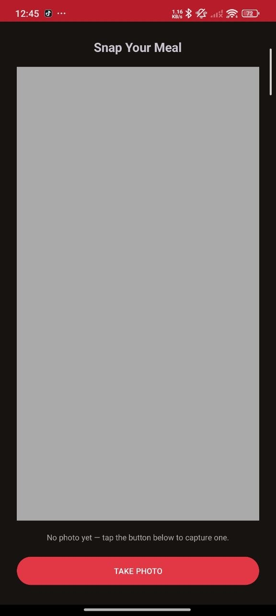
Figure: In-app camera (Snap Your Meal)

3.4.4 Push Notifications
Notifications are designed to fire only when they are important: on arrival at a destination (through geofencing) and when a highly-rated place (rating 4.5 or above) is found nearby. Ordinary searches do not produce notifications.

3.4.5 Additional Features
- Surprise Me: a decision spinner that picks a nearby place weighted by rating.
- Filtering: filter nearby results by open-now, halal, budget, and top rated, with an in-app guide.
- Favourites: save and remove favourite places, listed in the Saved tab.
- Photo reviews: each photo carries a description, rating, place, and date, and can be edited or deleted.

3.5 User Interface Storyboard
The storyboard below shows the sequence of screens in MakanMana. For each screen, the name, purpose, main controls, and navigation are described.
Screen | Purpose | Main Controls | Navigates To
Login | Sign in existing users | Email, password, Login, Register link | Register / Home
Register | Create a new account | Email, password, confirm, Create account | Home / Login
Home | Landing hub with Surprise Me and nearby picks | Surprise Me, Open map, carousel, bottom nav | Map / Details
Map | Search and filter nearby food places | Restaurants/Cafes, filter chips, markers | Details
Details | Show a place and its actions | Navigate, favourite, add photo, gallery | Google Maps / Camera
Camera | Capture and save a food photo | Take photo, details dialog | Profile / Details
Saved | List of favourite places | Favourite cards | Details
Profile | User info, meals gallery, settings | Snap a meal, log out, gallery | Camera / Login

Note: the current version launches directly into the Login screen; a dedicated splash screen and a separate About screen are identified as possible future additions.

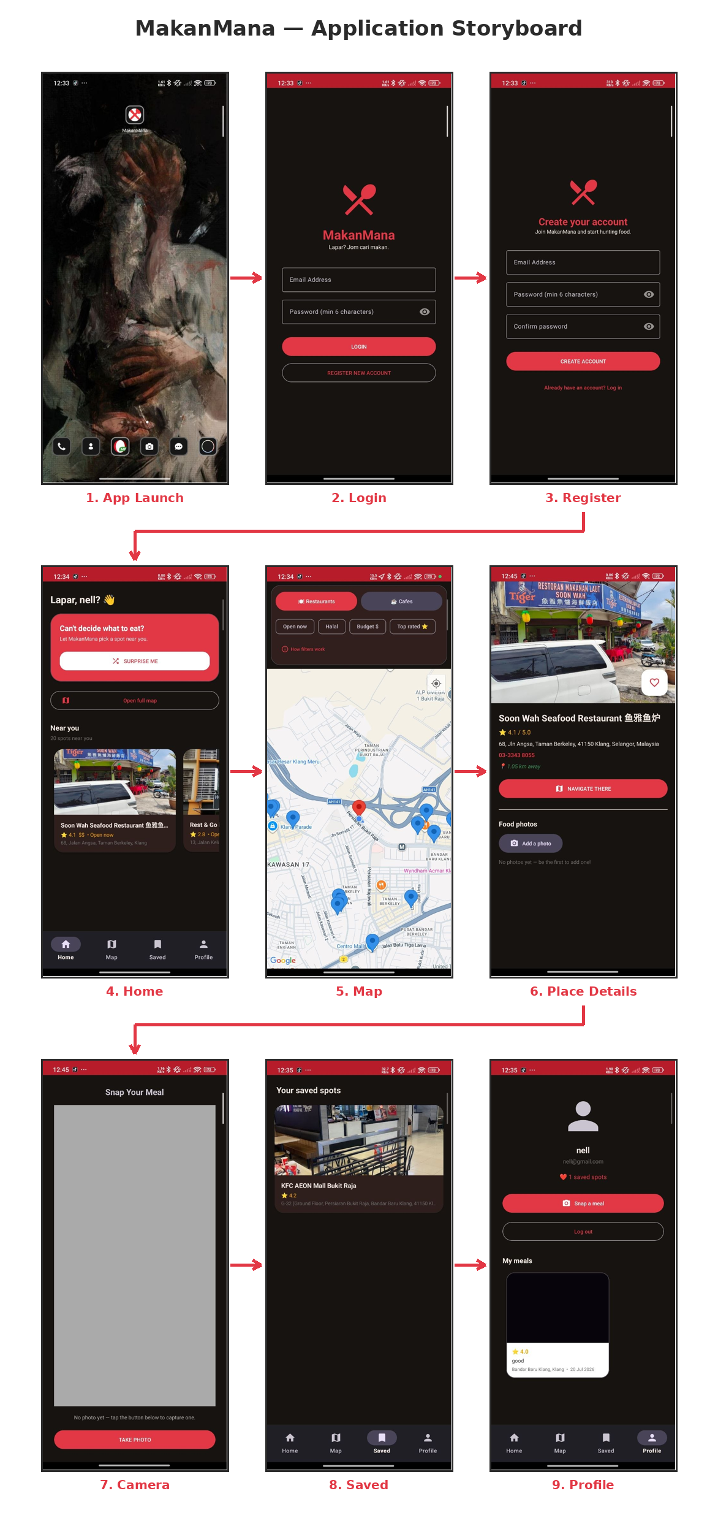
Figure 3.1: Application storyboard (screen flow)

3.6 Use Case Diagram
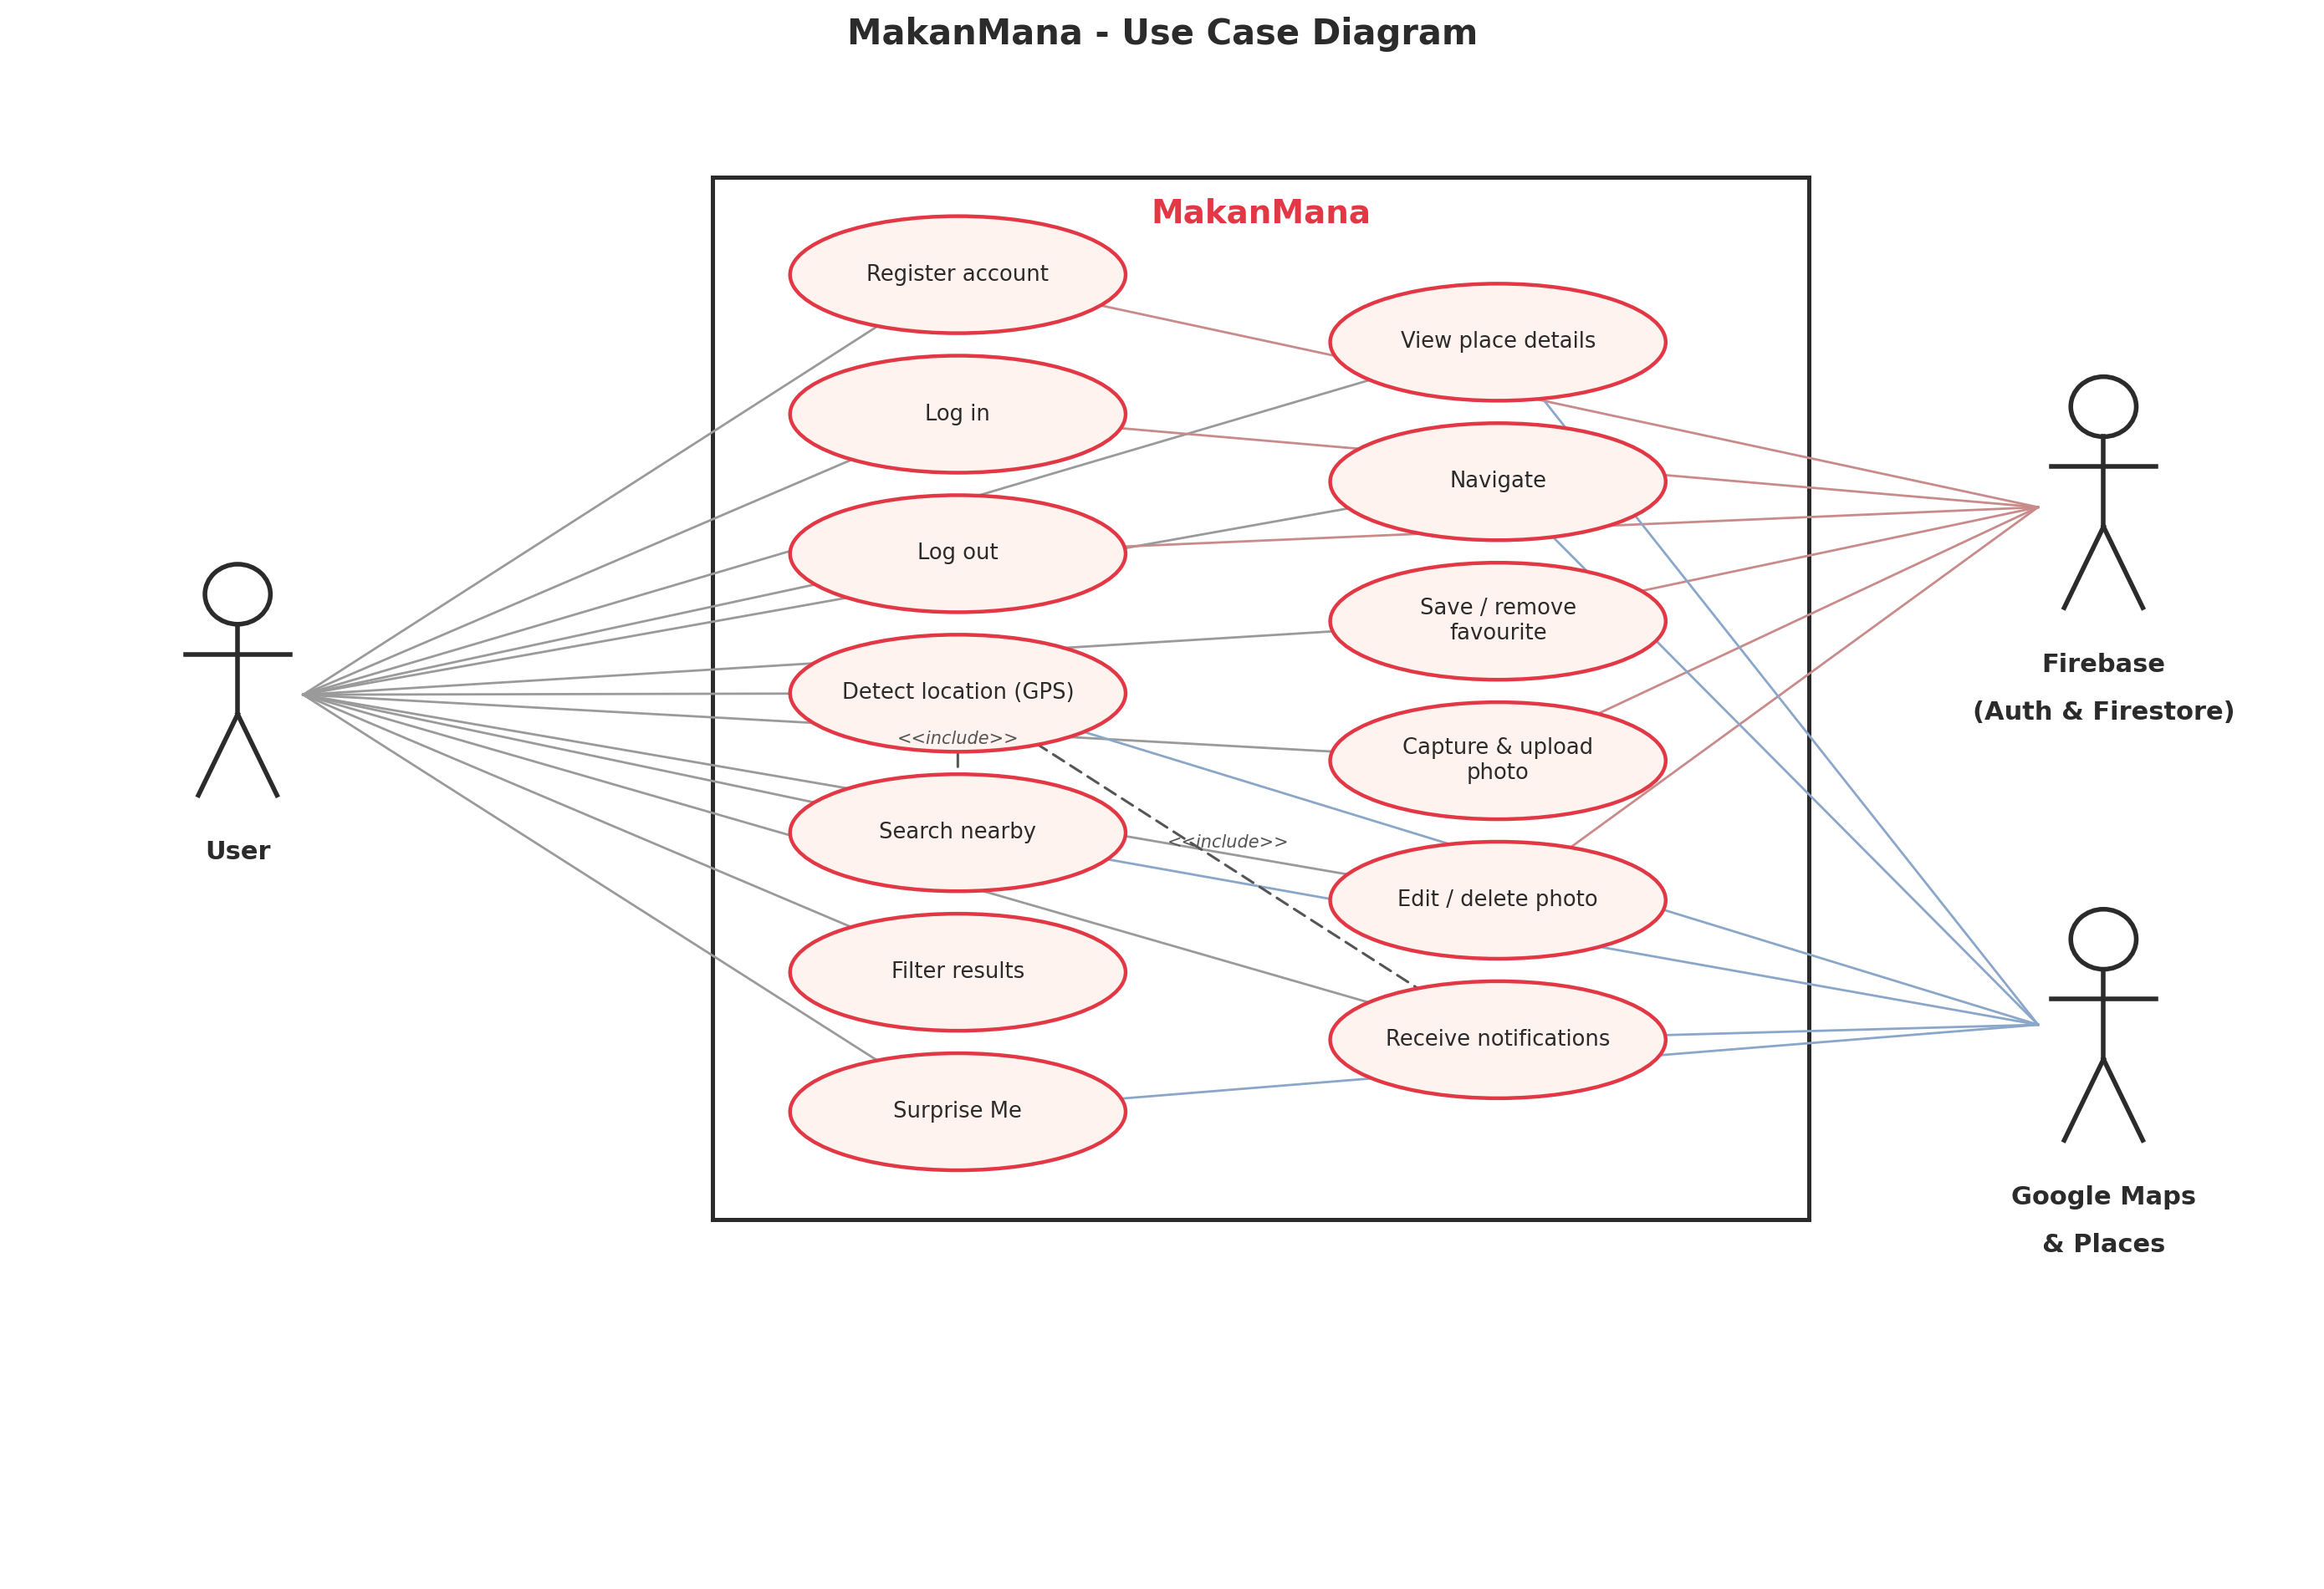
Figure 3.2: MakanMana use case diagram

3.6.1 Use Case Actors
- User: the primary actor who registers, logs in, searches and filters nearby food places, views details, navigates, saves favourites, uploads and manages food photos, and receives notifications.
- Firebase (supporting system actor): provides authentication and the cloud database. Google Maps and Google Places are external service providers for maps, place data, and navigation.

3.6.2 Use Case Descriptions
Use Case | Description
Register account | Create a new account using email and password.
Log in | Authenticate and enter the application.
Detect location | Obtain the user's current GPS position.
Search nearby | Retrieve nearby restaurants or cafes.
Filter results | Apply open-now, halal, budget, or top-rated filters.
View details | View a place's rating, address, phone, distance, and photo.
Navigate | Open Google Maps navigation to a place.
Save / remove favourite | Add or remove a place from the favourites list.
Surprise Me | Automatically pick a nearby place.
Upload photo | Capture a food photo and add description, rating, and place.
Edit / delete photo | Modify or remove a photo the user uploaded.
Receive notifications | Get an arrival alert or a highly-rated nearby alert.
Log out | Sign out of the application.

3.7 Software, Hardware, Programming Languages and Frameworks

3.7.1 Software
Software | Purpose
Android Studio | Used to design and develop the Android application.
Firebase Console | Used to manage authentication and the Cloud Firestore database.
Google Cloud / Maps Platform | Used to obtain the Google Maps and Places API key.
GitHub | Used to store and manage the project source code.

3.7.2 Hardware
Hardware | Purpose
Laptop or computer | Used for application development.
Android smartphone | Used to test the application on a real device.
Internet connection | Used to access online services and the database.

3.7.3 Programming Languages
- Java: used to write the application logic, including activities, fragments, repositories, and services.
- XML: used to define the user-interface layouts, styles, colours, drawables, and the app manifest.
SQL is not used because the application relies on Cloud Firestore, which is a NoSQL document database.

3.7.4 Frameworks, Libraries and Databases
- Firebase Authentication: email and password sign-up and sign-in.
- Cloud Firestore: online NoSQL database for favourites and photos.
- Google Maps SDK for Android: displays the interactive map and markers.
- Google Places API: Nearby Search, Place Details, and Place Photos.
- Fused Location Provider: supplies the GPS location.
- Geofencing API: triggers the arrival notification.
- Android SDK and AndroidX: core application framework.
- Material Components (Material 3): modern user-interface widgets and theming.
- Glide: efficient image loading and caching.
- Volley: HTTP requests to the Google Places web service.
- Secrets Gradle Plugin: keeps the API key out of the source code.

3.8 Application Screens and Explanations

3.8.1 Splash Screen
The application uses its adaptive launcher icon (the red crossed spoon and knife) as the brand identity shown when the app is opened. A dedicated animated splash screen is a planned enhancement.
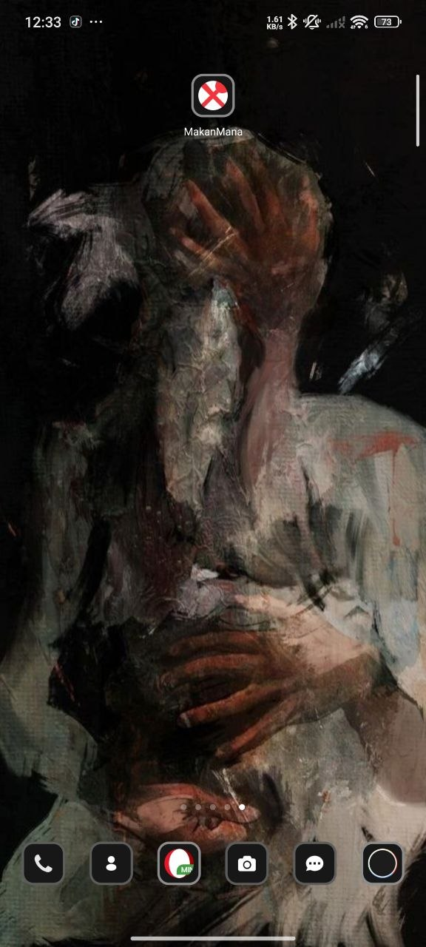
Figure: App launch / launcher icon

3.8.2 Login Screen
The login screen contains an email field, a password field with a show/hide toggle, a Login button, and a link to the registration screen. Input is validated so that empty fields are rejected. If sign-in fails, a simple message such as 'Incorrect email or password' is shown.
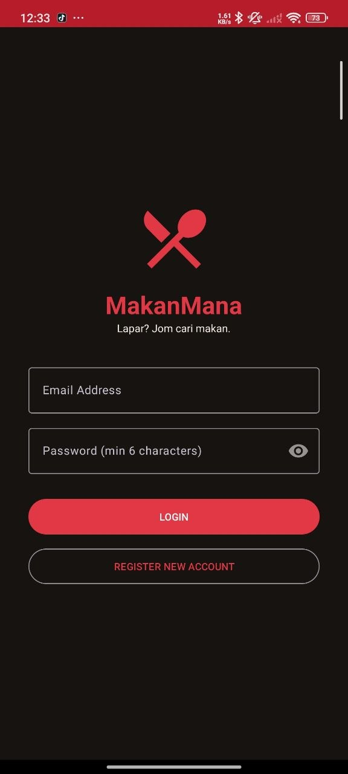
Figure: Login screen

3.8.3 Registration Screen
The registration screen is separate from login. It collects an email, a password, and a password confirmation. The application checks that fields are not empty, that the password is at least six characters, and that the two passwords match. Firebase Authentication then creates the account.
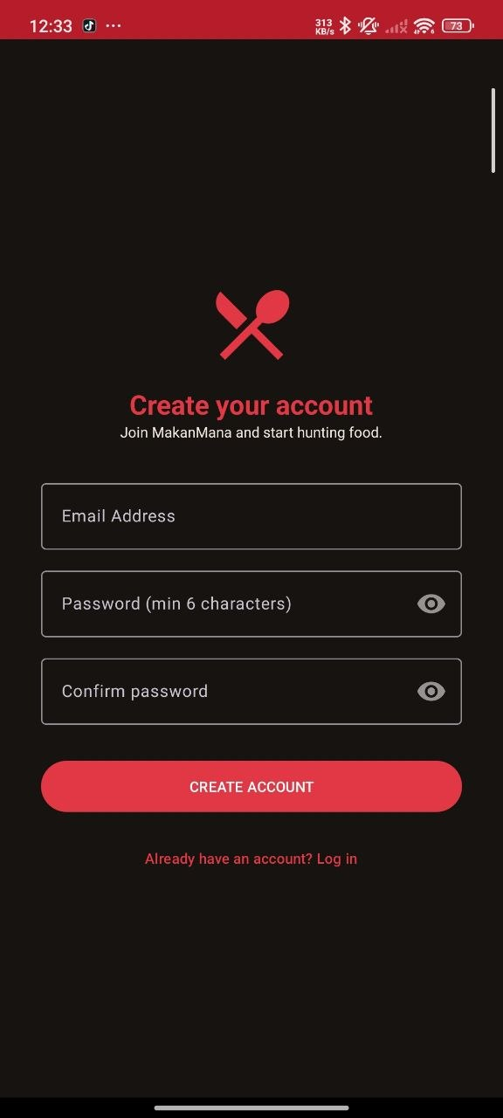
Figure: Registration screen

3.8.4 Home Screen
The Home screen is the main hub, reached through a bottom navigation bar (Home, Map, Saved, Profile). It greets the user and offers the Surprise Me decision spinner, an Open Map button, and a carousel of nearby food places.
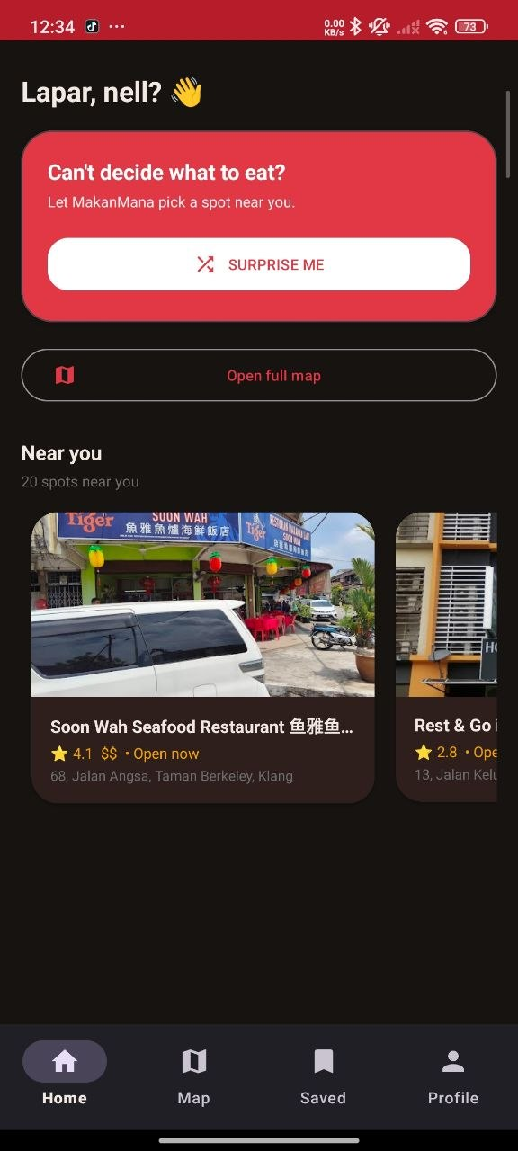
Figure: Home screen

3.8.5 Main Feature Screen (Map)
The Map screen is the core feature. It shows the user's location and nearby food places as markers. The user chooses Restaurants or Cafes and can apply the filter chips (open now, halal, budget, top rated). A 'How filters work' button explains each filter. Tapping a marker opens the details screen.
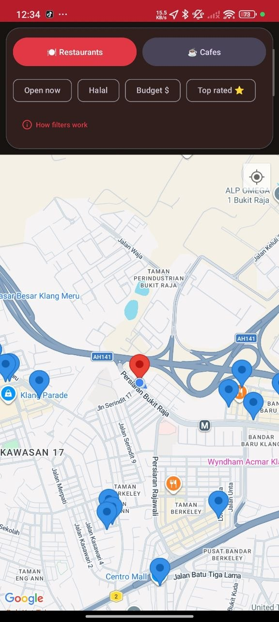
Figure: Map screen with filters

3.8.6 Details Screen
The details screen shows the place photo, name, rating, address, phone number, and distance. From here the user can navigate with Google Maps, save the place as a favourite, and add a food photo. A gallery displays user photos with their description, rating, place, and date.
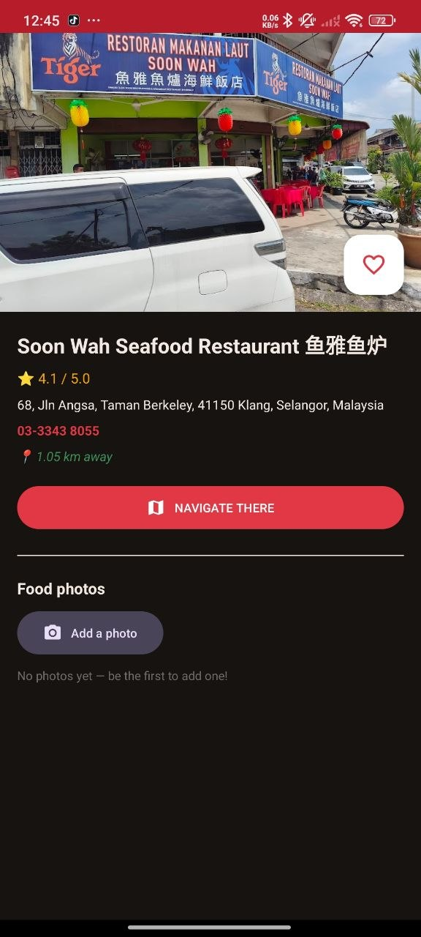
Figure: Place details screen

3.8.7 History or Saved Records Screen
The Saved screen lists the user's favourite places retrieved from Firestore. Users can open a saved place to view its details and remove it from favourites. Uploaded photos can also be edited or deleted, which serves as the update and delete operations for records.
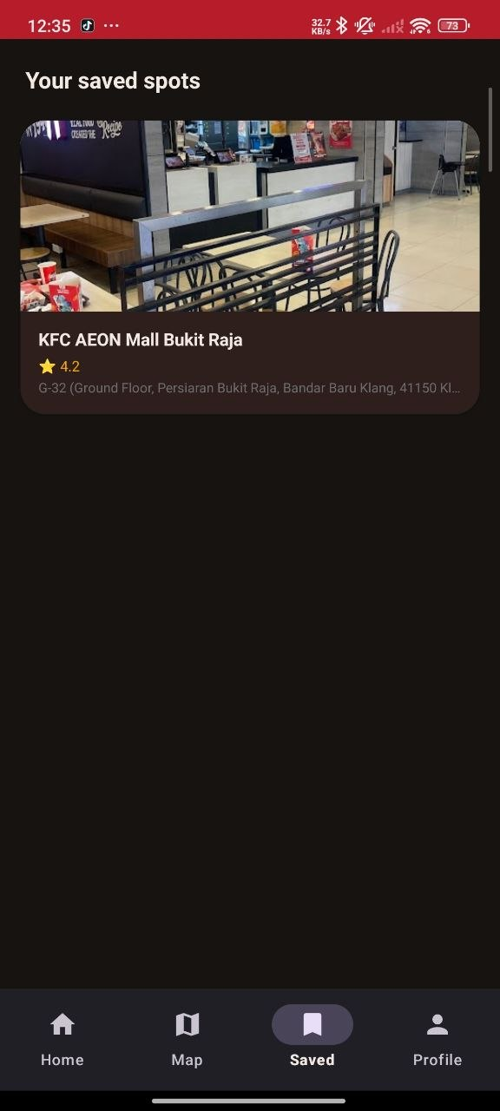
Figure: Saved (favourites) screen

3.8.8 Profile or Settings Screen
The Profile screen shows the user's account, the number of saved places, and a 'My meals' gallery of the photos the user has taken. It provides a Snap a Meal button and a Log out button. Tapping a meal photo allows the user to edit its details or delete it.
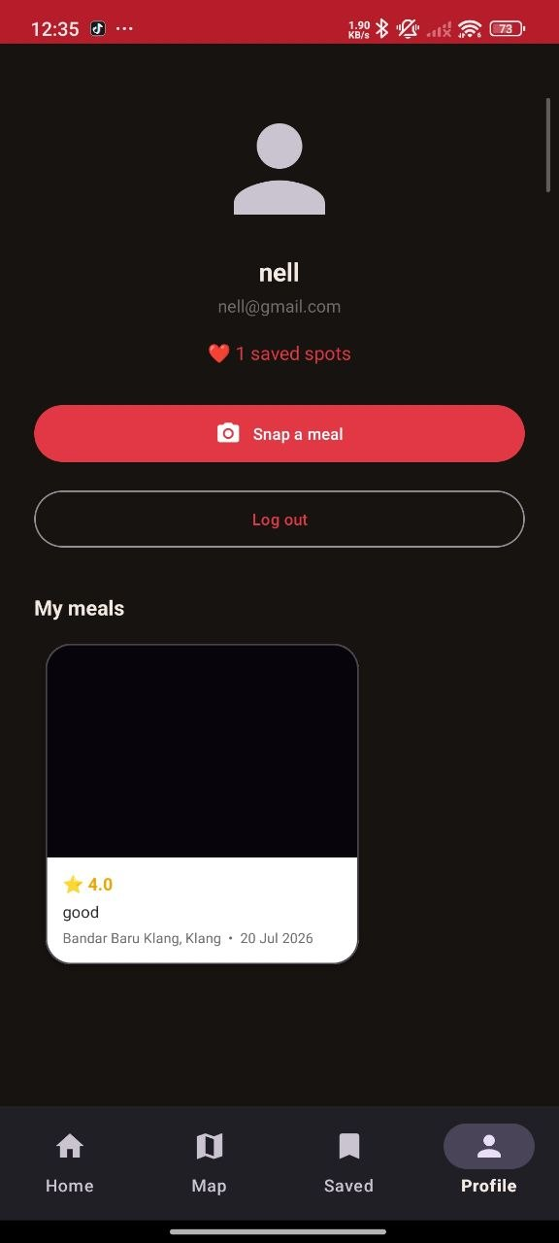
Figure: Profile screen with My meals gallery

3.8.9 About Screen
A dedicated About screen is not implemented in the current version. Information about the application and the development team is provided in this report; an in-app About screen is listed as a future enhancement.

3.9 Design and Development Practices

3.9.1 Design Pattern
MakanMana follows an activity- and fragment-based architecture with a separate data layer. Activities and fragments handle the user interface, while repository and service classes handle data access. This separation of concerns keeps the interface code clean and the data logic reusable, following the spirit of the Model-View-Controller pattern.

3.9.2 User Interaction
Users interact with buttons, text fields (email, password, description), menus (the bottom navigation bar), lists (nearby, saved, and photo galleries shown in RecyclerViews), dialog boxes (photo details, delete confirmation, and the filter guide), and notifications.

3.9.3 Navigation
The main sections are reached through the bottom navigation bar, which swaps fragments for Home, Saved, and Profile and opens the Map full screen. Detail, camera, login, and registration are separate activities. The device back button returns the user to the previous screen.

3.9.4 Layout and Interface Design
- Colour scheme: a warm palette of spice red (#E23744), amber (#F4A300), and cream (#FFF8F2) with dark charcoal text; a dark theme is also provided.
- Font and icons: Material Design typography with clear vector icons.
- Buttons: Material 3 filled, tonal, and text buttons used consistently.
- Screen arrangement: rounded cards, generous images, and consistent spacing.
- Consistency: the same theme, colours, and components are reused on every screen.

3.9.5 Best Practices in Development
- Meaningful names for classes, methods, and variables.
- Organised project packages: model, data, adapter, and ui.
- Reusable components such as shared adapters and a shared photo-details dialog.
- Input validation for login, registration, and photo details.
- Error handling with try/catch and clear user messages.
- Comments in the source code explaining important logic.
- Secure storage of the API key in a git-ignored local file, and Firestore access restricted to authenticated users.

3.9.6 Screen Feedback
The application gives clear feedback for every action: Toast messages confirm actions, alert dialogs confirm destructive actions such as deleting a photo, status text reports progress during a search or upload, and error messages report problems in plain language.

3.9.7 Authentication and Authorisation
Users register and log in through Firebase Authentication using email and password. Passwords are never stored by the application; Firebase handles them securely. When the application starts, it checks whether a user is signed in and only then allows access to the Home hub. Cloud Firestore security rules restrict reading and writing to authenticated users, and each user can edit or delete only the photos they uploaded.

3.10 Chapter Summary
This chapter described the Agile design and development process of MakanMana. It presented the planning, analysis, design, development, testing, and finalisation stages; the major features; the storyboard and use case model; the software, hardware, languages, and frameworks used; the completed screens; and the good design and development practices applied.

CHAPTER 4 CONCLUSION

4.1 Conclusion
MakanMana is an Android mobile application that provides users with an easier and smarter method of discovering nearby food stalls, restaurants, and cafes. The application addresses problems such as difficulty finding hidden food places, scattered food information, limited user reviews, and the lack of location-based recommendations.
The main functions of the application include GPS tracking, Google Maps navigation, filtering of food places, saved food locations, a decision spinner, in-app food photography with reviews, and push notifications. These functions allow users to discover food places, obtain directions, save favourite locations, and share their food experiences.
Overall, MakanMana improves the food-hunting experience by saving users' time and making food discovery more convenient. It may also support local food businesses and encourage users to participate by sharing reviews and food photographs.

4.2 Limitations
- The application is available only on Android.
- Most features require an internet connection to reach Google Maps, Google Places, and Firebase.
- The application depends on external APIs (Google Places and Maps), subject to usage quotas and billing.
- Food photos are stored as compressed images in Firestore to remain on the free plan, so they are kept small.
- Geofence-based arrival notifications can be delayed by the operating system and are less reliable on emulators.
- The application has not been published on the Google Play Store.
- Testing was conducted on a limited number of devices.

4.3 Improvements Made After the Presentation

4.3.1 Improvement 1: Notifications Only When Important
Feedback: the notifications were considered too frequent because a suggestion appeared every time a search was performed.
Problem: frequent notifications interrupted the user and reduced the value of the alerts.
Change made: notifications were redesigned to fire only for important events, namely arriving at a destination and when a highly-rated place (4.5 stars or above) is nearby. Ordinary searches no longer trigger notifications.
Benefit: users receive fewer but more meaningful alerts.

4.3.2 Improvement 2: Separate Login and Registration with Friendly Errors
Feedback: login and registration were combined on one screen, and error messages showed technical text.
Problem: the combined screen was confusing, and raw error messages were hard to understand.
Change made: registration was moved to its own screen with password confirmation and validation, and authentication errors are now shown as simple messages such as 'Incorrect email or password'.
Login screen
Separate registration screen
Benefit: the sign-in flow is clearer and the messages are easier to understand.

4.3.3 Improvement 3: Richer Photo Reviews with Edit and Delete
Feedback: uploaded photos had no context and could not be managed.
Problem: users could not describe, rate, or manage the photos they added.
Change made: each photo now stores a description, a star rating, the place, and the date, and users can edit these details or delete their own photos. To avoid paid cloud storage, photos are stored directly in Firestore.
Meal photo with rating, place, and date
Benefit: photos are more informative and users have full control over their own contributions.

4.4 Future Enhancements
- Develop an iOS version of the application.
- Publish the application on the Google Play Store.
- Add a dedicated splash screen and an in-app About screen.
- Add written reviews and comments in addition to photos and ratings.
- Support higher-resolution images through a free image hosting service.
- Add multilingual support (for example, Malay and English).
- Add offline caching of favourites for use without internet.
- Improve the recommendation logic using user history and preferences.
- Add cloud backup and synchronisation across devices.

REFERENCES
Android Developers. (2026). Android developer documentation. https://developer.android.com
Google. (2026). Maps SDK for Android documentation. https://developers.google.com/maps/documentation/android-sdk
Google. (2026). Places API documentation. https://developers.google.com/maps/documentation/places/web-service
Firebase. (2026). Firebase Authentication documentation. https://firebase.google.com/docs/auth
Firebase. (2026). Cloud Firestore documentation. https://firebase.google.com/docs/firestore
Google. (2026). Material Design 3 guidelines. https://m3.material.io
Bump Technologies. (2026). Glide image loading library. https://bumptech.github.io/glide
Google. (2026). Volley HTTP library. https://google.github.io/volley
Google. (2026). Secrets Gradle Plugin for Android. https://github.com/google/secrets-gradle-plugin
Burpple Pte. Ltd. (2026). Burpple - Food Reviews & Guides. Google Play Store.
Foursquare Labs Inc. (2026). Swarm: Check In, Explore, Map. Google Play Store.
Tripadvisor LLC. (2026). Tripadvisor: Plan & Book Trips. Google Play Store.

APPENDICES

Appendix A: Project GitHub Link
GitHub Repository: [Insert GitHub project link]
All API keys, database passwords, and confidential information were removed from the source code before uploading. The Google Maps API key is stored in a git-ignored local.properties file and injected at build time using the Secrets Gradle Plugin.

Appendix B: Additional Application Screenshots
Camera screen (Snap Your Meal)

Appendix C: Selected Source Code
Login (MainActivity):
mAuth.signInWithEmailAndPassword(email, password)
.addOnCompleteListener(this, task -> {
if (task.isSuccessful()) {
startActivity(new Intent(MainActivity.this, HomeActivity.class));
finish();
} else {
Toast.makeText(this, AuthErrors.forLogin(task.getException()),
Toast.LENGTH_SHORT).show();
}
});
Registration with validation (RegisterActivity):
if (password.length() < 6) { /* show 'at least 6 characters' */ return; }
if (!password.equals(confirm)) { /* show 'passwords do not match' */ return; }
mAuth.createUserWithEmailAndPassword(email, password)
.addOnCompleteListener(this, task -> { /* go to HomeActivity or show error */ });
Nearby search using Google Places (PlacesService):
Uri.Builder b = Uri.parse(BASE + '/nearbysearch/json').buildUpon()
.appendQueryParameter('location', lat + ',' + lng)
.appendQueryParameter('radius', '2500')
.appendQueryParameter('type', type)
.appendQueryParameter('key', AppConfig.getMapsApiKey(context));
if (openNow) b.appendQueryParameter('opennow', 'true');
if (maxPrice >= 0) b.appendQueryParameter('maxprice', String.valueOf(maxPrice));
Saving a favourite in Firestore (FavouritesRepository):
FirebaseFirestore.getInstance()
.collection('users').document(uid)
.collection('favourites').document(place.placeId)
.set(place.toMap());
Arrival notification via geofence (GeofenceHelper):
Geofence g = new Geofence.Builder()
.setRequestId(placeId).setCircularRegion(lat, lng, 120f)
.setTransitionTypes(Geofence.GEOFENCE_TRANSITION_ENTER)
.setExpirationDuration(2 * 60 * 60 * 1000L).build();
Reading the API key from the manifest at runtime (AppConfig):
ApplicationInfo ai = ctx.getPackageManager()
.getApplicationInfo(ctx.getPackageName(), PackageManager.GET_META_DATA);
return ai.metaData.getString('com.google.android.geo.API_KEY');

Appendix D: Testing Results
Test ID | Function Tested | Input or Action | Expected Result | Status
TC01 | Login | Enter valid account details | User enters home screen | Pass
TC02 | Login validation | Enter incorrect password | Friendly error message displayed | Pass
TC03 | Registration | Enter new email and matching passwords | Account created, home opens | Pass
TC04 | Registration validation | Passwords do not match | 'Passwords do not match' shown | Pass
TC05 | GPS location | Open map with location enabled | User location detected and centred | Pass
TC06 | Nearby search | Tap Restaurants | Nearby restaurants shown as markers | Pass
TC07 | Filter | Enable Open now / Halal / Budget | Results updated by filter | Pass
TC08 | Place details | Tap a marker info window | Details with rating and distance | Pass
TC09 | Navigation | Tap Navigate | Google Maps opens with route | Pass
TC10 | Favourite | Tap heart on a place | Place saved and shown in Saved tab | Pass
TC11 | Surprise Me | Tap Surprise Me | A nearby place is opened | Pass
TC12 | Capture photo | Take photo and add details | Photo saved with rating, place, date | Pass
TC13 | Edit photo | Edit a photo's description/rating | Updated details shown | Pass
TC14 | Delete photo | Delete an uploaded photo | Photo removed after confirmation | Pass
TC15 | Notification | Arrive at a saved destination | Arrival notification received | Pass
TC16 | Logout | Tap Log out | User returns to login screen | Pass

