CONFIDENTIAL — FOR DISCUSSION PURPOSES
DF 2026 Fixed Income, LLC
Distressed Multifamily Acquisitions
Business Plan

Prepared by: DiversyFund, Inc.
Date: April 2026

1. Executive Summary
DF 2026 Fixed Income, LLC (the “Fund”) is a closed-end private investment vehicle that lends capital to a related-party buyer entity (the “Buyer”), which uses the loan proceeds from the Fund to acquire deeply discounted multifamily real estate assets from banks, special servicers, and small private (mom-and-pop) owners across ten high-conviction U.S. growth markets. The Fund is designed to capitalize on a once-in-a-cycle dislocation in the U.S. commercial real estate market driven by the fastest interest-rate hiking cycle in four decades, a near-total retreat by traditional bank lenders, and a wave of forced sellers and over-leveraged operators.
The Fund lends capital to the Buyer, which sources assets and notes at acquisition prices targeted at $0.50–$0.70 on the dollar of intrinsic value. The Buyer uses the loaned capital make all-cash purchases of assets. The Buyer then uses the profits from these deals to repay loan from the Fund along with the accrued interest.
The Buyer expects to exit these acquisitions primarily through one of three paths: (i) wholesale resale to a vetted real estate operator on a bridge timeline, (ii) refinancing to recoup invested equity and retain the asset for income, or (iii) light repositioning over a slightly longer hold to capture a $1–$3 million minimum profit per transaction. Proceeds from each exit are used by the Buyer to repay the Fund’s respective loan for that asset along with the interest.
Investors in the Fund are offered two share classes: Class A with a maximum preferred return of 15% per annum (simple, non-compounding), and Class B with a maximum preferred return of 12% per annum (simple, non-compounding). Both classes are pari passu with one another. Minimum subscription is $250,000 for Class A and $100,000 for Class B. Capital is fully committed and funded at time of subscription, with subscribed capital deposited into an interest-earning money market account at Silicon Valley Bank, a division of First Citizens Bank. The preferred return accrues only on capital that has been loaned to the Buyer for a specific transaction; capital not yet deployed into a loan, capital between transactions, and any portion of capital not needed for a specific transaction (e.g., due to deal-sizing mismatches) earns money-market interest while held in the money market account, which is passed through to investors quarterly. The Fund will have a two-year deployment period that begins when the capital raise for the Fund is completed, followed by a one- to two-year orderly wind-down.

Fund Snapshot
Item | Detail
Fund type | Closed-end private fund
Strategy | Lending to Buyer for discounted multifamily acquisitions, note purchases, and wholesale resales
Target markets | 10 U.S. growth markets across the Sun Belt and Mountain West
Deployment period | 2 years from final close
Wind-down | 1–2 years following deployment period
Class A preferred return (max) | 15% per annum
Class B preferred return (max) | 12% per annum
Distributions | Quarterly (subject to deal-cycle timing of 120–180 days) for interest received from loans to Buyer
Cash management | Money market account at Silicon Valley Bank (a div. of First Citizens Bank)
Fund economics | Target size: $20M | Minimum investment: $250K for Class A and $100K for Class B

2. Market Opportunity
The current commercial real estate environment is one of the most dislocated in the modern era. Four converging forces have created a multi-year window for well-capitalized, all-cash buyers to acquire institutional-quality multifamily assets at significant discounts to replacement cost and intrinsic value.

2.1 The Fastest Rate Hike Cycle in 40 Years
Between March 2022 and July 2023, the Federal Open Market Committee raised the federal funds target rate by 525 basis points across eleven consecutive meetings — the fastest tightening cycle in roughly four decades (sources: Federal Reserve Board; Federal Reserve Bank of Richmond, Economic Brief 23-26, August 2023; Bankrate, “Federal Funds Rate History”). Property valuations, which are inverse to capitalization rates, repriced sharply downward in response. Owners who acquired or refinanced multifamily assets at peak valuations between 2020 and 2022 — typically on three-to-five-year floating rate bridge loans — now face loan maturities, rate-cap expirations, and debt-service shortfalls they cannot resolve in the conventional market, even as the Fed has begun cutting rates from the 2023 peak.

2.2 Oversupply Today, Undersupply Tomorrow
The current market is digesting the largest multifamily delivery wave in roughly four decades. According to Yardi Matrix, U.S. multifamily deliveries peaked at approximately 685,000 units in 2024, with 2025 deliveries forecast at roughly 585,000 units, before declining to approximately 441,000 in 2026 and bottoming around 407,000 units in 2027 (Yardi Matrix Q4 2025 Multifamily Supply Forecast). RealPage similarly projects a meaningful pullback in apartment deliveries beginning in 2026. This near-term oversupply has put downward pressure on rents in many Sun Belt markets, accelerating distress. Crucially, however, multifamily construction starts have collapsed — Yardi Matrix estimates 2024 starts at the equivalent of approximately 325,000 annualized units, roughly a 50 percent decline from 2022 and 2023 levels — because new development no longer pencils at current rates and construction costs. Lease-up of in-place supply is expected to absorb the overhang within roughly 12 to 24 months, after which a structural undersupply is likely to push rents — and therefore valuations — meaningfully higher. The Buyer is positioned to acquire near the bottom of this cycle and exit into recovery, with the Fund providing the loan capital that enables the Buyer to transact on an all-cash basis.

2.3 The Bank Lending Freeze
Regional and community banks — historically the largest source of small- and mid-balance multifamily debt — have substantially pulled back from CRE lending in response to balance-sheet stress, regulatory scrutiny, and elevated CRE loan concentrations. This has eliminated a primary refinancing path for thousands of distressed Buyers and has simultaneously left lenders motivated to dispose of nonperforming and sub-performing loans at material discounts to par. This dynamic is precisely what creates the Fund’s opportunity: capital that does not depend on bank financing can transact at price points unavailable to leveraged buyers.

2.4 Forced Sellers and Note Sales
Distress is showing up in three forms the Fund is built to address:
- Direct property sales by mom-and-pop owners who cannot refinance maturing loans or absorb negative cash flow.
- Bank-owned (REO) assets following deed-in-lieu or foreclosure that lenders need off their balance sheets.
- Discounted note sales by banks and special servicers — frequently at prices in the range of $0.30 on the dollar — that can be acquired and either flipped, restructured with the operator, or foreclosed in lender-friendly states such as Texas (which offers an approximately 30-day non-judicial foreclosure process).
Why a Private-Capital Vehicle, Why Now
Because banks are not lending against this asset class today, this strategy cannot be executed efficiently through traditional bank financing. It requires private, all-cash capital able to close in days. The Fund provides that capital to the Buyer, whose ability to close without bank financing is the structural advantage that drives acquisition pricing and protects investor returns.

3. Investment Strategy

3.1 Acquisition Criteria
The Buyer will pursue multifamily assets and the loans secured by them with the following baseline criteria, funded by loans from the Fund:
- Asset type: Stabilized or lightly distressed multifamily properties; preference for B and C class assets in A and B locations.
- Asset size: Properties typically ranging from 50 to 500 units, sized to align with the Buyer’s deployment cadence and to fit the buyer pool of mid-market operator counterparties for the wholesale exit.
- Acquisition basis: Targeted purchase price of $0.50 to $0.70 per dollar of underwritten intrinsic value or recent broker opinion of value.
- Capital structure: All-cash acquisitions by the Buyer, funded by loans from the Fund. No bank financing required at the acquisition stage; this is a core source of pricing advantage.
- Geographic focus: The ten target markets identified in Section 4, all of which the Sponsor has previously transacted in or has existing market relationships, and where the Sponsor maintains operating relationships.
- Deal size: Case-by-case; sized to align with quarterly capital deployment and fund concentration limits.

3.2 Three Exit Paths
Each acquisition by Buyer will be underwritten with at least two viable exits at acquisition. The three primary exit strategies are:

Exit Path 1 — Wholesale Resale to Operator (Primary Path)
Target hold: 60–180 days.
Mechanics: The Buyer acquires a multifamily property all-cash using loan proceeds from the Fund, then resells the asset (or assigns the contract / note) to a vetted real estate operator who will arrange traditional take-out financing. Sale proceeds are used to repay the Fund’s loan. The Buyer earns a transaction-level profit targeted at approximately $500,000 per deal, subject to deal economics, which profit is used to pay the interest on the loan from the Fund. Any remaining profits to Buyer after loan repayment accrues to DiversyFund, Inc. as the sole equity owner of the Buyer.
Why operators pay: Operators value certainty of close, the elimination of acquisition risk, and the ability to acquire below-market basis without warehousing capital during the diligence and lender-approval period.

Exit Path 2 — Refinance and Hold
Target hold: Variable; longer-term, case-by-case.
Mechanics: Where pricing and asset quality are exceptional and a take-out lender becomes available, the Fund may refinance the asset to recoup the equity invested and retain the property for ongoing income and appreciation. This path is selected only when a refinance can return the loan and interest in full or substantially in full.

Exit Path 3 — Light Reposition and Sale
Target hold: 6 to 12 months.
Mechanics: Selected on a case-by-case basis when the Sponsor identifies a specific value-add lever — burn-off of below-market leases, modest interior improvements, expense re-engineering, or operational repositioning — that is expected to generate a minimum $1 million to $3 million profit at exit.

3.3 Note Acquisition Strategy
In foreclosure-friendly jurisdictions, the Buyer will selectively acquire nonperforming notes from banks at deep discounts (illustratively in the $0.50 on the dollar range), funded by loans from the Fund. Texas is the cleanest example — a non-judicial state where foreclosure can complete in as little as 21 to 41 days from notice of default — but a number of other non-judicial states offer comparably lender-friendly timelines, including Georgia (frequently cited as among the fastest in the country, with average timelines of approximately 37 days), Tennessee, Alabama, Mississippi, Missouri, Arizona, Utah, North Carolina, and Virginia. Within the Buyer’s ten target markets, six sit in non-judicial states (Texas — Houston, Dallas, San Antonio; Arizona — Phoenix; Nevada — Las Vegas; Utah — Salt Lake City; North Carolina — Raleigh/Charlotte; California — San Diego), allowing the Buyer to apply the note strategy across the majority of its footprint. Florida and South Carolina, by contrast, are judicial-foreclosure states where note plays carry materially longer timelines and are pursued more selectively.
Once a note is acquired, the Fund has three downstream options:
- Foreclose and take title to the underlying property at a synthetic basis well below market.
- Restructure the note with the existing Buyer, often paired with a refinance arranged with a new operator.
- Resell (flip) the note at a markup to a retail or institutional investor seeking yield.
Underwriting Discipline
Every transaction will be underwritten to a downside scenario in which the primary exit fails. The Buyer will not acquire an asset or note unless at least two viable exit paths exist at the acquisition basis.

4. Target Markets
The Fund will operate primarily in ten markets where the Sponsor has previously acquired or sold multifamily assets, or has existing market relationships, providing direct underwriting knowledge and established boots-on-the-ground capability for property management, broker relationships, contractor networks, and local legal counsel.
Market | State | Sponsor Track Record / Market Presence
Florida (statewide) | FL | Previously acquired
Charleston | SC | Previously acquired
Raleigh / Charlotte | NC | Previously acquired / disposition history
San Antonio | TX | Previously acquired
Houston | TX | Existing market relationships
Dallas | TX | Previously acquired / disposition history
Salt Lake City | UT | Previously acquired / disposition history
Phoenix | AZ | Existing market relationships
Las Vegas | NV | Existing market relationships
San Diego | CA | Previously acquired / disposition history

These markets share several attributes that make them attractive for distressed multifamily acquisition: positive long-term population and job growth, meaningful exposure to the 2021–2023 development wave (creating short-term distress), and — in the case of the Texas markets — non-judicial foreclosure regimes that materially shorten the path from note purchase to property control.

5. Sourcing & Deal Flow
Deal sourcing is the single most important determinant of a strategy of this type. The Buyer’s pipeline will be built from four primary channels, each anchored by relationships the Sponsor has cultivated over a multi-decade real estate career.
- Bank and special servicer relationships: Direct relationships with regional bank workout groups, CMBS special servicers, and credit unions that hold multifamily REO and nonperforming notes.
- Mom-and-pop owner direct outreach: Targeted, market-by-market outreach to small private owners facing maturity defaults, rate-cap expirations, or operational distress, sourced through local broker relationships and the Sponsor’s direct network.
- Operator and broker network: Inbound deal flow from operators and brokers who recognize the Buyer as a credible all-cash counterparty able to close quickly.
- Note marketplaces and trade desks: Selective participation in note auctions and pool sales, typically by invitation.
Sponsor Relationships as a Moat
The Sponsor’s relationships across banks, brokers, and operators — built over decades — are the principal source of off-market deal flow. These relationships are difficult to replicate and, combined with the Buyer’s ability to execute all-cash acquisitions using the Fund’s loan capital, are the primary reason the Buyer expects to consistently access pricing in the $0.50–$0.70 on the dollar range.

6. Fund Structure & Terms

6.1 Vehicle
The Fund will be organized as a Delaware limited liability company, operating as a closed-end private investment vehicle, with subscriptions limited to accredited investors.

6.2 Term
Deployment period: Two (2) years from the final close of capital, during which the Fund may make investments by funding loans to the Buyer for the acquisition of assets and notes.
Wind-down period: Up to twenty-four (24) months following the end of the Deployment Period to complete note repayments, Buyer dispositions, and final distributions to investors, extendable for orderly liquidation as needed.

6.3 Share Classes and Preferred Returns
Share Class | Preferred Return | Notes
Class A | 15% per annum | Maximum 15% per annum, simple non-compounding. Pari passu with Class B. Minimum subscription: $250,000.
Class B | 12% per annum | Maximum 12% per annum, simple non-compounding. Pari passu with Class A. Minimum subscription: $100,000.
Both share classes are pari passu with one another — neither is senior or subordinate to the other. The preferred return rates (15% for Class A, 12% for Class B) are maximum caps, not guaranteed returns; actual returns depend on the Fund’s ability to deploy capital into loans to the Buyer and on the Buyer’s ability to service those loans. Returns accrue only on capital that has been loaned to the Buyer for a specific transaction. There is no sponsor promote, management fee, or carried interest at the Fund level. Complete terms will be set forth in the Private Placement Memorandum (PPM) and the Limited Liability Company Agreement (the “Operating Agreement”).

6.4 Capital Mechanics — Funded at Subscription, Loaned to Buyer per Transaction
The Fund is structured so that capital is fully funded at subscription, with the preferred return clock starting only when capital is actually loaned to the Buyer for a specific transaction:
- Investors commit and fund their full subscription amount at signing. Subscribed capital is wired directly into an interest-earning money market account at Silicon Valley Bank, a division of First Citizens Bank.
- Capital remains in the money market account, earning prevailing money-market interest, until the Fund has identified a transaction and is ready to fund a loan to the Buyer for that acquisition.
- Capital is then funded as a loan from Fund to the Buyer pursuant to a promissory note, the proceeds of which the Buyer uses to acquire the target asset or note for all-cash. The preferred return (up to 15% for Class A / up to 12% for Class B, simple non-compounding) accrues only on capital that has been loaned to the Buyer for an active transaction. Capital not yet loaned, capital between transactions, and any portion of subscribed capital not needed for a specific transaction due to deal-sizing (for example, if the Buyer requires $9 million for an acquisition and the Fund has $10 million available, the remaining $1 million continues to earn money-market interest) does not accrue the preferred return but does earn money-market interest, which is passed through to investors quarterly.
- As the Buyer repays loan principal following a disposition or refinance, repaid capital is redeposited to the money market account, where it earns money-market interest until loaned to the Buyer for a new transaction or distributed to investors.
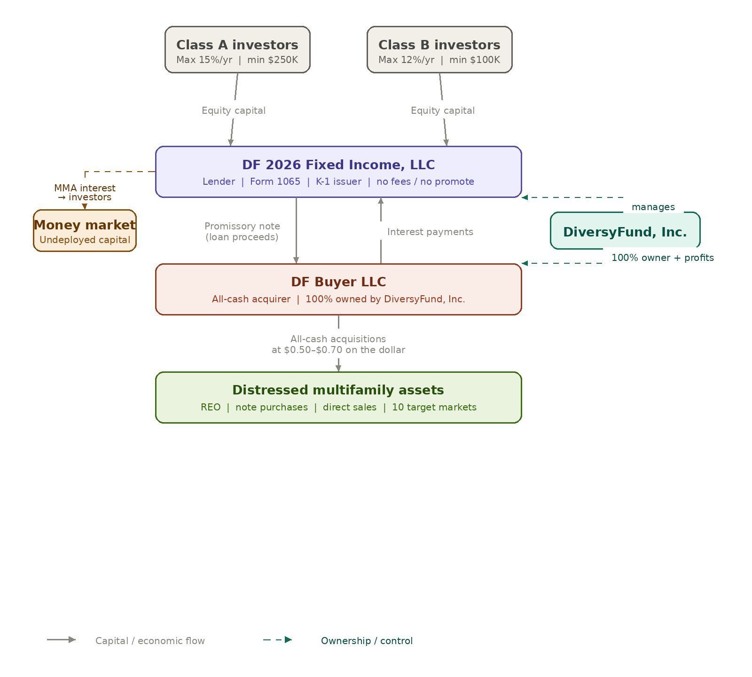

6.5 Distributions
Distributions of preferred return (funded from interest payments received from the Buyer on outstanding promissory notes) are targeted to be paid to investors on a quarterly basis. Investors should expect that, due to the natural transaction cycle — the Buyer typically requires 120 to 180 days from loan funding to disposition or refinance — quarterly distribution timing may lag the calendar quarter. Any deferred amounts will be made up in the next regular distribution to the extent interest has been paid by Buyer to the Fund. Money-market interest earned on undeployed capital is also distributed quarterly.

6.6 Cash Management
All Fund cash will be maintained in an interest-earning money market account at Silicon Valley Bank, a division of First Citizens Bank. This includes: (i) subscribed capital not yet loaned to the Buyer prior to the first transaction; (ii) capital between transactions, from the date the Buyer repays a loan to the date a new loan is funded; and (iii) any portion of available capital not required for a specific transaction due to deal-sizing (for example, where the Buyer’s acquisition requires less capital than the Fund has on hand). In all three cases, money-market interest earned on such capital will be allocated to investors and distributed quarterly. The preferred return does not accrue on capital in any of these three categories — it accrues only on capital actively loaned to the Buyer under an outstanding promissory note.

6.7 Reporting
Investors will receive quarterly reporting including a portfolio summary, transaction-level deal updates, capital account statements, and distribution detail, as well as audited annual financial statements and Schedule K-1s (or equivalent tax reporting) at year end.

7. Deal Economics — Illustrative Example
The figures below are illustrative only, intended to show how the Fund’s economics work mechanically. They are not a forecast and not a guarantee of returns. This shows potential profits that Buyer would then utilize for paying the interest on the loan due to the Fund.

Illustrative Single Transaction
Metric | Illustrative Value
Acquisition basis (% of intrinsic value) | 60%
Cash purchase price | $5,000,000
Hold period | 120 days
Resale price to operator | $5,500,000
Gross profit per transaction | $500,000
Implied gross profit on capital deployed (annualized) for Buyer available for interest payment to Fund | ~30%

Illustrative Reposition Transaction
Metric | Illustrative Value
Acquisition basis (% of intrinsic value) | 55%
Cash purchase price | $8,000,000
Hold period | 12 months
Reposition cost | $500,000
Sale price post-reposition | $10,500,000
Gross profit for Buyer available for interest payment to Fund | $2,000,000

Note on Capital Velocity
Because the Buyer’s primary strategy targets a 120–180 day hold, loan capital can be recycled multiple times during the two-year deployment period. The Fund’s preferred returns are designed to be funded primarily from the interest income the Fund earns on its loans to the Buyer, which in turn is supported by the Buyer’s transactional profitability rather than long-duration appreciation.

8. Team & Operating Capability

8.1 Co-Founder / CEO — Craig Cecilio, DiversyFund, Inc.
Craig Cecilio is the Co-Founder and CEO of DiversyFund, Inc. Over a roughly thirty-year career in real estate, Craig has navigated multiple market cycles and built a network of relationships across banks, brokers, operators, and institutional capital that is the principal source of the Buyer’s deal flow.

Mr. Cecilio has nearly three decades of experience in real estate, participating in the development of over 1,000 single-family and commercial properties as a sponsor, lender, and equity partner. Earlier in his career, he founded a real estate investment firm underwriting, operating, and financing projects across major U.S. markets. From 2012 to 2016, he owned and operated a private real estate investment fund. In 2014, he launched DiversyFund as a DBA and incorporated the company in 2016, where he serves as Founder and CEO. Since 1998, he has raised over $1 billion in capital, serving more than 30,000+ investors.

8.2 Boots on the Ground
In each of the ten target markets, the Sponsor has either previously acquired or sold multifamily assets, or has existing market relationships. As a result, the Buyer will leverage:
- Established local property management partners.
- Local broker relationships for both on- and off-market sourcing.
- Pre-vetted construction and renovation contractors for repositioning work.
- Local legal counsel familiar with foreclosure and title processes (especially valuable in Texas note acquisitions).

8.3 Sponsor Economics and Alignment
DiversyFund, Inc. serves as Manager of the Fund without a management fee, sponsor promote, or carried interest at the Fund level. There are no capital calls; all investor capital is funded in full at subscription.
The Sponsor’s economic return is earned entirely at the Buyer level. After the Buyer repays all outstanding note principal and accrued interest to the Fund, any residual profits generated by the Buyer’s acquisitions and dispositions accrue to DiversyFund, Inc. as the sole equity owner of the Buyer. This structure directly aligns the Sponsor’s financial interests with investor outcomes: the Sponsor earns its return only after investors have been paid the interest due from Buyer to the Fund.
Fund operating expenses (legal, accounting, tax preparation, K-1 issuance, state filings, and related costs) are borne by the Fund and capped at the greater of $50,000 per year or 0.5% of total capital raised. Based on a target raise of $20,000,000, this cap equals $100,000 per year.

9. Risk Factors
An investment in the Fund involves significant risk, including the possible loss of principal. The risks below are illustrative and not exhaustive; investors should review the full risk factors set out in the Fund’s Private Placement Memorandum.
- Market risk: Multifamily values may decline further or recover more slowly than the Sponsor anticipates, compressing margins or extending hold periods.
- Liquidity risk: Interests in the Fund are illiquid and not transferable except in accordance with the Fund’s governing documents.
- Execution risk: The Fund’s strategy depends on sourcing assets at targeted discounts, on operator demand for take-out, and on acceptable refinance availability.
- Concentration risk: Exposure is concentrated in a single asset class (multifamily), a defined set of geographic markets and a small number of asset acquisitions.
- Note acquisition risk: Note purchases involve Buyer defenses, title issues, environmental exposure, and timing risk through the foreclosure process.
- Interest rate / financing risk: Although the Buyer acquires all-cash, exit values for resales and refinances are sensitive to prevailing interest rates.
- Counterparty risk: The Fund relies on operators, banks, brokers, and other counterparties to close transactions on agreed terms.
- Key person risk: The Fund’s strategy depends meaningfully on the relationships and judgment of the CEO and senior team.
- Banking / cash management risk: Cash held in the money market account at Silicon Valley Bank, a division of First Citizens Bank is subject to FDIC limits on insured deposits and is otherwise exposed to that institution.
- Regulatory and tax risk: Changes in securities, banking, foreclosure, or tax law could materially affect the Fund’s operations and after-tax returns.

10. Use of Proceeds & Timeline

10.1 Use of Proceeds
Substantially all capital raised by the Fund will be loaned to the Buyer pursuant to promissory notes, the proceeds of which the Buyer will use to acquire multifamily assets and notes consistent with the strategy described above. There are no capital calls; investor capital is funded in full at subscription and held in the Fund’s money market account until loaned to the Buyer for a specific transaction. Fund operating expenses are borne by the Fund and capped at the greater of $50,000 per year or 0.5% of total capital raised; based on a target raise of $20,000,000, this cap equals $100,000 per year, although we expect Fund expenses to be significantly less.
Use | Indicative Allocation
Loans to Buyer for asset and note acquisitions | Substantially all capital raised
Fund operating expenses | Capped at greater of $50,000/yr or 0.5% of capital raised; $100,000/yr at $20M target raise

10.2 Indicative Timeline
Phase | Indicative Period | Activity
Pre-launch | 2Q 2026 | PPM finalization, fund formation, lead investor commitments
Initial close | 2Q 2026 | First investor subscriptions; pipeline activation
Final close | Targeting within ~6 months of initial close | Remaining commitments accepted
Deployment period | Months 0–24 from final close | Lending to Buyer for acquisitions, note purchases, and dispositions; interest distributions to investors
Wind-down | Months 24–48+ | Final dispositions, residual distributions, fund liquidation (1–2 years)

11. Important Disclosures
This document is provided for informational and discussion purposes only. It does not constitute, and shall not be construed as, an offer to sell or a solicitation of an offer to buy any securities, interests, or instruments. Any such offer or solicitation will be made only to qualified investors pursuant to a Confidential Private Placement Memorandum and the Fund’s definitive subscription and governing documents, which contain material information not included herein, including risk factors and conflicts of interest.
Statements regarding strategy, returns, market conditions, and outcomes are forward-looking and based on current beliefs and assumptions. Actual results may differ materially. Past performance is not indicative of future results. Targeted returns, including the 15% Class A and 12% Class B preferred returns, are objectives, not guarantees. There can be no assurance that the Fund will achieve its objectives or that investors will receive any return of capital.
Prospective investors should consult their own legal, tax, and financial advisors before considering any investment in the Fund.

DF 2026 Fixed Income, LLC | Confidential Business Plan

