EXPLORATORY DATA ANALYSIS

Jared Murundu

3/21/2022

# INTRODUCTION

Exploratory data analysis is generally data driven hypothesis generation. Explortaory data analysis has two aspects namely: 1. Numerical summarisation. 2. Data Visualization. The following data is of focus in relation to the above topics.

data<-read.csv("prostate_data.csv")  
  
data

## Count lcavol lweight age lbph svi lcp gleason pgg45  
## 1 1 -0.579818495 2.769459 50 -1.38629436 0 -1.38629436 6 0  
## 2 2 -0.994252273 3.319626 58 -1.38629436 0 -1.38629436 6 0  
## 3 3 -0.510825624 2.691243 74 -1.38629436 0 -1.38629436 7 20  
## 4 4 -1.203972804 3.282789 58 -1.38629436 0 -1.38629436 6 0  
## 5 5 0.751416089 3.432373 62 -1.38629436 0 -1.38629436 6 0  
## 6 6 -1.049822124 3.228826 50 -1.38629436 0 -1.38629436 6 0  
## 7 7 0.737164066 3.473518 64 0.61518564 0 -1.38629436 6 0  
## 8 8 0.693147181 3.539509 58 1.53686722 0 -1.38629436 6 0  
## 9 9 -0.776528789 3.539509 47 -1.38629436 0 -1.38629436 6 0  
## 10 10 0.223143551 3.244544 63 -1.38629436 0 -1.38629436 6 0  
## 11 11 0.254642218 3.604138 65 -1.38629436 0 -1.38629436 6 0  
## 12 12 -1.347073648 3.598681 63 1.26694760 0 -1.38629436 6 0  
## 13 13 1.613429934 3.022861 63 -1.38629436 0 -0.59783700 7 30  
## 14 14 1.477048724 2.998229 67 -1.38629436 0 -1.38629436 7 5  
## 15 15 1.205970807 3.442019 57 -1.38629436 0 -0.43078292 7 5  
## 16 16 1.541159072 3.061052 66 -1.38629436 0 -1.38629436 6 0  
## 17 17 -0.415515444 3.516013 70 1.24415459 0 -0.59783700 7 30  
## 18 18 2.288486169 3.649359 66 -1.38629436 0 0.37156356 6 0  
## 19 19 -0.562118918 3.267666 41 -1.38629436 0 -1.38629436 6 0  
## 20 20 0.182321557 3.825375 70 1.65822808 0 -1.38629436 6 0  
## 21 21 1.147402453 3.419365 59 -1.38629436 0 -1.38629436 6 0  
## 22 22 2.059238834 3.501043 60 1.47476301 0 1.34807315 7 20  
## 23 23 -0.544727175 3.375880 59 -0.79850770 0 -1.38629436 6 0  
## 24 24 1.781709133 3.451574 63 0.43825493 0 1.17865500 7 60  
## 25 25 0.385262401 3.667400 69 1.59938758 0 -1.38629436 6 0  
## 26 26 1.446918983 3.124565 68 0.30010459 0 -1.38629436 6 0  
## 27 27 0.512823626 3.719651 65 -1.38629436 0 -0.79850770 7 70  
## 28 28 -0.400477567 3.865979 67 1.81645208 0 -1.38629436 7 20  
## 29 29 1.040276712 3.128951 67 0.22314355 0 0.04879016 7 80  
## 30 30 2.409644165 3.375880 65 -1.38629436 0 1.61938824 6 0  
## 31 31 0.285178942 4.090169 65 1.96290773 0 -0.79850770 6 0  
## 32 32 0.182321557 3.804438 65 1.70474809 0 -1.38629436 6 0  
## 33 33 1.275362800 3.037354 71 1.26694760 0 -1.38629436 6 0  
## 34 34 0.009950331 3.267666 54 -1.38629436 0 -1.38629436 6 0  
## 35 35 -0.010050336 3.216874 63 -1.38629436 0 -0.79850770 6 0  
## 36 36 1.308332820 4.119850 64 2.17133681 0 -1.38629436 7 5  
## 37 37 1.423108334 3.657131 73 -0.57981850 0 1.65822808 8 15  
## 38 38 0.457424847 2.374906 64 -1.38629436 0 -1.38629436 7 15  
## 39 39 2.660958594 4.085136 68 1.37371558 1 1.83258146 7 35  
## 40 40 0.797507196 3.013081 56 0.93609336 0 -0.16251893 7 5  
## 41 41 0.620576488 3.141995 60 -1.38629436 0 -1.38629436 9 80  
## 42 42 1.442201993 3.682610 68 -1.38629436 0 -1.38629436 7 10  
## 43 43 0.582215620 3.865979 62 1.71379793 0 -0.43078292 6 0  
## 44 44 1.771556762 3.896909 61 -1.38629436 0 0.81093022 7 6  
## 45 45 1.486139696 3.409496 66 1.74919985 0 -0.43078292 7 20  
## 46 46 1.663926098 3.392829 61 0.61518564 0 -1.38629436 7 15  
## 47 47 2.727852828 3.995445 79 1.87946505 1 2.65675691 9 100  
## 48 48 1.163150810 4.035125 68 1.71379793 0 -0.43078292 7 40  
## 49 49 1.745715531 3.498022 43 -1.38629436 0 -1.38629436 6 0  
## 50 50 1.220829921 3.568123 70 1.37371558 0 -0.79850770 6 0  
## 51 51 1.091923301 3.993603 68 -1.38629436 0 -1.38629436 7 50  
## 52 52 1.660131027 4.234831 64 2.07317193 0 -1.38629436 6 0  
## 53 53 0.512823626 3.633631 64 1.49290410 0 0.04879016 7 70  
## 54 54 2.127040520 4.121473 68 1.76644166 0 1.44691898 7 40  
## 55 55 3.153590358 3.516013 59 -1.38629436 0 -1.38629436 7 5  
## 56 56 1.266947603 4.280132 66 2.12226154 0 -1.38629436 7 15  
## 57 57 0.974559640 2.865054 47 -1.38629436 0 0.50077529 7 4  
## 58 58 0.463734016 3.764682 49 1.42310833 0 -1.38629436 6 0  
## 59 59 0.542324291 4.178226 70 0.43825493 0 -1.38629436 7 20  
## 60 60 1.061256502 3.851211 61 1.29472717 0 -1.38629436 7 40  
## 61 61 0.457424847 4.524502 73 2.32630162 0 -1.38629436 6 0  
## 62 62 1.997417706 3.719651 63 1.61938824 1 1.90954250 7 40  
## 63 63 2.775708850 3.524889 72 -1.38629436 0 1.55814462 9 95  
## 64 64 2.034705648 3.917011 66 2.00821403 1 2.11021320 7 60  
## 65 65 2.073171929 3.623007 64 -1.38629436 0 -1.38629436 6 0  
## 66 66 1.458615023 3.836221 61 1.32175584 0 -0.43078292 7 20  
## 67 67 2.022871190 3.878466 68 1.78339122 0 1.32175584 7 70  
## 68 68 2.198335072 4.050915 72 2.30757263 0 -0.43078292 7 10  
## 69 69 -0.446287103 4.408547 69 -1.38629436 0 -1.38629436 6 0  
## 70 70 1.193922468 4.780383 72 2.32630162 0 -0.79850770 7 5  
## 71 71 1.864080131 3.593194 60 -1.38629436 1 1.32175584 7 60  
## 72 72 1.160020917 3.341093 77 1.74919985 0 -1.38629436 7 25  
## 73 73 1.214912744 3.825375 69 -1.38629436 1 0.22314355 7 20  
## 74 74 1.838961071 3.236716 60 0.43825493 1 1.17865500 9 90  
## 75 75 2.999226163 3.849083 69 -1.38629436 1 1.90954250 7 20  
## 76 76 3.141130476 3.263849 68 -0.05129329 1 2.42036813 7 50  
## 77 77 2.010894999 4.433789 72 2.12226154 0 0.50077529 7 60  
## 78 78 2.537657215 4.354784 78 2.32630162 0 -1.38629436 7 10  
## 79 79 2.648300197 3.582129 69 -1.38629436 1 2.58399755 7 70  
## 80 80 2.779440197 3.823192 63 -1.38629436 0 0.37156356 7 50  
## 81 81 1.467874348 3.070376 66 0.55961579 0 0.22314355 7 40  
## 82 82 2.513656063 3.473518 57 0.43825493 0 2.32727771 7 60  
## 83 83 2.613006652 3.888754 77 -0.52763274 1 0.55961579 7 30  
## 84 84 2.677590994 3.838376 65 1.11514159 0 1.74919985 9 70  
## 85 85 1.562346305 3.709907 60 1.69561561 0 0.81093022 7 30  
## 86 86 3.302849259 3.518980 64 -1.38629436 1 2.32727771 7 60  
## 87 87 2.024193067 3.731699 58 1.63899671 0 -1.38629436 6 0  
## 88 88 1.731655545 3.369018 62 -1.38629436 1 0.30010459 7 30  
## 89 89 2.807593831 4.718052 65 -1.38629436 1 2.46385324 7 60  
## 90 90 1.562346305 3.695110 76 0.93609336 1 0.81093022 7 75  
## 91 91 3.246490992 4.101817 68 -1.38629436 0 -1.38629436 6 0  
## 92 92 2.532902848 3.677566 61 1.34807315 1 -1.38629436 7 15  
## 93 93 2.830267834 3.876396 68 -1.38629436 1 1.32175584 7 60  
## 94 94 3.821003607 3.896909 44 -1.38629436 1 2.16905370 7 40  
## 95 95 2.907447359 3.396185 52 -1.38629436 1 2.46385324 7 10  
## 96 96 2.882563575 3.773910 68 1.55814462 1 1.55814462 7 80  
## 97 97 3.471966453 3.974998 68 0.43825493 1 2.90416508 7 20  
## lpsa train  
## 1 -0.4307829 TRUE  
## 2 -0.1625189 TRUE  
## 3 -0.1625189 TRUE  
## 4 -0.1625189 TRUE  
## 5 0.3715636 TRUE  
## 6 0.7654678 TRUE  
## 7 0.7654678 FALSE  
## 8 0.8544153 TRUE  
## 9 1.0473190 FALSE  
## 10 1.0473190 FALSE  
## 11 1.2669476 TRUE  
## 12 1.2669476 TRUE  
## 13 1.2669476 TRUE  
## 14 1.3480731 TRUE  
## 15 1.3987169 FALSE  
## 16 1.4469190 TRUE  
## 17 1.4701758 TRUE  
## 18 1.4929041 TRUE  
## 19 1.5581446 TRUE  
## 20 1.5993876 TRUE  
## 21 1.6389967 TRUE  
## 22 1.6582281 FALSE  
## 23 1.6956156 TRUE  
## 24 1.7137979 TRUE  
## 25 1.7316555 FALSE  
## 26 1.7664417 FALSE  
## 27 1.8000583 TRUE  
## 28 1.8164521 FALSE  
## 29 1.8484548 TRUE  
## 30 1.8946169 TRUE  
## 31 1.9242487 TRUE  
## 32 2.0082140 FALSE  
## 33 2.0082140 TRUE  
## 34 2.0215476 FALSE  
## 35 2.0476928 TRUE  
## 36 2.0856721 FALSE  
## 37 2.1575593 TRUE  
## 38 2.1916535 TRUE  
## 39 2.2137539 TRUE  
## 40 2.2772673 TRUE  
## 41 2.2975726 TRUE  
## 42 2.3075726 FALSE  
## 43 2.3272777 TRUE  
## 44 2.3749058 FALSE  
## 45 2.5217206 TRUE  
## 46 2.5533438 TRUE  
## 47 2.5687881 TRUE  
## 48 2.5687881 FALSE  
## 49 2.5915164 FALSE  
## 50 2.5915164 FALSE  
## 51 2.6567569 TRUE  
## 52 2.6775910 TRUE  
## 53 2.6844403 FALSE  
## 54 2.6912431 FALSE  
## 55 2.7047113 FALSE  
## 56 2.7180005 TRUE  
## 57 2.7880929 FALSE  
## 58 2.7942279 TRUE  
## 59 2.8063861 TRUE  
## 60 2.8124102 TRUE  
## 61 2.8419982 TRUE  
## 62 2.8535925 FALSE  
## 63 2.8535925 TRUE  
## 64 2.8820035 FALSE  
## 65 2.8820035 FALSE  
## 66 2.8875901 FALSE  
## 67 2.9204698 TRUE  
## 68 2.9626924 TRUE  
## 69 2.9626924 TRUE  
## 70 2.9729753 TRUE  
## 71 3.0130809 TRUE  
## 72 3.0373539 TRUE  
## 73 3.0563569 FALSE  
## 74 3.0750055 FALSE  
## 75 3.2752562 TRUE  
## 76 3.3375474 TRUE  
## 77 3.3928291 TRUE  
## 78 3.4355988 TRUE  
## 79 3.4578927 TRUE  
## 80 3.5130369 FALSE  
## 81 3.5160131 TRUE  
## 82 3.5307626 TRUE  
## 83 3.5652984 TRUE  
## 84 3.5709402 FALSE  
## 85 3.5876769 TRUE  
## 86 3.6309855 TRUE  
## 87 3.6800909 TRUE  
## 88 3.7123518 TRUE  
## 89 3.9843437 TRUE  
## 90 3.9936030 TRUE  
## 91 4.0298060 TRUE  
## 92 4.1295508 TRUE  
## 93 4.3851468 TRUE  
## 94 4.6844434 TRUE  
## 95 5.1431245 FALSE  
## 96 5.4775090 TRUE  
## 97 5.5829322 FALSE

## Numerical Summarization

Under this we focus on the foolowing measures; 1. Measures of location. 2. Measures of Spread 3. Measures of skewness 4. Measures of Correlation 5. Measures of simmillarity and dissimilarity

### Measures of Location

The measure of location entails the central tendencies, which includes the following; 1. The mean or the average 2. The Mode 3. The Median 4. The Dispersion of Variability 5. The Range and Inter-quartile Range

#### The Mean

This is the average of the data under study. This can be done using the respective variables under study. The following shows thee mean of the data variables of the prostrate data.

survey<-read.csv("prostate_data.csv",header = TRUE)  
names(survey)

## [1] "Count" "lcavol" "lweight" "age" "lbph" "svi" "lcp"   
## [8] "gleason" "pgg45" "lpsa" "train"

summary(survey)

## Count lcavol lweight age   
## Min. : 1 Min. :-1.3471 Min. :2.375 Min. :41.00   
## 1st Qu.:25 1st Qu.: 0.5128 1st Qu.:3.376 1st Qu.:60.00   
## Median :49 Median : 1.4469 Median :3.623 Median :65.00   
## Mean :49 Mean : 1.3500 Mean :3.629 Mean :63.87   
## 3rd Qu.:73 3rd Qu.: 2.1270 3rd Qu.:3.876 3rd Qu.:68.00   
## Max. :97 Max. : 3.8210 Max. :4.780 Max. :79.00   
## lbph svi lcp gleason   
## Min. :-1.3863 Min. :0.0000 Min. :-1.3863 Min. :6.000   
## 1st Qu.:-1.3863 1st Qu.:0.0000 1st Qu.:-1.3863 1st Qu.:6.000   
## Median : 0.3001 Median :0.0000 Median :-0.7985 Median :7.000   
## Mean : 0.1004 Mean :0.2165 Mean :-0.1794 Mean :6.753   
## 3rd Qu.: 1.5581 3rd Qu.:0.0000 3rd Qu.: 1.1787 3rd Qu.:7.000   
## Max. : 2.3263 Max. :1.0000 Max. : 2.9042 Max. :9.000   
## pgg45 lpsa train   
## Min. : 0.00 Min. :-0.4308 Mode :logical   
## 1st Qu.: 0.00 1st Qu.: 1.7317 FALSE:30   
## Median : 15.00 Median : 2.5915 TRUE :67   
## Mean : 24.38 Mean : 2.4784   
## 3rd Qu.: 40.00 3rd Qu.: 3.0564   
## Max. :100.00 Max. : 5.5829

summary(survey$age)

## Min. 1st Qu. Median Mean 3rd Qu. Max.   
## 41.00 60.00 65.00 63.87 68.00 79.00

mean(survey$lcavol,na.rm = TRUE)

## [1] 1.35001

mode<-mode(survey$lcavol)  
sd(survey$lcavol,na.rm = TRUE)

## [1] 1.178625

hist(survey$lcavol ,xlab = "The count",ylab = "The cavol counts")

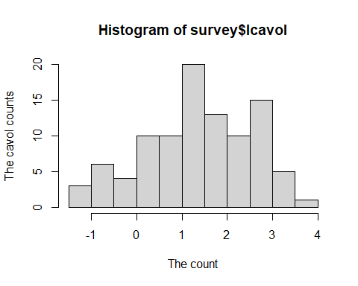

hist(survey$lweight,xlab = "The count",ylab = "The weight counts")

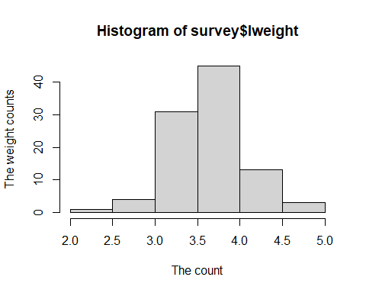

hist(survey$age,xlab = "The count",ylab = "The age ")

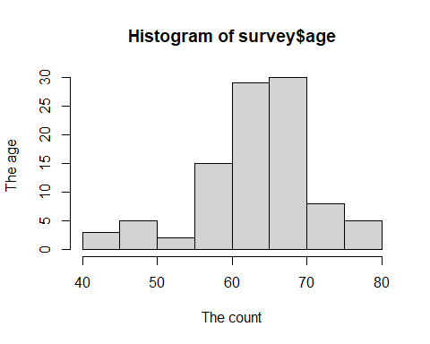

boxplot(survey$lcavol,main="A Box plot for Lcavol")

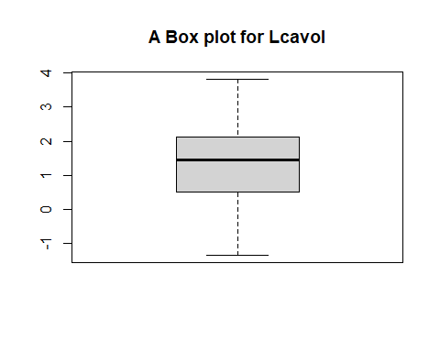

boxplot(survey$lcavol,horizontal = TRUE,main="A Box plot for Lcavol")

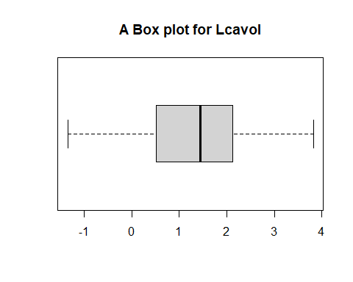 ## Ploting ta line graph

library(ggplot2)

library(ggplot2)