PurplePoster

SCORE Submission Report

Team Members:

Abhas Bodas [ab3599@columbia.edu](mailto:ab3599@columbia.edu)

Jared Pochtar [jrp2182@columbia.edu](mailto:jrp2182@columbia.edu)

Maria Taku [mat2185@columbia.edu](mailto:mat2185@columbia.edu)

Suhan Canaran [sc3055@columbia.edu](mailto:sc3055@columbia.edu)

Academic Course:

COMS W4156: Advanced Software Engineering

Columbia University, New York

Instructor Details:

Prof. Swapneel Sheth [swapneel@cs.columbia.edu](mailto:swapneel@cs.columbia.edu)

1. Basic Concept:

Purple Poster refers to the posters put up by movie filming crews when they film a movie. These posters look like “No Parking” notices placed by the police. They include an alias for a movie (or sometimes the real movie name will be used instead of an alias), the filming movie company, and date and time on which no parking is permitted in the area. We developed an application to allow users to post details of these purple posters and share them with fellow movie fans in NYC. PurplePoster web application will also allow users to keep track of and be alerted of filming locations of interests.

1. Description:

The PurplePoster application is targeted towards reporting, social sharing and collaborative tracking of spotted film shootings. Our system relies on users posting sightings of the purple posters announcing filming in the area. When a user sees a filming, they can report the filming by mentioning the name of the purple poster, date and location. Reporting the actual movie name is optional since it may not be available on the purple poster itself. This information can be guessed/known by a user and they will then be able to enter this information. The actual movie name is used to by the application to locate additional details on the movie--this auxiliary information is pulled and saved by the web application from Rotten Tomatoes (rottentomatoes.com). Once a poster/movie is in our database, users can set preferences to receive notifications about future filming reportings. Preferences can be set on the basis of a movie, a particular poster, actor/actress, or within a radius of a specified location. More detailed use cases can be found in the next section.

1. Use cases:
   * Report a filming: The user sees an ongoing filming. They open the web application, and enter the following details: Poster name, Movie name (optional), Date and Location (the default is current location retrieved by a browser geo-location - most effective in mobile submissions). The information is saved, and details about the movies are pulled from rottentomatoes.com. For example, on March 15th, 2012, a user sees a Purple Poster “Magnus Rex” at Columbia University, New York. User knows that this is the alias name used for the movie “Batman: The Dark Knight Rises”. They want to report the poster, so they enter relevant details. Upon saving the poster details, additional information is pulled from Rotten Tomatoes (e.g., cast, synopsis, movie posters, release date) and gets saved to the PurplePoster database.
   * Search for a filming: When the user wants to search for the filming of a movie / poster / actor / actress, they simply enter relevant keyword(s) in the search box. The results include purple posters which include the keyword in their name, movie name or the list of actors.
   * Set a preference: The user can go to their preferences and add particular posters, movies or actors that are currently available in the PurplePoster database into their tracking list for future filmings. They can also enter a particular location, for which they want to be alerted of nearby filmings.
   * Track Preference: When a poster is submitted, which includes the name, movie name or actor that matches the preferences set by a user, the user is alerted about the filming via email. An email gets sent every evening for any shootings that is happening the next day forward.
2. Team Members:

We are a team of four people, three of us are pursuing our Master’s in Computer Science at Columbia University, and one of us is currently in their senior year of high school while concurrently attending classes at Columbia University. The team members are:

* + Abhas Bodas [ab3599@columbia.edu](mailto:ab3599@columbia.edu)
  + Jared Pochtar [jrp2182@columbia.edu](mailto:jrp2182@columbia.edu)
  + Maria Taku [mat2185@columbia.edu](mailto:mat2185@columbia.edu)
  + Suhan Canaran [sc3055@columbia.edu](mailto:sc3055@columbia.edu)

1. Core Requirements:
2. Report Purple Poster sightings:

Users need ability to enter information regarding Purple Posters. They should be able to enter all the details available on the poster itself such as:

* 1. Movie Alias
  2. Real movie name (optional)
  3. Date of the film shooting
  4. Address of the shooting

1. Report additional details on movies:

When a real movie name is entered, additional details about that movie should be available to the user. Viewers should be able to see the cast, a synopsis and release dates of the movie being reported. If a real movie name is not entered, the application will attempt to locate the movie based on the entered alias (e.g., the user may not have realized that the alias was actually the real movie name, so it is worthwhile to attempt to location additional details based on the alias as well)

1. User login/preferences/Notifications:

Users should be able to sign up on the site and add certain things into their watch list. This will allow them to receive notifications on things they are most interested in.

* 1. Allow user to track certain purple posters or actors or movies. Allow them to enter an address to their watch list. User should receive an email notification as a reminder the day before if any of those tracked items will be part of a reported purple poster.

1. Search Functions

Users should be able to search for actors/movies or by filming companies. This will help them identify things they are interested in and add them to their watch list.

1. Administrative Site

Administrators can log into an Admin Site from which they can manage the data of the website as well as the users. For example, from this Admin Site and administrator can reset user passwords or ban users.

1. Database Schema: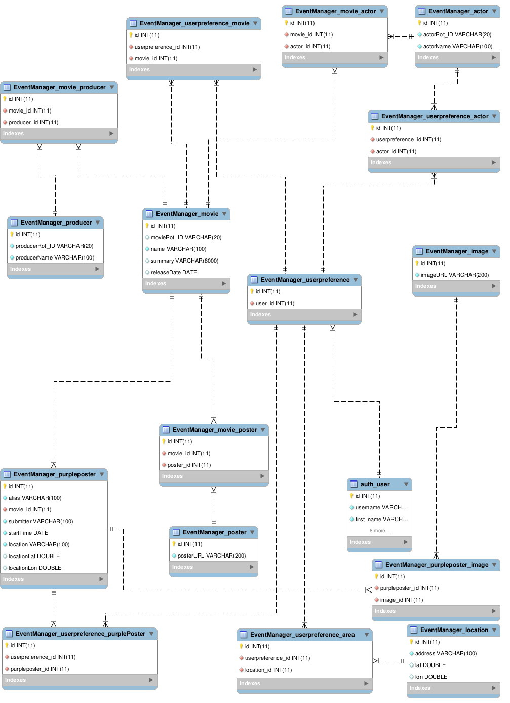
2. Technologies used:

Purple Poster is a web application developed on Django framework (version 1.4.2). Application code is written in Python. The UI is designed in html and javascript. Data is stored on a MYSQL database. It also uses shell scripts and cron jobs to schedule notification tasks.

* + Python,HTML, Javascript, shell scripts and cron job
  + Frameworks: Django 1.4.2
  + Database: MySQL

1. Course and Instructor details:
   * Academic Course: COMS W4156: Advanced Software Engineering

Columbia University, New York

* + Instructor: Prof. Swapneel Sheth

[swapneel@cs.columbia.edu](mailto:swapneel@cs.columbia.edu)

1. Contact Us:
   * Maria Taku: mat2185@columbia.edu