Jared Rivera 31 May 2017 804603106

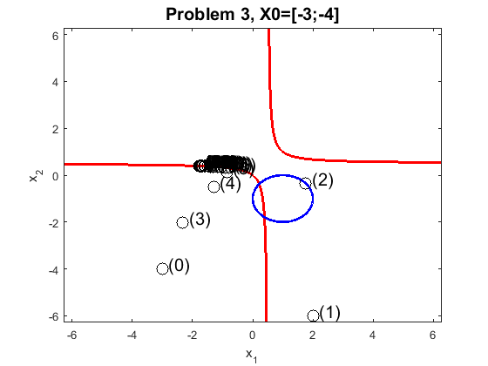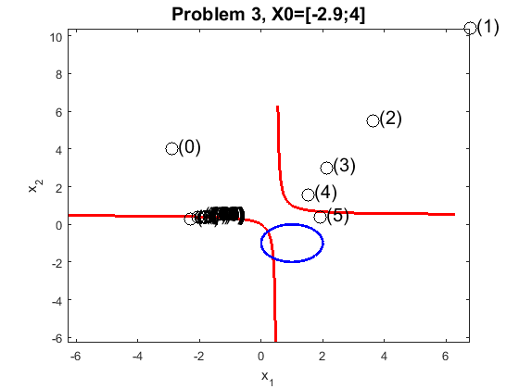CEE 103 HW#7

In the case of this problem, all initial guesses provided in the orginal problem statemnt and the modifications provided by the TA converged to the same solution, X=[-1.7932;0.3910]. This means that the system of equations only has a single solution. The only differnce due to starting point was its effect on iterations. The closer the starting point was to the solution, the less iterations it took to reach a solution that satisfied the residual stopping criteria. This is to be expected.

Looking at the figures above, the first few iteration in each case resulted in a new X value that was still fairly par from the solution, so the initial iterations were not very precise. However, after four or 5 iterations the method began to converge on a real solution, as can be seen by the tightly spaced groups of X values near the true solution above.