Homework 1 report skeleton
Describing and comparing distributions
Weekly cheese sales and promotional displays
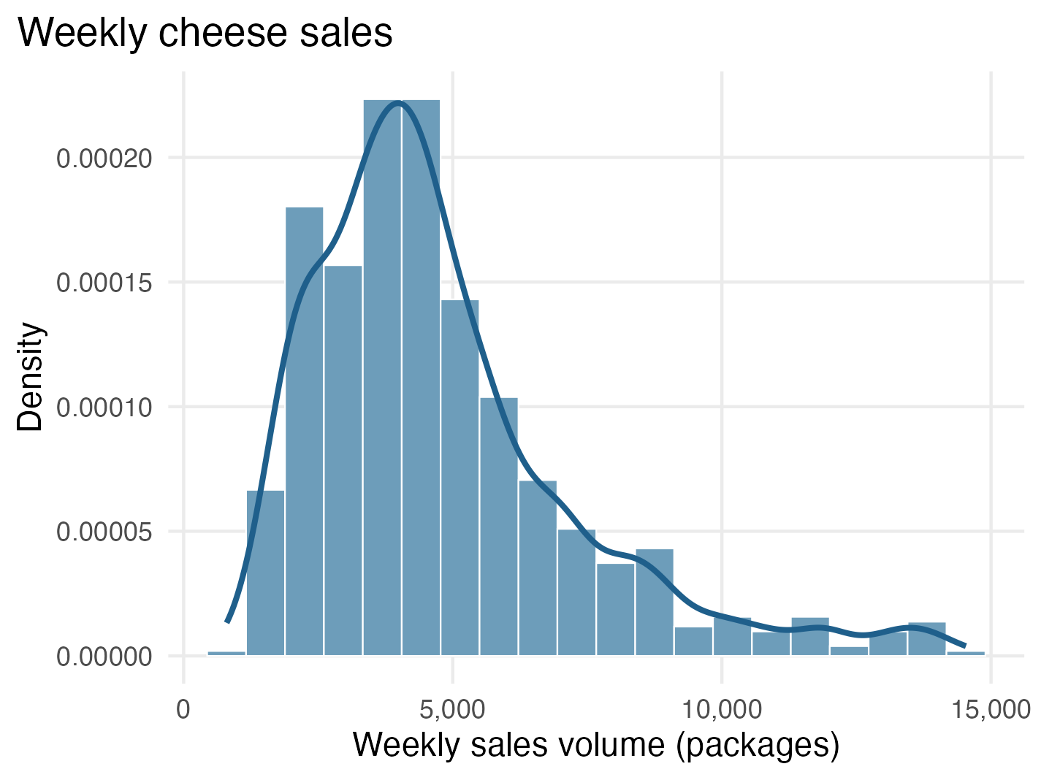
Figure 1. Overall weekly sales volume

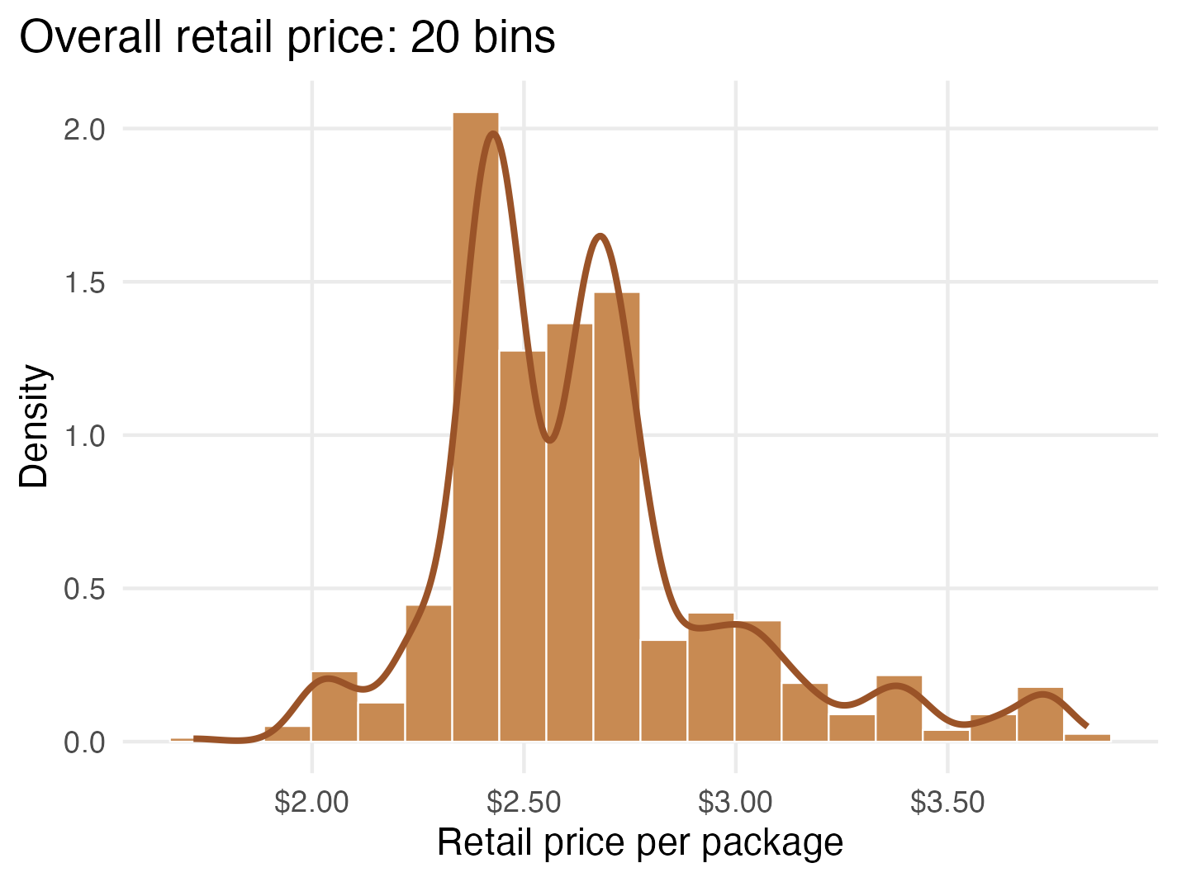
Figure 2. Overall retail price

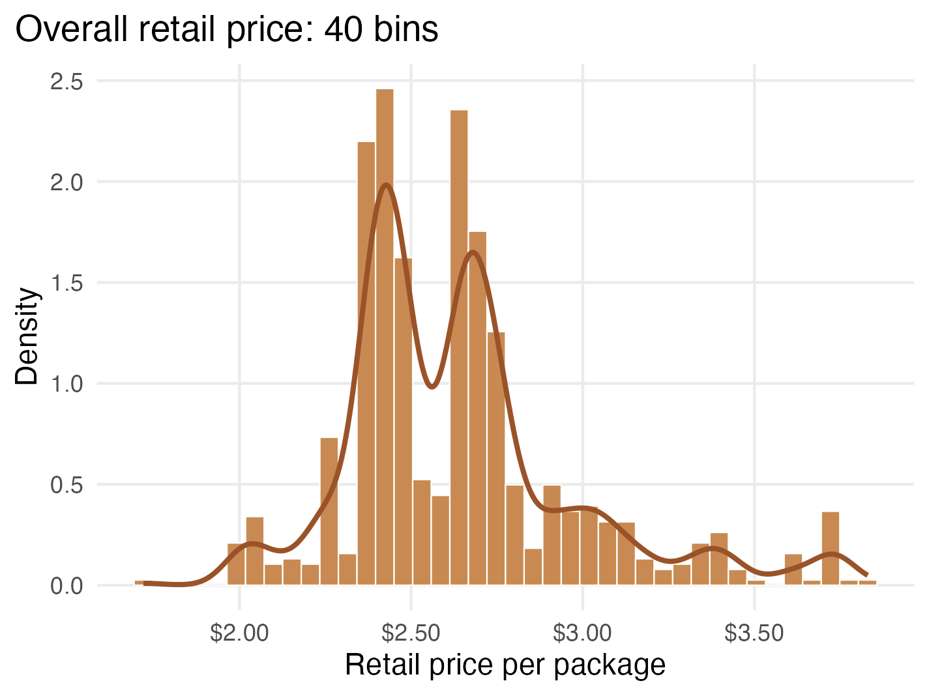
Figure 3. Overall retail price with narrower bins

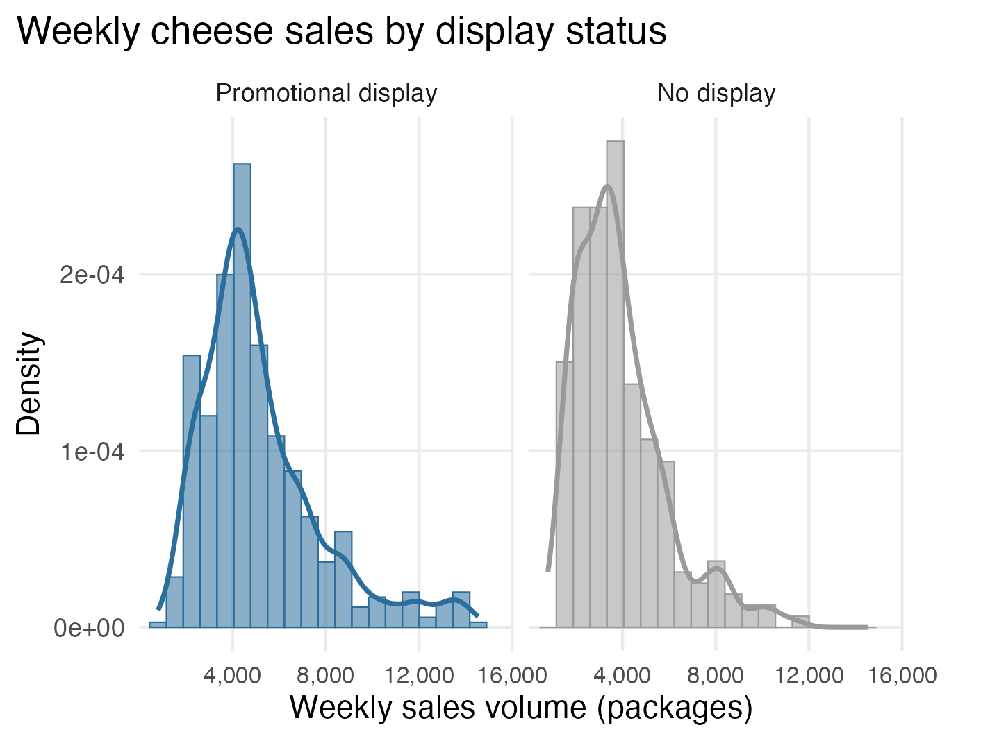
Figure 4. Weekly sales volume by display status

Table 1. Weekly sales-volume summary by display status
Group | Sample n | Miss. | Mean | SD | Q1 | Median | Q3 | IQR | Min. | Max.
All observations | 706 | 0 | 4,771.5 | 2,485.0 | 3,128.5 | 4,255 | 5,737.5 | 2,609 | 799 | 14,534
Promotional display | 485 | 0 | 5,182.7 | 2,603.2 | 3,510.0 | 4,549 | 6,292.0 | 2,782 | 799 | 14,534
No display | 221 | 0 | 3,869.2 | 1,920.7 | 2,380.0 | 3,498 | 4,680.0 | 2,300 | 1,237 | 11,318

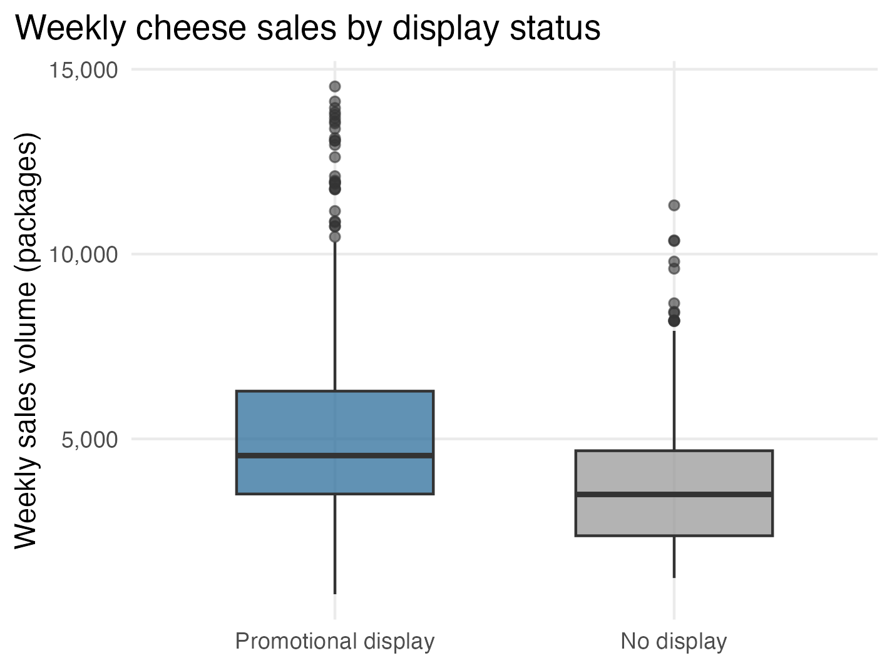
Figure 5. Weekly sales-volume box plots by display status

Table 2. Retail price summary by display status
Group | Sample n | Miss. | Mean | SD | Q1 | Median | Q3 | IQR | Min. | Max.
Promotional display | 485 | 0 | $2.57 | $0.28 | $2.41 | $2.50 | $2.69 | $0.28 | $1.72 | $3.83
No display | 221 | 0 | $2.79 | $0.41 | $2.47 | $2.73 | $3.03 | $0.56 | $2.03 | $3.74

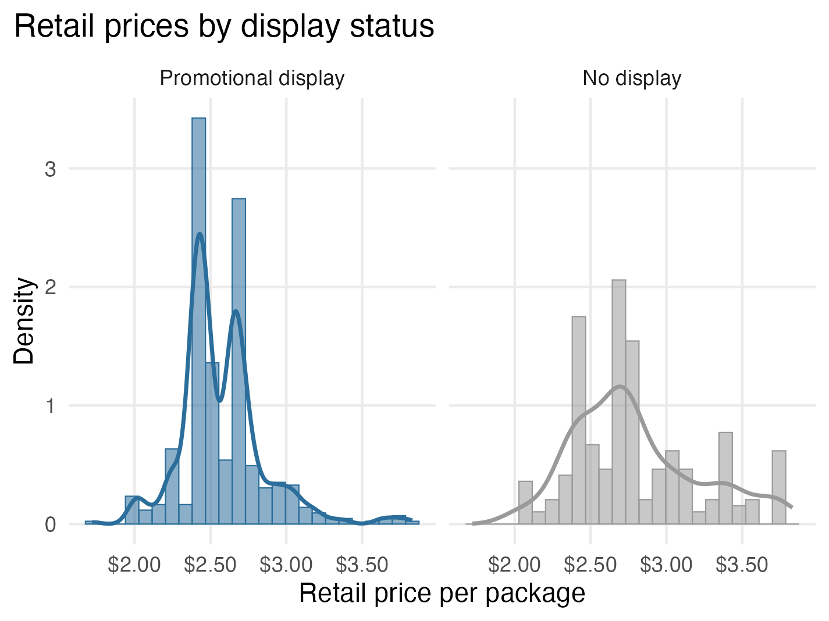
Figure 6. Retail price distributions by display status

Hybrid work, attrition, and productivity perceptions
Table 3. Attrition variable summary
Variable | Software type | Missing | Distinct observed values
treat | character | 0 | Control; Treatment
attrite_perc | double | 0 | 0; 100

Table 4. Employee attrition comparison
Group | N | Stayed | Left | Stayed (%) | Left (%)
Control | 820 | 761 | 59 | 92.8% | 7.2%
Hybrid WFH | 792 | 754 | 38 | 95.2% | 4.8%

Table 5. Perceptions variable summary
Variable | Software type | Missing | Distinct observed values
wave | character | 0 | 2
role | character | 0 | 2
productivity | character | 0 | 9

Table 6. Managers' baseline productivity perceptions
Original response | Count | Proportion
35%+ less efficient | 9 | 2.9%
25%-35% less efficient | 9 | 2.9%
15%-25% less efficient | 24 | 7.6%
5%-15% less efficient | 43 | 13.7%
About the same | 186 | 59.2%
5%-15% more efficient | 24 | 7.6%
15%-25% more efficient | 10 | 3.2%
25%-35% more efficient | 5 | 1.6%
35%+ more efficient | 4 | 1.3%

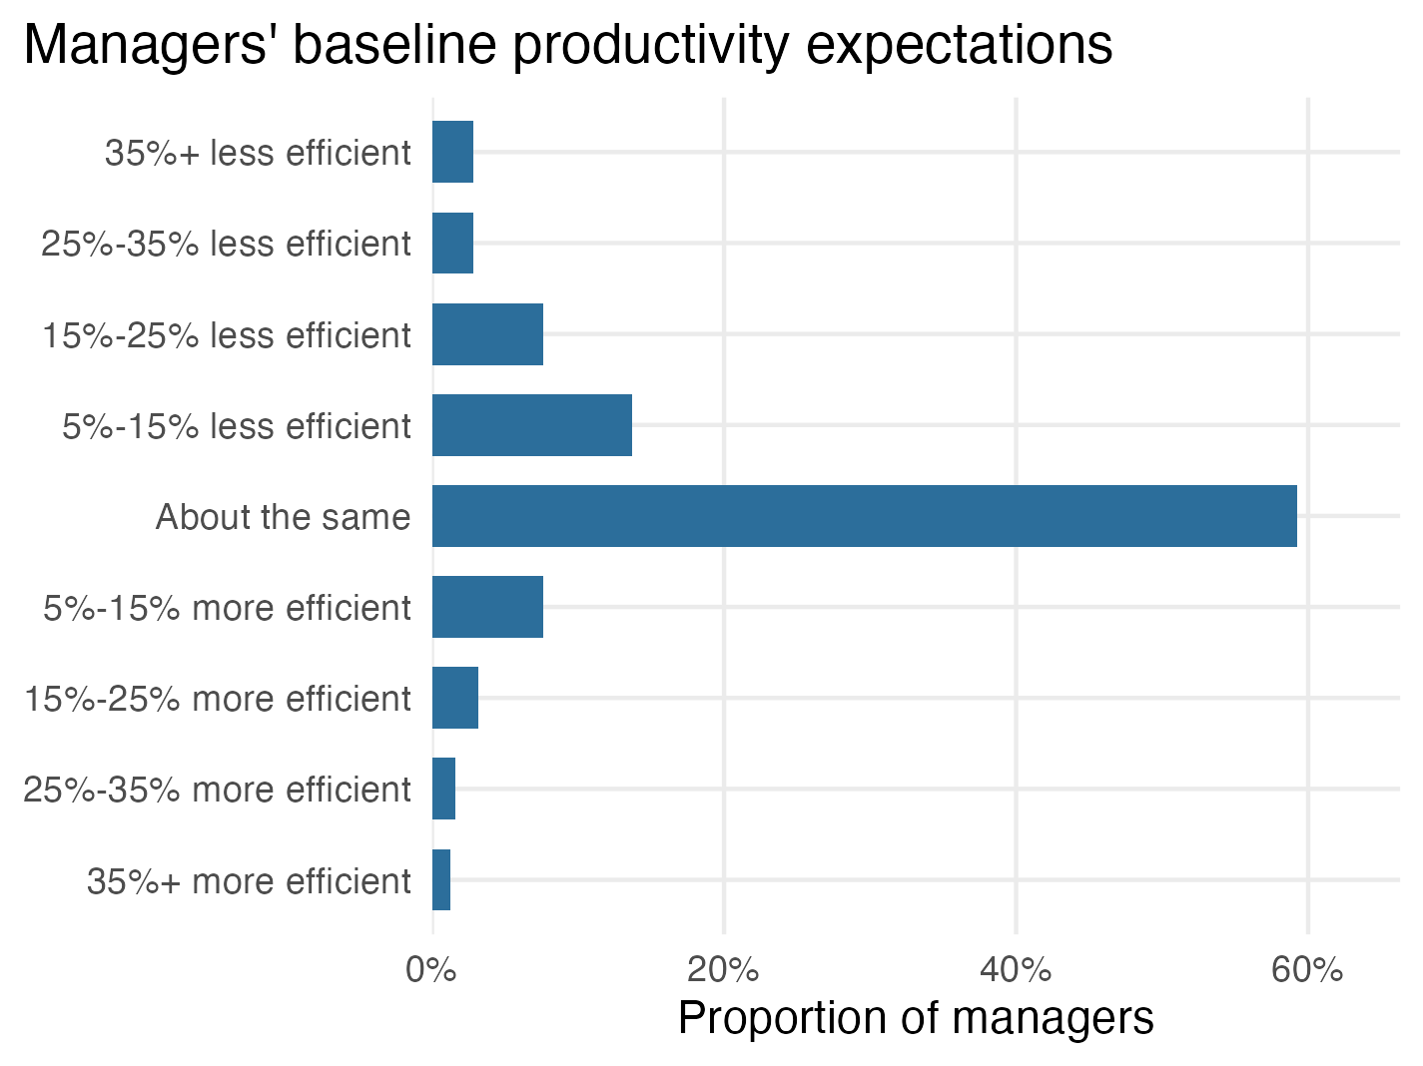
Figure 7. Managers' baseline productivity perceptions plot

