Homework 3 report skeleton
1.1. Return summaries
Table 1. 1.1 Return summaries
Asset | Months | Mean | SD
SPY | 192 | 0.011844 | 0.041391
GLD | 192 | 0.007845 | 0.045416

Table 2. 1.1 Correlation and covariance
Quantity | Value
Correlation | 0.082948
Covariance (decimal returns) | 0.00015593

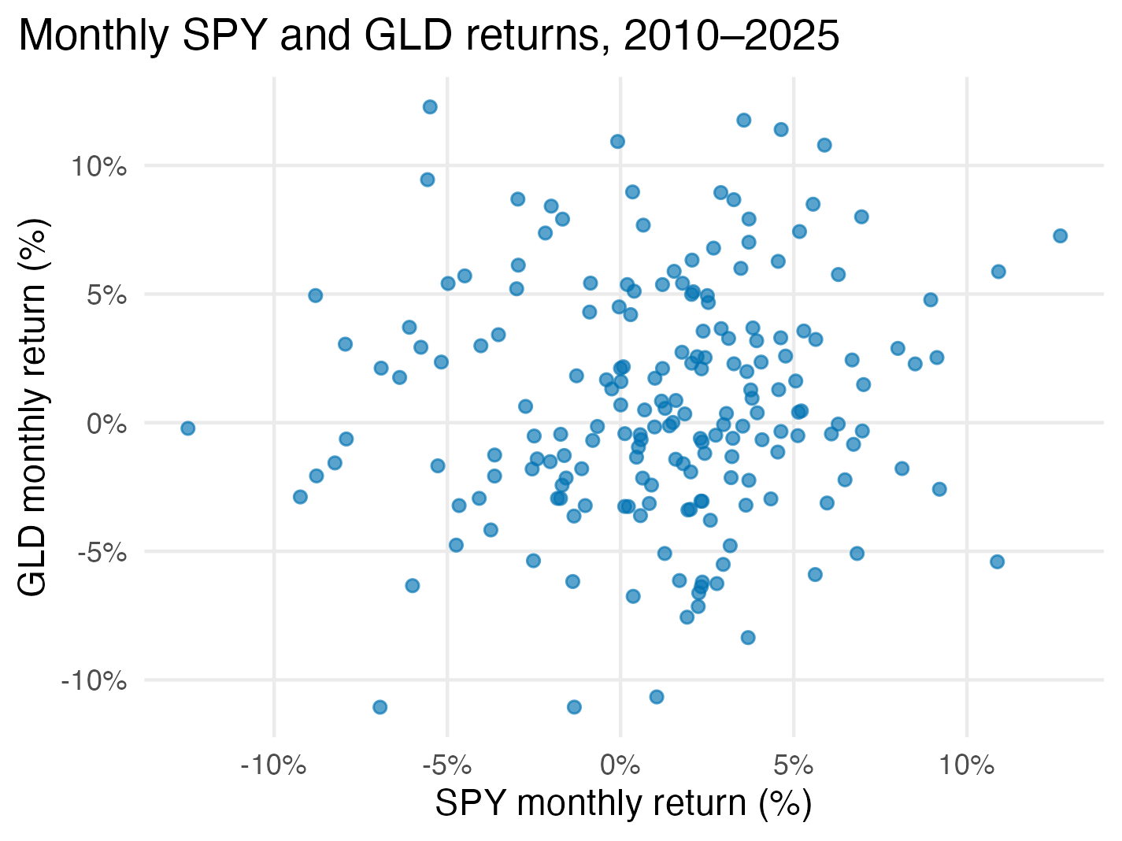
Figure 1. 1.1 Monthly SPY and GLD returns

1.2. A 60/40 portfolio
Table 3. 1.2 Direct 60/40 portfolio check
Quantity | Value
Months | 192
Mean monthly return | 0.010244 (1.02%)
Sample SD | 0.031963 (3.20 percentage points)

1.3. Portfolio allocations
Table 4. 1.3 Portfolio allocations
Allocation | SPY (%) | GLD (%) | Mean (%) | SD (pp) | Sharpe
Maximum Sharpe | 70.5 | 29.5 | 1.07 | 3.31 | 0.2466
Minimum SD | 55.0 | 45.0 | 1.00 | 3.18 | 0.2371
60/40 | 60.0 | 40.0 | 1.02 | 3.20 | 0.2423

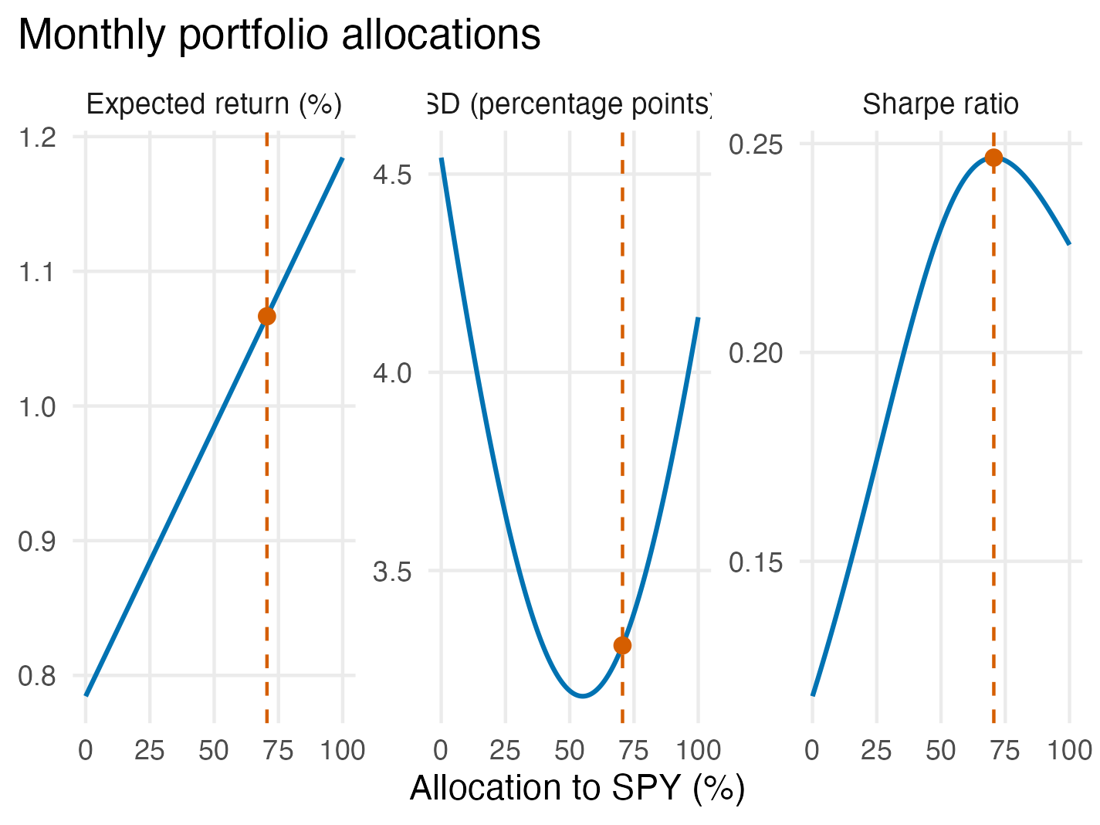
Figure 2. 1.3 Expected return SD and Sharpe ratio

Table 5. 1.3c Return summaries by period
Period | Asset | Months | Mean | SD
2010–2017 | SPY | 96 | 0.011430 | 0.034464
2010–2017 | GLD | 96 | 0.002698 | 0.049699
2018–2025 | SPY | 96 | 0.012258 | 0.047501
2018–2025 | GLD | 96 | 0.012992 | 0.040290

Table 6. 1.3c Correlation and covariance by period
Period | Correlation | Covariance
2010–2017 | 0.026520 | 0.00004543
2018–2025 | 0.137823 | 0.00026376

Table 7. 1.3c Maximum Sharpe allocations by period
Period | SPY (%) | GLD (%) | Mean (%) | SD (pp) | Sharpe
2010–2017 | 100.0 | 0.0 | 1.14 | 3.45 | 0.2591
2018–2025 | 38.3 | 61.7 | 1.27 | 3.28 | 0.3116

2. Lunch orders

3. Inspection workload

4.1. Inflation expectations
Table 8. 4.1c Mean inflation expectations software check
Quantity | Value
Sample size | 400
Mean | 0.034 (3.4%)
Sample SD | 0.040 (4.0 percentage points)
SE | 0.002 (0.2 percentage points)
Null mean | 0.040 (4.0%)
t-statistic | -3.000
95% CI lower | 0.030068 (3.007%)
95% CI upper | 0.037932 (3.793%)
Two-sided p-value | 0.00287

4.2. Family finances

5.1. Study design and summaries
Table 9. 5.1 Outcomes by assigned group
Group | Outcome | Assigned | Observed | Missing | Mean or proportion | Sample SD
Hybrid | Quitting | 792 | 792 | 0 | 38/792 = 0.047980 (4.80%) | —
Hybrid | Satisfaction | 792 | 680 | 112 | 8.1853 | 1.4847
Hybrid | Performance | 792 | 748 | 44 | 3.4385 | 0.8425
Office | Quitting | 820 | 820 | 0 | 59/820 = 0.071951 (7.20%) | —
Office | Satisfaction | 820 | 665 | 155 | 7.8346 | 1.5962
Office | Performance | 820 | 759 | 61 | 3.4941 | 0.8312

5.2. Quitting

5.3. Performance and satisfaction
Table 10. 5.3b Mean performance and satisfaction
Outcome | Hybrid minus office | 95% CI | Two-sided p-value
Performance (points) | -0.056 | [-0.140, 0.029] | 0.1976812
Satisfaction (points) | 0.351 | [0.186, 0.516] | 0.0000324

5.4. Recommendation

